Inspection Services Department of Urban Development
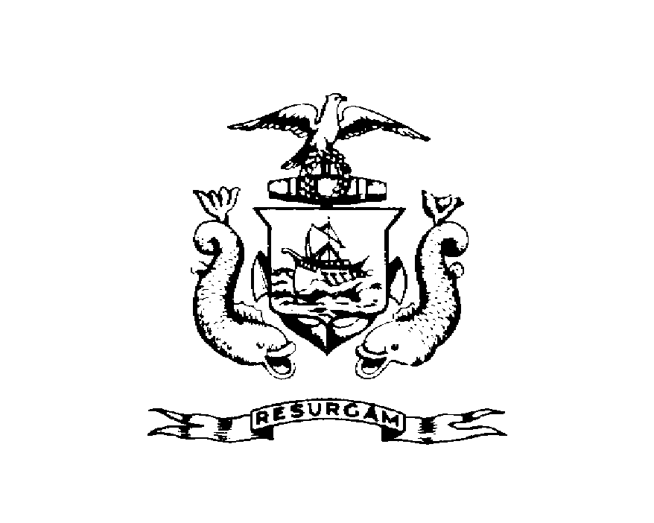
Michael J. Nugent Joseph E. Gray, Jr.
Manager Director

CITY OF PORTLAND
BILLING NOTICE
Second Notice
March 2, 2000

Restaurants Inc.
6 Custom House Wharf
Portland, Maine 04101

RE: Boone’s
CBL: 030-A-001

Dear Sir/Madam:

The City Council passed the following amendment on May 17, 1999:
Sec 11-37. Inspection Performance Requirements.
All licensed Food Service Establishments shall be inspected annually on forms approved by the State of Maine Dept. of Health Engineering. Establishments which obtain a score between 79 and 84 may be inspected monthly until the establishment has achieved the score of 85 or above. Establishments with a score of 78 or less may be reinspected within 10 days of the original unsatisfactory score. Establishments that score below 78 on two consecutive inspections shall be referred to the City Clerk for action pursuant to Chapter 15; provided, however, the foregoing shell not be construed to be a limitation on the authority of the City to refer violations to the City Clerk for action pursuant to Chapter 15.

Reinspection fee for FSE $75.00 per Re-inspection

Since that date, the City of Portland Inspection Services Team has inspected the above Food Service Establishment on the following dates with the following results:

9/14/99-51 9/24/99-79 10/20/99-55 11/23/99-90
The inspections from September had been previously billed on a notice sent 9/29/99. Our records show non-payment. This notice is a second notice with the additional substandard inspection noted.

Based on this standard your establishment has been reinspected 4 time. You now owe the City of Portland $ 300.00 in reinspection fees. Failure to pay the reinspection fee will cause this office to notify the City Clerk for action pursuant to Chapter 15. Please feel free to contact me at 874-8700, if you wish to discuss this.

Sincerely,

Mike Nugent
Manager of Inspection Services

