Inspection Services Department of Urban Development
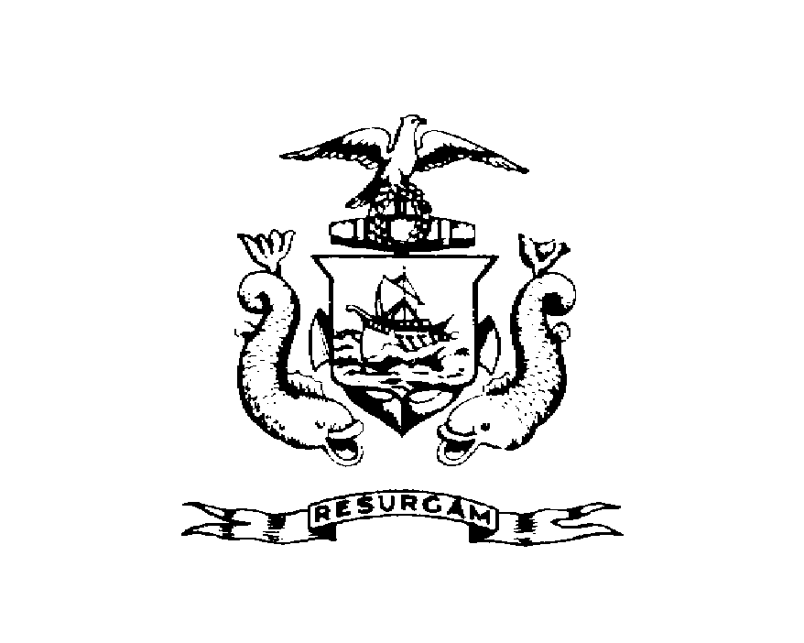
Michael J. Nugent Joseph E. Gray, Jr.
Manager Director

CITY OF PORTLAND
STOP WORK NOTICE
April 4, 2000

RE: Port Hole Restaurant – Custom House Wharf
CBL: 030-A-001
HAND DELIVER

Dear Oliver Keithly;

An evaluation of the property at Custom House Wharf revealed that the structure fails to comply with Section 107.1of the Building Code of the City of Portland.

Expansion of Outside Seating Area (without permit)

This is a STOP WORK ORDER pursuant to Section 117.1 of the Building Code (1999 BOCA). All construction activity must Stop immediately.

Submit complete building/use permit application for review and approval.

Failure to comply will result in this office referring the matter to the City of Portland Corporation Counsel for legal action and possible civil penalties, as provided for in Section 1-15 of the Code and in Title 30-A M.R.S.A. Ss 4452. This constitutes an appealable decision pursuant to Section 121.5 of the Code. Please feel free to contact me at 874-8697, if you wish to discuss the matter or have any questions.

Sincerely,

David Caddell
Code Enforcement Officer

Cc: Central File

dc/

