
Submittal

Prepared For: Brent Grass | Date: February 22, 2017  Customer P.O. Number:  Customer Project Number:
Sold To: HVAC Services | Job Number:  Job Name:  HVAC Services - Rob - CIEE

Trane U.S. Inc. dba Trane is pleased to provide the enclosed submittal for your review and approval.

Product Summary
Qty Product
7 Variable Air Volume Fan Powered Terminal Units

Daniel Broderick  Trane  860 Spring Street, Unit 1  Westbrook, ME 04092  Phone: (207) 828-1777  Cell:  Fax: (207) 828-1511 | The attached information describes the equipment we propose to furnish for this project, and is submitted for your approval.  Product performance and submittal data is valid for a period of 6 months from the date of submittal generation. If six months or more has elapsed between submittal generation and equipment release, the product performance and submittal data will need to be verified. It is the customer’s responsibility to obtain such verification.
/tmp/in/input.doc

Table Of Contents
Product Summary 1
Variable Air Volume Fan Powered Terminal Units (Items A1 - A4) 3
Tag Data 3
Product Data 4
Performance Data 4
Mechanical Specifications 6
Unit Dimensions 8
Accessory 12
Field Wiring 15

Tag Data - Variable Air Volume Fan Powered Terminal Units (Qty: 7)
Item | Tag(s) | Qty | Description | Model Number
A1 | FVAV 1-1, FVAV 1-2, FVAV 1-3 | 3 | VAV Fan Powered Terminal Units | VSEF1200S**CNONDD210-L-W0F15021W-*00
A2 | FVAV 1-4 | 1 | VAV Fan Powered Terminal Units | VSEF0800Q**CNONDD210-L-W0D05521W-*00
A3 | FVAV 1-6, FVAV 1-7 | 2 | VAV Fan Powered Terminal Units ( FP ) | VSEF0800P**0000DD210-L-W0D04521W-*00
A4 | FVAV 1-8 | 1 | VAV Fan Powered Terminal Units | VSEF0500P**CNONDD210-L-W0D02521W-*00

Product Data - Variable Air Volume Fan Powered Terminal Units
All Units
Series with electric heat
1" [26mm] foil faced insulation
Flanged connection
277/60/1 motor voltage
Single speed motor w/ SCR
Shaft only - with controls enclosure
Customer provided actuator
Left hand controls connection
Disconnect switch
2 stages of heat - equal increments
24 volt magnetic contactors
Electric heater air flow switch

Item: A1 Qty: 3 Tag(s): FVAV 1-1, FVAV 1-2, FVAV 1-3
12" (305 mm)
05 super quiet fan
480 volt, 3 phase
15.0 kilowatt

Item: A2 Qty: 1 Tag(s): FVAV 1-4
8" (203 mm)
03 super quiet fan
277 volt, 1 phase
5.5 kilowatt

Item: A3 Qty: 2 Tag(s): FVAV 1-6, FVAV 1-7
8" (203 mm)
02 super quiet fan
277 volt, 1 phase
4.5 kilowatt

Item: A4 Qty: 1 Tag(s): FVAV 1-8
5" (127 mm)
02 super quiet fan
277 volt, 1 phase
2.5 kilowatt

Performance Data - Variable Air Volume Fan Powered Terminal Units
Tags | FVAV 1-1, FVAV 1-2, FVAV 1-3 | FVAV 1-4 | FVAV 1-6, FVAV 1-7 | FVAV 1-8
Design cooling airflow (cfm) | 1500 | 600 | 500 | 250
Min cooling airflow (cfm) | 325 | 150 | 125 | 75
Valve heating airflow (cfm) | 750 | 300 | 250 | 125
Cooling inlet diameter (in) | 12.000 | 8.000 | 8.000 | 5.000
Cooling inlet velocity (ft/min) | 1910 | 1719 | 1432 | 1833
APD @ cooling airflow (in H2O) | 0.336 | 0.230 | 0.078 | 0.044
Fan airflow (cfm) | 1500 | 600 | 500 | 250
Downstream SP (in H2O) | 0.500 | 0.500 | 0.500 | 0.500
Fan TSP (in H2O) | 0.503 | 0.501 | 0.501 | 0.500
% of fan range (%) | 87.00 | 60.00 | 98.00 | 66.00
Fan power (hp) | 0.500 | 0.333 | 0.125 | 0.125
Plenum EAT (F) | 68.00 | 68.00 | 68.00 | 68.00
Primary EDB (F) | 55.00 | 55.00 | 55.00 | 55.00
Operating weight (lb) | 123.0 | 106.0 | 105.0 | 104.0
Unit heating airflow (cfm) | 1500 | 600 | 500 | 250
Coil heating capacity (MBh) | 51.22 | 18.78 | 15.37 | 8.54
Room heat loss (MBh) | 34.14 | 11.95 | 9.67 | 5.69
Room heating setpoint (F) | 72.00 | 72.00 | 72.00 | 72.00
Coil EAT (F) | 61.50 | 61.50 | 61.50 | 61.50
Unit LAT (F) | 92.97 | 90.35 | 89.83 | 92.97
Coil LAT (F) | 92.97 | 90.35 | 89.83 | 92.97
Full load amps (A) | 20.44 | 21.46 | 16.95 | 9.73
Min circuit ampacity (A) | 25.55 | 26.82 | 21.18 | 12.16
Max overcurrent protection (A) | 30.00 | 30.00 | 25.00 | 15.00
Electric heater kW (kW) | 15.00 | 5.50 | 4.50 | 2.50

Mechanical Specifications - Variable Air Volume Fan Powered Terminal Units
Item: A1 - A4 Qty: 7 Tag(s): FVAV 1-1, FVAV 1-2, FVAV 1-3, FVAV 1-4, FVAV 1-6, FVAV 1-7, FVAV 1-8

General Unit Information
Casing - The unit casing is 22 gauge galvanized steel. Outlet duct connection is flanged.
Total metal encapsulation of all insulation edges. Hanger Brackets provided. Side access is provided.
Filter - A filter is provided on the plenum inlet.
Agency Listing - UL and Canadian UL listed as environmental air terminal unit. UL Control #9N65. All Trane terminal units are AHRI 880 -98 certified.

General Unit Clearance
Leave a minimum of 36" on control box side of unit for adequate service access. Allow at least 12" on remaining sides for unit clearance. A minimum of one and one half duct diameters of straight duct work, upstream of the air inlet connection, should be present for optimum airflow measurement performance. Upstream duct work should be the same diameter as the primary inlet connection.

Electrical Installation Information
For electrical connections, consult field wiring section & equipment IOM.

IMPORTANT: Field Wiring
Most fan-powered VAV terminal units with electric reheat require a neutral connection from building power, however, some configurations do not. In order to prevent a building wiring issue once the boxes are installed, the wiring diagrams and field wiring installation for each unit MUST be checked to determine whether the neutral is required or not required.

1" [25.4 mm] Foil - Faced Insulation
The interior surface of the unit is acoustically and thermally lined with 1", 1.5 lb/cu. ft density glass fiber with a foil facing. The insulation is UL listed and meets NFPA-90A, UL 181 standards, and bacteriological standard ASTM C 665. All insulation options will meet the 25/50 smoke developed and flame spread rating (per ASTM E 84 and UL 723 and CAN/ULC S102-M88) Meets NFPA- 90B. The insulation R-value is 4.1. All cut edges of insulation are completely encapsulated in metal to prevent erosion.

0803SQ Air Valve/Fan Combination Size (Series)
8" Inlet designed for up to 900.0 cfm. Fan is 1200.0 cfm for Std Motor and 1100.0 cfm for ECM Motor.

Air Valve & Fan Description (Parallel) (Series)
The air inlet connection is an 18 gauge galvanized steel cylinder sized to fit standard round duct. A multiple point, averaging flow sensing ring is provided with balancing taps for measuring airflow within +/- 5% of unit cataloged airflow. Also provided with each unit is a calibration chart indicating airflow versus flow sensor pressure differential. The damper blade is constructed of a closed cell foam seal mechanically locked between two 22 gauge galvanized steel disks. The damper blade assembly is connected through a cast zinc stub axle and shaft supported by self lubricating bearings. The shaft is cast with a damper position indicator. The valve assembly includes a mechanical stop to prevent over stroking.
Air valve leakage <1% at 4".

1205SQ Air Valve/Fan Combination Size (Series)
12" Inlet designed for up to 2000.0 cfm. Fan is 1900.0 cfm for Std Motor and 2050.0 cfm for ECM Motor.

0502SQ Air Valve/Fan Combination Size (Series)
5" inlet designed for up to 350.0 cfm.
Fan is 700.0 cfm.

Fuse
Any electric heat unit with a calculated MCA greater or equal to 30 will have a fan fuse provided.

0802SQ Air Valve/Fan Combination Size (Series)
8" Inlet designed for up to 900.0 cfm.
Fan is 700.0 cfm.

Motor
Single Speed, direct drive induction, permanent split capacitor type. Thermal overload protection provided. Motors will be designed specifically for use with an open SCR which is standard. Motors will accommodate anti-backward rotation at start up. Motor and Fan assembly are isolated from terminal unit.

Electric Heat Coil
Factory provided and mounted. Resistance open-type heater, a disc-type automatic thermal primary safety device and manual reset load thermal secondary device. Heater element material is nickel-chromium. The heater terminal box is provided with knockouts for customer power supply. Terminal connections are plated steel with ceramic or phenolic insulators. All fan-powered units with electric reheat are single-point power connections.

Magnetic Contactor
An electric heater 24 volt contact for use with Direct Digital Control (D.D.C.) or Analog Electronic VAV Controls.

Transformer
The 50 VA transformer is factory mounted in the fan control box to provide 24 VAC for controls.

SCR- Variable Fan Speed Control Switch
The SCR speed control device allows the operator infinite fan speed adjustment so the fan output may be modified to achieve exact CFM requirements.

Power Disconnect Switch (for VSEF & VPEF)
A factory provided interlocking door disconnect switch located on the electric heater control panel.

Airflow Switch
An air pressure device designed to disable the heater when the unit fan is off.

Flanged Connection
A rectangular opening on the unit discharge to accept a 90 degree flanged duct work connection.

Controls Transformer
The 50 VA transformer is factory mounted in the fan control box to provide 24 VAC for customer supplied controls.

Unit Dimensions - Variable Air Volume Fan Powered Terminal Units
Item: A1 Qty: 3 Tag(s): FVAV 1-1, FVAV 1-2, FVAV 1-3
Unit Dimensions - Variable Air Volume Fan Powered Terminal Units
Item: A2 Qty: 1 Tag(s): FVAV 1-4
Unit Dimensions - Variable Air Volume Fan Powered Terminal Units
Item: A3 Qty: 2 Tag(s): FVAV 1-6, FVAV 1-7
Unit Dimensions - Variable Air Volume Fan Powered Terminal Units
Item: A4 Qty: 1 Tag(s): FVAV 1-8
Accessory - Variable Air Volume Fan Powered Terminal Units
Item: A1 Qty: 3 Tag(s): FVAV 1-1, FVAV 1-2, FVAV 1-3

Notes:
1. When attenuator is required, add inlet attenuator pressure
to discharge static pressure for final fan performance.

VSCF and VSEF maximum
Minimum
1-row coil maximum
2-row coil maximum

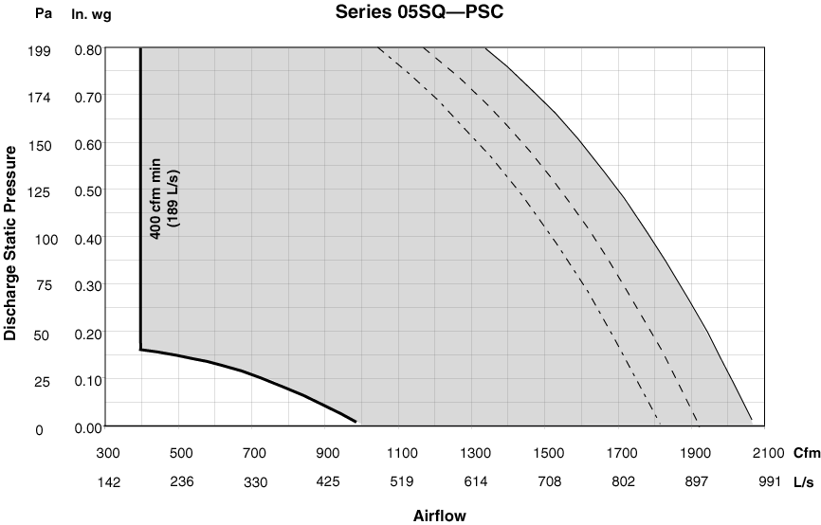
Accessory - Variable Air Volume Fan Powered Terminal Units
Item: A2 Qty: 1 Tag(s): FVAV 1-4

Notes:
1. When attenuator is required, add inlet attenuator pressure
to discharge static pressure for final fan performance.

VSCF and VSEF maximum
Minimum
1-row coil maximum
2-row coil maximum

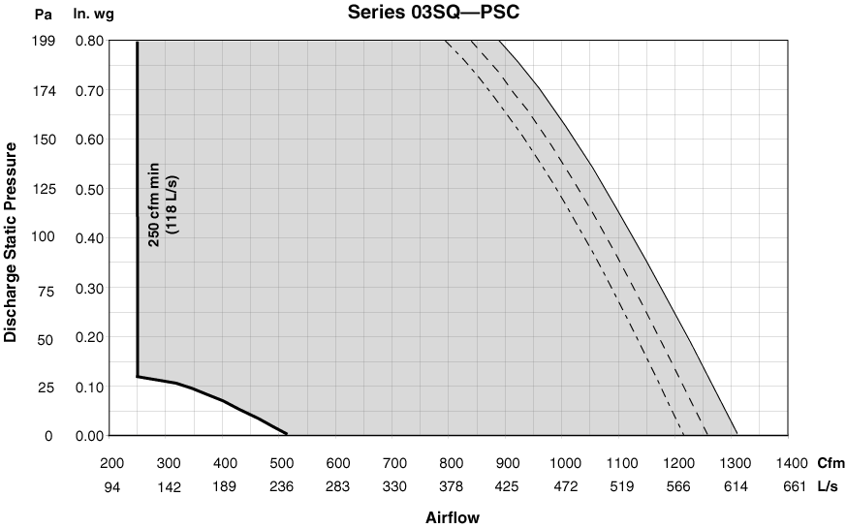
Accessory - Variable Air Volume Fan Powered Terminal Units
Item: A3, A4 Qty: 3 Tag(s): FVAV 1-6, FVAV 1-7, FVAV 1-8

Notes:
1. When attenuator is required, add inlet attenuator pressure
to discharge static pressure for final fan performance.

VSCF and VSEF maximum
Minimum
1-row coil maximum
2-row coil maximum

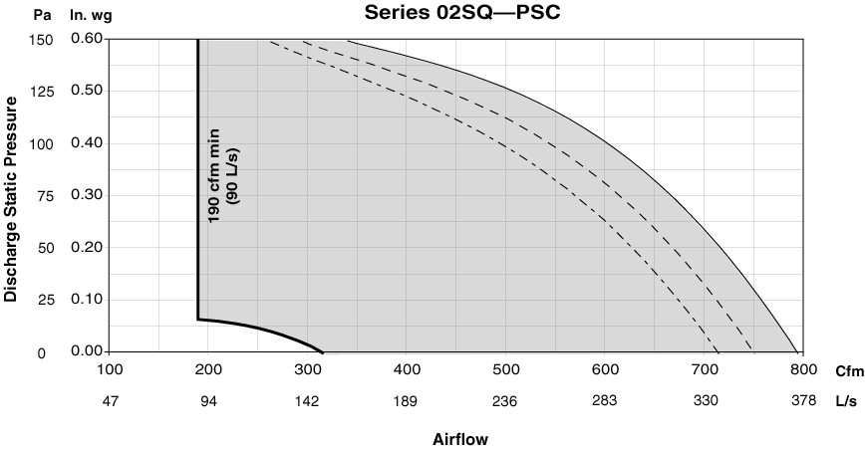
Field Wiring - Variable Air Volume Fan Powered Terminal Units
Item: A1 Qty: 3 Tag(s): FVAV 1-1, FVAV 1-2, FVAV 1-3
Field Wiring - Variable Air Volume Fan Powered Terminal Units
Item: A1 - A4 Qty: 7 Tag(s): FVAV 1-1, FVAV 1-2, FVAV 1-3, FVAV 1-4, FVAV 1-6, FVAV 1-7, FVAV 1-8
Field Wiring - Variable Air Volume Fan Powered Terminal Units
Item: A2 - A4 Qty: 4 Tag(s): FVAV 1-4, FVAV 1-6, FVAV 1-7, FVAV 1-8

