

PLANNING BOARD REPORT
PORTLAND, MAINE

Baxter Academy for Technology and Science
185 Lancaster Street
Level III and Traffic Movement Permit
2017-022
Baxter Academies of Maine, Applicant

Submitted to Portland Planning Board  Public Hearing Date: March 28, 2017 | Prepared by: Shukria Wiar  Date: March 24, 2017

I. INTRODUCTION
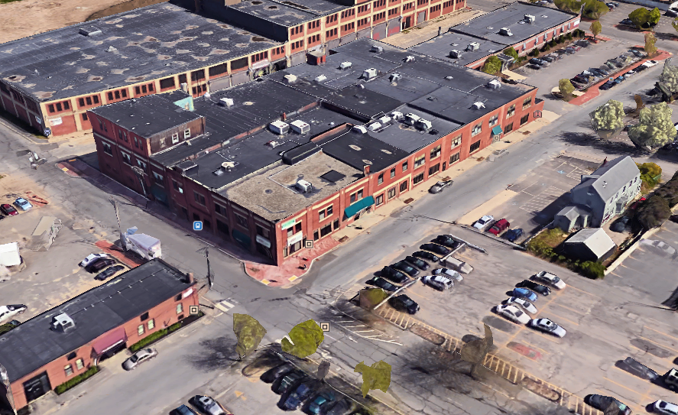
Baxter Academies of Maine, has requested a public hearing with the Planning Board for a Level III Site Plan for a change of use at 185 Lancaster Street and a traffic movement permit. The proposal is to convert most of the building to the Baxter Academy for Technology and Science, a public charter high school, which is an institutional use. The project involves interior renovations to an existing building and only minor site improvements are proposed. The office building has three floors and the most current uses include the Labor Department, Maine Career Center, and THRIVE Me. The site for the proposed Charter School consists of 75,026 SF that is fully developed and the existing three-story building is located in the Mixed Development District B-7 zone. The school is the first public charter school focusing on science, technology, engineering and mathematics.
Figure 1: Aerial of Proposed Baxter Academy Site

The City has the delegated review for the Traffic Movement Permit and the Board will review the submitted Level III site plan for the change of use that is more than 20,000 square feet.

Applicant Name Baxter Academies of Maine
Consultants Will Conway, Sebago Technics

II. PROJECT DATA
Existing Zoning | Mixed Development District B-7
Existing Use | Office Space- Labor Department, Maine Career Center, and THRIVEMe
Proposed Use | Institutional (Public Charter School)
Proposed Development Program | Change of Use from Office Space to Institutional
Parcel Size | 75,026 SF
 | Existing | Proposed
Building Footprint | 70,379 SF | Zero
Building Floor Area | 1,054 SF | 12,312 SF
Impervious Surface Area | 70,379 SF | Zero
Parking Spaces (on site) | 149 | 50
Bicycle Parking Spaces | 0 | 12
Estimated Cost of Project | $3,000,000

III. EXISTING CONDITIONS
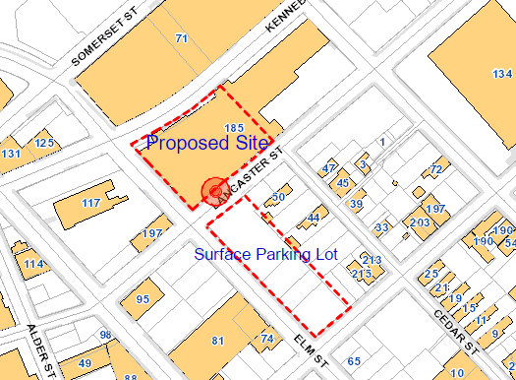
Baxter Academy is looking to relocate from their current locations at 54 York Street and 561 Congress Street to the existing two story brick building located at 185 Lancaster Street in Portland's Bayside neighborhood. The 53,779 SF office building sits at the corner of Lancaster and Elm Streets. The associated surface parking is located across Lancaster Street. The Schlotterbeck and Foss development is across Elm Street. The building is a multi-tenant building; the first-floor area was occupied mainly by the Maine Career Center with the remaining area was an office use. The entire second-floor area had been office use. Once the conversion is complete, the building will house the Baxter Academy for Technology and Science Charter School as the primary tenant.
Figure 2: Proposed Site and Parking

IV. PROPOSED DEVELOPMENT
The proposed site is an existing two-story building with a total floor area of approximately 92,561 SF. The Baxter Academy will lease and remodel 31,571 SF of the building for the expanded charter high school. The site has access from both Lancaster and Elm Streets. The academy is proposing a total of fifty (50) parking spaces in an off-site surface parking lot located across Lancaster Street. The spaces will be reserved exclusively for staff only; parking is not proposed for students at the site.

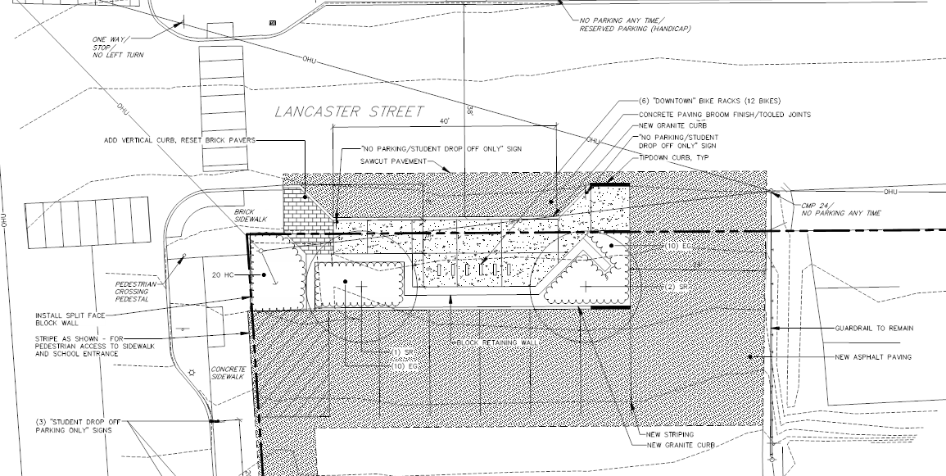
The school’s proposal is to convert much the building into a full four-year high school that focuses on the fields of mathematics, technology, and science. The total enrollment is planned for approximately 400 students and 60 staff members. It is projected that half of the total enrollment will come from Portland, South Portland and Westbrook, with the remaining coming from communities outside of the urban core. School operations will be from 8:00 AM to 2:00 PM, resulting in peak traffic generation associated with the school being between 7-8:00 AM and 2-3:00 PM.

The school will consist mainly of classroom and lab spaces with supporting office spaces. A cafeteria or food preparation area is not proposed at the facility. The improvements to the building are primarily interior with minor exterior enhancements to upgrade egress, such as replacement of existing exterior stairs and guardrails, replacing exterior doors (to match existing) and select exterior windows that have failed seals (to match existing).
Figure 3: Layout of the new sidewalk and bicycle parking across Lancaster Street.

Across Lancaster Street, there is a surface parking lot that is associated with the existing uses in the surrounding buildings. Currently there are seven parking spaces that back onto Lancaster Street. Those spaces will be eliminated as part of this project and replaced with a sidewalk and bicycle spaces.

V. PUBLIC COMMENT
As of the date of writing this report, three public comment has been submitted see Attachment 5. As part of the Traffic Movement Permit, the direct abutters were notified and notices for the workshop and public hearing were sent to property owners within 500 feet and to the interested citizen’s list. Eighty-four (84) notices were sent to area residents and interested citizen’s list. The legal ad appeared in the Portland Press Herald on March 20th and 21st editions. A neighborhood meeting was held on March 1, 2017 and minutes are included as Attachments L and M.

VI. RIGHT, TITLE AND INTEREST AND FINANCIAL/TECHNICAL CAPACITY
a. The owner of the property is Bayside II, LLC. The applicant has provided a copy of a quitclaim deed, recorded at the Cumberland County Registry of Deeds (Book 15298 Page 144), which demonstrates their right, title and interest in the property.

b. The estimated cost of the development is $3,000,000. The applicant has submitted a financial letter from Nonprofit Finance Fund, dated 01.03.2017, as demonstration of their financial and technical capacity to complete the proposed development.

VII. Zoning Assessment
The applicant wants to change the use from offices to a new school (a public charter high school). The property is located in a B-7 zone which allows the proposed use under, "Public or private schools of any type". There is no proposed addition to the building with the exception of replacing an exterior stairs and guardrails, as well as replacing exterior doors. Section 14-332.1(i) states that in the B-7 zone, off-street parking for all projects regardless of size, shall be governed by 14-332.2(c) of this article that states the Planning Board is to establish the parking requirement for the project. The applicant is proposing fifty (50) parking spaces for the academy staff.

Under external effects, Section 14-299 Performance Standards (b), (f), (n) and (o) apply to this project. Below is how the project is meeting the standards:

Sec. 14-299. Performance standards: All uses in the B-7 mixed development district zone shall comply with the following standards. Standards 14-299(a,(f),(j),(m),(n) and (o) below shall be reviewed by the Planning Authority.

(b) Noise: (A List of standards is itemized)

- Staff Comments: The maximum noise requirement of 60 decibels at lot boundaries shall be maintained during the “day time” hours. This performance standard is met subject the design specifications for all mechanical equipment being proposed be submitted for review and approval under the B-7 performance standards, prior to the issuance of the related building permit.

(f) Off-street parking and loading: Off-street parking is required as provided in division 20 (off-street parking) of this article. Division 21 (off-street loading) of this article shall not apply. Surface parking shall meet the following standards:

1. None of the spaces shall occupy all or a portion of a sidewalk within a street right-of-way.

Staff Comments: The loading and unloading of buses is proposed at the front entrance on Lancaster Street, which minimizes traffic impacts on the street system. The surface parking lots do not occupy any portions of the sidewalks. The lots are setback from the property lines. This performance standard is met.

2. Driveway entrances shall meet the City of Portland Technical Manual standards.

Staff Comments: The existing entrance to the surface parking lot meets City standards.

3. The parking area shall meet the landscape and buffer standards of the City of Portland Technical and Design Manuals.

Staff Comments: The surface parking area is an existing lot. The seven parking spaces that back out on Lancaster Street will be eliminated as part of this project and replaced with a sidewalk, bicycle spaces, and some landscaping. The rest of the surface parking lot will not be improved. The improvements meet city standards.

(n) Lighting: All lighting shall be designed and installed with cut-off fixtures to direct illumination onto the site and to prevent illumination from such fixtures on neighboring properties and as otherwise governed by the site lighting standards of the City of Portland Technical Manual.

Staff Comments: As part of this project, no new lighting is being proposed. If new exterior lighting is proposed it is subject to review under Portland standards in the Technical Manual.

(o) Building entrances: All buildings shall have a minimum of one (1) public pedestrian entrance facing the street frontage of the lot. Such building entrances shall also be reviewed under the B-7 bayside design standards.

Staff Comments: The building has two main entrances for the public. One of the entrances is on Lancaster Street and one is to the side of the building off of Elm Street. The entrances are highly visible from the street right-of-way, so this performance standard has been met.

All HVAC equipment shall meet the sound level requirements listed under 14-299 (b). Separate permits are required through Inspection Services for HVAC systems. Such application(s) shall provide HVAC dBA equipment levels. Separate permits are required for any new exterior signs.

The number of required parking spaces is determined by the Planning Board under the B-7 zone. Please refer to the discussion of parking discussion below under the Site Plan Standards.

VIII. SITE PLAN STANDARDS (Section 14-526)
The proposed development has been reviewed by staff for conformance with the relevant review standards of Portland’s site plan ordinance and applicable regulations. Staff comments are listed below.

- Transportation Standards
The proposed charter school will generate a total of 200 peak vehicle trips during the week and therefore this change of use requires a Traffic Movement Permit (TMP), which the City may issue under delegated review. The applicant had a scoping meeting on February 23, 2017 with Tom Errico, Consultant Traffic Engineer. Since this meeting, Mr. Errico and the applicant have been in constant discussion to finalize the TMP, below are his recommendations:

- Based upon traffic estimates conducted by the applicant, the project will generate new traffic that triggers the need for a Traffic Movement Permit. A Traffic Scoping meeting was held on February 23, 2016. In response to the scoping meeting a traffic assessment was conducted by Bill Bray. I have reviewed the details of the traffic assessment and I find the contents, methods and conclusions to be acceptable. I would note that the key directive to the applicant was developing a Transportation Operations and Management Plan and a Transportation Demand Management Plan. Details on these plans are provided below.
- In response to a coordination meeting with Bill Bray, the applicant has submitted a Response to Traffic Comments letter dated March 19, 2017. I concur with the details of that letter as it relates to elimination of the proposed parking bay on the south side of Lancaster Street; using Lancaster Street for bus loading and unloading activities; and identification of specific locations for parent pick-up and drop-off activities. I would note that the applicant would be responsible for all costs associated with changes to parking signage and removal/relocation of parking meters. The applicant shall submit a detailed plan that summarizes changes for review and approval by the City Planning Authority. The letter notes that student vehicle parking needs will be accommodated in the Marginal Way Rideshare Lot. The applicant has indicated that a specific parking lot location is still pending and details of an identified location will need to be a condition of approval. Based upon the Traffic Assessment, 36 vehicles will be generated by the student body and therefore the condition of approval should note this supply requirement. I would note that according to staffing projections, the provision of 50 parking spaces will be provided on the parking lot on the south side of Lancaster Street and I find this supply to be reasonable.

- I find the contents and recommendations contained in the Transportation Operations and Management Plan to be acceptable. I would suggest that the first monitoring period take place 6 months after occupancy. Details of the monitoring scope of work shall be coordinated with the City Planning Authority.

a. Impact on Surrounding Street Systems/ Access and Circulation
The proposed Baxter Academy site will be accessed from the proposed entrances on both Elm and Lancaster Streets. The applicant was proposing that the route for school buses will be arriving from Chestnut Street, onto Lancaster, and then load/unloading curbside on the east side of the street in a designated School Drop-Off Zone at the main entrance to the building. The route for arriving parents to drop off their students will be on Elm Street, with a couple of spaces on Lancaster Street, behind the bus drop-off area. Employees will park in a designed staff parking lot located at the corner of Lancaster and Elm Street. Mr. Errico has reviewed the plan and finds it acceptable … “I concur with the details of that letter as it relates to elimination of the proposed parking bay on the south side of Lancaster Street; using Lancaster Street for bus loading and unloading activities; and identification of specific locations for parent pick-up and drop-off activities”.

b. Parking
The academy will lease a total of fifty (50) parking spaces in an off-site surface parking lot located across Lancaster Street. The spaces will be reserved exclusively for staff only; parking will not be provided for students at the proposed site by the school. The Traffic Engineer is recommending that an additional parking spaces be provided for students, so the total number of required spaces for this use would be eighty-six (86). Below is condition of approval that Mr. Errico has recommended:

- Based upon the Traffic Assessment, 36 vehicles will be generated by the student body and therefore the condition of approval should note this supply requirement. I would note that according to staffing projections, the provision of 50 parking spaces will be provided on the parking lot on the south side of Lancaster Street and I find this supply to be reasonable.

Bicycle Parking
Currently, there are no bicycle parking facilities on site. The applicant is proposing to install six downtown "lollipop" bicycle racks for a total of twelve (12) parking spaces on Lancaster Street along the new proposed sidewalk. In their TDM plan, it states “[i]f demand warrants additional facilities, the school is committed to providing them”.

c. Transportation Demand Management (TDM)
A transportation demand management plan has been submitted. According to the plan (Attachment R), the School is encouraging variety of transportation options for students and staff. These options include charter buses, providing incentives for commuters on the METRO (Metro 8) or South Portland Bus services, and encouraging carpooling, walking, and biking. Baxter Academy has submitted a trip assignment model, prepared for all site trips impacting the street system directly adjacent to the proposed project site, see below:

400 Students and 60 Staff | Trips
40% of students (152) ride 3 chartered buses | 3
25% of students (100) commute with an adult:
- 40 students travel as a single occupant in vehicle with adult | 80
- 20 students travel with a second student and adult | 20
- 15 students travel with two other students and adult | 10
- 25 students travel with adult to work site and walk to school | 0
- 18% of students (72) use public transportation | 0
- 9% of students (36) drive personal auto and park off-site | 0
- 6% of students (24) car pool with fellow student and park off-site | 0
- 3% of students (12) walk | 0
- 1% of students (4) bike | 0
- 85% of students (51) will drive to site and park in Lancaster Street parking lot | 51
- 15 of students (9) will use other modes of transportation | 0
Total Trips Impacting Street System | 164

According to the chart, 109 trips of the total 164 peak trips, are expected to arrive at the site; the remaining 55 trips are parents leaving or dropping-off students. Mr. Errico has reviewed the document and offers the following comments:

- I find the contents and recommendations contained in the Transportation Demand Management Plan to be acceptable. I would suggest that the first monitoring period take place 6 months after occupancy. Details of the monitoring scope of work shall be coordinated with the City Planning Authority.

- Environmental Quality Standards
a. Landscaping
The seven spaces that back out on Lancaster Street will be eliminated as part of this project and replaced with a sidewalk, bicycle spaces, and landscaping. This area may be the only opportunity for landscaping on the proposed site; the rest of the surface parking lot will not be improved. Jeff Tarling has reviewed the proposed landscaping and finds it acceptable.

b. Water Quality, Storm Water Management and Erosion Control
The project consists of converting the existing an existing building into the Baxter Academy for Technology and Science; no building additions are proposed. The existing site is completely impervious; therefore, the project will not create any new impervious areas. Lauren Swett, Consultant Engineer with Woodard and Curran, reviewed the development plans and had come minor comments:

- The Applicant has provided a copy of the City of Portland Wastewater Capacity Application within the submission. A copy of the letter confirming capacity to serve should be forwarded upon receipt.
- The Applicant should provide additional detail pertaining to stairway upgrades along the northwestern side of the building on Kennebec Street. Specifically, will any regrading or pavement replacement be required? The area appears to be close to the right-of- way, and potential impacts due to construction should be reflected. A site plan should reflect any of these changes or impacts.
- The project is primarily an internal building upgrade, and will not be required to provide a Stormwater Management Plan. The project is still required to comply with the Basic Standards, and provide erosion and sedimentation control as necessary. The project will have some minor site disturbance. Catch basin protection should be provided in drainage structures in the vicinity of the project. Housekeeping notes should be provided to ensure that sweeping is completed as necessary to prevent tracking from disturbed areas of the site onto adjacent roadways.

- Public Infrastructure and Community Safety Standards
a. Sidewalk
There are existing sidewalks on Lancaster and Elm Streets around the building. Across Lancaster Street, there is a surface parking, which serves the existing uses in the surrounding buildings. Currently, there are seven parking spaces that back onto Lancaster Street. Those spaces will be eliminated as part of this project and replaced with a sidewalk and bicycle spaces.

b. Public Safety and Fire Prevention
Captain Keith Gautreau of Fire Department has reviewed the submitted site plans and finds the proposed site plan to be acceptable.

c. Availability and Adequate Capacity of Public Utilities
The current building has public utilities that are available at the site. The applicant has submitted a capacity letters from Portland Water District but will need a capacity letter from Department of Public Works. A copy of the letter confirming capacity to serve should be forwarded upon receipt. The school does not intend on having a kitchen and lunch will be outsourced to a local vender.

- Site Design Standards
a. Snow and Ice Loading
Snow and Ice Loading area has not been shown on the site plan. According to the applicant, the owner of the building currently has and will continue to remove snow from the parking lot through a snow plow contract with Seabreeze Property Services. The academy is aware that they will be responsible for snow removal on site.

b. Historic Resources
The project site is not located in a historic district; therefore, no review is required.

c. Exterior Lighting
The project is not proposing any new lighting fixtures and they intend to utilize the existing fixtures on site. Any proposed new exterior lighting would require review under Portland’s Technical Manual.

d. Signage and Wayfinding
A traffic signage and wayfinding plan has been submitted for review. Mr. Errico reviewed the site plan and finds the plan acceptable with the following comments:

- I would note that the specific on-street regulatory signage is not acceptable and details of parking restriction wording will be determined in conjunction of the City Parking Division.

- I would note that the applicant would be responsible for all costs associated with changes to parking signage and removal/relocation of parking meters. The applicant shall submit a detailed plan that summarizes changes for review and approval by the City Planning Authority.

e. Zoning Related Design Standards
The proposal is a reuse of an existing building. There are no additions or alterations being proposed to the building.

IX. PLANNING BOARD PROPOSED MOTIONS

Traffic Movement Permit
On the basis of the application, plans, reports and other information submitted by the applicant, findings and recommendations contained in Planning Board Report for application #2017-022 relevant to the Traffic Movement Permit and the testimony presented at the Planning Board hearing, the Planning Board finds the plan is/ is not in conformance with the standards for Traffic Movement Permit application for Baxter Academy for Technology and Science and grants/does not grant a permit subject to the following conditions:

- As part of the Transportation Operations and Management Plan, the first monitoring period shall be conducted six months after the certificate of occupancy. The details of the monitoring scope of work shall be coordinated with the Planning Division.

- As part of the Transportation Demand Management Plan, the first monitoring period shall be conducted six months after the certificate of occupancy. The details of the monitoring scope of work shall be coordinated with the Planning Division.

- Based upon the Traffic Assessment, the proposed fifty (50) parking spaces are adequate to meet staff parking demands and it has been determined that an additional thirty-six (36) vehicle spaces are warranted for students. Thus a total of eighty-six (86) parking spaces are required for the proposed use. The applicant shall provide the additional thirty-six (36) spaces prior to the issuance of a certificate of occupancy.

- The applicant shall submit signage and wayfinding plan that address the details of parking restriction and changes for review and approval by the Planning and Parking Divisions. The applicant shall be responsible for all costs associated with changes to parking signage and removal/relocation of parking meters.

- Site Plan Review
On the basis of the application, plans, reports and other information submitted by the applicant, findings and recommendations contained in Planning Board Report for application #2017-022 relevant to the Site Plan and other regulations, and the testimony presented at the Planning Board hearing, the Planning Board finds that the plan is / is not in conformance with the site plan standards of the land use code, subject to the following conditions to be met prior to the issuance of a building permit unless otherwise stated:

- That the applicant shall submit confirmation of ability to serve sewer letter DPS to the Planning Division prior to the issuance of a building permit; and

- The project shall comply with the Basic Standards of Chapter 500 and provide erosion and sedimentation control on site as necessary; and

- The Applicant shall provide additional detail pertaining to stairway upgrades along the northwestern side of the building on Kennebec Street, specifically, any regrading or pavement replacement, and potential impacts due to construction shall be reflected on the final site plan; and

- Based upon the Traffic Assessment, the proposed fifty (50) parking spaces are adequate to meet staff parking demands and it has been determined that an additional thirty-six (36) vehicle spaces are warranted for students. Thus a total of eighty-six (86) parking spaces are required for the proposed use. The applicant shall provide the additional thirty-six (36) spaces prior to the issuance of a certificate of occupancy.

- The applicant shall submit signage and a wayfinding plan that address the details of parking restriction and changes for review and approval by the Planning and Parking Divisions. The applicant shall be responsible for all costs associated with changes to parking signage and removal/relocation of parking meters.

- All HVAC equipment shall meet the sound level requirements listed under 14-299 (b). Separate permits are required through Inspection Services for HVAC systems. Such application(s) shall provide HVAC dBA equipment levels. Separate permits are also required for any new exterior signs from the Department of Permitting and Inspections.

ATTACHMENTS:

Planning Board Report Attachments
- Traffic Engineer review (memo from Thomas Errico, 03.23.2017)
- Department of Public Services review (memo from Lauren Swett, 02.27.2017)
- Fire Department (memo from Keith Gautreau, 03.23.2017)
- Public Comments
PC1 Jay York 2-14-17
PC2 Sarah Michniewicz
PC3 Bayside Neighborhood Association

APPLICANT’S SUBMITTAL

- Baxter Level III Site Plan Application
- Site Plan Submission Narrative
- Authorization letter
- Financial Capacity Letter
- Landlord Authorization
- Wastewater Capacity Application
- CMP Ability to Serve Letter
- PWD Ability to Serve Determination – 2016
- Code review - IBC and NFPA
- HVAC Letter
- Trash Removal
- Baxter Neighborhood Meeting
- Baxter Academy Neighborhood Meeting Minutes-FINAL
- Baxter - B7 Performance Standards
- Bayside II Deed
- Bayside II LLC - Title Policy includes 185 Lancaster Street
- Landry French Stair Excavation Sketch
- Baxter Academy TDM Plan - FINAL 030817
- TDM Plan Updated on March 19th per Errico's comments approved by Team
- Baxter Academy - Site Plan Comments Responses
- Baxter TMP Letter
- Baxter TMP
- Traffic Assessment- Updated
- Traffic Operations Movement Plan
- Transportation Operation and Management Plan
- Response to Tom Errico Comment

PLANS

Plan 1 DEMO Plan
Plan 2 Existing Conditions Plan
Plan 3 Site Plan
Plan 4 Preliminary Sketch-Baxter
Plan 5 Grading Plan
Plan 6 Bayside II- Survey Plan
Plan 7 S1 SITE PLAN
Plan 8 A1 BUILDING USE PLAN
Plan 9 A1-1 FIRST FLOOR PLAN
Plan10 A1-2 SECOND FLOOR PLAN
Plan11 A2 BUILDING ELEVATIONS
Plan12 Baxter Academy RTU Layout Plan
Plan13 Construction Management Plan

