PLANNING BOARD REPORT
PORTLAND, MAINE

Ten Unit Townhouses
70 Anderson Street
Level III Subdivision and Site Plan Review
2016-099
Redfern Properties, LLC, Applicant

Submitted to: Portland Planning Board  Public Hearing Date: September 27, 2016 | Prepared by: Shukria Wiar  Date: September 23, 2016

I. INTRODUCTION
Redfern Properties, LLC has requested a preliminary Level III site plan and subdivision review of a ten-unit townhouse urban infill development at the corner of East Lancaster and Anderson Streets in East Bayside. The proposed 12,312 SF development includes two buildings containing the ten (10) townhouses. The proposal also includes seven surface parking spaces, and sidewalk and landscaping improvements. The site is currently occupied by a residential single-family house, garage and shed.

The Planning Board held a workshop on this project on July 27, 2016. Overall the Board supported the project. The Board has concern with the massing and color scheme of the building. The Board also encouraged the applicant to work with neighbors on addressing concerns. The Planning Board will review the application for compliance with the site plan and subdivision standards. A total of one hundred and thirty-eight (138) notices were sent to property owners within 500 feet of the site and a legal ad ran on September 19th and 20th, 2016.

Applicant: Jonathan Culley, Redfern Properties
Consultants: Will Savage, Acorn Engineering; Ryan Senatore, Ryan Senatore Architecture; Nick Elliston, Titcom Associates

II. REQUIRED REVIEWS
Waiver Requests | Applicable Standards
Aisle width – To allow a 20 foot aisle in the parking area  Supported by consulting traffic engineer | Technical Manual, Section 1.14, requiring that aisle width for right-angle parking be 24 feet per Figure I-27
Compact parking spaces and parking dimensions – To allow six compact spaces at 8.5 X 18’ to be acceptable alternatives to the standard 9’ X 18’ space; the one remaining parking space will be a standard size, therefore it is 85% is compact spaces.  Supported by consulting traffic engineer | Technical Manual, Section 1.14 and Figures I-27 to I-29. Parking lots with greater than 10 spaces may be comprised of up to 20% compact spaces. 7 proposed = 1 compact permitted by right
Parking lot landscaping – Applicant to provide additional detail in final submittal | Site Plan Standard, Section 14-526(b)2.b(ii). Developments with 5+ parking spaces shall include at least 2 trees (or 1 tree and 3 shrubs) per 5 parking spaces planted in landscaped islands. Waiver permitted where site constraints prevent it. 7 parking spaces proposed = 2trees or 1 trees & 3shrubs required
Street trees – Applicant is proposing to plant 6 street trees on-site and the remaining 4 trees will be planted on the abutting Portland Housing Authority properties subject to a formal agreement. | Site Plan Standard, Section 14-526(b)2.b(iii) and Technical Manual, Section 4.6.1. All multi-family development shall provide one street tree per unit. Waiver permitted where site constraints prevent it. 10 units = 10 street trees required
Review | Applicable Standards
Site Plan | Section 14-526
Subdivision | Section 14-497
Workforce Housing Inclusionary Zoning | 14-484 (Applicant is required to have one unit, which is being proposed)

III. PROJECT DATA
Existing Zoning | Residential R-6
Existing Use | Residential
Proposed Use | Residential
Proposed Development Program | 10 residential units in two building: 6 unit and 4 units
Parcel Size | 9,064 SF
 | Existing | Proposed | Net Change
Building Footprint | 1,054 SF | 4,104 SF | 3,050 SF
Building Floor Area | 1,054 SF | 12,312 SF | 11,258 SF
Impervious Surface Area | 4,376 SF | 7,370 SF | -2,994 SF
Parking Spaces (on site) | Two | Seven (zoning req. 7) | Five
Bicycle Parking Spaces | 0 | 4 internal and 2 in ROW (meets standard) | 6
Estimated Cost of Project | $1,800,000

IV. BACKGROUND & EXISTING CONDITIONS
The site of the proposed porject lies at the southeast corner of E. Lancaster and Anderson Streets in East Bayside. The site is currently occupied by a single-family house with a detached garage and shed. About half of the property is currently covered by impervious surfaces including two bituminous driveways from Anderson and East Lancaster Streets.

The uses surrounding the site are mostly residential uses, including some large three-story multi-family housing. Most of the adjacent housing is of a smaller scale, with a mix of single and two-family buildings characteristic of the city’s East End. The Portland Housing Authority multifamily housing directly abuts the property on the west side and also is adjacent of site. The Kennedy Park basketball courts and the Fox Street recreational field, sites a couple of parcel to the northwest at the corner of Anderson and Fox Streets.

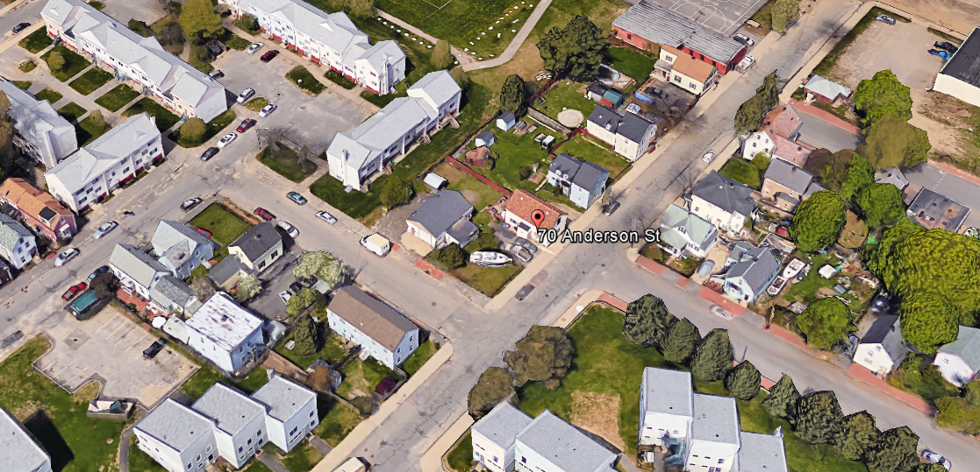
Figure 1: 70 Anderson Street Site

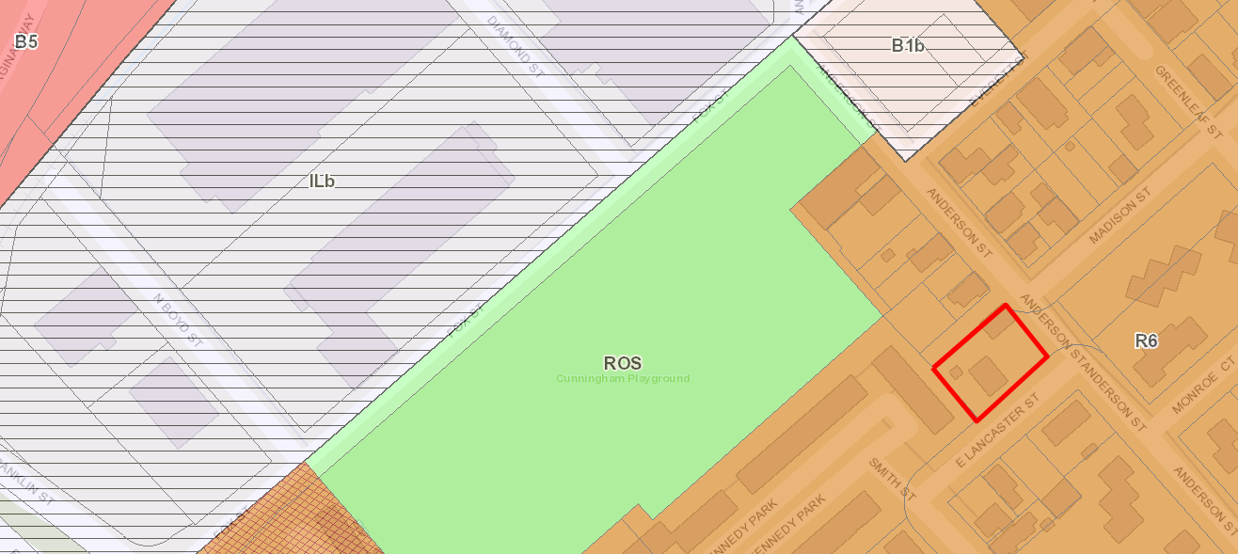
Figure 2: 70 Anderson Street; zoning context

V. PROPOSED DEVELOPMENT
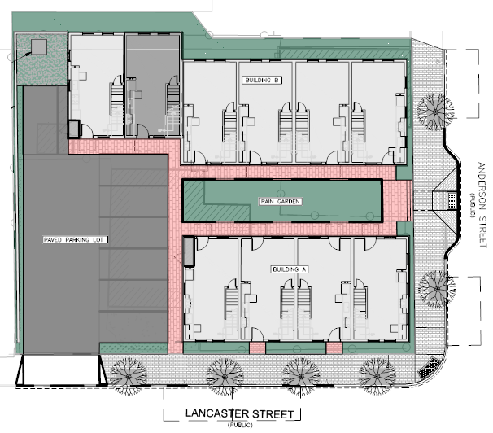
The development is proposed as a residential project with frontages on Anderson and E. Lancaster Streets. The project will consist of two townhouse buildings, one with six units and the other with four units. The new ten units will be orientated as such to create a courtyard and central walking space through the property. Within the courtyard, a rain garden is proposed as a central focus on stormwater mitigation on site and will be landscaped with perennials and other plantings. The courtyard will be visible from Anderson Street. All ten townhouses are three-bedroom, 1,254 square foot units. The interior fit out for each unit is identical; the proposed workforce unit does not differ in size or standard from the market-rate units. The market strategy for the workforce unit will also mimic the strategy of the market-rate units and is proposed to be approached in the same fashion.
Figure 3: 70 Anderson Street Site Plan

Tenant parking is to be provided on-site with a driveway access from East Lancaster Street. There will be seven surface parking spaces as part of the project. New brick sidewalks and street trees are proposed on Anderson and E. Lancaster Streets. The development is also proposed with landscaping between the building and proposing a green wall on both frontages.

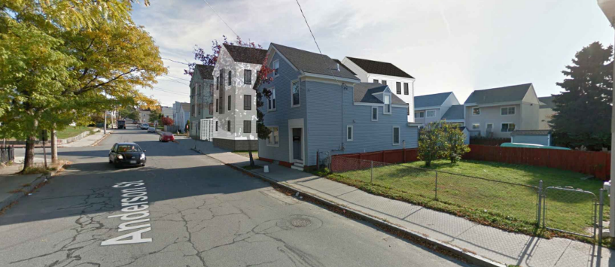
Figure 4: 70 Anderson Street Rendering Looking East on Anderson Street

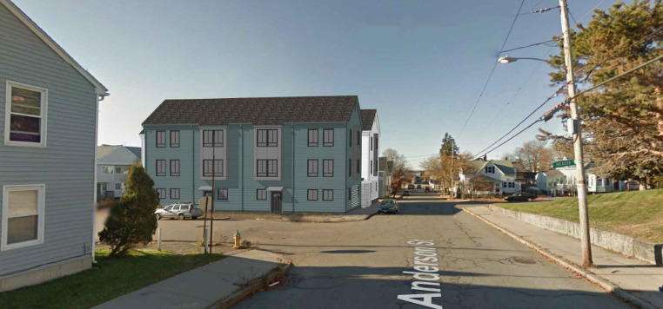
Figure 5: 70 Anderson Street Rendering Looking West on Anderson Street

VI. PUBLIC COMMENT
The applicant hosted a neighborhood meeting on August 3, 2016. Eleven attendees signed in at the meeting. Questions generally focused on the design of the building and vehicular parking, pedestrian safety at surrounding intersections, as well as landscaping, see Attachment Y for the Neighborhood Meeting minutes. In addition, staff received correspondence from four neighbors via email (Attachments 8a-d). This neighbors reiterated concerns about the building design, the number of proposed parking, and the parking circulation. As of the writing of this report, public comments have been received by the Planning Authority and are included as Attachment Y.

VII. RIGHT, TITLE, & INTEREST AND FINANCIAL & TECHNICAL CAPACITY
a. The owner of the property is Redfern Properties LLC. The applicant has provided a copy of a warranty deed, recorded at the Cumberland County Registry of Deeds (Book 32559 Page 282), which demonstrates their right, title and interest in the property.

Bill Clark, City Surveyor, conducted a review of the plat and had concerns about a note on the proposed plat. He states that “the Survey Note #5 states that Fee Interest in Anderson Lane apparently lies with the heirs of Moses Gould as described in a deed recorded in Book 290, Page 310. The unrecorded release deed from Portland Housing Authority to Redfern Properties does not state that the Portland Housing Authority acquired title from the heirs of Moses Gould”. The applicant has submitted an unrecorded release deed from Portland Housing Authority (PHA); staff has requested the applicant to provide PHA source of title for Anderson Lane. Staff will work with the applicant to provide the appropriate documentation prior to the signing of the plat. Accordingly, review and approval of the final plat has been included as a condition of approval.

b. The estimated cost of the development is $1.8 Million. The applicant has submitted a letter from NBT Bank, dated April 21, 2016, as demonstration of their financial and technical capacity to complete the proposed development.

VIII. ZONING ANALYSIS
The proposed residential ten unit townhouses are a permitted use in the Residential R-6 which allows multi-family dwellings. Under the R-6 zone all of the dimensional requirements are being met, except for maximum lot coverage. The applicant will need to show documentation that they meet this standard. For off street parking, Division 20 requires one parking space per unit for residential uses on the peninsula, except in the R-6 zone, the first three spaces are exempt. A total of seven parking spaces are shown which meets the zoning requirement. Under external effects, section 14-167(b), the maximum noise requirement of 55 decibels at lot boundaries shall be maintained.

IX. ENSURE WORKFORCE HOUSING CONDITIONAL USE- Tyler Norod, Housing Planner
Conditional Use is authorized by Division 30, Section 14-487, Ensuring Workforce Housing, to secure the creation of Workforce Housing Units as part of new residential projects that propose 10 or more units. The ordinance requires a minimum of 10% of the project to be restricted for Workforce Households and that the number of bedrooms required under Section 14-487(e)3 be at least 10% of the total number of bedrooms made available as part of the project. The project located at 70 Anderson Street proposes the creation of 10 three-bedroom townhouse units. Based on the total number of units the project will be required to provide at least one (1) workforce unit with a minimum of three bedrooms affordable to households earning up to 100% of area median income (AMI).
By providing one (1) three-bedroom unit on-site, the project has met the minimum requirements set forth in Section 14-487.

Staff recommends the Board Approve this Conditional Use provided the Applicant and the City enter into an Affordable Housing Agreement (AHA) before a Building Permit may be issued. The Affordable Housing Agreement will outline the details of the affordability restrictions placed on the workforce units based on the City’s Inclusionary Zoning Implementation Regulations and will be filed as covenant to the property's deed with the Cumberland County Registry of Deeds before a Certificate of Occupancy may be issued.

X. DEVELOPMENT REVIEW

A. SITE PLAN SUBMISSION REQUIREMENTS (Section 14-527) and SUBDIVISION PLAT
AND RECORDING PLAT REQUIREMENTS (Section 14-496)

In accordance with the city’s land use ordinance, the applicant provided a draft plat in the final plan submittal. Due to the timing of the revised submittal, Corporation Counsel and DPS have not had the full opportunity to review the revisions. The review and approval of the final plat has been included as a condition of approval. The final plat shall be revised to reflect any waivers and conditions of approval that relate to the subdivision plan. Any waivers granted must be recorded at the Registry of Deeds within 90 days of a Planning Board decision.

B. SubDivision (Section 14-497)
The proposed development has been reviewed by staff for conformance with the relevant review standards of Portland’s Subdivision Ordinance and applicable regulations. Staff comments are listed below.

- Will Not Result in Undue Water and Air Pollution (Section 14-497 (a) 1), and Will Not Result in Undue Soil Erosion (Section 14-497 (a) 4)
Lauren Swett, P.E. with Woodard and Curran Engineering, has reviewed the erosion and sediment control plan and states the applicant has provided plans, notes, and details have been that erosion and sediment control requirements and inspection and maintenance requirements, in accordance with the Basic Standard.

- Sufficient Water Available (Section 14-497 (a) 2 and 3)
The project will be served by new water service located in E. Lancaster Street. The Applicant will have to contact the City Department of Public Services requesting ability to serve water and sewer demand. Confirmation of ability to serve sewer from DPS should be forwarded to the Planning Authority upon receipt. The applicant is proposing a central rain garden and a roof dripline drain system for stormwater management.

- Will Not Cause Unreasonable Traffic Congestion (Section 14-497 (a) 5)
The site will be accessed by an existing curb cut on E. Lancaster Street. The circulation for the site will consist of vehicles pulling in and backing out onto E. Lancaster Street. After reviewing the site plan, there may be opportunity for the first three parking spaces along the street, to maneuver so they can pull out of the parking lot instead of backing out. Tom Errico, P.E. Ty Lin reviewed this detail and also reviewed the proposal’s details including the access, parking, and vehicle circulation (Attachment 1). The proposed project is not anticipated to cause unreasonable traffic congestion. Mr. Errico finds the project to be acceptable and states:

- Given low trip generation estimates for the project, a traffic impact study is not required. The project would not be expected to have a significant impact on traffic mobility and safety.
- The parking layout will likely require vehicles to back out into East Lancaster Street. Given low traffic volumes on East Lancaster Street and low trip generation from the site, I find this condition to be acceptable.

- Will Provide for Adequate Sanitary Sewer and Stormwater Disposal (Section 14-497 (a) 6), and Will Not Cause an Unreasonable Burden on Municipal Solid Waste and Sewage (Section 14-497 (a) 7)
There is an existing sewer lateral that will be abandoned in Anderson Street. The project will be served by new sewer line located in E. Lancaster Street. Ms. Swett has reviewed the plans and finds the plans acceptable.

- Scenic Beauty, Natural, Historic, Habitat and other Resources (Section 14-497 (a) 8)
The proposal site is not within an historic district. It is in an urban neighborhood surrounded by a variety of residential building types. The proposed building does not impact the natural beauty of the area or adversely affect any significant wildlife habitat, rare or irreplaceable natural areas, or any public access to the shoreline. The staff finds the proposal in conformance with this standard.

- Comprehensive Plan (Section 14-497 (a) 9)
The staff has identified the following goals and policies which are relevant to the proposed housing development and finds the proposal in conformance with the Comprehensive Plan:

Portland Housing Goal: Ensure that an adequate supply of housing is available to meet the needs, preferences, and financial capabilities of all Portland households, now and in the future.
Policies
- Ensure the construction of a diverse mix of housing types that offers a continuum of options across all income levels, which are both renter and owner-occupied, including but not limited to the following:
ii. Housing units for decreasing household size, such as young professionals, empty nesters, single-parent households, and senior citizens.
- Encourage higher density housing for both rental and home ownership opportunities, particularly located near services, such as schools, businesses, institutions, employers, and public transportation.
- Increase Portland’s rental housing stock to maintain a reasonable balance between supply and demand yielding consumer choice, affordable rents, and reasonable return to landlords.
- Identify vacant land and redevelopment opportunities throughout the City to facilitate the construction of new housing.

- Financial Capability (Section 14-497 (a) 10)
The estimated cost of the development is $1.8 Million. The applicant has submitted a letter from NBT Bank, dated April 21, 2016, as demonstration of their financial and technical capacity to complete the proposed development.

C. Site Plan Standards (Section 14-526)
The proposed development has been reviewed by staff for conformance with the relevant review standards
of Portland’s site plan ordinance and applicable regulations. Staff comments are listed below.

- Transportation Standards
  - Impact on Surrounding Street Systems and Access and Circulation- see Subdivision, Paragraph VIII (B) (3), above.

  - Construction Management Plan
A construction management plan has been submitted by the applicant for review. All the construction is proposed within the limits of the property lines. Tom Errico has reviewed the plan and notes that the applicant “The applicant has provided a plan that notes full closure of the existing sidewalk along the property frontage, with sidewalk detours and temporary crosswalks. I generally find the plan to be acceptable, although final details will need to be provided for review and approval. I would note that I would prefer a barrier protected temporary sidewalk on Anderson Street, if space permits. In my professional opinion most pedestrians will not follow the detour routing”.

This has been included as a condition of approval.

  - Sidewalks
The applicant is proposing to install new brick sidewalk along their frontage on both streets, as well as internal brick walkways. Pedestrian access to the site will be provided off of Anderson Street into the central courtyard and via East Lancaster Street along the parking area.

As part of the infrastructure improvements, Mr. Errico has reviewed the plans and recommends the following:

- A crosswalk on Anderson Street (to Madison Street) may be a requirement for this project. I am coordinating this item with other City staff and will provide feedback in the future.
- I continue to review and coordinate the design of the proposed sidewalk ramp on the project corner. I am coordinating with other City staff on the ramp design. Additionally, the crosswalk on East Lancaster Street shall include a fully compliant ramp on the south corner of the intersection.

The applicant’s plans also include the addition of a curb extension and a crosswalk at the intersection of Anderson Street and Madison Street. The City staff has reviewed the proposed plans and would recommend that the proposed crosswalk be perpendicular with ADA complaint curb ramps. In doing this, the pedestrian crossing may or may not consist of curb extensions on one or both sides of Anderson Street. City staff will work with the Applicant to get a final design for this area and have these changes be formalized on the plans. Mr. Errico states:

The details of the subject crosswalk needs further design development given site conditions on both the property frontage and on the corner of Madison Street. Bruce Hyman will be providing some general design criteria for the crosswalk. In general it is seeking a fully ADA compliant crossing that has a perpendicular alignment. The applicant shall be responsible for developing concept designs for the crosswalk inclusive of ramp configurations on both sides of the street. Upon receipt of the concept plans, City staff (Planning/DPW/Fire) will review and provide comments on a preferred design. The applicant will be responsible for construction of the ultimate design along their property frontage only.

The applicant is also proposing a sidewalk ramp at E. Lancaster and Anderson Street intersection. This ramp will have to be a fully ADA complaint. In regard to this ramp, Mr. Errico has stated “Adjustment to the ramp design is suggested given that a crossing of Anderson Street is not formalized. The applicant shall provide a revised layout for review and approval. The applicant is only responsible for improvements on their corner of the intersection”.

Accordingly, review and approval of the final design has been included as a condition of approval.

  - Public Transit Access
The proposed development is not located along a public transit route. As such, no provisions for transit access are required.

  - Parking
Division 20 of the land use ordinance requires one parking space/unit for residential development located on the peninsula (Section 14-332(a)3) and Section 14-332.1 (k) states “for residential development on the peninsula and in the R-6 and R-6A Zones, including new construction, the parking requirement is one space per dwelling unit, the first three units are exempt from providing parking”. Therefore applicant is proposing seven surface parking spaces to meet zoning requirements and these spaces are located on the rear of the property. Six of the seven parking spaces do not meet technical standards for dimensions. The dimension of a standard parking space is 9’x18’, the standard for compact space is 8’x15’, and the applicant is proposed 8.5’x 18’. The technical manual goes on to state “Any parking lot with 10 or fewer spaces shall contain standard sized parking spaces. Parking lots with greater than 10 spaces may be comprised of up to 20% compact parking spaces”; according to the applicant’s submittal, 85%, or 6, of the proposed on-site parking spaces are designed as compact spaces. Mr. Errico addresses this in his memo, Attachment 1:

The surface parking lot will have a twenty foot (20’) parking aisle width that does not meet standard of twenty-four feet (24’); therefore the applicant has requested a waiver of this standard. An auto-turn analysis has been provided documenting adequate vehicle circulation and the information has been reviewed by the City’s traffic engineer, who states that “the applicant has provided an Auto-turn analysis and I support a waiver from City standards given site characteristics”.

  - Bicycle Parking
The applicant’s proposal includes bicycle parking spaces at the northwest corner of the site. The ordinance standard is two bicycle spaces per five vehicle spaces. The proposed area is not located near the entrances to the townhouses.

- Environmental Quality Standards
  - Preservation of Significant Natural Features
There are no known significant natural features on the site.

  - Landscaping and Landscape Preservation
The site will have a green wall along the front of the buildings as well as a rain garden in the middle of two building, visible along Anderson Street. There is a fence at the westerly side of the property; staff had recommended a screening at the northerly side as well but the applicant has stated that the neighbor does not want a fence at this location. The street tree requirement would be one tree per unit, or ten street trees, in or near the ROW. Applicant is proposing to plant six street trees, Armstrong Maples, on-site: two on Anderson Street and four on E. Lancaster Street. The remaining four trees will be planted on the abutting Portland Housing Authority properties subject to a formal agreement with the Authority. According to the applicant, if no such agreement is reached, then a contribution to the Portland Tree Fund will be made per City requirement.

Trellises and screens are proposed at the courtyard and along the Anderson Street to enhance visual interest. The central courtyard area is composed of a densely planted rain garden, where stormwater is managed, as a focal design piece.

The applicant is proposing a transformer and a solid waste storage at the rear of the property: according to the site plan, both the solid waste and transformer will be screened by a four foot fence.

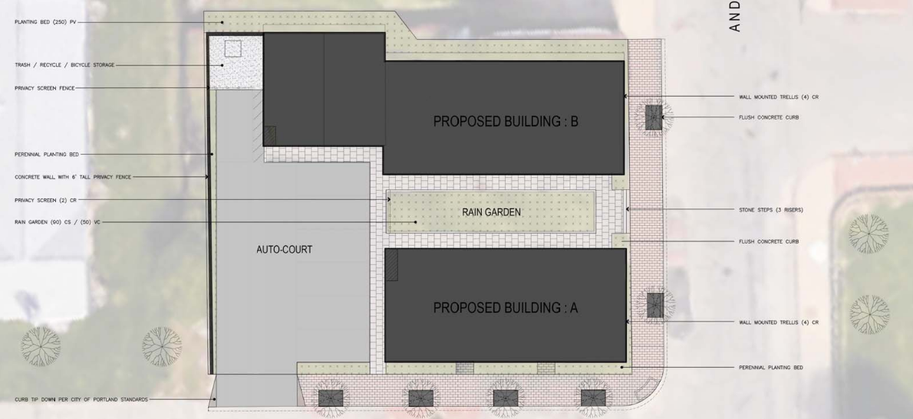

Jeff Tarling, City Arborist, previous recommendations were addressed on the revised plans.

  - Water Quality, Storm Water Management and Erosion Control
Currently the stormwater runoff is directed to the westernmost corner of the site and eventually enters the Fox Street municipal stormwater system. The site as a whole is relatively flat with an average grade of approximately 3% sloping to the rear of the property. The project will result in a net increase of impervious area above 1,000 sf, as such, is required to include stormwater management features for stormwater quality & quantity control.
The applicant will provide water quality treatment to the stormwater through filtration by utilizing a rain garden and roof dripline filtration. These treatments will provide water quality treatment for no less than 95% of the new impervious area and 80% of the developed area. The remainder of the stormwater will be transported to the municipal stormwater system within Anderson Street via a perforated distribution pipe.

Under Section 5 of the City of Portland Technical Manual, a Level III development project is required to submit a stormwater management plan pursuant to the regulations of MaineDEP Chapter 500 Stormwater Management Rules, including conformance with the Basic, General, and Flooding Standards. Lauren Swett, P.E. with Woodard and Curran Engineering, has reviewed the drainage plan and stormwater report, and states that the revised plans meet the standards of the General and Flooding Standards.

- Public Infrastructure and Community Safety Standards
  - Consistency with Master Plans
See Subdivision, Paragraph VIII (B)6 above.

  - Public Safety and Fire Prevention
The Crime Prevention through Environmental Design (CPTED) standards in the site plan ordinance address the principles of natural surveillance, access control and territorial reinforcement so that the design of developments enhance the security of public and private spaces and reduce the potential for crime.

The applicant has provided a catalogue cuts indicating one type of full cutoff fixture in accordance with the city’s Technical Manual. The applicant has not submitted an accompanying photometric plan, but the proposed lighting fixtures are proposed internally to the project and along E. Lancaster Street. As such there will not be spillage onto neighboring properties, which conforms to the Technical Manual standards. In the revised submittal, the applicant has also depicted two Bayside Medium LED street light fixtures on each of the frontages as requested by staff.

  - Availability and Adequate Capacity of Public Utilities
The project will be served by the Portland Water District, City Department of Public Works, and underground\ power /cable/communications. The Applicant has submitted a capacity letter from Portland Water District. The applicant shall submit ability to serve letter from the Department of Public Services requesting sewer demand and be forwarded to the Planning Authority upon receipt.

- Site Design Standards
  - Snow and Ice Loading
Snow storage plans have been provided Attachment Plan 4. In their revised submittal, he applicant has indicated that, in heavy storm events, snow will be removed from the site.

  - View Corridors
This site is not within a Protected View Corridor as per the “View Corridor Protection Plan” approved by the Portland City Council in 2001.

  - Historic Resources
The site is not in any historic district; therefore the project does not have to be reviewed by Historic Preservation.

  - Exterior Lighting
The applicant has provided a catalogue cuts indicating one type of full cutoff fixture in accordance with the city’s Technical Manual. The applicant has not submitted an accompanying photometric plan, but the proposed lighting fixtures are proposed internally to the project and along E. Lancaster Street. As such there will not be spillage onto neighboring properties, which conforms to the Technical Manual standards. In the revised submittal, the applicant has also depicted two Bayside Medium LED street light fixtures on each of the frontages as requested by staff.

  - Noise and Vibration
All heating, ventilation and air conditioning equipment (HVAC), air handling units (AHU), emergency generators, and similar equipment will have to be shown on the plans and meet state and federal emissions requirements. These mechanical equipment should be located to the interior of the site, away from abutting residential properties and be screened from view from any public street and from adjacent sites by structure walls, evergreen landscaping, fencing, masonry wall or a combination thereof.

  - Signage and Wayfinding
No signage or wayfinding is proposed at this time.

  - Zoning Related Design Standards
A design review according to the City of Portland Design Manual Standards was performed for the proposed new construction of a multi-family dwelling at 70 Anderson Street. The review was performed by Caitlin Cameron, Urban Designer, Nell Donaldson, Planner, and Shukria Wiar, Planner. The project was reviewed against the R-6 Small Infill Development Design Principles & Standards. The original design did not pass all of the criteria; some of the outstanding comments from original review include lack of relationship to the street, the roof pitch and height of the gable roofs do not reflect and reinforce the traditional building character of the neighborhood, and lack of façade articulation (no bays, gables/dormers, recessed entry, balconies are proposed). The applicant had met with staff and has submitted revised plans based on staff recommendation. The new concept now meets the design guidelines of the R-6 zone. Ms. Cameron comments are included at Attachment 5.

XI. PROPOSED MOTIONS
- Conditional Use
On the basis of the application, plans, reports and other information submitted by the applicant, findings to the Ensure Workforce Housing and recommendations contained in the Planning Board Report, relevant to Portland’s Conditional Use Standards and other regulations, and the testimony presented at the Planning Board hearing:

The Planning Board finds the proposed conditional use for workforce housing [does or does not] meet the standards of Section 14-484 with the following conditions:

- That the Applicant and the City shall enter into an agreed upon Affordable Housing Agreement (AHA) prior to the issuance of a building permit. The Affordable Housing Agreement shall outline the details of the affordability restrictions placed on the Workforce Units; and

- That the Affordable Housing Agreement shall be filed as covenant to the property's deed with the Cumberland County Registry of Deeds prior to the issuance of a Certificate of Occupancy.

- Waivers
On the basis of the application, plans, reports and other information submitted by the applicant; findings and recommendations contained in the planning board report for the public hearing on September 27, 2016 for application 2016-099 relevant to Portland’s technical and design standards and other regulations; and the testimony presented at the Planning Board hearing:

- The Planning Board [finds/does not find], based upon the consulting transportation engineer’s review (Attachment 1), that extraordinary conditions exist or undue hardship may result from strict compliance with the Technical Manual standard (Section 1.14) which requires that aisle width for right-angle parking be 24 feet per Figure I-27 . The Planning Board [waives/does not waive] the Technical Manual standard (Section 1.14) to allow a 20 foot wide aisle in the parking area at the interior of the site;

- The Planning Board [finds/does not find], based upon the consulting transportation engineer’s review (Attachment 1), that extraordinary conditions exist or undue hardship may result from strict compliance with the Technical Manual standard (Section 1.14 and Figures I-27 to I-29) limiting compact spaces to 20% of total parking supply. The Planning Board [waives/does not waive] the Technical Manual standard (Section 1.14 and Figures I-27 to I-29) to allow 85% compact spaces;

- The Planning Board [finds/does not find] that the applicant has demonstrated that site constraints prevent the planting of all required trees in the parking area due to the area’s size and configuration. The Planning Board [waives/does not waive] the site plan standard (Section 14-526(b)2.b(ii)); and

- The Planning Board [finds/does not find] that the applicant has demonstrated that site constraints prevent the planting of all required street trees in the right-of-way. The Planning Board [waives/does not waive] the site plan standard (Section 14-526 (b) (iii) requiring one street tree per unit for multi-family development and concludes that the applicant shall either plant the four trees on the Portland Housing Authority properties, subject to an agreement, or contribute $800 for four street trees to Portland’s tree fund.

- SUBDIVSION
On the basis of the application, plans, reports and other information submitted by the applicant; findings and recommendations contained in the planning board report for the public hearing on September 27, 2016 for application 2016-099 relevant to the subdivision regulations; and the testimony presented at the planning board hearing, the Planning Board finds that the plan [is/is not] in conformance with the subdivision standards of the land use code, subject to the following conditions of approval, which must be met prior to the signing of the plat:

      - The applicant shall finalize the subdivision plat and confirm evidence right, title, and interest in Anderson Lane, for review and approval by Corporation Counsel, the Department of Public Services, and the Planning Authority; and

      - The final plat shall include setting the property corners and proposed granite monument, and a stamp of the Professional Land Surveyor.

- Development Review
On the basis of the application, plans, reports and other information submitted by the applicant; findings and recommendations contained in the Planning Board Report for the public hearing on September 27, 2016 for application 2016-099 relevant to the site plan regulations; and the testimony presented at the planning board hearing, the Planning Board finds that the plan [is/is not] in conformance with the site plan standards of the land use code, subject to the following conditions of approval that must be met prior to the issuance of a building permit, unless otherwise stated:

- The applicant shall provide a revised construction management plan, including the details regarding pedestrian detours, ADA compliance, and contractor parking as requested by the city’s consulting traffic engineer;

- The applicant shall submit a revised plan set, including modifications to ramps, sidewalks extensions, and documentation of ADA accessibility, as requested by the city’s consulting traffic engineer (Attachment 1) for review and approval by the Planning Authority and Department of Public Services; and

- That the applicant shall provide a maintenance agreement for the stormwater drainage system, shall be submitted, signed, and recorded prior to the issuance of a building permit with a copy to the Department of Public Services.

XII. ATTACHMENTS
Planning Board Report Attachments
- Traffic Engineer review (memo from Thomas Errico, 9.22.2016)
- Civil Engineer and Department of Public Services review (memo from Lauren Swett, 9.22.2016)
- City Arborist review (memo from Jeff Tarling, 7.21.2016)
- Fire Prevention Department review (memo from Keith Gautreau, 9.19.2016)
- Design review (memo from Caitlin Cameron, 9.16.2016)
- Housing Planner (memo from Tyler Norod, 9.19.2016)
- City Surveyor, (memo from William Clark, 9.23.2016)
- Public Comments
- Public Comment- Christian MilNeil
- Public Comment- Karen Snyder 1
- Public Comment- Karen Snyder 2
- Public Comment- Peter Monro
- Public Comment- Steve Davis

Applicant’s Submittals
- Cover Letter (from Will Savage of Acorn Engineering , Inc., 8.23.16)
- Level III Site Plan application
- Evidence of Right, Title, and Interest
- Zoning Analysis
- Summary of Easements
- Written Request for Waivers
- Evidence of Financial Capacity
- Stormwater Report
- Erosion and Sedimentation Control Report
- Fire Department Letter
- Solid Waste
- Utility Cover
- Construction Management Plan
- Architectural Design Narrative
- Cover Letter (from Will Savage of Acorn Engineering , Inc., 6.28.16- IZ)
- Conditional Use IZ Application
- Conformity with Conditional Use Standards
- Comment Response Letter
- Architectural Narrative
- Landscaping Narrative
- Stormwater Drainage System Maintenance Agreement
- Photometric Specifications Sheet
- Impervious Surface Exhibit
- Autoturn Analysis
- Aug 3 neighborhood meeting package

PLANS
- Cover Sheet & Legend
- General Notes
- Existing Conditions Plan
- Site Plan
- Utility Plan
- Grading, Drainage, & Erosion Control Plan
- Site Details - 1
- Site Details - 2
- Utility Details
- Drainage Details
- Erosion Control Details & Notes
- Demolition and Construction Management Plan
- Landscape Schematic Design
- First Floor Plan
- Second Floor Plan
- Third Floor Plan
- Roof Plan
- First Floor Plan
- Second Floor Plan
- NE and SE Elevation- Building A
- Plan 21 NW and SE Elevation- Building
- SE and NE Elevation- Building B
- SW and NW Elevations
- Looking East from Anderson
- Looking West from Anderson
- Looking South on Madison
- Looking North on E. Lancaster
- Landscaping NE View from E Lancaster
- Landscaping NW View
- Landscaping_SE View
- Landscaping_SW View from Madison
- Landscaping_SW View
- Subidivision Plat

