Inspection Services Department of Urban Development
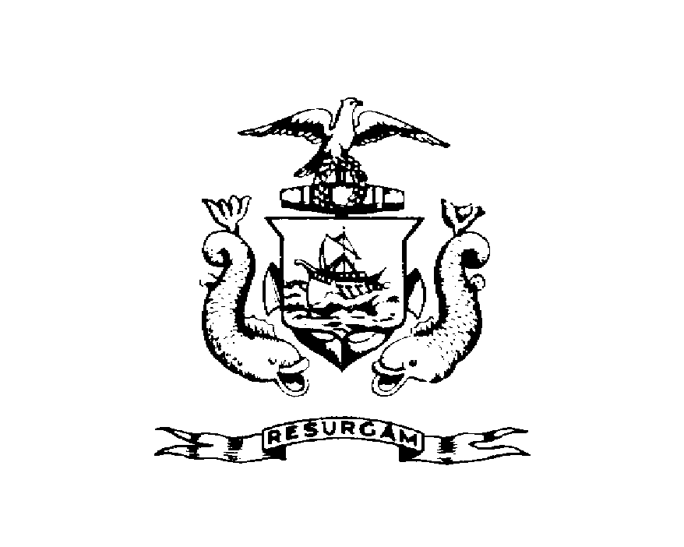
Michael J. Nugent Joseph E. Gray, Jr.
Manager Director

CITY OF PORTLAND

June 29, 1999

Administration Vet Affairs
7320 Old York Road
Philadelphia, PA 19126

RE: 49 Mayo Street
CBL: 022-I-010

To Whom It May Concern:

Certified Mail Receipt # Z 397 901 710

An evaluation of your property at 49 Mayo St. on June 25, 1999 revealed that the structure fails to comply with Section 120.1 of the Housing Code of the City of Portland.

The violations are as follows:

Fire Damage

Based on that list, and pursuant to Section 6-120.(1)(2)(3), this office declares the dwelling unit is unfit for human habitation. A reinspection of the premises will occur on June 26, 1999 at which time the (dwelling unit/structure) must be totally vacated and secured from vandalism. Failure to comply will result in this office referring the matter to the City of Portland Corporation Counsel for legal action and possible civil penalties, as provided for in Section 1-15 of the Code and in Title 30-A.M.R.S.A.ss4452.

This constitutes an appealable decision pursuant to Section 6-127 of the Code. Please feel free to contact me at 874-8707, if you wish to discuss the matter or have any questions.

Sincerely,

David Caddell
Code Enforcement Officer
Nbg/

