To: Sheila Hill-Christian, Acting City Manager

From: Mary Davis, Director, Housing and Community Development Division

Cc: Jeff Levine, Director, Planning and Urban Development Department

Amy Grommes Pulaski, HCD Program Manager

Date: March 30, 2015

**RE: CDBG Targeted Areas Map**

**Background.** CDBG Program regulations require that funded activities must meet one of three national objectives. The national objective most frequently utilized in Portland is benefitting low and moderate income persons. This benefit can be on an individual basis (person directly benefiting from the activity or service) or an area-wide basis (the population of that area must be at least 51% low-moderate income). Our office utilizes a map displaying Census or American Community Survey (ACS) data of low-moderate income population in targeted areas of the City of Portland as a reference tool.

The current map was created in 2003 using 2000 Census data. HUD recently released new data from the American Community Survey (2006-2010). We updated the map using the new data to determine which areas would be targeted for area-wide activities. The City’s policy has been to use a two-part test in which a block group must have both a population of at least 51% low-moderate income residents *and* be located in a Census Tract that had a low-moderate income population of at least 51%. In the HCD office, we call this the “Census Tract Rule”.

Our recommendation is to continue with the Census Tract Rule which will create CDBG targeted areas and encourage projects or activities in areas that have a higher percentage of low-moderate income residents, based on both Tract and block group data.

**Applying the Census Tract Rule to 2014.**

*Using the Census Tract Rule policy would mean that the following block groups would no longer fall within the targeted area:*

1. Census Tract 20.02, Block Group 1 (Libbytown as shown on the next page):

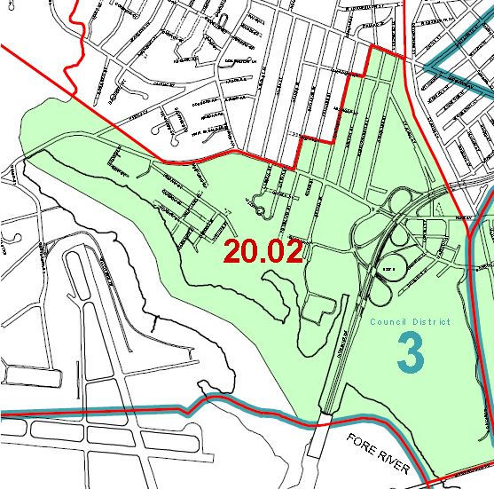

1. Census Tract 2, Block Group 2 (Munjoy Hill) This area is bounded by Congress Street, Atlantic Street, Fore Street and Vesper Street.

*Several block groups would be added to the CDBG targeted area:*

1. Census Tract 3, Block Group 2 (Downtown/Waterfront) – This area is bounded by the waterfront to the south, Cumberland Ave to the north, Elm Street to the west, Franklin Street to the east and along the waterfront over to Atlantic Street. However projects in this geography would need to ensure they were complying with the HUD regulation of benefitting a “primarily residential” area.
2. Census Tract 15, Block 3 (Oakdale) – This area is bounded by Brighton Ave, Falmouth Street, and Forest Avenue.
3. Census Tract 1, Block Group 3 (East End School) – This area abuts the Eastern Prom and includes the East End School.
4. Census Tract 2, Block Group 1 (Eastern Promenade) – This area also abuts the Eastern Prom.
5. Census Tract 11, Block Group 3 (West End) - This is the area between State and High Streets in the West End, bounded by Spring Street to the north and Commercial Street to the South.

**Targeted Areas.** These boundaries are meant to reference targeted areas but do not guarantee a project’s eligibility. In addition, there may be areas of the City, outside of these targeted areas, in which an area wide project or activity may be eligible for funding.

I would like to acknowledge the work of Maeve Pistrang, former staff person who worked with our office on this mapping effort along with Jessica Gooch from Public Services.

Please let me know if you would like to discuss the data and the new CDBG Targeted Area Map. The map will become part of our FY 2015-2020 HUD 5-Year Consolidated Plan which will be submitted to Council for approval at their May 4th meeting.