
Memorandum
Planning and Urban Development Department
Planning Division

To: Stuart O’Brien, Chair and Members of the Portland Planning Board

From: Caitlin Cameron, Urban Designer and Rebeccah Schaffner, COG Senior Planner

Date: June 19, 2014

Re: Fore Street – mixed use building, 185 Fore Street, Bateman Partners, LLC

Project #: 2014-066 CBL: 020 F023

Meeting Date: June 24, 2014

I. INTRODUCTION

Bateman Partners, LLC has submitted a Preliminary Site Layout Plan for a Level III Site Plan/Subdivision review for the vacant property located at 185 Fore Street. The applicant proposes to develop a four story mixed use building that contains 4,085 square feet of office/retail use on the first floor and six residential units on the second through fourth floors. A total building floor area is 21,175 square feet, with a footprint of 5,372.

Applicant: Bateman Partners, LLC, represented by Nathan Bateman
Consultants: Joseph A. Laverriere, P.E., Fay, Spofford & Thorndike; David Lloyd, Archtype

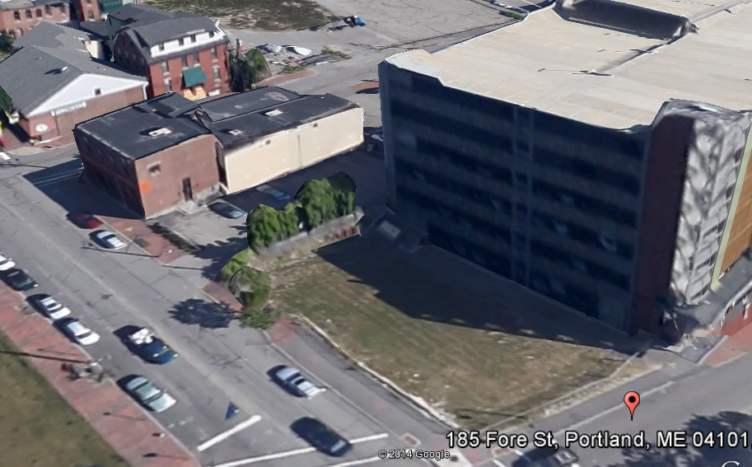
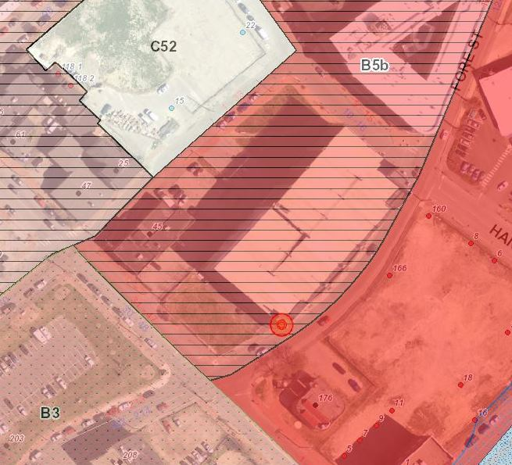

Required Reviews:
Review | Applicable Standards
Subdivision (Article IV) | The term subdivision shall also include the division of a new structure into three (3) or more dwelling units within a five-year period, this application is subject to Subdivision Review under Article IV of the Land Use Code, § 14-491 – 14-520
Site Plan (Article V) | This application qualifies as a Level III Site Plan  requiring Planning Board approval; the application is subject to Site Plan Review under Article V of the Land Use Code, § 14-521 – 14-540.
Waiver Requests | Applicable Standards
Street Trees –6 trees required, 2 proposed | Site Plan Standard (Section 14-526(b)2.b(iii)), and Technical Manual standard 4.6.1 requiring one tree per residential unit with trees 30 to 45 feet apart on center.

II. PROJECT DATA
Existing Zoning: | B-5b
Existing Use: | Vacant Lot
Proposed Use: | Mixed Use Building
Existing number of lots: | one
Proposed number of lots: | one
Parcel Size: | 6,947 sq.ft.
Impervious Surface Area: Existing: | 0
Impervious Surface Area: Proposed | 5,372 sq. ft.
Impervious Surface Area: Net Change | 5,372 sq. ft.
Total Disturbed Area: | 6,947 sq. ft.
Proposed Building Area: | 21,175 sq. ft.
Proposed Building Net Change: | 21,175 sq. ft.
Proposed Building Footprint: | 5,372 sq. ft
Proposed Residential Units: | 6
Number of Units to be Demolished: | 0
Number of Affordable Units: | 0
Bedroom Mix | 3 two-bedroom and 3 three-bedroom units
Building Height(s): | 62’ 3.5”, per the application
Parking Spaces Existing: | 96 (lease agreement)
Parking Spaces proposed: | 0 on-site – lease for 94 spaces in Ocean Gateway Garage
Number of Handicapped Spaces: | Not indicated in application
Bicycle Parking Spaces Existing: | 0
Bicycle Parking Spaces Proposed: | 4 for non-residential uses – internal storage area for residential owners
Estimated Cost of Project: | $3,900,000
Uses in Vicinity: | The site is on the corner of India and Fore Streets. Micucci’s and Ocean Gateway Garage are on either side of the lot. Parking lots on across the street. The site is in the B-5b zone with B-3, B-6 across from the site.

III. EXISTING CONDITIONS
The previous development on the site was associated with American Hoist & Derrick Company. It was razed and replaced with lawn area, although remnants of the foundation are still visible. The land area on the site slopes approximately 6% northwest to southwest towards Fore Street. Most of the grade differential is along the India Street frontage. There is a masonry wall associated with the previous development still standing along the northwest side of the property adjacent to the Micucci’s parking lot, and there is a remnant of a temporary excavation system installed as part of the Ocean Gateway Garage development. The site is currently enclosed with a 6 foot chain-link fence.

This parcel was designated as a potential office development site for the Longfellow Residence and Retail Project, which was proposed by Riverwalk LLC and approved in 2007. The Planning Board approvals have expired for that project and Bateman Partners, LLC has obtained an option to purchase this separate parcel.

IV. PROPOSED DEVELOPMENT
The proposed development site is located on the corner of Fore and India Streets. Micucci’s Grocery is located directly northwest of the property. The proposal seeks to develop the property with a four story mixed-use development with one office unit on the first floor, and six residential units on the second through fourth floors. The 2nd and 3rd floor will each contain two residential units, and the 4th floor will contain two residential units each with its own mezzanine floor above. The residential units will be 2 and 3-bedroom. The ground floor of the building has a footprint of 5,372 s.f. with 4,085 s. f. of ground floor office space. There is a pedestrian connection between the proposed building and the adjacent Ocean Gateway Garage on an upper floor.

The office space has a primary entrance on Fore Street and a secondary entrance on India Street. The residential units have a ground floor lobby with elevator access and a primary entrance on Fore Street toward the eastern corner of the building (next to the garage).

The Applicant proposes to provide both office and residential tenants with 94 spaces of existing parking in the abutting Ocean Gateway Garage. There is direct garage access from the building on an upper floor.

Landscaping plans include replacement of 1 existing street tree on India Street, and the addition of 1 more street tree on India Street; and 2 planters adjacent to the building on Fore Street. The project is required to provide 6 street trees in total and the applicant will need to provide a waiver request for the financial contribution of the remaining 4 trees not provided on-site.

Public utilities including water, sewer, natural gas, power and communications are readily available in the area. Power will be installed underground per the subdivision ordinance, although the design is not final.

V. PUBLIC COMMENT
Public notice appeared in the Portland Press Herald on June 16 and 17, 2014. A total of 623 notices were sent to property owners within 500 feet and the interested citizen list.

The applicant held the required neighborhood meeting on June 12th, 2014 and the packet is included in the Applicant’s submission as Attachment H.

Generally, there has been positive reaction to the project. At the neighborhood meeting, questions were asked about the height of the building and how the building affects views and interaction with the waterfront and also clarification of the parking agreement.

VI. RIGHT, TITLE AND INTEREST AND FINANCIAL/TECHNICAL CAPACITY
a. The owner of the property is East India Land Company, LLC. The applicant has provided a copy of a Memorandum of Purchase Option Agreement with the property owner as well as the Quitclaim Deed with Covenant of the property owner, recorded at the Cumberland County Registry of Deeds (Book 30624, Page 17), which demonstrates their right, title and interest in the property.

b. The estimated cost of the development is $3,900,000. The applicant has submitted a letter from Michael P. O’Reilly of Bangor Savings Bank, dated May 2nd, 2014, stating the bank has a “high degree of interest in providing construction financing for the project” and has successfully worked with the Applicant in the past as demonstration of their financial and technical capacity to complete the proposed development.

VII. Zoning Assessment

- ZONING REVIEW- Marge Schmuckal, Zoning Administrator, June 3, 2014
It is noted that the original input CBL was changed to reflect the appropriate lot that this project is to be built on.

This retail and six unit residential building is located in the B-5b zone. It is important to note that the front of the building faces Fore Street. That is where the maximum front setback is required. Because of the angle of Fore Street to the building points of the building are setback along the front. However, my scaling showed that the building is not setback more than 10 feet.

All other B-5b dimensional requirements are being met. The maximum building height is 65' and the given height is approximately 60.29 feet. The architect showed me how the average grade was determined and I accept that.

Section 14-332.1(g) exempts B-5 zones (which I interpret to include the B-5b zones) from meeting having to meet any parking requirements under zoning.

Separate permits will be required for signage and HVAC systems. The HVAC systems shall meet the maximum allowable noise requirements. When permits are applied for, it will be necessary to show decibel outputs for any units.

VIII. DEVELOPMENT REVIEW

- SITE PLAN SUBMISSION REQUIREMENTS (Section 14-527) and SUBDIVISION PLAT AND RECORDING PLAT REQUIREMENTS (Section 14-496)

The Applicant has submitted a preliminary plan for the Board’s consideration on May 6th 2014, which has been reviewed and commented on by staff for conformance with the relevant reviews standards of the Subdivision and Site Plan ordinances. A final plan meeting all of the submission requirements is required, including a recording plat meeting all of the provisions of the Subdivision Ordinance. In general, the applicant will need to submit all utility capacity letters and respond to review comments. Staff members are reviewing the Applicant’s response to staff comments that was submitted by the Applicant on June 13th, 2014.

- Site Plan Standards (Section 14-526)

- Transportation Standards
  - Impact on Surrounding Street Systems
The project requires review under the City’s delegate review for a Traffic Movement Permit (TMP). The scoping meeting is scheduled for June 25, 2014. Mr. Errico’s, Consulting Traffic Engineer, comments are pending review of the traffic study to be prepared for the traffic movement permit.

  - Access and Circulation
Pedestrian access to the residential units is through an entry off the Fore Street public sidewalk. The non-residential first floor has a primary entry off Fore Street with a secondary access from India Street. The applicant is proposing a direct pedestrian connection from the building to the adjacent parking garage, Ocean Gateway Garage, where the applicant holds a lease for 94 spaces for this proposal.

David Margolis-Pineo reviewed the initial submission and his comments are pending on the June 13th revised plans pending his return from vacation. Following are his comments pertaining to curb ramps.

Curb ramps must be designed in detail showing the dimensions of tipdown curbs, flush curb and dimensions of detectable warning panels. Also show the location of any drainage structures and utilities that may impact curb ramp location and design.

As noted in a recent staff meeting, detailed drawings are required of the ramp proposed to direct pedestrians across Fore Street in particular, as it appears there is insufficient space for a landing that will meet city specifications.

  - Public Transit Access
This project does not trigger the requirement to provide public transit facilities. The METRO bus provides service on India Street with Routes 8 and 8A.

  - Parking

a. Location & Required # of Vehicle Parking Spaces
The Applicant has submitted a copy of Parking Lease agreement between Ocean Gateway Garage LLC and East India Land Company, LLC (property owner) for 94 parking spaces to serve the proposed development. As the upper 3 floors of the development are to be residential units (condominiums), not lease tenants of the building, it is recommended Corporation Counsel review the lease agreement to ensure it is enforceable in regards to meeting parking space requirements.

Additionally, per the lease agreement, the 94 spaces will not be designated or reserved for the units, so it is unclear if handicapped parking requirements have been met.

A direct pedestrian connection is proposed from the building to the parking garage at an upper level for residents. The staff asked for additional information regarding the need for 94 parking spaces, which exceeds the zoning requirements for parking. The required number of parking spaces is one space per residential unit on the peninsula and 1 space per 400 square feet of office space. Thus 6 spaces are required for the residential units and approximately 10 spaces for an office use. The required number of parking spaces will be determined based upon the final use of the first floor; however providing 94 spaces significantly exceeds the City’s minimum standards.

b. Location & Required # of Bicycle Parking Spaces
Following are the review comments submitted by David Margolis-Pineo on June 2, 2014. The applicant is proposing building residents use their ground floor storage units for bicycle parking which is currently only accessible through the back of the building. Bike racks are also proposed outside of the building on-street. The applicant submitted revised plans on June 13, but Mr. Margolis-Pineo’s review of the revised plans is pending his return from vacation. His initial review regarding the placement and location of exterior bike racks is as follows:

Bike racks within the public ROW/easement areas (can also be used for parking internal to the site):
- If bike racks are placed at the curb and parallel to the curb, they shall be located a minimum of 24" from the back of curb (36" preferred). The minimum spacing between racks (on center) shall be 6'. They should be placed/spaced to avoid car doors opening based upon expected parking spacing.
- If bike racks are located next to and parallel to the building, they shall be a minimum of 30" from the building (36" preferred). The minimum spacing between racks (on center) shall be 6'.
- If bike racks are located next to and perpendicular to the building, they shall be a minimum of 48" (on center) from the building (60" preferred). The minimum spacing between racks (on center) shall be 36" (48" preferred).
- Bike racks may not be placed when bicycles are parked to reduce the clear sidewalk width below 5'.
- Bike racks are to be located in closer proximity to primary entrances to the building.

  - Transportation Demand Management (TDM)
This project does not trigger the requirement to submit a Transportation Demand Management Plan.

- Environmental Quality Standards
  - Preservation of Significant Natural Features
The site was formerly developed and has been vacant since the demolition of the structure. There are not significant natural features to preserve on this site.

  - Landscaping and Landscape Preservation
The Applicant’s response to initial staff comments has not been reviewed by staff, however it should be noted that underground power conduits on Fore Street prevent the planting of street trees and the Applicant has proposed 2 planter boxes adjacent to the building. Following is the review prepared by Jeff Tarling, City Arborist, for the initial submission.

Both of these projects 185 Fore Street and 16 Middle Street need to have three trees planted at each site. At 185 Fore Street request one tree along the Fore Street frontage and two along India Street. Due to the recent tree problems at a nearby project that was unable to plant 8 trees due to underground utilities, we have six NEENA tree grates and guards in the City's possession that can be used for this project. It will offer uniformity. We can work with the project team to decide on the recommended tree type. Need to review the sunlight and space availability.

The Planning staff note that the planters are shown extending into the street right-of-way, which reduce the sidewalk to a width of 6 feet. At this time, staff is recommending that the planters be revised to stay within the private property boundaries or removed completely in order to maintain a wide sidewalk along Fore Street.

  - Water Quality, Storm Water Management and Erosion Control
David Senus, PE, Woodard and Curran, conducted a review of the preliminary plans submitted for 185 Fore Street. His memo is included as Attachment 1 to this memo. In his memo, he notes the additional material that will be needed to for the final plan review and confirms that the project must meet the stormwater provisions of the site plan ordinance and Technical Manual. He also notes that the project is subject to previous environmental cleanup efforts that are restricted in the form of a restrictive deed covenant. He requests the applicant clarify the restrictions.

In Dave Senus’ review he notes in comments 10 and 11 that there are underground conduits for telecommunications lines and other utilities. He has provided additional information to the applicant regarding these utilities, so the applicant will be able to depict them on a revised site plan.

Mr. Senus is on vacation, so he has not had the opportunity to review the revised plans submitted on June 13, 2014.

- Public Infrastructure and Community Safety Standards
  - Consistency with Master Plans
This property falls within the Eastern Waterfront and as such, is subject to the Master Plan and Design Guidelines for the Eastern Waterfront. The project is consistent with applicable guidelines as outlined below but especially meets the intent of the Master Plan as an infill development project of mixed-use and with shared parking infrastructure. The project does not seem to impact public view corridors or access to the waterfront.
A3. Sidewalks – the project maintains the current sidewalk widths; street trees are provided on India Street; Street lights will be maintained on India Street; Planters are provided on Fore Street where street trees are not feasible; Bicycle parking is provided near building entrances. The project could potentially do more to enhance the sidewalk realm such as through its lighting scheme, for example.
A6. Underground Utilities – All utilities associated with this project are underground.
A8. Bicycle Safety – The project provides bicycle parking on-street near building entrances.
B1. Contextual Design – The infill nature of this development regulates the size and mass of the building footprint. The surrounding buildings vary in scale, use, and form and the proposal is able to transition both in scale and architecture expression between the garage and smaller, historic buildings like Micucci’s. The building meets the street edge and creates a desirable street wall. The building entrances are oriented to the street, although staff would prefer more prominence given to India Street. The ground floor uses storefront design principles and adds to the pedestrian environment.

The India Street Sustainable Neighborhood Plan is being developed and has not been adopted at this date however, this project falls within the intent of that planning process in that it adds to the active street wall of India Street, is of a desirable height and scale, and shares parking infrastructure rather than creating more parking space.

  - Public Safety and Fire Prevention
a. Crime Prevention through Environmental Design
The Planning Staff have identified safety concerns regarding the alley between the proposed development and the Ocean Gateway Garage. The revised plan shows light fixtures along this passage to improve the safety.

c. Consistency with Public Safety Standards
The Applicant’s response to initial staff comment has not been reviewed by staff, however it should be noted the Applicant has not added all Construction Management Plan notes requested by Fire Department staff to the C1.1 General Notes and Legend drawing. Captain Pirone’s May 30th review comments on the initial submission are as follows:

Construction Management Plan
- Streets must maintain a 20’ width for Fire Department access at all times.
- Fire Hydrants shall not be blocked or enclosed by fencing. A 3’ foot clearance must be kept at all times around the fire hydrant.
- If gates are locked, a Portland Fire Department Knox padlock must be purchased by the applicant to allow access for the Fire Department.
- The Construction Company’ emergency contact information shall be posted on the property in case of an after-hours emergency.
- All construction shall comply with 2009 NFPA 1 Chapter 16 Safeguards During Building Construction, Alteration, and Demolition Operations.
- Any cutting and welding done will require a Hot Work Permit from Fire Department.

Exit Discharge
- A Life Safety Evacuation Plan shall be submitted with the Building Permit detailing the exiting and waiting area for occupants.

2009 NFPA 1 18.3 Water Supplies and Fire Hydrants
- If the building has a sprinkler system; fire hydrants must be within 100’ but no closer than 40’.
- Fire Department Connections shall not be located where large diameter hose may block egress.

  - Availability and Adequate Capacity of Public Utilities
Capacity letters from the utility companies and the sewer division of the Department of Public Services are required for the final submission.

- Site Design Standards
  - Massing, Ventilation and Wind Impact
The proposed building does not trigger the requirement for a wind study. Refer to Caitlin Cameron’s Design review of the building regarding the proposed massing of the building.
  - Shadows
The proposal does not trigger the requirement for a shadow study.
  - Snow and Ice Loading
  - View Corridors
The proposed building does not block any designated view corridors.
  - Historic Resources
The proposed development is not within an historic district and it is more than 100 feet from the Commercial Street Historic District. As part of the India Street Sustainable Neighborhood Plan, there is a proposal for creating an India Street Historic District, but the district is still in the planning stages and is not adopted.
  - Exterior Lighting
An exterior lighting plan and photometrics have not, yet, been provided. Staff are concerned with the presence of the building on India Street at night as well as the safety on less active frontage such as Fore Street and the corridor between the building and the garage.
  - Noise and Vibration
The noise and vibration specifications for the mechanical systems, such as heating, ventilation and air conditioning must be submitted for review as part of the final plan.
  - Signage and Wayfinding
  - Zoning Related Design Standards

Design Review - B5b Standards (Design Manual):
A preliminary design review was conducted on May 27 with Caitlin Cameron, Alex Jaegerman, and Barbara Barhydt. Below is a summary of that review:
1a) Shared Infrastructure: Meets the requirement by using the neighboring parking garage to meet parking requirement. There is one point of physical access to the garage on an upper, residential floor.
1b) Buildings and uses shall be located close to the street where practicable. The project in its current iteration has brought the ground floor closer to the street on India Street which serves to provide a strong street edge and now meets the requirement.
1c) Overall, the review team felt the project could do more to create an active and engaging facade on India Street. Because it appears the use on the ground floor is office rather than retail/restaurant, design elements that have a dialogue with the street are important (entries, transparency, lighting, proximity to street, etc.) The project has been revised to bring the ground floor to the street and storefront design is used with high transparency. Some clarification of the awnings and lighting plan were requested to understand the presence of the building at night and other forms of articulation. The slope of India Street is challenging but we feel a more prominent entrance on India Street is called for as the main street of the neighborhood.
1d) Parking lots - Not applicable.

Multi-family Standards (Design Manual):
1a1) The project is located several blocks away from the typical residential buildings. The form and height, porches and facade variation do a good job of mediating the different scales and building characters around it. However, there are a couple of points that we feel do not, yet, meet the intent of the standard:
- We are concerned about authenticity of materials and durability of the thin brick and EIFS for the facade and cornice.
- Additional visual interest and dialogue with the streetscape is needed on India Street
1a2) We appreciate the infill nature of this project and its location is very important in how it contributes to and improves the streetscape on India Street. For example, is there potential for a more prominent entrance on India Street?
The remaining standards are met or are not applicable.

- Next Steps
- Submit a final plan meeting the requirements of the site plan and subdivision ordinance and responding to staff comments.
- Schedule a 2nd workshop or move to a public hearing to review the proposal

Attachments
Report Attachments
1. Rebeccah Schaffner Comments dated 5-28-14
2. Fire Department Comments dated 6-2-14
3. City Arborist comments dated 5-30-14
4. Civil Engineer Comments dated 5-30-14 and 6-2-14
5. Urban Designer Comments dated 5-23-14
6. Zoning Administrator Comments dated 6-3-14
7. Engineer Review Comments dated 5-29-14

Applicant’s Submittal
A. Cover Letter
B. Site Plan Application
C. Table of Contents
D. Development Description
E. Technical and Financial Capacity
F. Conformity with Applicable Design Standards
G. Applicant Response to Comments
H. Neighborhood Meeting Material
Plans
Plan 1 Cover Sheet
Plan 2 General Notes
Plan 3 Site Plan
Plan 4 Grading and Drainage
Plan 5 Utility Plan
Plan 6 Driveway Apron
Plan 7 Utility
Plan 8 Electrical
Plan 9 Rendering
Plan 10 Context Perspective 1
Plan 11 Context Perspective 2

