Inspection Services Department of Urban Development
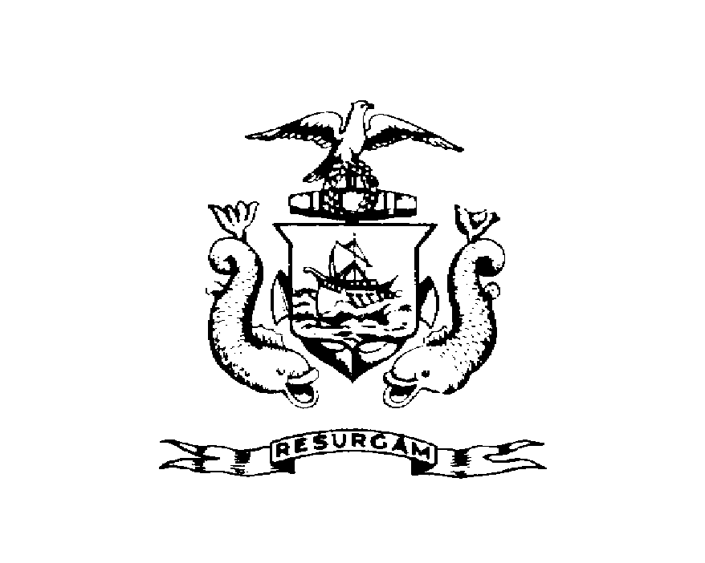
Michael J. Nugent Joseph E. Gray, Jr.
Manager Director

CITY OF PORTLAND

July 30, 2026

Betty A. Pomroy
P.O. Box 432
Westbrook ME 04098

RE: 66 Federal St
CBL: 020D02500101

Dear Betty A. Pomroy:

A re-inspection at the above noted property was made on May-15-2000.

This is to certify that you have complied with our request to correct the violation(s) of the Municipal Code relating to housing conditions noted on our letter dated Feb-16-2000.

This notice is intended to document that you have corrected the specific violations as previously noted. It is not intended to indicate compliance with other City regulations, it also does not imply that the structure or premises is violation free.

Thank you for your cooperation. If you have any questions, feel free to contact this office
Arthur Rowe @ 874-8697.

Sincerely,

Arthur Rowe @ 874-8697
Code Enforcement Officer

