Inspection Services Department of Urban Development
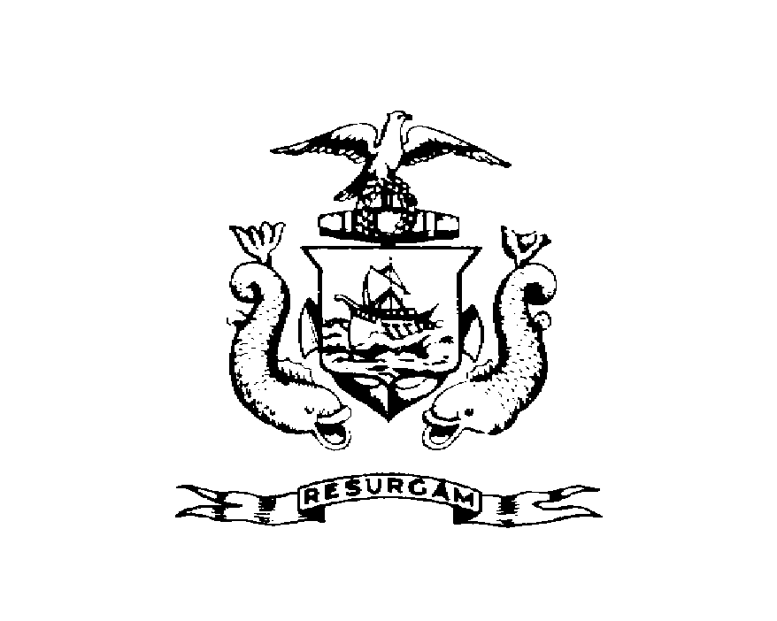
Michael J. Nugent Joseph E. Gray, Jr.
Manager Director

CITY OF PORTLAND
NOTICE OF VIOLATION

July 30, 2026

Betty A. Pomroy
PO Box 432
Westbrook, Me 04098

RE: 66 Federal St.
CBL: 020-D-025

Hand Delivered
Dear Betty Pomroy:

An evaluation of your property at 66 Federal St. on April 12, 2000 revealed that the stair structure fails to comply with Section 107.1 of the BOCA 1999 Building Code of the City of Portland.

There is no Building Permit on file for the stairs and landing which has been built.

This is a notice of violation. A building permit application and all required submissions and appropriate fees must be submitted to this office within 10 days of the date of this notice. Failure to comply by April 28, 2000 will result in this office referring the matter to the City of Portland Corporation Counsel for legal action and possible civil penalties, as provided for in Chapter 266 of 22 M.R.S.A. Sec. 1633.

This constitutes an appealable decision pursuant to Section 121.1 of the Code. Please feel free to contact Jeanie Bourke @ 874-8715, if you wish to discuss the matter or have any questions.

Please be advised that the Portland City Council has amended the Building regulations to include a $75.00 re-inspection fee. This violation will automatically cause a re-inspection at no charge. If there are any subsequent inspections, however, the $75.00 fee will be assessed for each inspection.

Sincerely,

Jeanie Bourke @874-8715
Code Enforcement Office

Jmb/

