PLANNING BOARD REPORT
PORTLAND, MAINE

Seaport Lofts (Bay House Phase II)
101-121 Newbury Street and 40 Hancock Street
Level III Site Plan and Subdivision Review - Condition of Approval, Design Review
2013-179
113 Newbury Street, LLC, Applicant

Submitted to: Portland Planning Board  Public Hearing Date: July 8, 2014 | Prepared by: Nell Donaldson, Planner  Date: July 3, 2-14  CBLs: 20-D-13, 14, 15, 32

I. INTRODUCTION
On October 22, 2013, the City of Portland Planning Board held a final public hearing to review a 39-unit housing development, the Seaport Lofts, at the corner of Newbury and Hancock Streets in the Eastern Waterfront. The hearing followed a long series of discussions between board members, city staff, and the applicant regarding the building’s architecture. Notwithstanding these discussions, significant design concerns remained at the October hearing. Referencing the B-2b design guidelines, Board members raised questions about the massing of the building, façade articulation (particularly with respect to the rear), and neighborhood compatibility. After considerable discussion, the Board approved the project on the condition that the applicant address outstanding design concerns and return to the Planning Board for additional design review.

In the intervening time, the applicant has elected to hire a new architect, met with city staff on several occasions to review potential design improvements, and made significant changes to the building architecture. This report describes those changes and presents the final design for Planning Board review.

A total of 133 notices were sent to property owners within 500 feet of the site and a legal ad ran on June 30 and July 1.

Applicant: 113 Newbury Street, LLC, Demetri Dasco
Consultants: Will Conway, Sebago Technics; Mark Mueller, Architect

II. DESIGN MODIFICATIONS
B-2b Design Standards
The city’s site plan ordinance states that “development in the…B-2b business zone shall provide an established street wall with entrances and public portions of the building oriented to and directly accessible from the public sidewalk and shall be designed and scaled to be compatible with surrounding residential and commercial development as demonstrated by compliance with all applicable design standards listed in the Design Manual” (Section 14-526(d)9.a(iii)). The Design Manual’s standards further require that buildings in the B-2b zone:
- create and preserve an urban street wall;
- be oriented toward the street;
- include windows along the street frontage;
- create an active presence along the sidewalk;
- be compatible with residential and commercial neighbors, including in terms of building materials; and
- include landscaping and buffers to protect neighboring properties.

October 2013 Design
The applicant’s final site plan submission, considered by the Board in October, included a set of design drawings intended to meet the above standards (Figures 2-5). These drawings represented one in a series of iterations meant to respond to city and Board comments. However, as noted above, the Board expressed considerable outstanding concerns regarding the design as presented, particularly with respect to articulation and compatibility. Given these
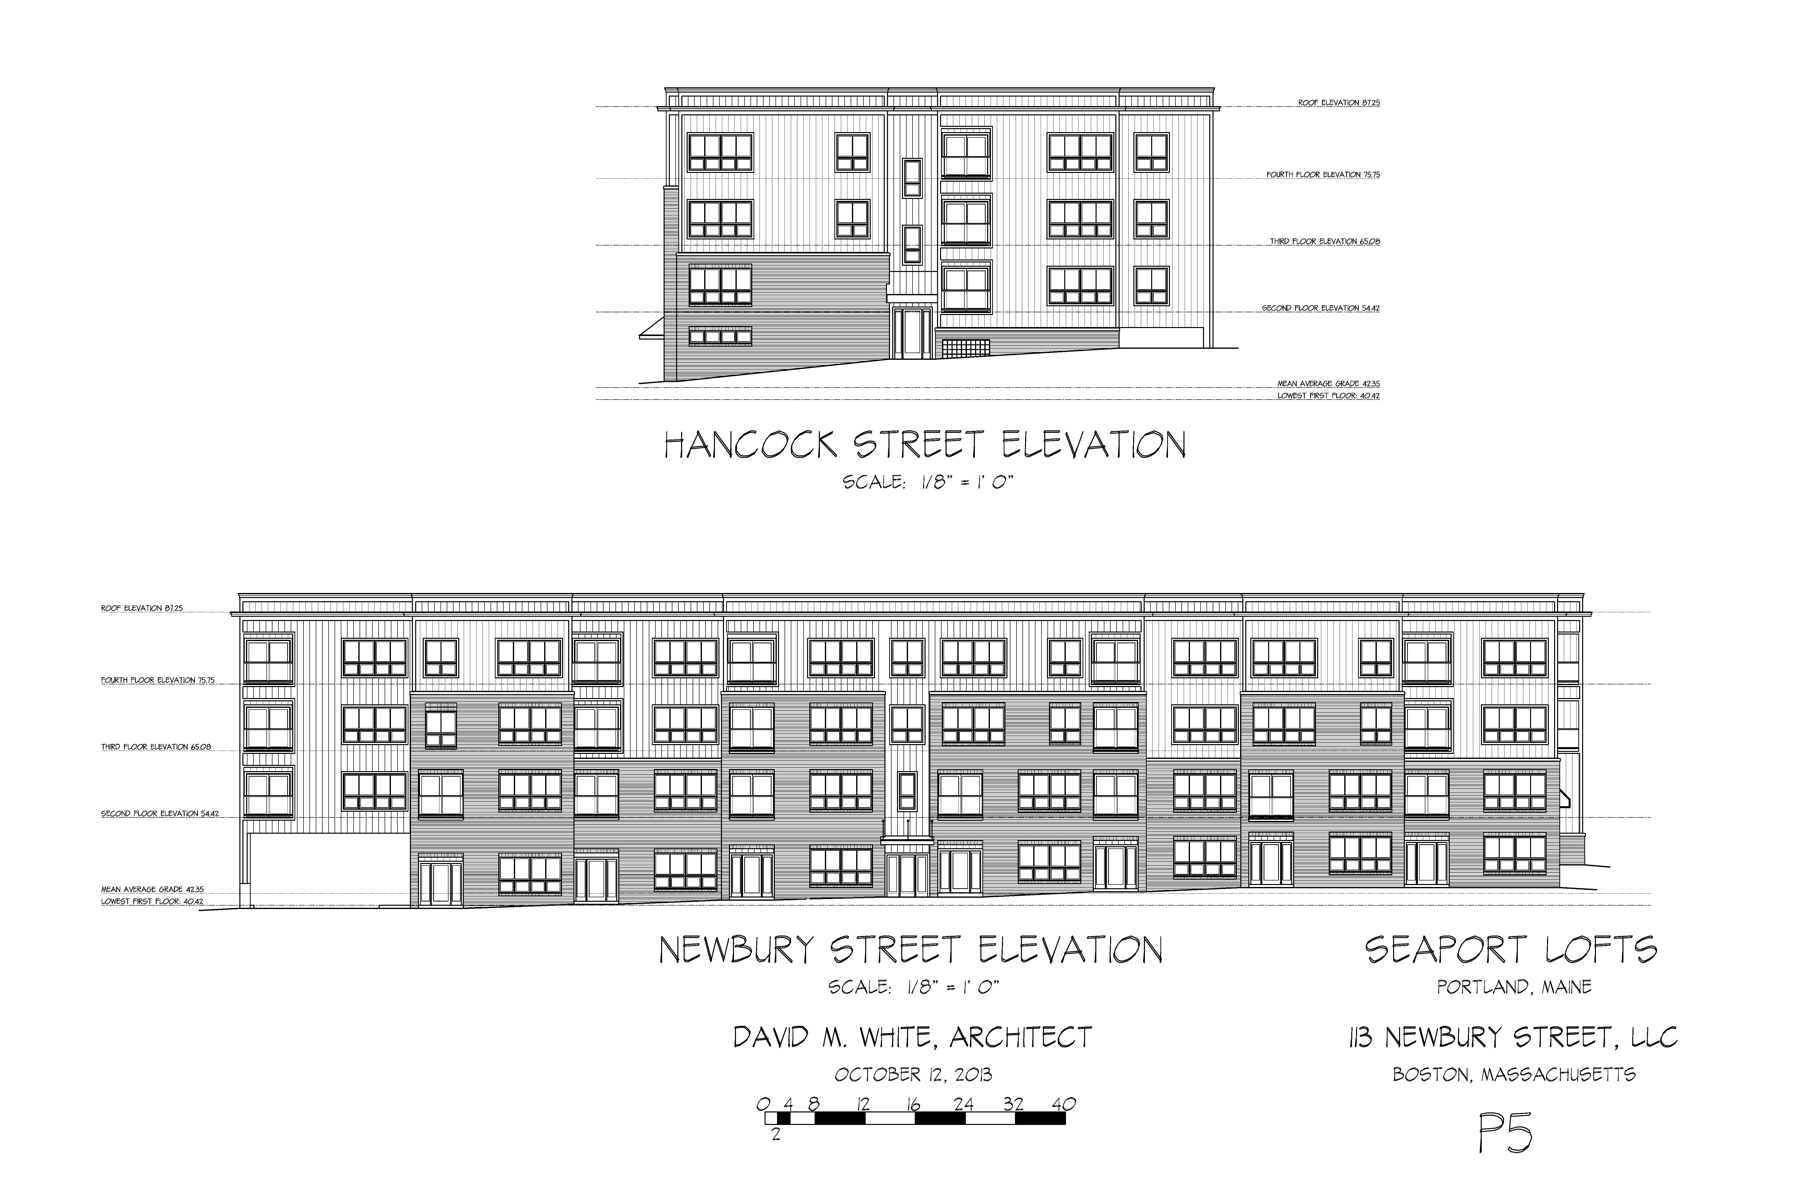
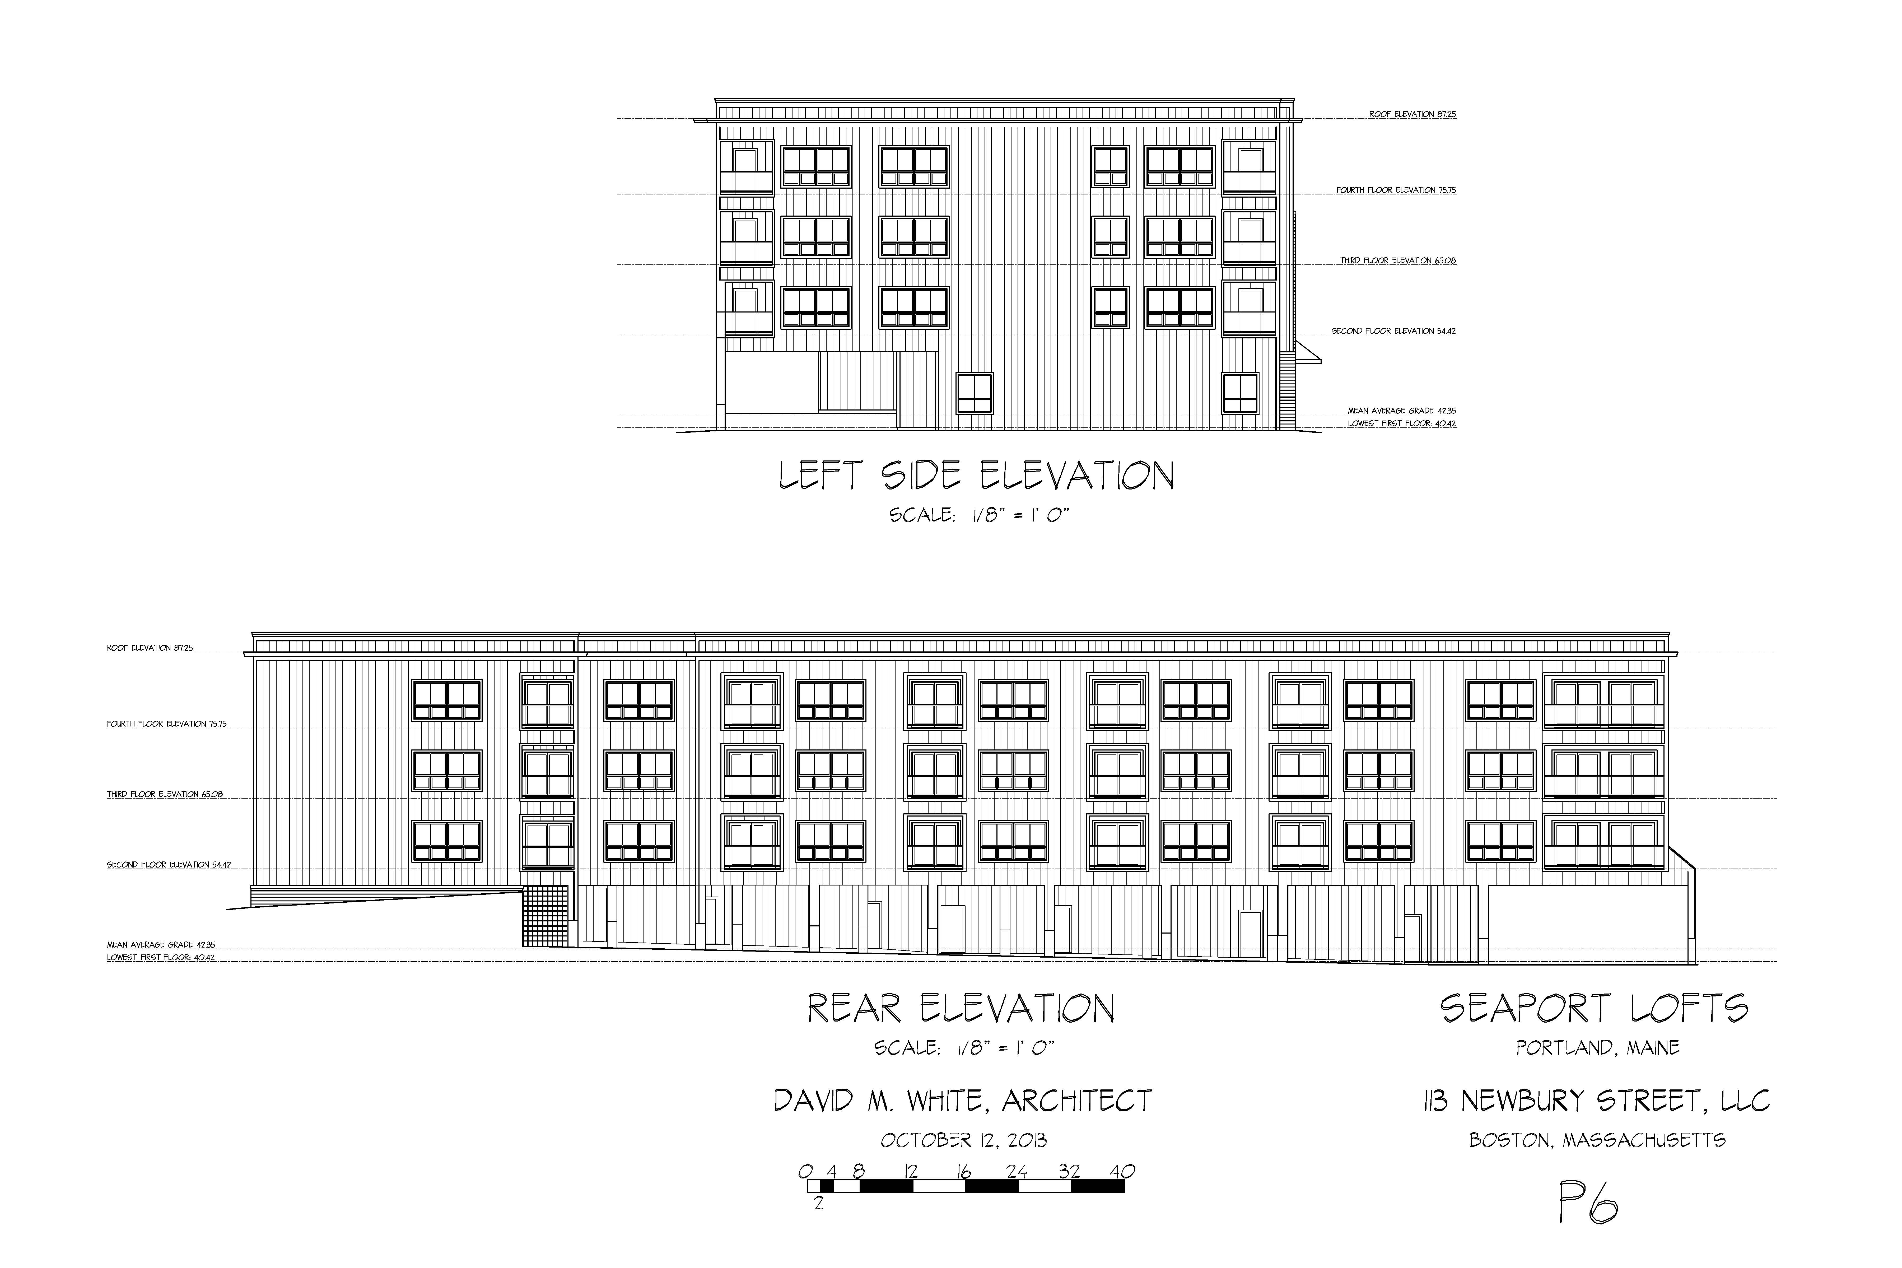
Figures 2, 3, 4, and 5: October 2013 elevations.

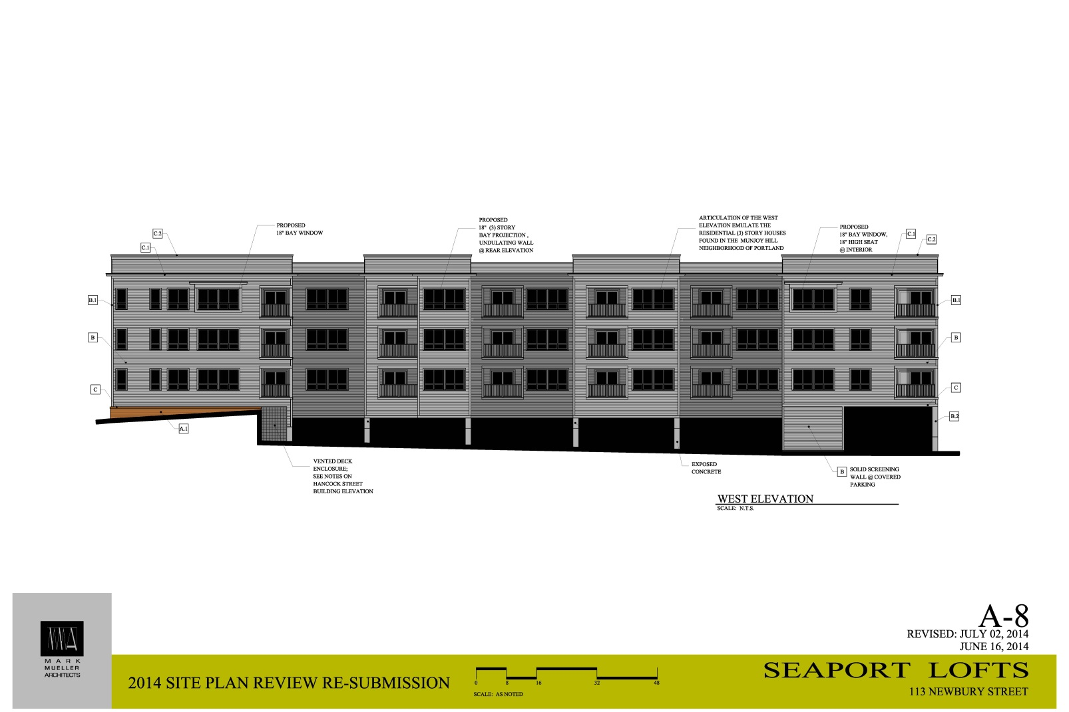
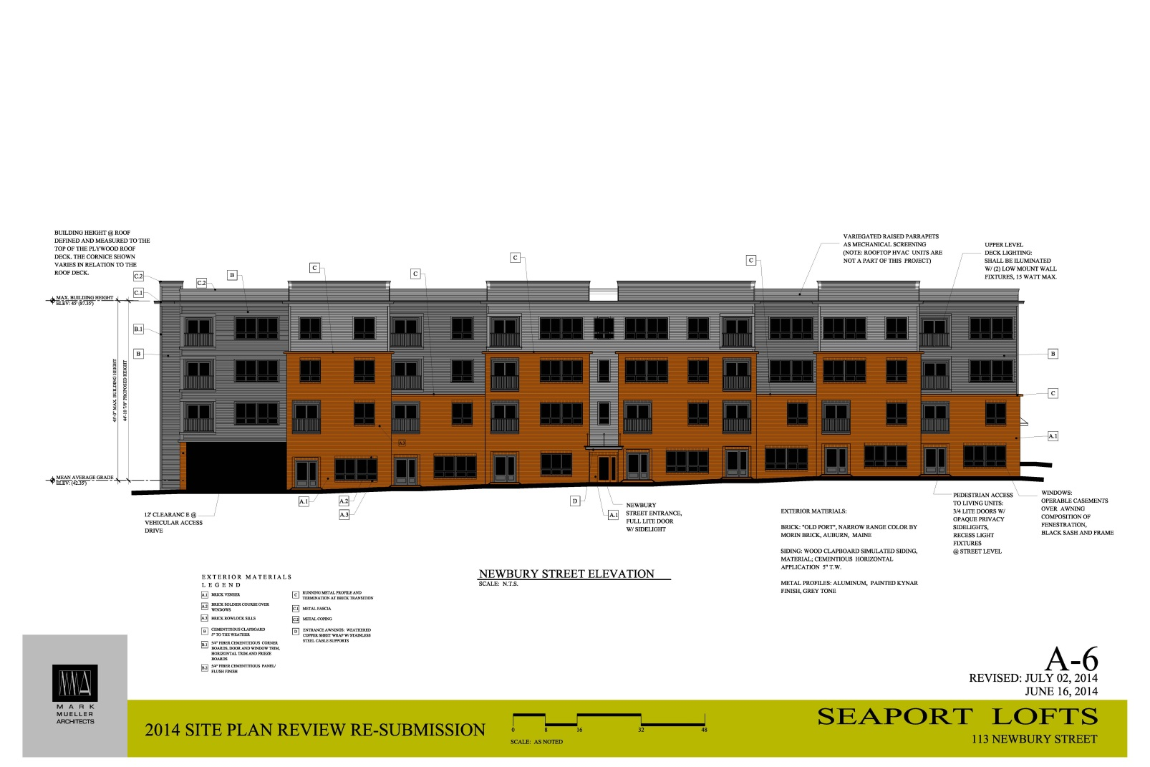
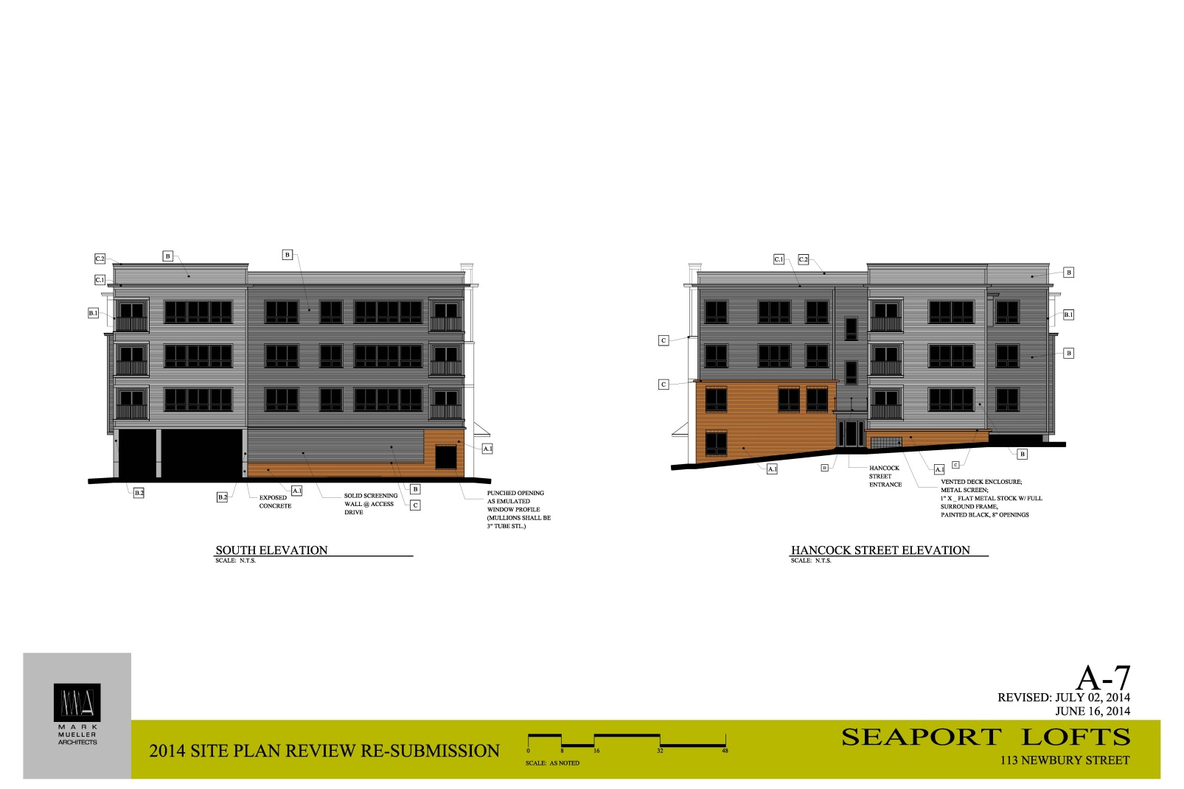
Figures 6, 7, 8, and 9: Revised elevations.

reservations, the Board crafted a condition of approval requiring additional design review. The condition of approval reads as follows:

The applicant shall provide revised elevations with emphasis on articulation of the rear elevations, overall building massing with emphasis on the rear of the building, renderings, details, and material samples addressing the recommendations of the Planning Board and staff on outstanding design issues (including but not limited to the treatment of proposed awnings, the proposed soldier course, metal screens, exterior lighting, and color and materials) in compliance with the Design Standards for review and approval by the Planning Board.

July 2014 Design
In an effort to meet this condition of approval, the applicant submitted working drawings in January of 2014 and again following a change of architect in early May. Staff reviewed these drawings, met with the applicant, and provided comments. The applicant submitted final floor plans, elevations, renderings, and samples the first week of July (Figures 6-9 and Plans 1-12). The changes in architecture include the following:

- Awnings: Responding to staff recommendations, the awning at Hancock Street has been redesigned to be consistent with that proposed at the Newbury Street entrance. Both entries are now depicted with a weathered copper awning hanging from stainless steel cables, a contemporary style requested by city staff.
- Treatment of northwest corner: The October 2013 design included an offset post at the northwest corner of the building which appeared unresolved. The applicant has modified the floor plan, adding area to the upper floor units, to eliminate this post and resolve this issue.
- Soldier course: At the October hearing, city staff recommended that the architect add a soldier course between the second and third floors of the Newbury Street façade in order to rationalize the change in composition there, where the townhouse units meet the upper story flats. The applicant considered this option, but elected not to introduce this soldier course and instead made other design changes to address massing and articulation concerns.
- Windows & parapet: The applicant has added windows and changed the window pattern on the Hancock Street, rear, and west facades, a modification meant to add visual interest and reduces the appearance of mass. The applicant has also introduced a parapet of varying heights on all facades. This feature is again intended to address concerns regarding massing and visual interest; the parapet helps to create the illusion of multiple distinct buildings rather than a single uniform one.
- Articulation of the rear façade: Maybe most significantly, and in response to Board concerns, the rear of the building is now articulated much like the front. In the October 2013 design, the rear elevation was entirely flat. This uniform wall has been replaced with an articulated one, which steps in and out as the Newbury
Street one does. The architect has also added 4th story bay windows at the far ends of the rear façade, and a three story bay near the center of this elevation.
- Materials & colors: The applicant’s final submittal also modifies the materials and colors of the previous design. The metal cladding originally proposed on the upper floors of the front façade and the entirety of the building’s rear has been replaced with composite clapboards with a 5” reveal in two shades of gray. These two shades have been used in an alternating pattern in an effort to break up each façade. It should be noted that the applicant and architect expressed a preference for a typical Old Port red brick color; as such, the gray brick has been eliminated. Fiberglass windows are proposed with casing in black.
- Metal screens: Some additional detail has been provided on the composition of the metal screens on the Hancock and rear facades. These screens are shown in a grid pattern. Notes indicate that they will be metal painted black.
- Exterior lighting: Lastly, the applicant has provided cut sheets for a number of exterior lights, including sconces for the covered parking area, recessed downlights for the building entrances, and deck lights (Attachment A), as well as a lighting plan (Plan 9). As in prior submittals, updated site plans show sconces on the rear of the building as well, which are not depicted in this lighting plan. Revised cut sheets for these sconces have not been provided. A complete lighting submittal is outstanding. It is anticipated that lighting questions could be resolved under a further condition of approval, which has been proposed.

III. PUBLIC COMMENT
The Planning Division received no public comment on the revised drawings.

IV. PROPOSED MOTION
On the basis of the revised drawings, plans, and other information submitted by the applicant; findings contained in the Planning Board report for the public hearing on July 8, 2014 for application 2013-179 relevant to Portland’s site plan ordinance, technical and design standards, and other regulations; and the testimony presented at the Planning Board hearing:

The Planning Board finds that the applicant has/has not met the condition of approval from the approval letter dated October 31, 2013 requiring that revised elevations, renderings, details, and material samples address the recommendations of the Planning Board and staff on outstanding design issues (including but not limited to the treatment of proposed awnings, the proposed soldier course, metal screens, exterior lighting, and color and materials) in compliance with the design standards, with the further condition that the applicant provide a complete lighting package meeting the standards of the city’s Technical Manual for review and approval by the city’s Planning Authority.

V. ATTACHMENTS
Planning Board Report Attachments
- Approval Letter (from City of Portland, 10-31-13)

Applicant’s Submittals
- Lighting Cut Sheets

C. PLANS
Plan 1 1st Floor Plan
Plan 2 2nd Floor Plan
Plan 3 3rd Floor Plan
Plan 4 4th Floor Plan
Plan 5 Roof Plan
Plan 6 Newbury Street Elevation
Plan 7 South & Hancock Street Elevations
Plan 8 West (Rear) Elevation
Plan 9 Lighting Plan
Plan 10 Rendering from Newbury Street looking northeast
Plan 11 Rendering from Newbury Street looking southeast
Plan 12 Rendering from rear

