Memorandum
Planning and Urban Development Department
Planning Division

To: Beth Boepple, Chair, and Members of the Portland Planning Board
From: Nell Donaldson, Planner
Date: November 5, 2015
Re: AC Hotel, 158 Fore Street
Project #: 2015-169 CBL: 19-B-2
Meeting Date: November 10, 2015

I. INTRODUCTION
Portland Norwich Group has requested a preliminary Level III site plan and subdivision review for the development of a 6-story 120,760 SF building at 158 Fore Street in the Eastern Waterfront. The project includes a 150 room hotel, 16 residential condominium units, and 4,000 SF of ground floor retail, some of which may be fit up as restaurant space. The plans show enhancements to the Fore Street, Hancock Street, and Thames Street streetscapes, new vehicular and pedestrian circulation interior to the site, landscaping, and stormwater treatment.

This development is being referred to the planning board for compliance with the site plan and subdivision standards. The Planning Division sent a total of 159 notices to property owners within 500 feet of the site and a legal ad ran on November 2 and 3, 2015.

Applicant: Ara Aftandilian, Portland Norwich Group, LLC
Consultants: Pat Carroll, Carroll Associates; Stephen Bradstreet, Ransom Consulting; John Swan, Owen Haskell, Rob Festa, Group One Partners (architect)

II. REQUIRED REVIEWS
Waiver Requests | Applicable Standards
Street trees  16 trees required. 13 trees proposed on street frontage, six trees proposed on interior alley.  Applicant requests that all trees be counted toward street tree requirement. | Site Plan Standard, Section 14-526(b)2.b(iii) and Technical Manual, Section 4.6.1. All multi-family development shall provide one street tree per unit. Waiver permitted where site constraints prevent it, with applicant contributing proportionate amount to Tree Fund.
Review | Applicable Standards
Site Plan | Section 14-526
Subdivision | Section 14-497

III. PROJECT DATA
Existing Zoning | B-6, with portion of site in Shoreland Zone
Existing Use | Vacant lot
Proposed Use | Residential, commercial
Proposed Development Program | 16 residential condominiums units (8 1-br, 8 2-br)  150 room hotel  4,000 SF ground floor commercial (restaurant/retail)
Parcel Size | 27,767 SF (to be split from larger 60,642 SF lot)
 | Existing | Proposed | Net Change
Building Footprint | 0 SF | 20,385 SF | 20,385 SF
Building Floor Area | 0 SF | 120,760 SF | 120,760 SF
Impervious Surface Area | 60,642 SF | 59,868 SF | -774 SF
Parking Spaces | 0 | 65 in Ocean Gateway* | 0 on site
Bicycle Parking Spaces | 0 | 4 | 4
Estimated Cost of Project | $2,000,000
* number to be confirmed at final plan review
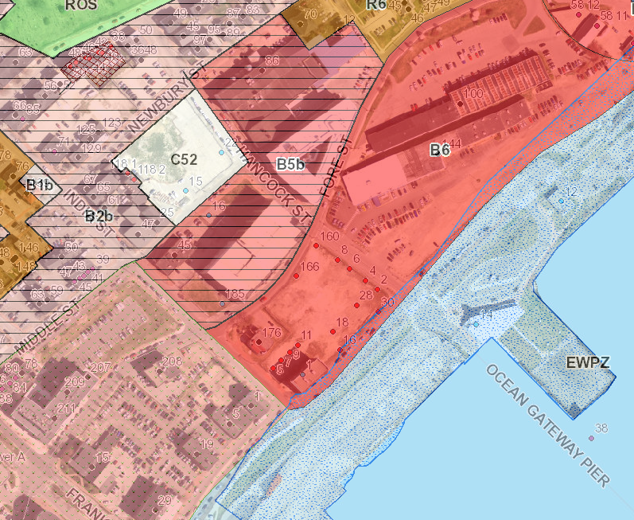
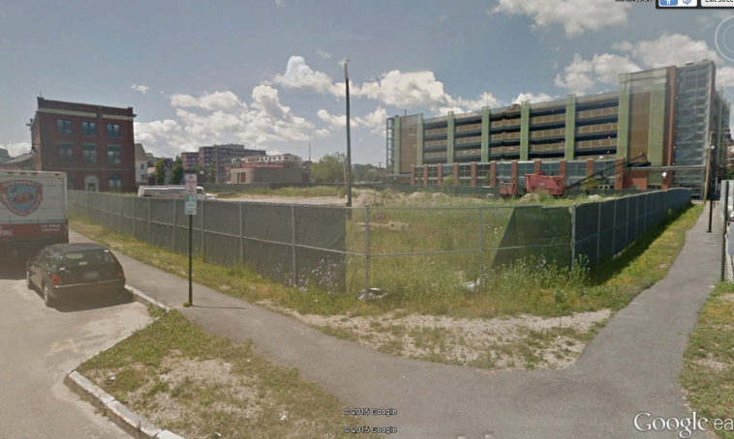
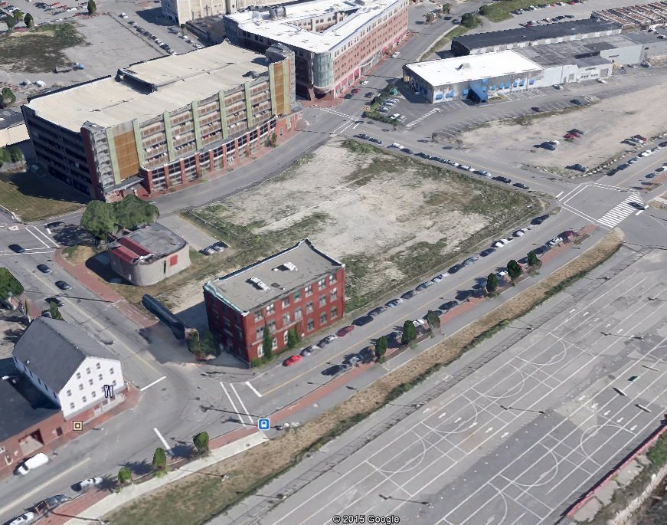

Lot 1

Lot 2

Figures 1, 2, and 3: 158 Fore Street site showing proposed lot split (above); site from Thames/Hancock Streets (above right); existing zoning context.

IV.BACKGROUND & EXISTING CONDITIONS
The AC Hotel is proposed on a 60,000 SF site on the block bounded by India Street, Fore Street, Hancock Street, and Thames Street in the eastern waterfront (Figure 1). The site, which is currently vacant, shares the block with the historic Grand Trunk building as well as the Portland Water District’s downtown pump station. The Ocean Gateway garage sits to the north, the Portland Company complex lies to the east, the Ocean Gateway Terminal lies to the south, and the retail and restaurants of Commercial Street lie to the west. The site is zoned B-6, the Eastern Waterfront zone. A small area of the site along Thames Street also falls into the Shoreland zone (Figure 3).
Anderson Street

V. PROPOSED DEVELOPMENT
Under the applicant’s plans, the eastern half of the site would be split off to create a separate 28,000 SF lot, depicted as Lot 1. This lot would be developed with a 150 room hotel, 16 top-floor residential condominium units, and 4,000 SF of ground floor commercial on Thames Street, some of which could potentially be developed as restaurant space (Figures 4 and 5). The applicant proposes to create a landscaped courtyard interor to the block on the western side of the hotel building. This courtyard would serve as the vehicular drop off and major entry to the hotel. It would also serve as the only entry to the 6th floor residential units. The hotel would have a secondary entrance from Hancock Street; commercial spaces would be accessed from Thames Street. New sidewalks, bumpouts, street lights, and street trees are proposed. All parking demand would be accommodated in the Ocean Gateway garage. Utility connections are proposed to Thames and Fore Streets. A filtered subsurface storage system would manage stormwater. The remainder of the site, depicted as Lot 2 on the plans, would be built out under future phases of development.

VI. PUBLIC COMMENT
The applicant hosted a neighborhood meeting on Wednesday, November 4. Meeting minutes were not available as of the writing of this memo. Staff received no comments on the preliminary plans.

VII. RIGHT, TITLE, & INTEREST
Retail/Restaurant
Hotel
Figures 4 and 5: Rendering of 158 Fore from Fore/Hancock Streets (top); preliminary site plan.
The applicant’s submittal includes a purchase and sale agreement as evidence of right, title, and interest (Attachment E). This agreement also conveys rights to the Ocean Gateway garage to the applicant.

As proposed, the development would involve several easements or license agreements. These include agreements from the city for a canopy and grease trap which are proposed in the right-of-way, and a public access easement to the city for areas of sidewalk which would fall on private property.

It should be noted that the site was previously party to a subdivision and condominium project which, per the applicant, has been extinguished. Staff is consulting with Corporation Counsel on right, title, and interest requirements with respect to a new plat under this application.

VIII. FINANCIAL & TECHNICAL CAPACITY
The estimated cost of the development is $20 million. The applicant has submitted a letter from Citizens Bank indicating their intent to consider financing for the project (Attachment J). The applicant has also provided a list of consultants.

IX. ZONING ANALYSIS
Staff has requested that the applicant confirm several calculations related to the dimensional requirements of the B-6 zone, including proposed lot size, lot coverage, and building height. All other dimensional requirements of the B-6 zone appear to be met. It should be noted that, per the dimensional standards of the B-6 zone, buildings on the 158 Fore Street lot are required to build to key building envelopes depicted in the B-6 Building Height Overlay & Building Envelopes map, which is included in the city’s Design Manual. Staff has confirmed that the proposed building complies with the map.

A portion of the project also falls within the Shoreland zone. However, none of the proposed structures would lie within 75 feet of the normal high water line. Per discussion with Ann Machado, the city’s zoning administrator, the project complies with the city’s Shoreland zoning ordinance. The Shoreland zone should be depicted on the revised survey and site plan.

X. SITE PLAN SUBMISSION REQUIREMENTS (Section 14-527) and SUBDIVISION PLAT
AND RECORDING PLAT REQUIREMENTS (Section 14-496)
The following materials should be submitted at time of final review:
- Final site plan and subdivision submittal requirements as noted in Sections 14-496 and 14-527(e) and (f), including a subdivision plat meeting the requirements of Section 14-496. The revised plat should show the building footprint, a table listing residential units and unit sizes, all proposed easements, any common elements which will be subject to condominium documents (e.g. stormwater treatment), and a signature block.
- A revised existing conditions plan showing existing utilities in adjacent roadways; and
- A revised site plan set including details for
  - Vertical Granite Curb;
  - Brick Sidewalk;
  - Brick Driveway Apron; and
  - ADA Pedestrian Ramps.

Related to construction, it should be noted that Fore Street from Atlantic Street to Franklin Street is on the city’s street opening moratorium list through October of 2016. This will have implications for the construction sequencing on the site. Mike Farmer, of the city’s Department of Public Services, writes,

Fore Street from Atlantic St. to Franklin St. is on the Street Opening Moratorium list. This section of Fore Street was paved on 10/21/2011, which means it will come off the moratorium list on 10/22/2016. When a street, such as Fore Street, is on the moratorium list, certain limits may apply; the street opening permit fee charged for excavating in the street is typically higher than the fee for the same excavation when the street is not on the moratorium list. Any party planning an excavation in a City street should contact the City Department of Public Services, before committing to dig the excavation, to learn about permit fees and requirements.

Staff has met with the applicant to discuss staging the work to address the moratorium issue.

XI. SUBDIVISION REVIEW (14-497(a). Review Criteria)
The proposed development has been reviewed by staff for conformance with the relevant review standards of the City of Portland’s subdivision ordinance. Staff comments are below.

1. Water, Air Pollution
The development is not anticipated to have detrimental water or air impacts.

2 & 3. Adequacy of Water Supply
Evidence of capacity from the Portland Water District will be required at final plan review.

4. Soil Erosion
No unreasonable soil erosion or reduction in the capacity of the land to hold water is anticipated.

5. Impacts on Existing or Proposed Highways and Public Roads
The applicant has provided preliminary trip generation estimates which indicate some impact to adjacent roadways. The analysis of these impacts is discussed under site plan review below.

6. Sanitary Sewer/Stormwater Disposal
Impacts to sewer and stormwater infrastructure are discussed under site plan review below. The applicant has submitted a wastewater capacity application to the Department of Public Services. Verification of capacity will be required at the time of final plan.

7. Solid Waste
The applicant has proposed an interior common trash room, which would be accessed from Hancock Street. Staff has requested floor plans, which should clarify how this space will be used by all tenants of the building.

8. Scenic Beauty
This proposal is not deemed to have an adverse impact on the scenic beauty of the area.

9. Comprehensive Plan
The project would develop a long-vacant waterfront parcel and help to bridge the Eastern Waterfront with the Old Port. Further, the project will add 16 units of housing to the city’s housing stock. The plans thus meet several objectives of the city’s comprehensive plan.

10. Financial and Technical Capacity
The applicant has submitted a letter from Citizens Bank documenting the bank’s intent to consider financing for the project (Attachment J).

11. Wetland/Water Body Impacts
There are no anticipated impacts to wetlands.

12. Groundwater Impacts
There are no anticipated impacts to groundwater supplies.

13. Flood-Prone Area
Per the city’s existing flood maps, the site is not located in a flood zone.

XII. SITE PLAN REVIEW
The proposed development has been reviewed by staff for conformance with the relevant review standards of the City of Portland’s site plan ordinance. Staff comments are below.

- Transportation Standards
- Impact on Surrounding Street Systems
The applicant has provided a preliminary trip generation analysis completed by Gorrill-Palmer Consulting Engineers (Attachment L). This analysis estimates a total of 131 AM peak hour trips and 150 PM peak hour trips. Given these figures, a Traffic Movement Permit will be required. Tom Errico, the city’s consulting traffic engineer, writes,

I find the trip generation analysis to be reasonable and accordingly the project requires a Traffic Movement Permit. The applicant shall submit a Traffic Movement Permit application for review and approval. A scoping meeting will be scheduled upon approval of the application.

The applicant has met with staff to discuss parameters for the traffic study associated with the Traffic Movement Permit.

- Access and Circulation
The applicant has proposed modifications to the design of Fore Street to allow on-street parking with bumpouts at the Fore/Hancock Street intersection. Mr. Errico has reviewed this design and notes,

The application indicates that a Fore Street improvement plan will be provided. I will review the plan upon receipt.

I will coordinate with the Parking Division and DPS on Fore Street on-street parking regulations. Please note that the on-street parking stalls are not to include painted lines separating spaces. This should be noted on the plan.

In terms of circulation on the site, the preliminary plans show a 22’ drive at the rear of the proposed hotel. This alley terminates in a one-way circle with a landscaped island at center, although the applicant has indicated the intent to carry this drive through to Thames Street under future phases of development. Vehicular access to the hotel would occur from this circle, as would vehicular access to the upper floor residences, as the major entries to both of these uses are proposed off the circle area. Vehicular access to parking would occur at the western end of the Ocean Gateway garage opposite Fore Street. Mr. Errico has reviewed the design and notes,

The driveway apron material does not meet City design standards and I will refer this issue to DPS.

Detectible warning panels are not required at the site driveway. I would suggest tip-down curbing for improved sidewalk slope conditions.

Mr. Errico has also asked for details on deliveries, which are proposed to occur at an overhead door on Hancock Street,

Specific details on deliveries shall be provided. The painted detail on Hancock Street should be eliminated. I will coordinate with the Parking Division on sign regulations.

Pedestrian access is proposed around the building via new brick sidewalks on the Fore Street, Hancock Street, and Thames Street frontages, and a brick sidewalk along the alley at the building’s rear. Secondary hotel doors are proposed on the north end of the Hancock Street façade. Retail/restaurant doors are proposed on the Hancock/Thames corner. Pedestrian access to the garage occurs at both the east and west ends of the building.

Regarding pedestrian access, staff has requested that the applicant review the location of the hotel entrance on the north end of the building near the intersection of Fore and Hancock, as it seems inconsistent with the likely travel patterns to and from the site. Staff has also requested that the applicant document that ADA-compliant access to the building is proposed. On the topic of ADA access, Mr. Farmer notes,

The circular driveway plans show accessible sidewalk ramps adjacent to granite cobblestone pavement in the driveway. The granite cobblestones would look nice; but, I wonder if the cobblestone surface can be constructed smooth enough to meet ADA design standards.

Mr. Errico adds,

I need to further review the configuration of the corner handicapped ramps to ensure optimal compliance.

It should be noted that public pedestrian easements will be required on the Fore and Thames Street frontages where areas of sidewalk encroach on private property.
With respect to sidewalk details, Michael Farmer has noted,

All new (or reset) granite curb construction should be laid out so that mitered corners are not used on curb “bump outs,” or other areas, where they are exposed to possible plow damage. Circular curb should be used in these areas in lieu of mitered corners. The curb layout should be designed so no curb pieces shorter than 4 feet are required.

- Public Transit Access
The site is not located along a public transit route. As such, no transit facilities are required.

- Parking
Division 20 of the land use ordinance allows the planning board to establish the parking requirement for projects over 50,000 SF in size. The applicant has provided a parking analysis which relies on parking standards from the city’s land use code to arrive at an estimated parking demand. The analysis factors in a shared use reduction and an allowance for offset peak demand periods to arrive at a total projected parking demand of 65 spaces. All of these spaces are proposed in the 720-space Ocean Gateway garage, to which the applicant has rights. Off-site parking of this kind is permitted for uses in non-residential zones per Section 14-334 of the ordinance. Regarding the off-site parking in the Ocean Gateway garage, Mr. Errico notes,

I need to review the parking generation analysis in detail. The applicant should provide documentation of parking supply adequacy in the Ocean Gateway garage. The applicant should provide details on the valet parking program and how pedestrians will be routed between the garage and the site. Specifically the provision of safe facilities. A crosswalk may make sense at Hancock Street.

The preliminary plans include two bicycle racks on the alley and internal bicycle parking is referenced in the narrative. Staff has requested that the applicant show the location of interior bike storage and confirm the number of bicycle spaces required pending Mr. Errico’s review of the parking generation analysis. The total bicycle parking requirement, based upon the applicant’s preliminary numbers, is 18 spaces.

- Transportation Demand Management
As a commercial development over 50,000 SF in total floor area, a TDM plan is required. A TDM plan should be provided in the revised submittal.

2. Environmental Quality Standards
- Preservation of Significant Natural Features
There are no known significant natural features on the site.

- Landscaping and Landscape Preservation
The applicant has provided a preliminary landscaping plan. The plan shows 13 street trees, including red maples and zelkovas along the Fore Street, Hancock Street, and Thames Street frontages, as well as six gingkos and honey locusts on the alley. The applicant has requested that the six trees planned for the alley be counted toward the city’s street tree requirement. The plans also include various shrubs, including azaleas, bearberries, honeysuckles, hydrangeas, rhododendrons, bayberries, and sedge, on the interior courtyard. Miscanthus grass is planned for the center of the circle on the alley. Jeff Tarling, the city’s arborist, has not yet reviewed the landscaping plan. Mr. Tarling’s comments will be available at the time of final review.

Regarding Lot 2, which is slated for future development, David Senus, the city’s consulting civil engineer, has noted that some minimal landscaping treatment should be provided. He writes,

At this time, development and landscaping plans have been provided for Lot 1-1 of the subdivided Site; the Applicant should clarify the intent for the interim surface condition of Lot 1-2 between completion of this project and development of a future project on that lot. At minimum this area should be cleared, loamed and seeded.

- Water Quality/Storm Water Management/Erosion Control
The site generally slopes from south to north and currently drains into catch basins on Fore Street, Hancock Street, and Thames Street. The applicant has argued that the entire site is impervious in its existing condition. Under the proposed plans, the impervious surface on site would decrease by over 700 SF. As such, the applicant is not required to treat stormwater runoff from the site.

However, the applicant has proposed to install a pervious paver filter system with subsurface storage that would drain to the closed storm drain system in Thames Street. Roof drains would also outlet to the subsurface detention system. Regarding these plans, Mr. Senus writes,

Basic Standards: The Applicant has noted that erosion and sedimentation control measures are detailed within the design plans; however, it does not appear that appropriate plans, notes, and details have been provided at this time to address erosion and sediment control requirements, inspection and maintenance requirements, and good housekeeping practices in accordance with Appendix A, B, & C of MaineDEP Chapter 500 and Chapter 32 of the City of Portland Code of Ordinances. We anticipate that this information will be provided with a final application submittal, and we will review the project for conformance with the Basic Standards at that time.

General Standards: …The project will not result in an increase in impervious area. As such, the project is not required to include any specific stormwater management features for stormwater quality control. However, the Applicant has proposed permeable pavers with a filter system to provide some level of treatment. The Applicant should address the following comments, per Chapter 7.7 of Volume III of the MaineDEP Stormwater BMP Manual:
- Infiltration rate should be confirmed with a double ring infiltrometer test to determine the soils ability to accept water.
- Provide calculations demonstrating that the proposed filter system has been adequately sized.
- Appropriate notes should be provided on the proposed detail specifying filter media and reservoir course.

Flooding Standard: The project will not result in an increase in impervious area. As such, the project is not required to include any specific stormwater management features to control the rate or quantity of stormwater runoff from the site. However, the Applicant has proposed an R-Tank system below a portion of the permeable pavers filter system to provide storage for stormwater runoff. The Applicant has demonstrated that the proposed development will not result in an increase in the peak rate of runoff from the Site; however, it appears that a time of concentration of 0 was utilized in the Existing Conditions model, while a Time of Concentration of five minutes was utilized in the Proposed Conditions model. In addition, it appears the 2, 10 and 25 year, 24-hr storm depths utilized in the model do not reflect the most recent requirements of the updated Chapter 500 flooding standards.

The separated storm drain system in Hancock and Thames Streets has specific capacity considerations, as it routes through a stormwater treatment unit on the Ocean Gateway site that is regulated under a Site Location of Development permit granted to the City by the MaineDEP. In 2006, the City hired Woodard & Curran to provide an analysis of the contributing development parcels that abut and contribute drainage to Hancock Street. That analysis considered development on this parcel with a subsurface storage system to control the rate of runoff from the site (and to allow for additional input to the system from uphill development). The subsurface storage system proposed by the applicant appears to result in similar discharge rates for the modeled storm events as the prior analysis conducted in 2006, and is therefore an acceptable approach for redevelopment of the site.

The Applicant should show the proposed storm drain pipes and structures on the plans, including connections into the public storm drain system.

The Applicant should show details for the proposed R-Tank System.

3. Public Infrastructure and Community Safety Standards
- Consistency with Related Master Plans
As noted above, the project is generally deemed consistent with related master plans.

- Public Safety and Fire Prevention
The applicant has provided a fire department checklist for review by the city’s Fire Prevention Bureau (Attachment B). Assistant Fire Chief Keith Gautreau, of the Fire Prevention Bureau, has requested an analysis of existing fire hydrants in the immediate area (Attachment 4).

- Availability and Capacity of Public Utilities
The preliminary plans show the majority of the site’s utility connections in Thames Street. Water service would originate from the 10 inch main in Thames Street. Sewer would flow to the 12 inch main in Thames Street. Two grease traps are proposed, one on Hancock and one on Thames, with one of these serving the hotel and the other serving a potential restaurant use in the ground floor commercial space. As noted above, at the time of final site plan review, the applicant will need to present evidence that there is sufficient water and sewer capacity to serve all proposed uses on the site.

The preliminary plans show gas service from Thames Street. Electrical service would be from Fore Street and would run beneath the sidewalk on Hancock and Thames to a below grade transformer vault on private property in the alley. Mr. Farmer writes of the electrical service,

We recommend that the electric power supply for the project be extended from the existing underground electric power distribution system in Fore Street and other adjacent streets, not from the existing utility pole and overhead wires at the corner of Fore St. and Hancock St., as shown on the plans. The project plans should include removing the existing utility pole and overhead wires, if this can reasonably be done at a reasonable cost.

Underground electric power (and underground communication) conduits in the street right of way should be in incorporated into concrete encased duct banks. The details on sheet C2.0 should be revised accordingly.

We would like to have a chance to review the electric utility service plans for the project after they have been approved by CMP Co. staff.

Staff has met with the applicant to discuss the location of the underground electrical service.

Regarding the grease traps, Mr. Farmer adds,

The plans show two grease traps, which would be privately owned and maintained, in the street right-of way. We have allowed private grease traps in City streets in some retrofit situations where existing buildings and existing businesses had no practical alternatives. However, in projects such as this, which entail complete site development and new building construction from the foundation up, there would seem to be no good reasons why an efficient and practical design that includes private grease traps on private property could not be created. We believe that public streets should be reserved for public purposes. For these reasons, we recommend that the design be revised to put the grease traps on private property. There should also be sanitary sewer manhole(s) on the grease trap discharge lines, so that the wastewater from the grease traps could be isolated and collected for analysis.

The grease trap details on sheet C2.0 should be revised as follows, if they are to be located in a public street or sidewalk. The grease traps should be H-20 load rated. The grease traps should be recessed below finish grade and the access ports should be provided with cast iron manhole frames and covers, set on three or more courses of brick and mortar (concrete grade rings might be used in some situations).

Staff has also met with the applicant to discuss the grease trap locations.

Mr. Senus has reviewed the utility plan as well. He writes,

Two existing catch basins are shown in the sidewalk (CB5 & 10) at the intersection of Hancock and Thames; however, no catch basins exist in the sidewalk in this area.

A catch basin exists at the apex of the radius (in the crosswalk) at the intersection of Hancock and Thames; however, this structure is not noted on the plans.

Three catch basins exist along the proposed reconstructed curb line in Fore Street, these structures should be reconstructed as part of the project.

Refer to memo from Mike Farmer, Project Engineer with the Department of Public Services dated October 19th for comments specific to the proposed electrical service.
The 1,500 gallon grease trap in the Hancock Street roadway ROW appears to conflict with an existing electrical/communications duct bank.

Utility saw cuts/trench limits should be depicted on the plans.

Water services should be coordinated with the Portland Water District; we would anticipate that a domestic and fire protection service will be required with valves on each.

The “Below Grade Electrical Transformer Vault” is depicted on Lot 1-2 of the subdivision. There is no easement shown for this vault on the subdivision plan. The location of the vault may conflict with future development plans for this lot.

4. Site Design Standards
- Massing, Ventilation, and Wind Impact
No comments.

- Shadows
Not applicable.

- Snow and Ice Loading
Snow storage areas should be delineated on the revised plans.

- View Corridors
Not applicable.

- Historic Resources
The site falls just within 100 feet of the Old Port Historic District, which encompasses and extends beyond the Grand Trunk building to the east. Deb Andrews, the city’s Historic Preservation Manager, has reviewed preliminary plans as part of the city’s design review (Attachment 5). She has noted that future phases of development along Thames Street and India Street will be subject to additional review as they relate directly to the Grand Trunk building and associated historic districts.

- Exterior Lighting
A lighting plan, complete with photometrics, should be submitted at the time of final review. The plans should specify the street lights as Eastern Waterfront fixtures.

- Noise and Vibration
Staff has requested that the applicant provide information related to the rooftop mechanical and, as possible, reduce the size of the screen for these functions.

- Signage and Wayfinding
No signage or wayfinding is proposed at this time.

- Zoning-Related Design Standards
Staff conducted a preliminary design review based on the multi-family design standards and the design guidelines for the Eastern Waterfront. Caitlin Cameron, the city’s urban designer, writes,

Because there are not many buildings surrounding the site to provide an architectural context, the design aspects of the project we are most focused on include building orientation and circulation, as well as visual impact as a gateway along the waterfront.

Orientation of corner treatments: Emphasis and legibility of building entrances is a key principle of concern for any urban project. If the primary entrances to both the hotel and the residential units will be interior to the block, then the reviewers agree that emphasis and special treatment should be on the building corner on Fore Street interior to the block, rather than the Hancock/Fore corner. Emphasis and visual cues oriented to the building approaches (from Commercial Street and from downtown direction) provide legibility about where to enter the building.

Articulation: With such a large building, details will be important for facade articulation and visual interest. Please provide more information about details such as depth of window recesses, reveals, overhangs and projections, lintels and headers, etc.

Facades/Use: The facade design could potentially differentiate between residential and hotel uses more (difficult to evaluate without floor plans).

Ms. Cameron has requested floor plans in the final submittal.

XIII. NEXT STEPS
- Final plan submission, including subdivision and site plan submittal requirements as included in 14-496(a) and (b) and 14-527(e) and (f) for review by the Planning Authority and Planning Board; and
- Hold final Planning Board hearing.

XIV. ATTACHMENTS
Planning Board Report Attachments
- Department of Public Services review (memo from Mike Farmer, 10/19/15)
- Traffic Engineer review (memo from Thomas Errico, 10/28/15)
- Civil Engineer review (memo from David Senus, 10/27/15)

- Fire Prevention Bureau review (memo from Keith Gautreau, 10/28/15)
- Design review (memo from Caitlin Cameron, 10/26/15)

Applicant’s Submittals
- Cover Letter
- Level III Site Plan application
- Location Maps
- Description of Project
- Evidence of Right, Title, and Interest
- Evidence of State or Federal Permits
- Written Assessment of Zoning Compliance
- Summary of Easements
- Written Request for Waivers
- Evidence of Financial Capacity
- Evidence of Technical Capacity
- Trip Generation and Parking Demand Analysis
- Stormwater Management Narrative

PLANS
- Cover Sheet
- Boundary Survey
- Existing Condition Plan
- Subdivision Plat
- Site Plan
- Utility Plan
- Grading, Drainage, and Erosion Control Plan
- Construction Details
- Construction Details
- Landscape Plan
- Landscape Details
- Exterior Elevations

