

PLANNING BOARD REPORT
PORTLAND, MAINE

4-unit Condominium Development
31 Fore Street

Level III Site Plan and Subdivision Review
Peninsula Property Development, Applicant

Submitted to: Portland Planning Board  Date: March 18, 2016  Public Hearing Date: March 22, 2016 | Prepared by: Jean Fraser, Planner  CBL: 016 J026001  Project #: 2016-005

- INTRODUCTION
Bob and Carrie LeBlanc are requesting the Planning Board consider a final Subdivision and Site Plan application for a new four-unit residential building at 31 Fore Street, at the corner of Fore Street and Waterville Street in the R-6 zone. The project was considered at a Planning Board Workshop on February 9, 2016.

The proposals comprise the demolition of the existing three-unit residential building and replacement with a new structure that includes a lower level for covered parking for 6 vehicles, stormwater treatment in a raingarden, and landscape and sidewalk improvements.

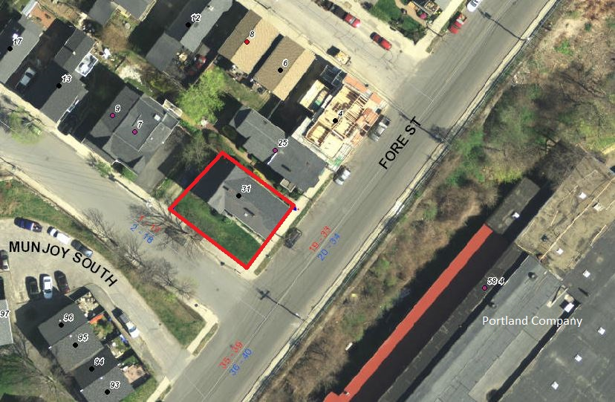
The proposal includes a mix of 1 one-bedroom, 1 two-bedroom, and 2 three-bedroom units, accessed by one set of stairs and an elevator and with entrances at both the lower (garage) level and the Fore Street (first floor) level.

A total of 115 notices were sent to property owners within 500 feet of the site and interested parties, and a legal ad was published in the Portland Press Herald on March 14 and 15, 2016. The project is not required to hold a Neighborhood Meeting.

Applicant: Bob and Carrie LeBlanc, Peninsula Property Development
Consultants: Will Savage, Acorn Engineering; Jason Pica, Port City Architecture; Owen Haskell, Surveyor;
Tom Jewell, Attorney

Required Reviews and Waivers:
Review | Applicable Standards
Subdivision: Construction of new building with 4 residential dwelling units | Section 14-497 for the division into 4 residential units.
Site Plan: Multifamily development | Section 14-526 for the proposed multifamily residential development.
Waiver Requests to Planning Board | Applicable Standards
Distance of driveway from corner: The driveway is located 31.26 feet from the corner (Plan P4 and Att H) and a waiver is requested due to architectural constraints. | Technical Standard 1.7.1.7 requires “access driveways to corner lots shall be located a minimum of 35 ft from the intersection of the projection of right-of-way lines to the center line of the driveway”. The Traffic Engineering and Dept of Public Works reviewers support a waiver of 3.74 feet based on an understanding that the driveway location is constrained by the architectural requirements (Atts 5 & 6).
Parking Drive Aisle: Waiver required for parking drive aisle that is approximately 25.75 ft wide to facilitate maneuvering within the garage (Att H). | Technical Standard 1.14 Parking Lot and Parking Space Design require a drive aisle of 24 feet width for 90 degree parking. The Traffic Engineering Reviewer supports this waiver (Att 6).
Street Trees: Four street trees are required and there is only room for three in the ROW. | Site Plan Standard and waiver (Section 14-526(b)2.b(iii)), requires one street tree per unit. The City Arborist supports the applicant planting a 4th small street tree just within the applicant’s site on Waterville Street frontage (Att 7)

II. PROJECT DATA
SUBJECT | DATA
Existing Zoning | R-6
Existing Use | 3 unit residential building
Proposed Use | Residential (4 condominium units)
Residential mix | 2 three BR; 1 two BR; 1 one BR
Parcel Size | 4,068 sq ft
 | Existing | Proposed | Net Change
Impervious Surface Area | 2070 sq ft | 2942 sq ft | 872 sq ft
Building Footprint | 1590 sq ft | 2457 sq ft | 867 sq ft
Building Floor Area | 3120 sq ft | 7249 sq ft | 4129 sq ft
Parking Spaces | 2 | 6 | 4
Bicycle Parking Spaces | 0 | 2 (inside) and  2 (outside in ROW) | 2 (inside) and  2 (outside in ROW)
Estimated Cost of Project | $2 million

III. EXISTING CONDITIONS
The site totals 4180 sq ft and slopes across two planes, with an approximate change in grade of 5 feet along the uphill side boundary and 9 feet between the highest (back east corner) and lowest (corner Fore and Waterville) points. The site is occupied by an existing 3 story with basement residential building of 1590 sq ft footprint dating from the1870s.

The site currently has an open aspect across Fore Street over the eastern end of 58 Fore Street (Portland Company). The area around the exsiting house is mostly lawn with shrubs along both boundaries; there is one street tree on Fore Street and one on Waterville Street, as can be seen in the photographs below.
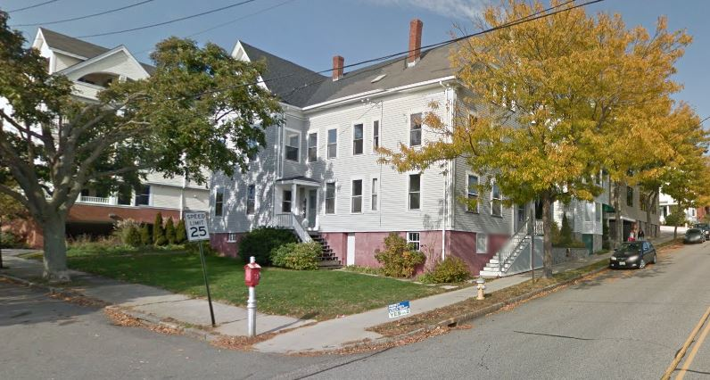
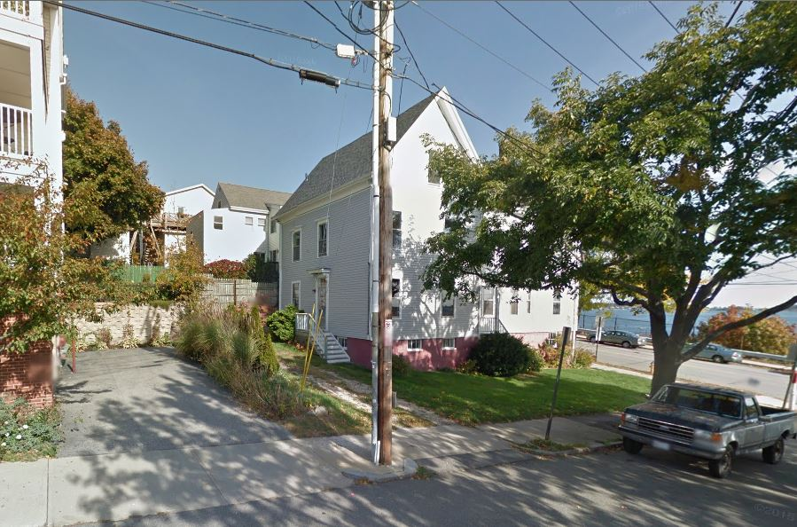

from Waterville Street from corner of Waterville and Fore Street
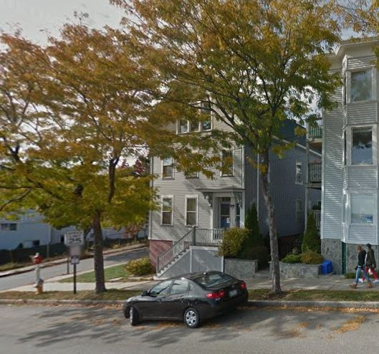
To the north on Waterville there is a relatively new (built 2005) residential builidng of 4 storys over a parking garage comprising 4 condo units.

Abutting the site to the east on Fore Street is a 3 story 3-unit condominium dating from the 1980s. This abutting building is currently 15 feet from the side of the existing building that is proposed to be demolished, separated by low planting.

Both of the abutting condo buildings have decks at all living levels that overlook the subject site.

To the west are the Munjoy South Townhouse apartments which are accessed from Fore Street.

The sidewalks along the frontage are concrete and in reasonable condition except where the existing large street tree has caused buckling. Brick is the specified sidewalk material for this area.
From Fore Street looking west

IV. PROPOSED DEVELOPMENT
The proposals comprise 4 residential condo units, 2 on the first floor and 1 each (3-bedroom) on the floors above (see site plan, elevations and floor plans in Plans P4., P9., and P10.). The ground floor (see plan below) is partially below ground and provides 6 parking spaces, with stair and elevator access to the floors above. The height of the building is just under 40.5 feet and there is a 5 foot stepback at 35 feet at the rear side, as required to meet the zoning dimensional requirements.

The footprint of the proposed building is about 870 sq ft larger than the existing building; it is approximately 3 feet closer to the abutting property on Waterville Street, it has been moved approximately 3 feet away from the side (uphill) property line.

.
Final Site Plan (Plan P4)

The building is proposed to have two entrances: one from Fore Street up steps and along the uphill side into a side door and lobby; and one from Waterville Street into a door next to the garage door. The design of these entrances has been revised so they are both large doors with a design treatment.

The entrance at the lowest (ground ) level from Waterville Street has been identified by the applicant as the ADA accessible route, as it does not involve steps and leads to the elevator at the garage level.

Stormwater is routed into a raingarden where it is retained and treated before entering the Citys system.

There are three small decks at the southwest corner of the building, plus a small at-grade patio accessed via stairs from the first floor unit that does not have a deck. Landscape Plan (Plan P8) illustrates the proposed landscape improvements, including boundary planting, reconstruction of the sidewalk and existing tipdown in brick, and replacement of the existing street tree with 2 new street trees.

The proposed materials are primarily Nichiha Fiber Cement Shakes, Azak Trim on the upper levels, and masonry with cornerstone veneer stone on the lowest (garage) level (shown in elevations- Plan P10 and below).
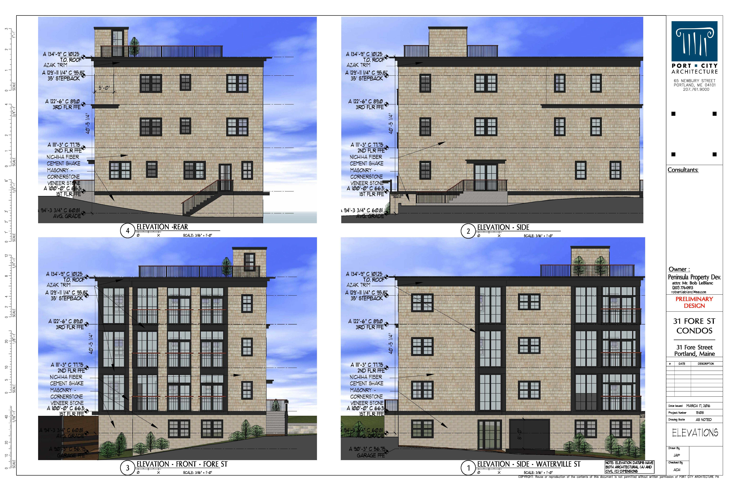
V. PUBLIC COMMENT AND WORKSHOP DISCUSSION
The Planning Division received three public comments. PC1 is from Ms Preisser, a condo owner next door and the comments were made prior to the PB Workshop in February; no further comment has been received. The other comments are from Ms. Casale, a neighbor in Waterville Street, who is suggests that the existing street tree in Waterville Street should be retained by relocating the driveway. The issues related to this street tree are discussed below in section XI 2.

At the PB Workshop the Planning Board generally supported the project, and requested:
- Further explanation as to why the existing street tree on Waterville Street had to be removed;
- Clarification as to where the mechanical equipment would be located;
- That vinyl cladding products be avoided with some suggestions for other types of shakes;
- That the entrance on Fore Street be more prominent.
VI. RIGHT, TITLE, & INTEREST
The applicant has provided deeds as evidence of right, title, and interest (Attachment B).

VII. FINANCIAL & TECHNICAL CAPACITY
The applicant has submitted a letter from Gorham Savings Bank confirming financial capacity of the applicant (Att. C).

VIII. ZONING ASSESSMENT

The site is within the R-6 zone which covers most of the surrounding area except along the waterfront which is B6.

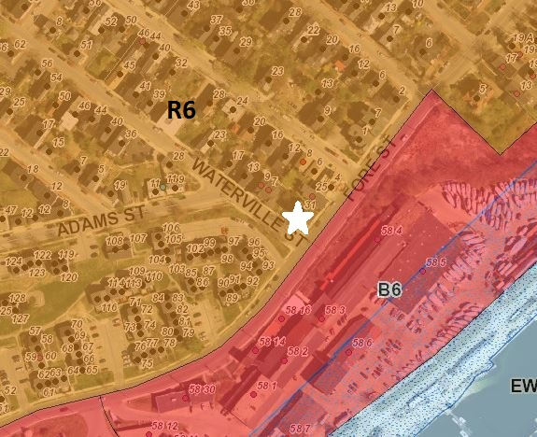
The proposals have been revised to include the stepback at 35 feet and now meet all of the dimensional standards of the R-6 zone. The stepback is required under the R-6 zoning where a building is located within 10 feet of the side boundary and 15 feet of the rear boundary.

The proposed building requires a 5 foot stepback on the side (uphill) because it is 5 feet from the property boundary. The applicant has incorporated this stepback as shown in the elevations/sections (Plan P10) and on the floor plans (Plan P9).

At the PB Workshop the applicant had shown a second set of stairs within the stepback area because proposals at that time required a second set of stairs under the IBC Building Code. The City’s ordinance allows stairs and elevator towers to be above the required height in section 14-430, which states:

Div 25. Space and Bulk Regulations and Exceptions):
14-430 (a) Roof structure. Roof structures for the housing of elevators, stairways, tanks, fans, or other building operating equipment not intended for human occupancy, skylights, steeples, roof signs, flag poles, chimneys, smokestacks, radio or television masts, water tanks, or silos may be erected above the height limitation herein prescribed for buildings.

The City’s Zoning Administrator has confirmed that the interpretation of this ordinance provision would have allowed the second set of stairs to be located within the stepback (Attachment 9).

The applicant modified the surrounding grading (adding a retaining wall at the back along Waterville Street) which amended the grades and associated calculations (Attachment N. – grades 6 feet from building). These revised calculations confirmed that under IBC requirements the building did not need to have the second set of stairs; this is confirmed in an e-mail from the Building Code Inspector Jeanie Bourke (Attachment 8.).

Division 20 of the land use ordinance provides an exception for the off-street parking requirement for the first three units in the R-6 zone and a 1:1 requirement thereafter. The proposal for 4 units would require one parking space on site, and this is met by the provision of the 6 parking spaces in the garage

IX. SITE PLAN SUBMISSION REQUIREMENTS (Section 14-527) and SUBDIVISION PLAT
AND RECORDING PLAT REQUIREMENTS (Section 14-496)
The applicant has submitted a draft subdivision plat (Plan P3), which is generally acceptable. The standard condition requiring the submission of a final (stamped) plat for final review has been included in the motions for the Board to consider.

The applicant has not provided drafts of the condominium documents and the submission for review and approval is included as a potential condition of approval.

X. SUBDIVISION REVIEW (14-497(a). Review Criteria)
The proposed development has been reviewed by staff for conformance with the relevant review standards of the City of Portland’s subdivision ordinance. Staff comments are below.

1. Water, Air Pollution
The portion of the site to be developed is currently occupied by a lawn and surface parking. The proposals add 872 sq ft of additional impervious surface and the applicant proposes to detain and treat stormwater runoff with a raingarden located at the lowest point of the site at the corner of Waterville Street and Fore Street. David Senus, the city’s consulting civil engineer, has reviewed this system and indicated his approval (Attachment 3.) No detrimental water or air quality impacts are anticipated.

2 & 3. Adequacy of Water Supply
The applicant has received a capacity letter from the Portland Water District (Attachment G).

4. Soil Erosion
No unreasonable soil erosion or reduction in the capacity of the land to hold water is anticipated.

5. Impacts on Existing or Proposed Highways and Public Roads
The proposal does not raise any concerns regarding the impacts to the existing street network (Attachment 6.).

6. Sanitary Sewer/Stormwater Disposal
The applicant has submitted a Final Stormwater Report and an Erosion Control Report in Attachments I and J. The proposals for the stormwater raingarden have been revised to address the Peer Engineer’s earlier comments and the only issue is the location of the sewer back water valve which is proposed in the ROW (Attachment 3). A potential condition of approval addresses this minor concern.

The applicant has received the wastewater capacity letter (Attachment G).

7. Solid Waste
The proposed development includes an internal solid waste area as noted on the Site Plan (Plan P4.) and the owners will be responsible for bringing solid waste and recyclable to the curb side for collection (Attachment F).

8. Scenic Beauty
The proposals involve the removal of a mature Sweetgum street tree on Waterville Street and replacement with two new street trees. The City Arborist supports this proposal and neighbors have mixed views on its value. This is discussed in greater detail in Section XI 2. The utilities are proposed to be underground in compliance with subdivision requirements (Plan P5).

9. Comprehensive Plan
The plans meet multiple goals from the city’s housing plan, including “encourag[ing] higher density housing for both rental and home ownership opportunities, particularly located near services, such as schools, businesses, institutions, employers, and public transportation.”

10. Financial and Technical Capacity
As noted above, the applicant has submitted a letter from Gorham Savings Bank attesting to the applicant’s financial capacity (Attachment C).

11. Wetland/Water Body Impacts
There are no anticipated impacts to wetlands or water bodies.

12. Groundwater Impacts
There are no anticipated impacts to groundwater supplies.

13. Flood-Prone Area
Per the city’s existing flood maps, the site is not located in a flood zone.

XI. SITE PLAN REVIEW
The proposed development has been reviewed by staff for conformance with the relevant review standards of the City of Portland’s site plan ordinance. Staff comments are below.

- Transportation Standards
- Impact on Surrounding Street Systems
This small residential development is not a concern in terms of traffic except during construction, and the Traffic Engineering reviewer has requested a construction management plan for review and approval (Attachment 6). It should also be noted that the relocation of the driveway will necessitate changes in the parking regulations along the Waterville Street frontage, and the applicant is advised that this will require their support in the preparation of the City Council report materials.

- Access and Circulation
The proposals include a relocated driveway which improves the separation from the adjacent Waterville Street property driveway but brings it to 31.26 feet from the corner of Fore/Waterville, which does not meet the 35 foot Technical Standard for corner clearance. The applicant has requested a waiver due to architectural constraints (Attachment H.) which has been supported by staff (Attachments 5 & 6). The existing driveway is proposed to be closed with a new sidewalk constructed across it (Plan P4.).

- Pedestrian Circulation and ADA
The applicant has indicated that the garage will be the accessible route to meet ADA requirements, and has pointed out in Attachment P that the garage will be daylit and welcoming and the access will not be “inferior”. This access and door have been redesigned to be as prominent as the entrance on Fore Street, which has raised a question regarding which is the main entrance and how the main entrance will be distinguished (see Att 4).

- Public Transit Access
The proposed development is not located along a public transit route. As such, no provisions for transit access are required.

- Parking
- Vehicle: The ordinance requirement for vehicle parking is one off-street space per unit, and in the R-6 zone parking for the first 3 units is not required. Six are being provided, which exceed the zoning requirements.
- Bicycle: The ordinance requirement is 2 spaces, which has been met by the proposal for two bike racks in the ROW near the driveway on Waterville street, and two within the garage. The rack in the ROW is acceptable subject to it meeting the City’s Technical Standards and this is included in the proposed conditions of approval.

- Transportation Demand Management
A transportation demand management plan is not required.

2. Environmental Quality Standards
- Preservation of Significant Natural Features
There are no known significant natural features on the site.

- Landscaping and Landscape Preservation
The site is largely grassed with some small plantings along the boundary with the abutting condo on Waterville Street, and dense shrub and ornamental planting on the boundary shared with the abutter on Fore Street (uphill). There is a large existing street tree in the esplanade along the Waterville frontage and a smaller but mature street tree in Fore Street.

The applicant has submitted a Landscape Plan (Plan P8.) which has added boundary treatment and details of the raingarden. The proposals remove the Sweetgum street tree in Waterville Street and replace it with two new street trees placed to accommodate the relocated driveway (Plan P4. and P8.)

A neighbor, Ms Casale, has sent photographs of the tree to be removed (PC3) and the applicant has submitted photographs as part of the explanation as to why it needs to be removed (Attachment H). The City Arborist has visited the site and further considered the issue and concludes (Attachment 7):
I have inspected the Sweetgum tree on Waterville Street. In review of the proposed plans for the project, given the building location and tree crown width, tree impact would be severe due to
construction site work in both the root zone and the crown due to the proposed building wall which is much closer than existing.

The existing Honeylocust on Fore Street which is 15' east or uphill from the fire hydrant is in good condition and will require 'tree protection' during construction. This should include trunk protection and orange construction fencing around the tree rootzone area. (Condition) The next uphill tree is about 25 feet east of the existing tree and no other space along the Fore Street frontage is open for tree planting.

There maybe room to include a smaller ornamental tree near the Waterville Street edge, recommending a tree that will provide basic greening and not compete with view corridor concerns. This could be a Magnolia, Dogwood or Sourwood tree for example. (Attachment 7)

Staff recommend that the applicant’s proposals to replace the existing street tree in Waterville Street are acceptable as shown on the submitted plans, and have suggested a condition of approval to protect the existing street tree on Fore Street as outlined by the City Arborist above.

- Water Quality/Storm Water Management/Erosion Control
See above under Section VI B Subdivision Review.

3. Public Infrastructure and Community Safety Standards
- Consistency with Related Master Plans
As noted above, the project is generally deemed consistent with related master plans.

- Public Safety and Fire Prevention
Keith Gautreau, of the Fire Prevention Bureau, does not have any concerns and has noted that the second set of stairs is not required from a Fire Prevention Code viewpoint. (Att. 2).

- Availability and Capacity of Public Utilities
See Attachment G and Plan P5; all utilities have been addressed adequately.

4. Site Design Standards
- Massing, Ventilation, and Wind Impact
There are no anticipated impacts to ventilation or wind patterns.

- Shadows
There are no anticipated impacts to publicly accessible open spaces.

- Snow and Ice Loading
Three balconies are located at the back edge of the Fore Street sidewalk and there is the potential for ice and snow to fall onto the public sidewalk. These balconies are on the corner and their other side is over the raingarden, so the design should ensure that drainage and snow overflow from the balconies is directed to the raingarden side. A suggested condition of approval addresses this concern.

- View Corridors
Waterville Street is not a protected view corridor.

- Historic Resources
There are no historic districts or landmarks within 100 feet.

- Exterior Lighting
The applicant has indicated in Attachment D that lighting is proposed to light the steps and side entrance from Fore Street. Details of the light fixtures and associated photometric information should be included in the revised designs for both entrances (as requested in relation to the design review below). A condition of approval has been suggested to require this information to ensure (given the proximity of neighbors on Fore Street) that the final proposals meet the standards and that there is no light trespass.
- Noise and Vibration
The applicant has not submitted details of exterior heating, ventilation, and air conditioning equipment and staff suggest this should be the subject of a condition that allows for a final staff review. The Site Plan ordinance specifies that these should be at the interior of the site and away from abutting residential properties and also be screened from view from any public street and adjacent sites by structure walls, evergreen landscaping, fencing etc

- Signage and Wayfinding
No signage or wayfinding is proposed at this time.

- Zoning-Related Design Standards
      - R-6 Infill Development Design Principles and Standards
The applicant has submitted a narrative outlining how the proposed design addresses the R-6 design standards (Attachment L). Staff reviewed the applicant’s final submitted plans and the final Design Review comments are in Attachment 4.

The applicant has addressed all of the previous design concerns except for the design of the entrances, where the comment is (Attachment 4):

F-6 Main Entries: The main entry is not adequately emphasized. A side entry requires indication at the street – improve the visibility of this main entrance with elements such as an extended canopy or porch toward the sidewalk. If the Waterville Street entry is to be considered the main entry, then additional emphasis should be created whether with a canopy, lighting, building signage or other method.

The suggested condition of approval requests that the applicant confirm which entrance is the main entrance and revise this main entrance to meet the R6 Design standards as outlined in the Design Review comment.

2. Multi-family and Other Housing Types Design Standards
In addition, there are design standards that apply to all multifamily development including this proposal. These are more general standards that include design standards as well as several other standards as listed below with staff comments.

(i) TWO-FAMILY, SPECIAL NEEDS INDEPENDENT LIVING UNITS, MULTIPLE-FAMILY, LODGING HOUSES, BED AND BREAKFASTS, AND EMERGENCY SHELTERS:
(1) STANDARDS. Two-family, special needs independent living units, multiple-family, lodging houses, bed and breakfasts, and emergency shelters shall meet the following standards:

a. Proposed structures and related site improvements shall meet the following standards:
1. The exterior design of the proposed structures, including architectural style, facade materials, roof pitch, building form and height, window pattern and spacing, porches and entryways, cornerboard and trim details, and facade variation in projecting or recessed building elements, shall be designed to complement and enhance the nearest residential neighborhood. The design of exterior facades shall provide positive visual interest by incorporating appropriate architectural elements;

2. The proposed development shall respect the existing relationship of buildings to public streets. New development shall be integrated with the existing city fabric and streetscape including building placement, landscaping, lawn areas, porch and entrance areas, fencing, and other streetscape elements;

Staff comment: The proposals have been evaluated in the context of the R-6 Design Standards (above) which cover the design elements mentioned in standards 1 and 2 in greater detail (7 pages of specific standards). Please refer to the Design Review comments in Attachment 4.

3. Open space on the site for all two-family, special needs independent living unit, bed and breakfast and multiple-family development shall be integrated into the development site. Such open space in a special needs independent living unit or a multiple-family development shall be designed to complement and enhance the building form and development proposed on the site. Open space functions may include but are not limited to buffers and screening from streets and neighboring properties, yard space for residents, play areas, and planting strips along the perimeter of proposed buildings;

Staff comment: Three of the 4 new units will have balconies and the fourth unit has direct access to a patio to the rear of the building.

4. The design of proposed dwellings shall provide ample windows to enhance opportunities for sunlight and air in each dwelling in principal living areas and shall also provide sufficient storage areas;

Staff comment: This standard appears to be met.

5. The scale and surface area of parking, driveways and paved areas are arranged and landscaped to properly screen vehicles from adjacent properties and streets;

Staff comment: The parking is located underneath the units and therefore is screened.

XII. STAFF RECOMMENDATION
Subject to the proposed motions and conditions of approval listed below, Planning Division staff recommends that the planning board approve the proposed 4-unit condominium development at 31 Fore Street.

XIII. PROPOSED MOTIONS

- Waivers
On the basis of the application, plans, reports and other information submitted by the applicant; findings and recommendations contained in the planning board report for the public hearing on March 22, 2016 for application 2016-005 relevant to Portland’s technical and design standards and other regulations; and the testimony presented at the planning board hearing:

- Distance from corner
The planning board finds/does not find, based upon the consulting traffic engineer’s review, that extraordinary conditions exist or undue hardship may result from strict compliance with the Technical Manual standard (Section 1.14) which requires that aisle width for right-angle parking be 24 feet per Figure I-27, that substantial justice and the public interest are secured with the variation in this standard, and that the variation is consistent with the intent of the ordinance. The planning board waives/does not waive the Technical Manual standard (Section 1.14) to allow a 27.75 foot wide aisle in the parking garage; and

- Parking Drive Aisle
The planning board finds/does not find, based upon the consulting traffic engineer and DPW reviews, that extraordinary conditions exist or undue hardship may result from strict compliance with the Technical Manual standard 1.7.1.7 that requires “access driveways to corner lots shall be located a minimum of 35 ft from the intersection of the projection of right-of-way lines to the center line of the driveway”, that substantial justice and the public interest are secured with the variation in this standard, and that the variation is consistent with the intent of the ordinance. The planning board waives/does not waive the Technical Manual standard (Section 1.7.1.7) to allow the access driveway to be 31.26 feet from the intersection based on an understanding that the driveway location is constrained by the architectural requirements.

- Street Trees
The planning board finds/does not find that the applicant has demonstrated that site constraints prevent the planting of all required street trees in the right-of-way. The planning board waives/does not waive the site plan standard (Section 14-526 (b) (iii) requiring one street tree per unit for multi-family development and concludes that the applicant shall plant a fourth small “street tree” just within the applicant’s site on Waterville Street frontage (species to be agreed with the City Arborist), and if it is determined (in agreement with the City Arborist) that this is not feasible, the applicant shall contribute $200 for one street tree to Portland’s tree fund.
- SUBDIVSION
On the basis of the application, plans, reports and other information submitted by the applicant; findings and recommendations contained in the planning board report the public hearing on March 22, 2016 for application 2016005 relevant to the subdivision regulations; and the testimony presented at the planning board hearing, the planning board finds that the plan is/is not in conformance with the subdivision standards of the land use code, subject to the following conditions of approval, which must be met prior to the signing of the plat:

      - The applicant shall finalize the subdivision plat for review and approval by Corporation Counsel, the Department of Public Works, and the Planning Authority; and

      - The applicant shall finalize condominium documents for review and approval by Corporation Counsel, the Department of Public Works, and the Planning Authority.

- Development Review
On the basis of the application, plans, reports and other information submitted by the applicant; findings and recommendations contained in the Planning Board Report for the public hearing on March 22, 2016 for application 2016005 relevant to the site plan regulations; and the testimony presented at the planning board hearing, the planning board finds that the plan is/is not in conformance with the site plan standards of the land use code, subject to the following conditions of approval that must be met prior to the issuance of a building permit, unless otherwise stated:

- That the applicant shall confirm which entrance is the main entrance and revise this main entrance to meet the R6 Design standards as outlined in the Design Review comments, and to meet the Site Lighting Standards of the Technical Manual, with the revised proposals submitted to the Planning Authority for review and approval prior to the issuance of a building permit; and

- That the applicant shall prepare a revised Construction Management Plan to address the comments of the Traffic Engineering reviewer Tom Errico dated 3.16.2016, for review and approval by the Planning Authority; and

- That the applicant shall submit plans and associated information the clarify the location and sound levels of all external heating, ventilation and other mechanical equipment and document that they meet the City’s Site Plan, Zoning and Technical Standards, for review and approval by the Planning Authority; and

- That the applicant shall take all measures to protect the existing street tree on Fore Street as recommended in the City Arborist comments dated 3.16.2016; and

- That in respect of the City’s ROW the applicant shall:
  - address the comments of the Department of Public Work David Margolis -Pineo dated 3.16.2016 and the comments of the Peer Engineer Dave Senus dated 3.17.2016;
  - Ensure that the bicycle parking hitches in the ROW are designed to meet the Technical Standards; and
  - Show that the design of the balconies will direct drainage and ice/snow so that it will not fall on the sidewalk.

- That the applicant shall submit a revised on-street parking layout that takes account of the relocated curb cut for review and approval by the Planning Authority prior to the issuance of a Certificate of Occupancy. It should be noted that any changes to on-street parking will require City Council action prior to the issuance of a Certificate of Occupancy, and the applicant would be required to assist in preparing council meeting materials.

ATTACHMENTS:

Attachments to the Report
  - Planner Prelim comments
  - Fire Department final comments
  - Peer Engineer Review final comments
  - Design Review final comments 3.11.2016
  - DPW final comments 3.2.2016
  - Traffic Engineering comments
  - City Arborist comments
  - Building Code Reviewer
  - Zoning Administrator determination re exemptions to height limits

Public comments
PC1 D Preisser 2.6.16
PC2 M Casale 2.9.16
PC3 M Casale March 2016

Applicant’s Submittal
- Final Cover Letter and Final Application updated 3.1.16
- Right, Title and Interest
- Financial Capability letter
- Conformity with SP & Zoning Ordinance
- Fire Department checklist
- Solid Waste
- Utility Capacity letters 3.1.16
- Request for Waivers updated 3.1.16
- Final Stormwater Report 3.1.16
- Erosion Control Plan
- Construction Management Plan as updated 3.1.2016
- R-6 Narrative re R-6 Design Standards Jan 2016
- ADA Narrative and Info Jan 2016
- Average Grade analysis
- Comment response letter 3.1.2016

Plans
P1. Cover Sheet, Notes and Survey (2 sheets)
P2. Survey
P3. Draft Recording Plat
P4. Site Plan
P5. Utility Layout plan
P6. Grading, Drainage and Erosion Control Plan
P7. Site, Utility and Drainage Details (5 sheets)
P8. Landscape Plan
P9. Floor Plans
P10. Elevations and sections (Amended elevation added 3.18.2016)
P11. Renderings

