Memorandum
Planning and Urban Development Department
Planning Division

To: Chair Boepple and Members of the Portland Planning Board

From: Jean Fraser, Planner

Date: February 5th , 2016

Re: February 9th Planning Board Workshop
Level III Subdivision and Site Plan:
Redevelopment to create 4 residential units, 31 Fore Street
Bob and Carrie LeBlanc, Peninsula Property Development, Applicants

I. INTRODUCTION
Bob and Carrie LeBlanc are requesting the Planning Board consider a Subdivision and Site Plan application for a new four-unit residential building at 31 Fore Street, at the corner of Fore Street and Waterville Street in the R-6 zone. The proposal is to replace the existing three-unit building with a new structure that includes a lower level for covered parking for 6 vehicles, stormwater treatment in a raingarden, and landscape and sidewalk improvements.

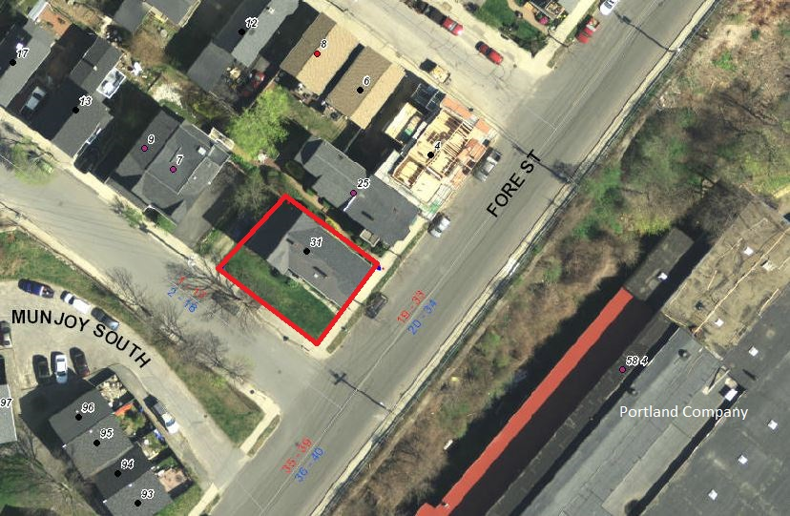
The proposal includes a mix of 1 one-bedroom, 1 two-bedroom, and 2 three-bedroom units, accessed by stairs and an elevator and with entrances at both the lower (garage) level and the Fore Street (first floor) level. The site is subject to the R-6 Design Standards.

A total of 115 notices were sent to property owners within 500 feet of the site and interested parties, and a legal ad was published in the Portland Press Herald on February 1 and 2, 2016. The project is not required to hold a Neighborhood Meeting.

Applicant: Bob and Carrie LeBlanc, Peninsula Property Development
Consultants: Will Savage, Acorn Engineering; Jason Pica, Port City Architecture; Owen Haskell, Surveyor; Tom Jewell, Attorney

Required Reviews and Waivers:

Review | Applicable Standards
Subdivision: Construction of new building with 4 residential dwelling units | Section 14-497 for the division into 4 residential units.
Site Plan: Multifamily development | Section 14-526 for the proposed multifamily residential development.
Waiver Requests to Planning Board | Applicable Standards
Distance of driveway from corner: The driveway is located 31 feet from the corner per the plans attached to this Memo. The applicant has indicated they could increase this slightly but would not be able to get to 35 ft and will therefore be requesting a waiver. (See background in Att O) | Technical Standard 1.7.1.7 requires “access driveways to corner lots shall be located a minimum of 35 ft from the intersection of the projection of right-of-way lines to the center line of the driveway”. The Traffic Engineering Reviewer supports a waiver to reduce this distance to 31 feet based on an understanding that the driveway is constrained by the architectural requirements (Att. 6); DPW has requested more info to support any waiver from this standard (Att 5).
Parking Drive Aisle: Waiver required for parking drive aisle that is approximately 25.7 ft wide to facilitate maneuvering within the garage. | Technical Standard 1.14 Parking Lot and Parking Space Design require a drive aisle of 24 feet width for 90 degree parking. The Traffic Engineering Reviewer supports this waiver (Att 6).

II. PROJECT DATA

SUBJECT | DATA
Existing Zoning | R-6
Existing Use | 3 unit residential building
Proposed Use | Residential (4 condominium units)
Residential mix | 2 three BR; 1 two BR; 1 one BR
Parcel Size | 4,180 sq ft
 | Existing | Proposed | Net Change
Impervious Surface Area | 2070 sq ft | 2942 sq ft | 872 sq ft
Building Footprint | 1590 sq ft | 2457 sq ft | 867 sq ft
Building Floor Area | 3120 sq ft | 7371 sq ft | 4251 sq ft
Parking Spaces | 2 | 6 | 4
Bicycle Parking Spaces | 0 | 2 (inside) | 2
Estimated Cost of Project | $2 million

III. EXISTING CONDITIONS (see photos next page)
The site totals 4180 sq ft and slopes across two planes, with an approximate change in grade of 5 feet along the uphill side boundary and 9 feet between the highest (back east corner) and lowest (corner Fore and Waterville) points. The site is occupied by an existing 3 story with basement residential building of 1590 sq ft footprint dating from the1870s.

The site currently has an open aspect across Fore Street over the eastern end of 58 Fore Street (Portland Company). The area around the exsiting house is mostly lawn with shrubs along both boundaries; there is one street tree on Fore Street and one on Waterville Street, as can be seen in the photographs below.

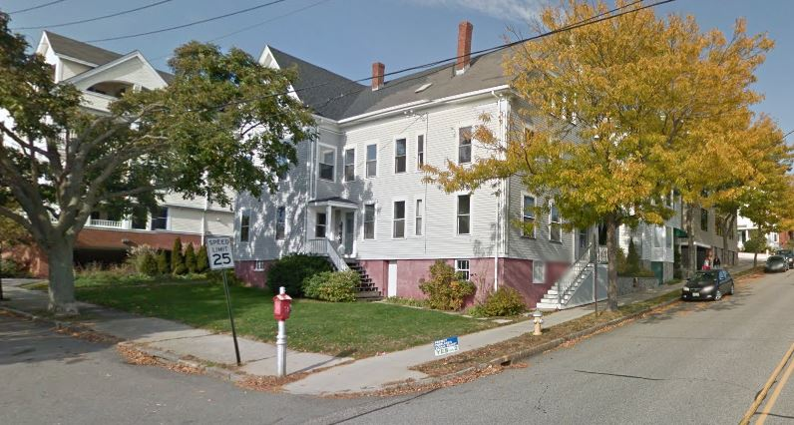
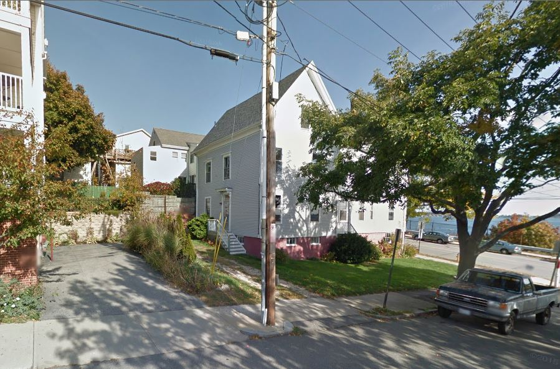
from Waterville Street from corner of Waterville and Fore Street

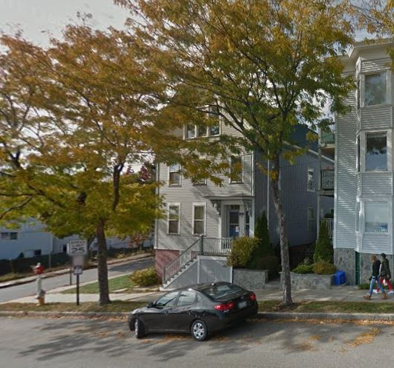
To the north on Waterville there is a relatively new (built 2005) residential builidng of 4 storys over a parking garage comprising 4 condo units.

Abutting the site to the east on Fore Street is a 3 story 3-unit condominium dating from the 1980s. This abutting building is currently 15 feet from the side of the existing building that is proposed to be demolished, separated by low planting.

Both of the abutting condo buildings have decks at all living levels that overlook the subject site.

To the west are the Munjoy South Townhouse apartments which are accessed from Fore Street.

The sidewalks along the frontage are concrete and in reasonable condition except where the existing large street tree has caused buckling. Brick is the specified sidewalk material for this area. from Fore Street looking west

IV. PROPOSED DEVELOPMENT
The proposals comprise 4 residential condo units, 2 on the first floor and 1 each (3-bedroom) on the floors above (see site plan, elevations and floor plans in Plans P3., P8., and P9.). The ground floor (see plan below) is partially below ground and provides 6 parking spaces, with stair and elevator access to the floors above.

The footprint of the proposed building is about 870 sq ft larger than the existing building; it is approximately 3 feet closer to the abutting property on Waterville Street, it has been moved approximately 3 feet away from the side (uphill) property line.

The hatched area on the plan below denotes the location of a second set of stairs which the applicant understands may be needed to meet building codes. This has been questioned by staff as it has implications for required stepbacks as discussed below and in Sections VI A. Zoning and VI C 4. Site Design Standards.
.

The building is proposed to have two entrances: one from Fore Street up steps and along the uphill side into a side door and lobby; and one from Waterville Street into a door next to the garage door. The design of these entrances was not finalized at the time this Memo was prepared.

The entrance at the lowest (ground ) level from Waterville Street has been identified by the applicant as the ADA accessible route, as it does not involve steps and leads to the elevator at the garage level. The extent of ADA compliance is the subject of further disdussion.

Stormwater is routed into a raingarden where it is retained and treated before entering the Citys system.

There are three small decks at the southwest corner of the buidlng. The site plan (Plan 3.) includes some landscape improvements, including reconstruction of the sidewalk and existing tipdown in brick and replacement of the existing street tree with 2 new street trees.

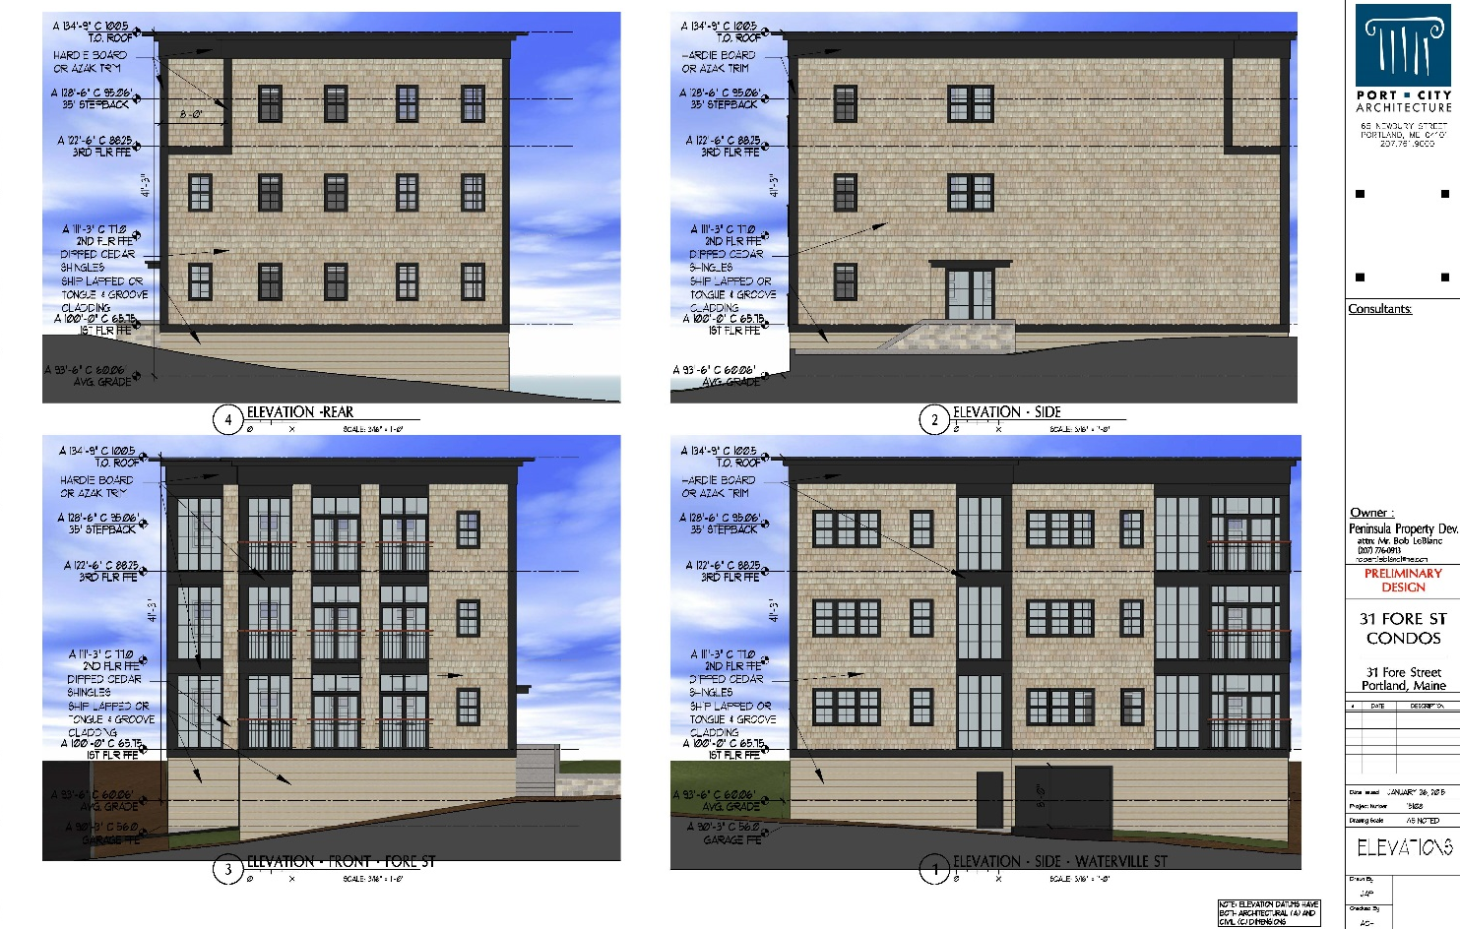
The proposed materials are primarily Dipped Cedar Shakes and Hardie Board or Azek Trim, with clapboard shown for the lowest level (see elevations below and Attachment L).

The elevation shows a small stepback at the back corner on the basis that the hatched area on the plans will be largely taken up by a second set of stairs and that most of the elevation would be exempt from the stepback requirements. Staff are awaiting clarification from the applicant and building code reviewers as to whether the second set of stairs is required by building codes, as a longer section of stepbacked façade, with windows and other articulation, would be the preferred design to meet the objectives of the zoning requirement - see Section VI A. Zoning below.

V. PUBLIC COMMENT
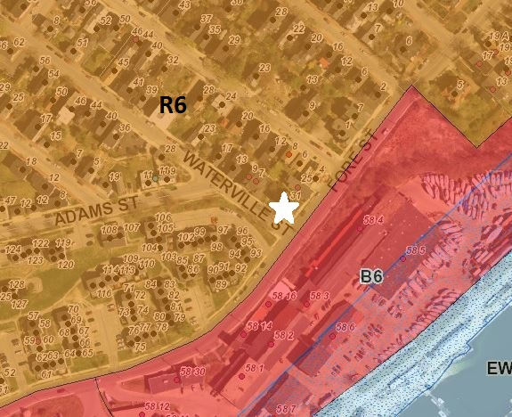
The Planning Division has not received any written comments although there have been several requests to see the proposed plans.

VI. STAFF REVIEW

- ZONING ASSESSMENT
The site is within the R-6 zone which covers most of the surrounding area except along the waterfront which is B6.

The proposals meet the dimensional standards of the R-6 zone with the exception of the required stepbacks at 35 feet. The stepbacks are required under the R-6 zoning where a building is located within 10 feet of the side boundary and 15 feet of the rear boundary. The ordinance (under Div 25. Space and Bulk Regulations and Exceptions) confirms the following as exceptions to the stepback requirement:

14-430 (a) Roof structure. Roof structures for the housing of elevators, stairways, tanks, fans, or other building operating equipment not intended for human occupancy, skylights, steeples, roof signs, flag poles, chimneys, smokestacks, radio or television masts, water tanks, or silos may be erected above the height limitation herein prescribed for buildings.

The proposed building requires a 5 foot stepback on the side (uphill) because it is 5 feet from the property boundary. The applicant has incorporated this stepback for a small section at the rear (see elevations in Plan P9). This section is short because the floorplans (Plan P8.) anticipate 2 sets of stairs, a lobby and elevator along that side of the building and these are excepted from the stepback requirement.

The area for the second set of stairs is shown hatched on the floor plans (Plan P8). Staff have questioned the need for a second set of stairs (between the elevator and the rear wall) as this affects whether the project is compliant with zoning.

Assistant Fire Chief Keith Gautreau has confirmed (Attachment 2) that since the building is proposed to be sprinkled and is 4 stories or less, the Fire Codes allow a single means of egress and the second set of stairs is not required. However, under Building Codes the second set of stairs would be required if the building is considered to be 4 stories as defined in the IBC, and not required if the building is defined as 3 stories. The definition of a story relates to the extent to which it is below final grade and the applicant has been requested to provide the relevant calculations in order to establish the number of stories.

Whatever part of the building is not comprised of stairs/elevator and over 35 feet will need to be stepped back 5 feet on the east side. The elevation would be expected to include windows and other articulation.

Division 20 of the land use ordinance provides an exception for the off-street parking requirement for the first three units in the R-6 zone and a 1:1 requirement thereafter. The proposal for 4 units would require one parking space on site, and this is met by the provision of the 6 parking spaces in the garage.

- SUBDIVISION REVIEW (14-497(a). Review Criteria)
The subdivision review criteria have generally been met, except as noted below. In addition, the draft Subdivision Plat (Plan P2.) will need further revisions to meet survey standards (same comments as for the survey of existing conditions- see Attachment 5.

2 & 3. Adequacy of Water Supply
The applicant has requested a capacity letter from the Portland Water District (Attachment G).

6. Sanitary Sewer/Stormwater Disposal
The applicant has submitted Preliminary Stormwater and Erosion Control Reports in Attachments I and J. This is a preliminary review so these reports would be more complete as part of the final submissions. The proposals for the stormwater raingarden are acceptable in principle, and the Peer Engineer reviewer has requested some minor revisions and for the plans to include further details (Attachment 3.). A key review comment is the need for an oil/grease separator in the parking garage and the applicant would need to address that concern as part of the final submissions.

The applicant has submitted a wastewater capacity letter application in Attachment G, and this is awaited.

- SITE PLAN REVIEW
The proposed development has been reviewed by staff for conformance with the relevant review standards of the City of Portland’s site plan ordinance; for this Memorandum only the standards of relevance to this project are included.

Transportation Standards

- Impact on Surrounding Street Systems
This small residential development is not a concern in terms of traffic except during construction, and the Traffic Engineering reviewer has requested a construction management plan for review and approval (Attachment 6). It should also be noted that the relocation of the driveway will necessitate changes in the parking regulations along the Waterville Street frontage, and the applicant is advised that this will require their support in the preparation of the City Council report materials.

- Vehicle Access and Circulation
The proposals include a relocated driveway which improves the separation from the adjacent Waterville Street property driveway but brings it to 31 feet from the corner of Fore/Waterville, which does not meet the 35 foot Technical Standard for corner clearance. The applicant has indicated that they will need to request a waiver due to architectural constraints (Attachment O.) although a detailed waiver request has not been submitted.

This particular waiver is not often granted. In looking at the plans, it appears there may be scope to increase the distance from the corner even if not to the full 35 feet. The Department of Public Works David Margolis-Pineo has requested the applicant look again at ways to meet the standard (Attachment 5) and the Traffic Engineer Reviewer Tom Errico is supportive of a waiver in principle due to the particular characteristics of this location (Attachment 6).

- Pedestrian Circulation and ADA
While stepped entrances are common in the surrounding area because of the slopes, it is unfortunate that the “main” entrance on Fore Street is stepped as it leads direct to the lobby and elevator. The entrance from Waterville Street goes into the parking garage.

The applicant was requested to confirm how the proposals meet ADA requirements and the submitted narrative is included at Attachment M. The applicant has indicated that the garage will be the accessible route to meet ADA requirements, and has pointed out in Attachment P that the garage will be daylit and welcoming and the access will not be “inferior”. Staff remain concerned that the ADA requirements are not fully addressed.

- Parking
- Vehicle: The ordinance requirement for vehicle parking is one off-street space per unit, and in the R-6 zone parking for the first 3 units is not required. Six are being provided, which exceed the zoning requirements.
- Bicycle: The ordinance requirement is 2 spaces, which has technically been met by the proposed bike racks within the garage. On similar projects both staff and the Planning Board have requested some bicycle parking outside for visitors to the building, and it is recommended that there be bike parking spaces outside.

2. Environmental Quality Standards
- Preservation of Significant Natural Features
There are no known significant natural features on the site.
- Landscaping and Landscape Preservation
The site is largely grassed with some small plantings along the boundary with the abutting condo on Waterville Street, and dense shrub and ornamental planting on the boundary shared with the abutter on Fore Street (uphill). There is a large existing street tree in the esplanade along the Waterville frontage and a smaller but mature street tree in Fore Street.

The proposals remove the street tree in Waterville Street and replace it with two new street trees placed to accommodate the relocated driveway (Plan P3.) The plan does not indicate replacement planting nor remedial planting within the site along the boundaries; minimal planting information is given for the raingarden.

Jeff Tarling, City Arborist, has commented (Attachment 7):

Street trees - The two new street trees proposed for Waterville Street should be
'Autumn Gold' Ginkgo 2" caliper, planted in 4 x 7' tree cut outs in the walk. Exact tree
locations should match the 'in-between' spaces for any on-street parking to help avoid
door openings into the tree trunk.

The street tree along Fore Street should be protected during construction, any broken
branches damaged should be pruned as part of the project.

Landscape area - The area North or uphill of the project between the existing residential unit should receive landscape treatment. This should be in the form of trees / shrubs and ground treatment options of 'lawn' or 'groundcover'. The same for the space between the building and the next door unit on Fore Street. Vegetated buffer similar to existing should be considered for the proposed project.
Rain Garden - Specific details on the rain garden are requested, if the project is to qualify for 'Stormwater' credits the project should follow Portland Water Resources 'rain garden' guidelines.

- Water Quality/Storm Water Management/Erosion Control
See above under Section VI B Subdivision Review.

3. Public Infrastructure and Community Safety Standards

- Public Safety and Fire Prevention
Keith Gautreau, of the Fire Prevention Bureau, does not have any concerns and has noted that the second set of stairs is not required from a Fire Prevention Code viewpoint. (Att. 2).

- Availability and Capacity of Public Utilities
See above under Section VI B Subdivision Review.

4. Site Design Standards

- View Corridors
Waterville Street is not a protected view corridor.

- Exterior Lighting
The applicant has indicated in Attachment D that lighting is proposed to light the steps and side entrance from Fore Street. Staff have not provided formal review comments as the entrance from Waterville Street has not been clarified and is likely to require some additional lighting. In both cases staff request that the light fixtures and photometric information that shows that lighting levels meet the standards and that there is no light trespass.

- Zoning-Related Design Standards

      - R-6 Infill Development Design Principles and Standards

The applicant has submitted a narrative outlining how the proposed design addresses the R-6 design standards (Attachment L). Staff reviewed the applicant’s submitted narrative and plans and provided preliminary detailed comments in Attachment 4. There were 3 areas where the proposals were considered to need further revisions to meet the R-6 DESIGN STANDARDS:

- Main entry (from Fore Street) needs to be better scaled and more clearly emphasized;
- Ground level materials, trim, fenestration and landscaping need further consideration;
- Size of balconies below standards.

2. Multi-family and Other Housing Types Design Standards

In addition, there are design standards that apply to all multifamily development including this proposal. These are more general standards that include design standards as well as several other standards as listed below with staff comments.

(i) TWO-FAMILY, SPECIAL NEEDS INDEPENDENT LIVING UNITS, MULTIPLE-FAMILY, LODGING HOUSES, BED AND BREAKFASTS, AND EMERGENCY SHELTERS:
(1) STANDARDS. Two-family, special needs independent living units, multiple-family, lodging houses, bed and breakfasts, and emergency shelters shall meet the following standards:

a. Proposed structures and related site improvements shall meet the following standards:

1. The exterior design of the proposed structures, including architectural style, facade materials, roof pitch, building form and height, window pattern and spacing, porches and entryways, cornerboard and trim details, and facade variation in projecting or recessed building elements, shall be designed to complement and enhance the nearest residential neighborhood. The design of exterior facades shall provide positive visual interest by incorporating appropriate architectural elements;

2. The proposed development shall respect the existing relationship of buildings to public streets. New development shall be integrated with the existing city fabric and streetscape including building placement, landscaping, lawn areas, porch and entrance areas, fencing, and other streetscape elements;

Staff comment: The proposals have been evaluated in the context of the R-6 Design Standards (above) which cover the design elements mentioned in standards 1 and 2 in greater detail (7 pages of specific standards). Please refer to the staff preliminary Design Review comments in Attachment 4.

3. Open space on the site for all two-family, special needs independent living unit, bed and breakfast and multiple-family development shall be integrated into the development site. Such open space in a special needs independent living unit or a multiple-family development shall be designed to complement and enhance the building form and development proposed on the site. Open space functions may include but are not limited to buffers and screening from streets and neighboring properties, yard space for residents, play areas, and planting strips along the perimeter of proposed buildings;

Staff comment: Three of the 4 new units will have balconies and there is a landscaped open area with patio to the rear of the building. The landscaped area requires further revisions to address the City Arborist comments (Attachment 7) and to meet the objectives outlined in this standard.

4. The design of proposed dwellings shall provide ample windows to enhance opportunities for sunlight and air in each dwelling in principal living areas and shall also provide sufficient storage areas;

Staff comment: This standard appears to be met, although the side elevation (where a stepback is required per zoning) has few windows.

5. The scale and surface area of parking, driveways and paved areas are arranged and landscaped to properly screen vehicles from adjacent properties and streets;

Staff comment: The parking is located underneath the units and therefore is screened.

VII. NEXT STEPS

The final submission will need to include:

- Subdivision Plat with revisions to address staff comments
- Revisions to address the zoning stepback requirements once the required number of stairwells to meet the building code is clarified
- Provision of details of entrances and address design review comments
- Increased screening and landscaping to meet the City Arborist comments and Multi-family design standards
- Modification of lighting (wall mounted/freestanding) to address technical and CPTED standards
- Revision of proposals to address the all review comments
- Additional information and compliance with ADA requirements
- Submission of waiver request for the distance from the corner
- Submission of utility capacity letters and construction management plan
- Revisions to add oil and grease separator in garage and outside bicycle parking
- Revisions to address Planning Board comments

ATTACHMENTS:
Attachments to Memorandum
  - Planner Prelim comments
  - Fire Department comments
  - Peer Engineer Review comments
  - Design Review comments
  - DPW comments
  - Traffic Engineering comments
  - City Arborist comments

Public comments
(none received at time Memo was completed)

Applicant’s Submittal
- Cover Letter and Application
- Right, Title and Interest
- Financial Capability letter
- Zoning Analysis
- Fire Department checklist
- Solid Waste
- Utility cover letters
- Request for Waivers
- Preliminary Stormwater Report
- Erosion Control Plan
- Construction Management Plan
- R-6 Narrative re R-6 Design Standards
- ADA Narrative
- Average Grade analysis
- Waiver info for driveway distance from corner
- Add’l info re ADA compliance

Plans
P1. Cover Sheet, Notes and Survey (3 sheets)
P2. Draft Recording Plat
P3. Site Layout and Landscape Plan as of 2.2.16
P4. Utility Layout plan
P5. Grading, Drainage and Erosion Control Plan
P6. Site, Utility and Drainage Details (5 sheets)
P7. Floor Plans as of 2.2.16
P8. Elevations as of 2.2.16

