FOfflbliPO4
DISPLAY THIS CARD 01
CITY c
Pemnit Number 03 1020
this department.
B
ting this permit shall comply with ail es of the City of Portland regulating
res, and of the application on file in
UI-HER REOUlpeq APPRWALS
N PRiNCIPAL FRONTAGE OF WORK

bF PORTLAND
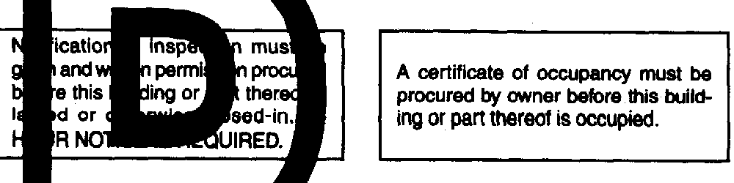
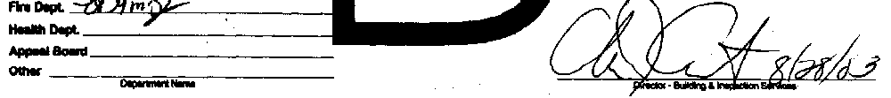
PENALTY FOR REMOVlNGTHlS CARD /

City of Portland, Maine - Building or Use Permit Application Mo~~mo ISJM ^{Date}:CBL:
389 Congress Street, 04101 Tel: (207) 874-8703, Fax: (207) 874-8716 016 GO01001
La!8lioIl of cmn:

124 Congress St
-Nome:
-yer’a Nans
Owner Name:

City Of Portland ContractorName: City of Portland Phontz
OwnerAddreav
389 Congress St
ContractorAd
389 Congress Street Portland PermitType:
Alterations - Commercial
Phone
PhOlX
2078748895
;qituse:
Harry Cummings Center
Propwed me:

Parks & Ret offices
Pendt Fee:
1 Coal of Work: pEcmtri~




$0.00 1 $40,ooo.00 1 1
I
FIREDEPT:
Approved
q Denied
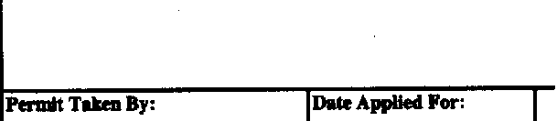
Roporea Project Description: Tenant fit-up
I

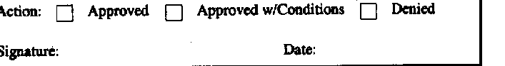
Signature:
-wy7
PJ%DEX$TRUN A- DISTRICT (P.A.D.) V I
kwd 1 08/19/2003

This permit application does not preclude the Applicant(s) from meeting applicable State and Federal Rules. .

Building permits do not include plumbing, septic or electrical work.
Building permits are void if work is not started
within six (6) months of the date of issuance. False information may invalidate a building permit and stop all work..
speskslzoneor~ws
0 Shonland
0 Wetland

l--J modzme
0 Subdivisioa q SitePlan
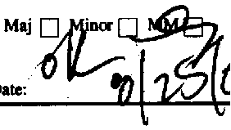
Zoning Approval
Zo-8 Appeal
I-J variance
!J Miscellaneous
0 cooditioMluse
0 IntclpretatioIl

0 APPV~
I-Jtknied
3
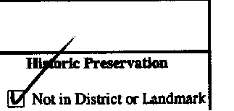
0 Does Not Require Review

0 Reqaires Review
0 Approved w/Conditicms
q M
4MC:
CERTIFICATION
I hereby certify that I am the owner of record of the named property, or that the proposed work is authorized by the owner of record and that
I have been authorized by the owner to make this application as his authorized agent and I agree to conform to all applicable laws of this jurisdiction. In addition, if a permit for work described in the application is issued, I certify that the code official’s authorized representative
shall have the authority to enter all areas covered by such permit at any reasonable hour to enforce the provision of the code(s) applicable to such permit.
SKiNATuRE OF APPLICANT
ADDRESS
DATE
PHONE
RIWONSIBLB PBRSON IN CHARGE OF WORK, TITLE
DATE
PHONE

‘03-/82a
All Purpose Building Permit Application .
.




If you or the Property Owner owes real e$ate pr per&al property taxes or’user charges on any property wlthln
the City, payment arrangements must be made
I
Location/Address of Construction:rr/-rrtva- &f&s &#q&Jf4
V

Total SqyxeFootageof ProposedStructure Square Footage of Lot

I”
TClX~t3SSOhJJ - ti,-Block & Lot I Owr: f// I Telephone: I
I chart# Black#

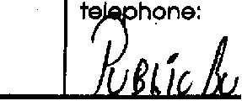
Lessee/Buy&s Name (If Applicable)
Current use:


&pllcant name, address &
.
lrch f-w
t
Fe@: $
If the looatkm Is ourrently vacant, what was prior use:
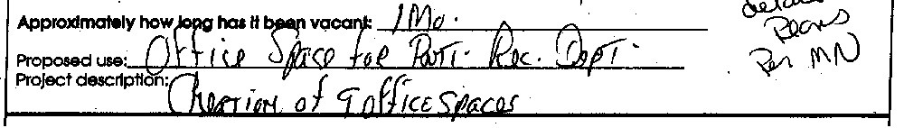
Zontractor’s name, address & telephone:
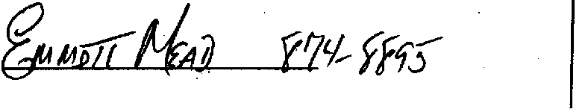
ho should we contact when the permit Is ready:
vlalllng address:
We wlli contbct you by phone when the permit Is ready. You inust come In and pick up the permlt and evlew the requirements before starting any work, with a Plan Reviewer. A stop work order will be issued md a $100.00 fee If any work starts before the permit Is plcked up.
IF THE REQUIRED INFORMAnON Is NOT INCLUDED IN THE SlJBhMSSlONs THE PERMIT WILL BE AUTOMATCALLY DENIED AT THE DlSCREllON OF THE BUILDING/PLANNING DEPARTMENT, WE MAY,REQUlRE ADDlTlONAl INFORMATlON IN ORDER TO APROVE THIS PERM.
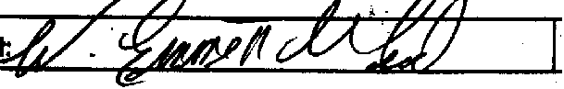
Slgnature of appllcan

/
bate:
fbfF .I

This IS NOT a permit, you may not commence ANY work untli permit IS iced.
if you are in a Historic district you may be subject to additldnal permlfflng and fees wlth the
Piannlng Department on the 4* floor of City Hall

0A
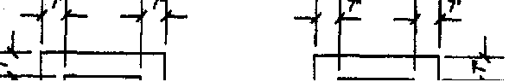
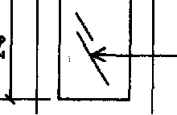
- i/4’\ b

WI,\hr
tempered

glees panel
5
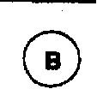
\
10/T\
0C
DOOR TYPES
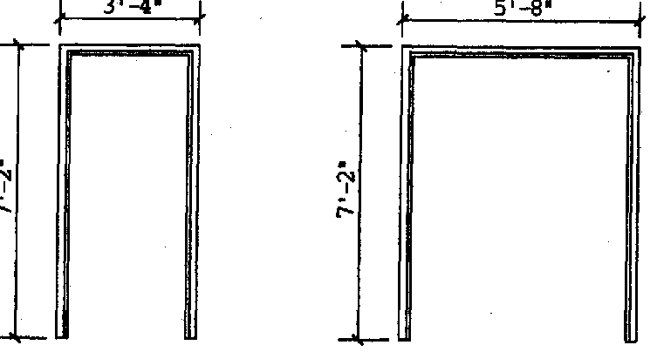
0Fl
0F2
FRAME TYPES

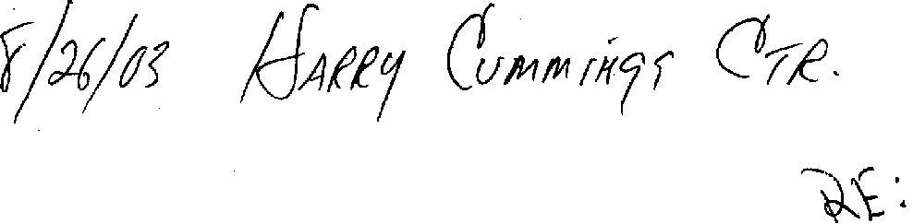



-----~-_{T}--------_{T}-_{r}----
I I I I
I I I I I I I I
I I I I
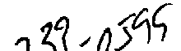

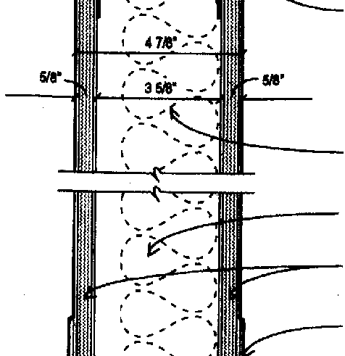
4Jlbbe6~~dlwmiw,anpemtbneexteod
upto-ofwPtwkb*tmok
w/2@bg& dbeQwBtoflub8andd w/acoudceedent.~prtlEkns&not extenduptode&braa9to8trumeabove

critng.

~AcoWkbdtutTypelAp8dtion
3wtlldalrhKk 0 16”O.C.

WFCQWB

seelhtbh$chedlbforbaBetype

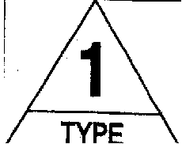
n1 AS DRAWN
QWITH ACOUSTIC BATTS
Fmma Dim.
P

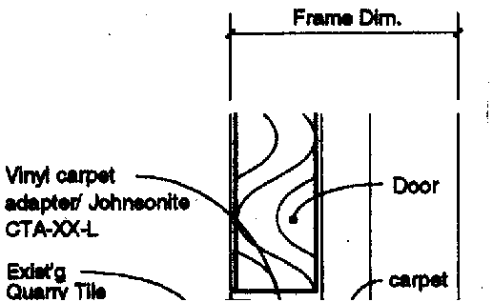

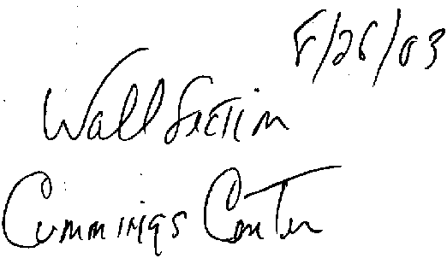

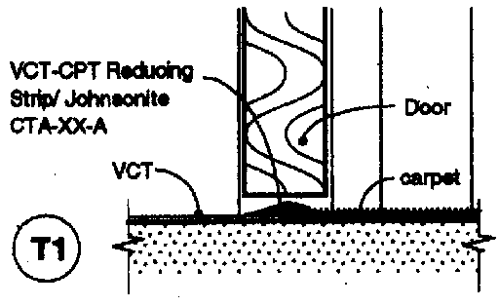
.~.~.‘.‘.‘.‘.‘.‘.~.‘.‘.‘.~.~.~.~.~.’.~.~.~.’.~ I
. . . . . . . . . . . . . . . ..~... ::. . . . . . . . . . * . . . . , . , . . .
. . * ., . . . . * * .
1
THRESHOLDTYPES
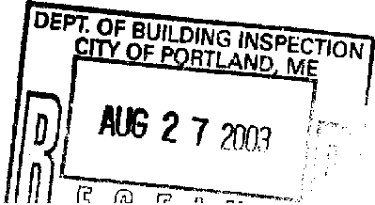


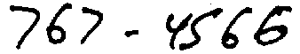
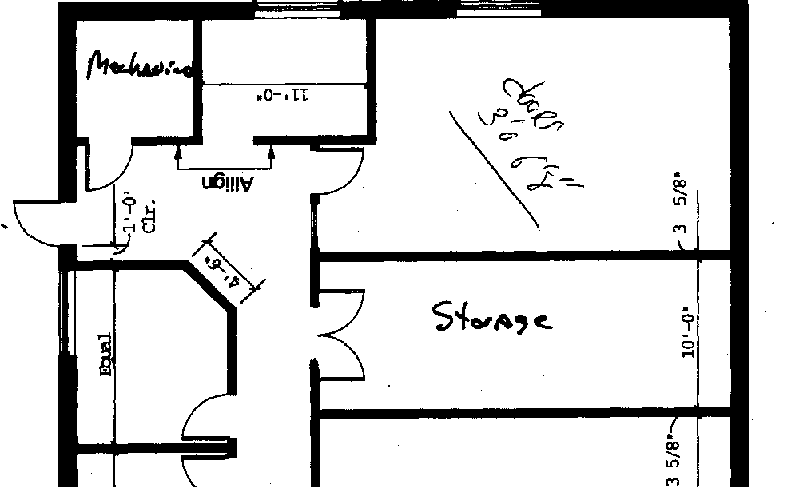
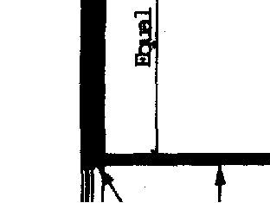
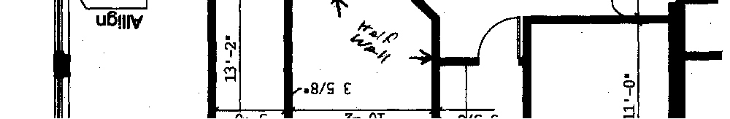
I
‘II
lI
b
il.
4-m
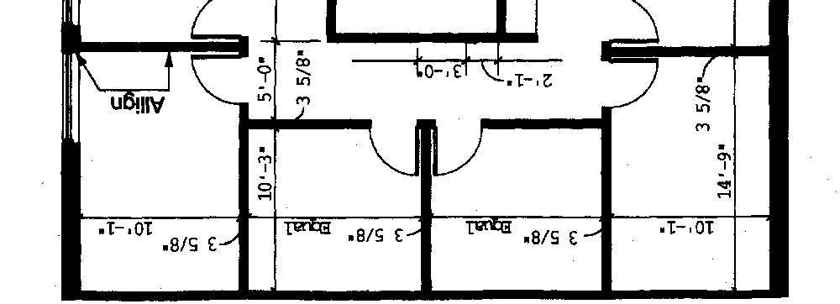
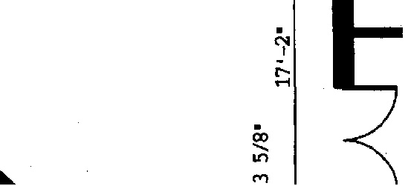
. I I-•oT= = I

