Memorandum
Planning and Urban Development Department
Planning Division

To: Chair Morrissette and Members of the Portland Planning Board

From: Jean Fraser, Planner

Date: December 13th, 2013

Re: December 17th, 2013 Planning Board Workshop
Level III Site Plan and Subdivision:
14 unit residential and commercial condominium, 118 Congress Street
“118 on Munjoy Hill”
118 Condominiums, LLC (Ed Theriault), Applicant

- Introduction
On behalf of 118 Condominiums LLC, Pinkham & Greer Consulting Engineers have submitted a Level III Site Plan and Subdivision application for the construction of a 14 unit condominium building at 118 Congress Street, comprising 12 residential units and 2 commercial units and ground floor parking within the building for 18 vehicles. The 10,728 sq ft site currently is occupied by parking spaces and a single story building with footprint of 2,644 sq ft; the proposed building will have a footprint of 9,122 sq ft and be 4 stories high.
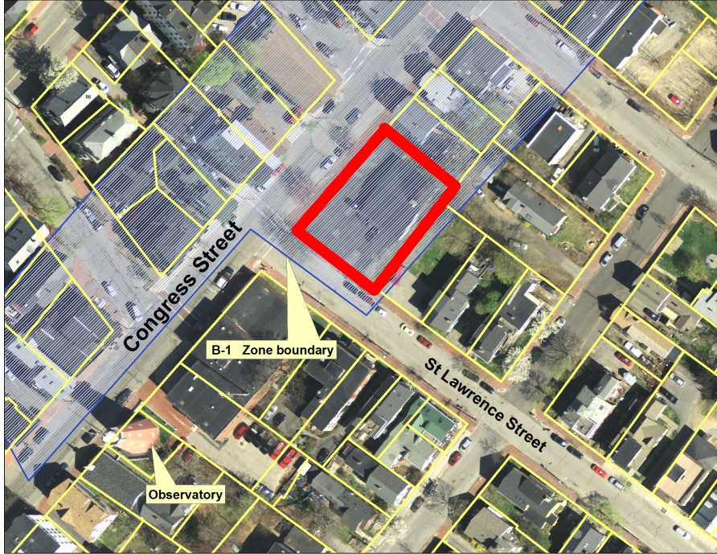
The parcel is located at the highest point of Congress Street on Munjoy Hill, at the east corner of Congress Street and St Lawrence Street. It is within the B-1 zone where the height may be up to 50 feet if the ground floor is commercial, if the B1 text amendment is approved by the City Council on 12.16.2013.

The applicant will be holding a Neighborhood Meeting on Decmeber 18, 2013 (invitation in Attachment H . The Planning Division has not received any public comments as of the time of completion of the Memo.

This Workshop was noticed to 242 neighbors and interested parties, and the public notice appeared in the Portland Press-Herald on December 9th and 10th, 2013.

Required reviews; no waivers have been requested but a waiver for parking space size will be required:

Applicant’s Proposal | Applicable Standards
New structure of 12 dwelling units and 2 commercial units | Subdivision Review
Multifamily building of 36,131 square feet | Level III Site Plan Review and R-6 Design Review
Waiver required for size ofparking space to allow 8’5’ by 18 ‘ spaces within the internal parking garage | Technical Manual Standard 1.14 requires standard spaces of 9’ by 18’ or compact spaces 8’ by 15’. A waiver request with supporting information should be submitted.

- PROJECT DATA

SUBJECT | DATA
Existing Zoning | B-1
Existing Use | Professional offices
Proposed Use | Residential and commercial
Parcel Size | 10,728 sq ft
Number of lots in subdivision | 14 (2 commercial; 12 residential
Impervious Surface Area  --Existing  --Proposed  --Net Change | 9,131 sq ft  9,514 sq ft  383 sq ft
Total Disturbed Area | 10, 728 sq ft
Building Footprint  --Existing  --Proposed  --Net Change | 2,644 sq ft  9,122 sq ft  6,478 sq ft
Building Floor Area  --Existing  --Proposed | 2,644 sq ft  36,131 sq ft
Parking Spaces  -Existing  -Proposed | 14  22
Bicycle parking Spaces | 4 outside; 12 inside
Estimated cost of the project | $5,101,500

- EXISTING CONDITIONS
The proposal site is located on the summit of Congress Street about 200 feet east of the Portland Observatory and within an area of mixed heights up to 4 stories. Immediately abutting the site on the south and east sides are 2-3 story residential properties, with the fire station opposite on St Lawrence.

The photomontages below were presented to the Board when the B1 text amendment was being considered and are included to illustrate the existing conditions for the proposed development.:

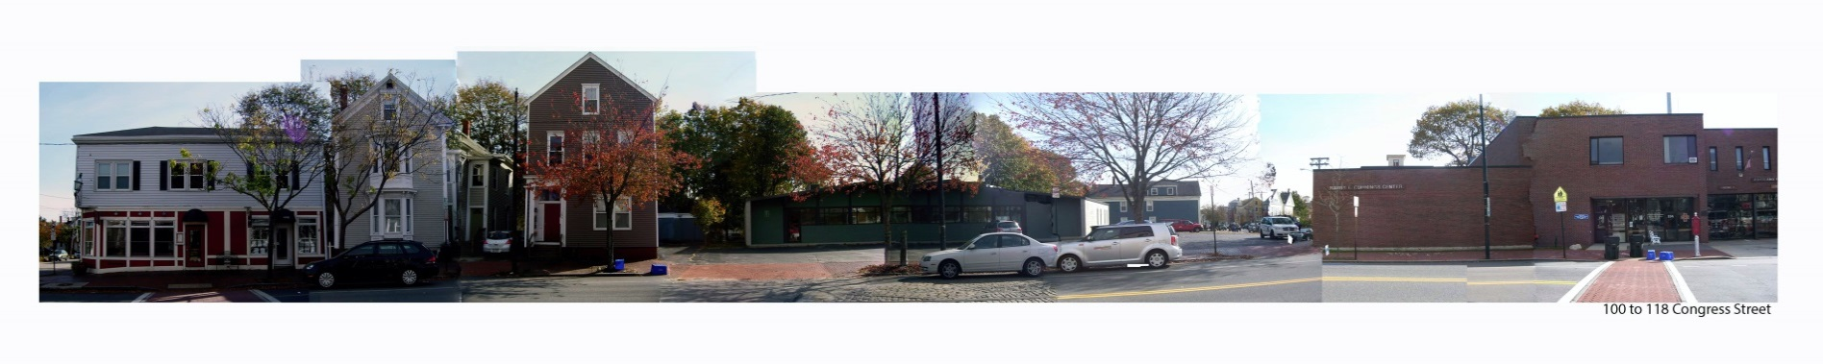
The site:
Congress Street opposite the site:

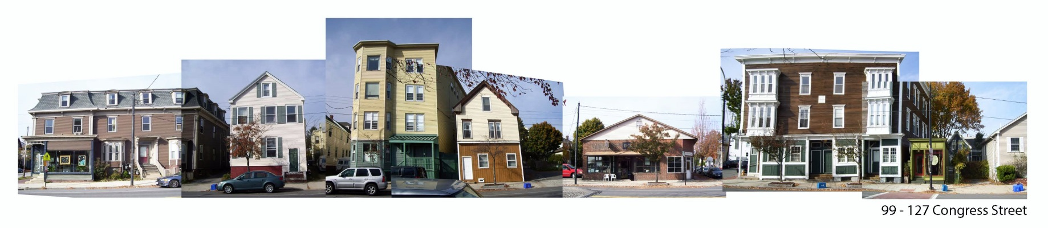
- PROPOSED DEVELOPMENT
The proposals, including floor plans, elevations, and renderings, are illustrated in the Plan Set.

The existing one-story building of 2644 sq ft footprint is proposed to be demolished and replaced with a 4 story building of 9122 sq ft footprint comprising two commercial units of 1080sq ft and 722 sq ft on the ground level, and 12 residential units over 3 upper floors ranging from 1519 sq ft to 2118 sq ft in floor area. The residential units have an entrance on Congress Street between the commercial/retail units.

Each of the 12 units have a balcony and a small amount of living space that projects from the building up to 2’6” (Plans 12 and 16). These project over the right of way (sidewalk). The fourth floor units also have roof top decks (Plan 15).

Parking provision is located within the building behind the commercial units and totals 22 spaces.

A small area of landscaping is located between the building and the abutting house/driveway to the east.
The existing four street trees (mature) are proposed to be removed and relocated and replaced with five new street trees (Plan 9).

- STAFF REVIEW

        - ZONING ASSESSMENT

The proposed development is within the B-1 Business Zone, which extends beyond the rear property line and abuts the R-6 Residential Zone (Plan 5). The Zoning Administrator and applicant have agreed on the interpretation of the B-1 setback language and the footprint of the building has a “jog” at the southeast corner to meet the setback requirement of 20 feet for that section of the property line (Attachment 3).

B. SUBDIVISION STANDARDS

The staff anlaysis below addresses the key issues raised by the application.

Traffic
The proposal will have the vehicular access to the garage on St Lawrence Street and the Traffic Engineering reviewer does not have concerns regarding traffic generation (Attachment 2.)

Parking
The number of parking spaces is adequate but the size of spaces does not meet the Technical Standards. The Traffic Engineer Tom Errico has requested a formal waiver and supporting information to be submitted (Attachment 2).

Stormwater/Wastewater
The Stormwater Report (Attachment K) concludes that the small increase in impervious surface (383 sq ft) does not require stormwater treatment or flow controls. The Consulting Engineer Dave Senus agrees with this conclusion but notes that the roof and foundation drains connect directly into the combined sewer system in St Lawrence Street and that the applicant should explore means to eliminate these connections (Attachments 1 and 4).

Capacity letters have not been submitted regarding water and wastewater.

Street Trees

The subdivision requirement would be one tree per unit, or 14 street trees, in or near the ROW. There are already 4 street trees, which are proposed to be removed and replaced with 5 street trees. The City Arborist is very concerned at the impact on the existing street trees and comments (Attachment 6):

The size and mass of the proposed development with overhangs obscures significant streetscape
and overwhelms the historic views of traditional Congress Street. The lack of any landscape greening,
planters, and removing available space for street trees is like no other project in recent memory.

* The existing mature street-trees have high value, especially on the Waterville Street side. Continuing the street tree canopy along Congress Street is a high priority. The project as proposed severely reduces the street tree value along Congress Street & Waterville Street. Reducing tree space is counter to over 20
years of greening efforts and street tree planting in the Munjoy Hill, CDBG area.

* Proposed building overhang over the sidewalk seriously effect street-tree growth and are strongly
opposed as shown. The building overhang eliminates ALL future shade tree / street tree possibilities and
is unacceptable as it changes the character of Congress Street and the Eastern Promenade.

* Historic views on Congress Street that include tree canopy, along with views to the Eastern Promenade and to the Portland Observatory are interrupted by the proposed development as presented.

The project also requires an additional 9 street trees or equivalent contribution to the Street Tree Fund.

C. SITE PLAN STANDARDS

14-526 Requirements for approval

Traffic - as discussed above under Subdivision Review

Bicycle Parking
The proposals meet the standards with 4 outside spaces and 12 inside spaces near the main residential entrance on Congress Street.

Site Landscaping and Screening
There is a small area of planting to the east of the building and the five proposed street trees. The City Arborist comments (Attachment 6):

The proposed development should include additional street-view landscape treatment as typical on most of Congress Street. The proposed development scale and lack of greenery changes the existing residential character of this important Munjoy Hill landscape. This includes planters, pockets of vegetation & greenery for pedestrian view point.

Water quality, Stormwater Management and Erosion Control - As discussed above under Subdivision Review.

Sidewalk and ROW
The Department of Public Services has reviewed the proposal and comments are included in Attachment 4; it is noted that Congress Street is a moratorium street until 2017.

A key concern is that there are 12 places (each about 20 feet long) where the building overhangs the ROW. The depth of the overhangs varies between 2’4” and 2’6” with a clearance over the sidewalk of about 10 feet for Congress Street and 12 feet for St Lawrence Street (see Plan 16). DPS comment (Attachment 4):

- The proposed areas encroaching into the Congress and St Lawrence St right of way are excessive and should be scaled back or the building should be set back to accommodate these features. Falling ice and snow is a pedestrian safety issue.

The City Arborist also is concerned about the overhangs in terms of the impact on street trees and views (Attachment 6), and the Urban Designer notes that there is no compelling reason (eg site constraints or to maintain historic character) why the building can not be set back so that the balconies are within the property line (Attachment 7 ).
Site Design Standards

Massing, Ventilation and Wind Impact

The applicable site plan standard is (14-526 (d) (1) b:

The bulk, location or height of proposed buildings and structure shall minimize, to the extent feasible, any substantial diminution in the value or utility to neighboring structures under different ownership and not subject to a legal servitude in favor of the site being developed.

There appear to be negative impacts on the immediate neighbor to the east but this has not been closely evaluated and additional information is requested.

It is noted that some of the public comments are concerned regarding the proposed heightof 50 feet (if the text amendment is approved). The combination of the height, footprint and elevation design appears to create some adverse impacts and suggests the need for reconsideration of one or more of these elements.

Historic Resources

This project is not within 100 feet of an historic district or landmark and the ordinance does not apply.

Exterior Lighting

This has not been reviewed in detail.

- DESIGN STANDARDS IN THE SITE PLAN ORDINANCE

B1 Design Principles and Standards
The City’s Urban Designer Caitlin Cameron has provided an extensive analysis of the proposal in Attachment 7. There are two key issues: the proposed overhangs over the ROW and the elevations that face away from the streets.

- Overhangs over the ROW: This is discussed above as the DPS and City Arborist are concerned regarding the negative impacts on the use of the sidewalk and street trees. The Urban Designer also considers these overhangs problematic and staff recommend that the building be setback so that the entirety of the building is within the property boundaries.

- East and South Elevations (Plan 16): These side and back facades are viewed not only by abutting residential properties but also from the public streets. Their design is “flat” and lacking in articulation and staff suggest further revisions to address the Urban Design comments.

Multi-family and Other Housing Types Design Standard

This design standard also applies to this proposal is outlined in sections below with associated staff review comments:

(i) TWO-FAMILY, SPECIAL NEEDS INDEPENDENT LIVING UNITS, MULTIPLE-FAMILY, LODGING HOUSES, BED AND BREAKFASTS, AND EMERGENCY SHELTERS:
(1) STANDARDS. Two-family, special needs independent living units, multiple-family, lodging houses, bed and breakfasts, and emergency shelters shall meet the following standards:
a. Proposed structures and related site improvements shall meet the following standards:
1. The exterior design of the proposed structures, including architectural style, facade materials, roof pitch, building form and height, window pattern and spacing, porches and entryways, cornerboard and trim details, and facade variation in projecting or recessed building elements, shall be designed to complement and enhance the nearest residential neighborhood. The design of exterior facades shall provide positive visual interest by incorporating appropriate architectural elements;
Staff comment: See Urban Design comments (Attachment 7).

  - The proposed development shall respect the existing relationship of buildings to public streets. New development shall be integrated with the existing city fabric and streetscape including building placement, landscaping, lawn areas, porch and entrance areas, fencing, and other streetscape elements;

Staff comment: See Urban Design comments (Attachment 7).

3. Open space on the site for all two-family, special needs independent living unit, bed and
breakfast and multiple-family development shall be integrated into the development site. Such open space in a special needs independent living unit or a multiple-family development shall be designed to complement and enhance the building form and development proposed on the site. Open space functions may include but are not limited to buffers and screening from streets and neighboring properties, yard space for residents, play areas, and planting strips along the perimeter of proposed buildings;

Staff comment: All 12 of the new residential units will have generous balconies.

4. The design of proposed dwellings shall provide ample windows to enhance opportunities for sunlight and air in each dwelling in principal living areas and shall also provide sufficient storage areas;

Staff comment: This standard appears to be met.

5. The scale and surface area of parking, driveways and paved areas are arranged and landscaped to properly screen vehicles from adjacent properties and streets;

Staff comment: The parking is located within the building.

VI. NEXT STEPS

The final submission will need to address the following:
- The concerns regarding the overhangs and street trees and side and rear facades
- Submit renderings that look straight up and down Congress Street to illustrate impact on the view corridor
- Submission of additional information to clarify impacts on the immediate abutters
- Need to eliminate conections of stormwater into combined sewer system
- Staff technical comments (survey; stormwater; additional site landscape etc)
- Waiver information re parking space size
- Submit draft Condominium Documents and revised Plat
- Planning Board comments

Attachments to Memorandum
  - Engineering Review comments
  - Traffic Engineering Review comments
  - Zoning comments
  - DPS (David Margolis-Pineo) comments
  - Fire Department comments (not received)
  - City Arborist comments
  - Urban Designer Comments

Attachments to Memorandum, continued
  - Public comments
- Linda Tyler
- Francine O’Donnell
- Linda Tyler
- Susan Baker-Kaplan

Applicant’s Submittal
- Cover Letter and Application including Data 11.13.2013
- Zone Information
- Project Description
- Right, title and Interest
- Maps
- Building and Fire code analysis
- Financial and Technical Capability letters
- Neighborhood Meeting Invitation
- Utility letters
- Lighting specifications
- Stormwater Report
- Traffic Report
- Bike Rack Elevation
- Congress Street Emission Statement

Plans
      - Boundary Survey
      - Subdivision Recording Plat
      - Condominium Plan
      - Site Plan
      - Site Plan with zoning (site plan part superceded)
      - Existing Conditions and Demolition plan
      - Grading and Utilities Plan
      - Erosion Control Plan
      - Landscape Plan
      - Details
      - Details
      - Ground Floor Plan
      - Typical Unit Floor Plan
      - Fourth Floor Plan
      - Roof Plan
      - Building elevations
      - Lighting
      - Section showing building in context of Observatory (“street view”)
      - Rendering - NE
      - Rendering - NW
      - Rendering

