PLANNING BOARD REPORT
PORTLAND, MAINE

“118 on Munjoy Hill”
12 unit residential and 2 unit commercial condominium, 118 Congress Street
Final Level III Site Plan and Subdivision
Project ID 2013-255
118 Condominiums, LLC (Ed Theriault), Applicant

Submitted to: Portland Planning Board  Public Hearing Date: January 28th, 2014 | Prepared by: Jean Fraser, Planner  Date: January 24th, 2014

- Introduction
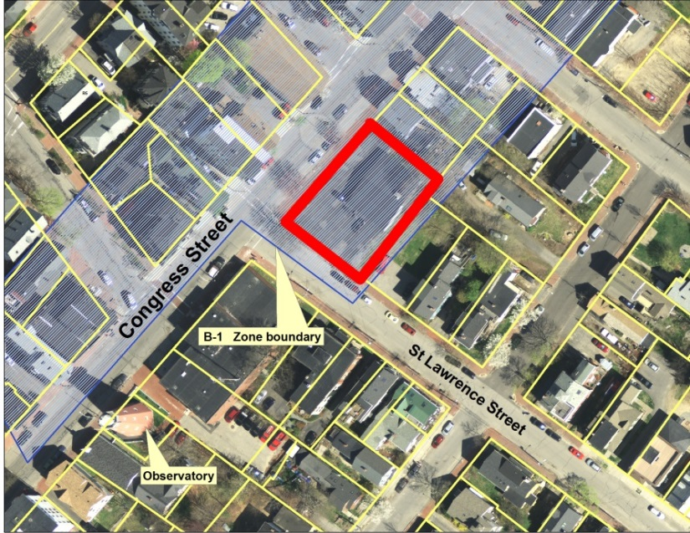
On behalf of 118 Condominiums LLC, Pinkham & Greer Consulting Engineers have submitted a final Level III Site Plan and Subdivision application for the construction of a 14 unit condominium building at 118 Congress Street. The proposed building would comprise 12 residential units over 2 commercial units, and ground floor parking within the building for 18 vehicles. The 10,728 sq ft site currently is occupied by parking spaces and a single story building with footprint of 2,644 sq ft; the proposed building will have a footprint of 8,884 sq ft and be 4 stories high.

The parcel is located at the highest point of Congress Street on Munjoy Hill, at the east corner of Congress Street and St Lawrence Street. It is within the B-1 zone where the height may be up to 50 feet if the ground floor is commercial, based on a B1 text amendment that was approved by the City Council on 12.16.2013.

The applicant held a Neighborhood Meeting on December 18, 2013 (Certification Attachment G ) which was attended by 11 people. The Planning Division has received 4 written public comments since the December Workshop, of which three object to the scale and massing of the proposed building (see Public Comment Attachment PC 1-8).

This Workshop was noticed to 242 neighbors and interested parties, and the public notice appeared in the Portland Press-Herald on January 20th and 21st, 2014.

Required reviews; a waiver request (Attachment C) was submitted in respect of parking space dimensions and width of the parking drive aisle. The waivers are supported by the Traffic engineering review (Attachment 2)

Applicant’s Proposal | Applicable Standards
New structure of 12 dwelling units and 2 commercial units | Subdivision Review
Multifamily building of 36,131 square feet | Level III Site Plan Review and R-6 Design Review
Waiver requested for size of parking space to allow 13 spaces to be 8’6” by 18’ within the internal parking garage to provide 6 additional parking spaces over the minimum required (12 required; 18 provided). | Technical Manual Standard 1.14 requires standard spaces of 9’ by 18’ or compact spaces of 8’ by 15’.
Waiver requested for the parking drive aisle to be 23 ft wide instead of the required 24 ft wide to reduce encroachment of the buidling on the ROW. | Technical Manual Standard 1.14 requires a 24 ft wide parking aisle where there is 90 degree parking.

- PROJECT DATA

SUBJECT | DATA
Existing Zoning | B-1
Existing Use | Professional offices
Proposed Use | Residential and commercial
Parcel Size | 10,728 sq ft
Number of lots in subdivision | 14 (2 commercial; 12 residential)
Impervious Surface Area  --Existing  --Proposed  --Net Change | 9,131 sq ft  9,457 sq ft  326 sq ft
Total Disturbed Area | 10, 728 sq ft
Building Footprint  --Existing  --Proposed  --Net Change | 2,644 sq ft  8,884 sq ft  6,240 sq ft
Building Floor Area  --Existing  --Proposed | 2,644 sq ft  35,362 sq ft
Parking Spaces  -Existing  -Proposed | 14  18
Bicycle parking Spaces | 4 outside; 12 inside
Estimated cost of the project | $5,101,500

- EXISTING CONDITIONS
The proposal site is located on the summit of Congress Street about 200 feet east of the Portland Observatory and within an area of mixed heights up to 4 stories. Immediately abutting the site on the south and east sides are 2-3 story residential properties, with the fire station opposite on St Lawrence.

The photomontages below were presented to the Board when the B1 text amendment was being considered and are included to illustrate the existing conditions for the proposed development.:

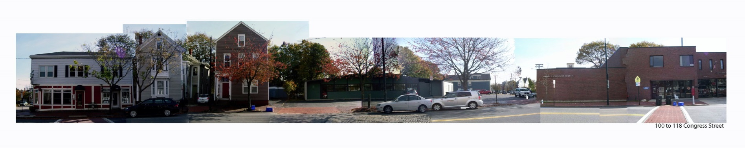
The site:

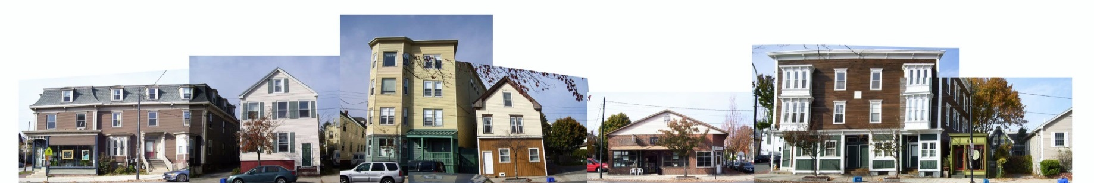
Congress Street opposite the site:

- PROPOSED DEVELOPMENT
The proposals, including floor plans, elevations, and renderings, are illustrated in the final Plan Set and are similar to the proposals seen at the Workshop except that:
- the entire building has been pulled back from the Congress Street ROW by a foot; thus the building overhangs along congress street are now 1’ 4”;
- the foundation drains have been omitted (based on geotechnical info);
- a landscaped raingarden (to detain roof stormwater drainage) has been incorporated between the proposed building and nearest abutter on Congress Street;
- the side and rear elevations have a darker base and modified windows (and retained green trellis with wisteria proposed); and
- the street tree proposals include the option of retaining the mature Pin Oak Street tree on St Lawrence (the other 3 existing street tree to be removed and relocated/replaced).

The existing one-story building of 2644 sq ft footprint is proposed to be demolished and replaced with a 4 story building of 8884 sq ft footprint comprising two commercial units of 1088sq ft and 719 sq ft on the ground level, and 12 residential units over 3 upper floors ranging from about 1500 sq ft to 2100 sq ft in floor area. The residential units have an entrance on Congress Street between the commercial/retail units.

Each of the 12 units have a balcony and a small amount of living space that projects from the building by 2’4” on Congress Street (of which 1’4” is over the ROW) and by 2’6” for the 3 decks on St Lawrence Street (all of this is over the ROW (Plans P12, P15 and P22). The fourth floor units also have roof top decks (Plan P14).

Parking provision is located within the building behind the commercial units and totals 18 spaces.

A small area of landscaping combined with a raingarden to detain roofwater drainage is located between the building and the abutting house/driveway to the east. The existing four street trees (mature) are proposed to be removed and relocated and replaced with five or six new street trees (Plan P10 Landscape Improvement Plan).

- PUBLIC COMMENT and WORKSHOP

A. Public comments:
Four written comments were included in the Workshop Memo (3 people) and the main objections were that the proposal was out of scale and there was no parking for the commercial component (thus putting pressure on street parking). At the Workshop these concerns were raised by 7 members of the public; 2 others were in support of the project and one was concerned that this was not meeting the need for ‘average “ housing. Since the Workshop a total of five written comments have been received (Attachment PC 5-9). Three of the comments particularly object to the scale and massing of the building and request further revisions. One comment raises concerns over the impacts on the sidewalk and street trees; and one is from the abutter on St Lawrence (Mr Gross) who is concerned about the proximity of the proposed building to his property line and whether it will constrain future development on his lot.

B. Planning Board comments:
Several of the Planning Board members questioned the scale and massing of the proposed building, particularly noting that the entire building (including the overhangs) should be within the property boundaries and that the side and rear elevations should be designed to the same standard as the other two elevations. Board members also requested additional graphics illustrating impacts on the views of the Portland Observatory (landmark) from both directions, local views (eg St Lawrence) and identified view corridors. These have been submitted and are included in Plans P18-P21 (total of 10 graphics including near and far views and montages)

- RIGHT, TITLE AND INTEREST
The applicant (EMT,LLC) has fee ownership of the site and has submitted the Warranty Deed in Attachment M.

- STAFF REVIEW

        - ZONING ASSESSMENT
The proposed development is within the B-1 Business Zone, which extends 10-15 ft beyond the rear property line and abuts the R-6 Residential Zone. The Zoning Administrator and applicant have agreed on the interpretation of the B-1 setback language and the footprint of the building has a “jog” at the southeast corner to meet the setback requirement of 20 feet for that section of the property line (Attachments4 and 12). Otherwise there is no rear setback requirement in this zone and the 5 feet between the building and the rear property line is not a requirement.

The height limitation of 45 feet in the B1 zone is allowed to be 50 feet for this project as it meets the recently approved height amendment that states:

(14-165 Dimensional Requirements)
2. On-peninsula B-1 and B-1b locations, as defined in Section 14-47: Forty-five (45) feet except in the case of a building in a B-1 zone along Congress Street with commercial first floor and residential upper floors where fifty (50) feet is allowed. The commercial first floor uses shall utilize at least 75 percent of the first floor frontage along Congress Street and shall have an average depth of at least 20 feet.

The depth of the larger proposed commercial unit is at least 23 ft (widens to 26 ft at widest and 19ft along St Lawrence). The depth of the smaller retail unit ranges from 17 to 21 feet, so the proposed commercial units meet the requirement.

B. SUBDIVISION STANDARDS

14-496. Subdivision Plat Requirements
The applicant has submitted a draft Subdivision Plat (Plan P2) and draft Condominium Documents (Attachment F). The potential conditions of approval suggest amendments to both documents and further review by staff as they do not fully address the Subdivision Plat requirements nor include specific references to particular maintenance requirements (eg raingarden). The Associate Corporation Counsel has advised that such documents should be substantially complete when presented to the hearing, and the submitted documents need to address her comments which confirm the essential contents of the plat (Attachment 8).

14-497. General Requirements (a) Review Criteria

- Will Not Result in Undue Water and Air Pollution (Section 14-497 (a) I), and Will Not Result in Undue Soil Erosion (Section 14-497 (a) 4
The applicant has submitted an Erosion Control Plan (Plan P7) and the Engineering Reviewer has requested additional notes regarding potential impacts to the ROW (Attachment 1).

- Sufficient Water Available (Section 14-497 (a) 2 and 3)
The applicant has submitted a letter from the Portland Water District dated 12.2.2013 confirming water capacity for this development.

- Will Not Cause Unreasonable Traffic Congestion (Section 14-497 (a) 5)
The access to the lower level parking area for 18 cars is via a widened existing curb cut on St Lawrence Street and Tom Errico, the Traffic Engineer consultant does not have concerns regarding traffic generation (Attachment 2). The proposed number of parking spaces is adequate but the size of spaces does not meet the Technical Standards and a waiver has been requested for 13 of the spaces to be .5 foot narrower than “standard” (Attachment C).

Mr Errico (Attachment 2) has confirmed that the parking is adequate; parking provision for the commercial uses is not a requirement and he is supportive of the waivers as requested.

- Will Provide for Adequate Sanitary Sewer and Stormwater Disposal (Section 14-497 (a) 6), and Will Not Cause an Unreasonable Burden on Municipal Solid Waste and Sewage (Section 14-497 (a) 7)
The applicant has revised the proposals so that the roof stormwater is directed into the raingarden area and detained prior to entering the combined sewer system in St Lawrence Street. The foundation drains have been eliminated entirely, and the applicant has submitted geotechnical information showing that these are not required in this location (Attachment E). The Stormwater Report has been revised (Attachment J) to reflect these revisions.

David Senus, the Consulting Engineer, supports this approach in principle, but has commented that the raingarden design needs refinement and the associated connection to the combined sewer in St Lawrence should allow for a future sewer separation (Attachment1). The potential conditions of approval include a requirement to address these comments. The capacity letter for wastewater is included at Attachment H.

- Scenic Beauty, Natural, Historic, Habitat and other Resources (Section 14-497 (a) 8)

Street Trees
The subdivision requirement would be one tree per unit, or 14 street trees, in or near the ROW. There are already 4 street trees, which include the larger pin oak on St Lawrence Street and 3 others on Congress Street.

The preliminary submission proposed to remove all of the existing street trees and replace with 5 new street trees in new locations (3 on Congress and 2 on St Lawrence). The final proposals include an option to “save’ the existing pin oak on St Lawrence Street (see below), remove the existing 3 trees on Congress and replace with 4 new street trees in different locations, and to add a street tree in St Lawrence near the back corner of the new building (Plan P10).

The City Arborist, Jeff Tarling, has commented (Attachment 6):

a) Street-trees - the project proposes to plant (6) street trees, (4) along Congress Street, 'save'
the existing Pin Oak and plant (2) new on Saint Lawrence Street. Updated plan shows the trees
planted in raised granite tree wells with herbaceous planting. If on-street parking is proposed, the
tree spacing or setback away from the curb to prevent the opening of car doors is important. The
trees can be placed to match the in-between on-street parking, making sure there is good access to
the sidewalk from parked cars. The residential tree standard of one tree per unit would also be a condition.
Building overhangs over the public way should be discouraged to allow the street tree growth.

Tree types - It would be ideal if the tree types along Congress Street are all the same species. I would
recommend the Columnar 'Musashino' Zelkova to be ideal due to the narrow space.
See http://www.jfschmidt.com/articles/musashino and photo below.

The 'Red Sunset' Maple crown shape is too broad for this space. Along Saint Lawrence Street again a more
narrow tree is needed, it could be Ginkgo 'Magyar' or 'Autumn Gold' cultivar (seedless), due to narrow sidewalk space.

Granite planters in right of way - the six granite planters are proposed to be planted with street-trees
and 'Cranesbill', perennial geranium. This will add interest to the typical mulched tree well. Long term
however it is unlikely the city would be able to maintain these plantings. Ideally, the project could
adopt the tree wells and maintain the landscape planting.

If the Board agrees to the removal of existing street trees and their replacement, a potential condition of approval has been included to allow for further adjustments to the location of the new street trees and maintenance of the other plantings in the ROW to address the City Arborist comments.

Pin Oak- should it be saved
The largest existing street tree is a pin oak on St Lawrence near the intersection with Congress Street, which is visible in long and short views (in center of photo as viewed from near Washington Ave).

The applicant obtained a detailed assessment of the pin oak by an arborist, Kyle Rosenberg (Forest to Shore Arborist), who recommends that the pin oak be removed and replaced with new plantings as it would inevitably be adversely impacted and decline in the short term (Attachment D). The applicant’s landscape architect Stephen Mohr of Mohr Seredin, and the City Arborist Jeff Tarling, concur with this assessment (Attachments D and 6).

The applicant has offered the alternative of planting 2 new street trees to replace the pin oak (Plan P10) which would result in a total of 7 new street trees for this project. If the Board agrees with this approach, that would leave 7 street trees to be addressed by an equivalent contribution to the Street Tree Fund (potential condition included).
- Comprehensive Plan (Section 14-497 (a) 9)
The project is compatible with Comprehensive Plan goals and policies related to residential and mixed use development.

7. Financial Capability (Section 14-497 (a) 10)
A letter dated 10.18.2013 confirming financial capability is included at Attachment P.

C. SITE PLAN STANDARDS

14-526 Requirements for approval
- Transportation

- Traffic - as discussed above under Subdivision Review

- Construction Management Plan- The applicant has submitted a Construction Management Plan (Plan P16) that utilizes adjacent property for the staging, and creates a parallel path for pedestrians along Congress Street and reroutes pedestrians to the other side of St Lawrence Street. The plan has been reviewed by Tom Errico, Traffic Engineer and while acceptable in principle there are a number of details that need to be addressed, with a revised plan submitted for review and approval (Attachment 2). A potential condition of approval addresses Mr Errico’s comments.

- Sidewalk and ROW
The Department of Public Services has reviewed the proposal and comments on the final submissions are included in Attachment 4; it is noted that Congress Street is a moratorium street until 2017.

Although the applicant has set the building back one foot, the Congress Street decks (6 - each about 20 feet long) still overhang the ROW by 1ft 4 inchs. On St Lawrence the three overhangs are 2ft 6 inches in depth and the entirety of this width overhangs the ROW (see note on Elevations in Plan P15 and Plans P12 and P22).

The table below compares the overhangs as proposed at the Workshop with the revised overhangs incorporated in the final Plan Set:

 | Submitted version  presented at Workshop | Final version (Jan) for Hearing (building moved back 1 ft from Congress)
Congress St east (3 levels)  - Overhang over ROW  - Length of overhang  - Area over ROW | - 2ft 4 inches  - 20ft 9 inches  - 48.4 sq ft over ROW | - 1ft 4 inches  - 21 ft  - 28 sq ft over ROW
Congress St west (nearest St Lawrence (3 levels)  - Overhang over ROW  - Length of overhang  - Area over ROW | - 2ft 4 inches  - 22ft 8 inches  - 52.8 sq ft over ROW | - 1ft 4 inches  - 22ft 10 inches  - 30.4 sq ft over ROW
St Lawrence St (3 levels)  - Overhang over ROW  - Length of overhang  - Area over ROW | - 2 ft 6 inches  - 19 ft 6 inches  - 48.8 sq ft over ROW | - 2 ft 6 inches  - 19 ft 6 inches  - 48.8 sq ft over ROW
Entrance Canopy over Congress St  - Overhang over ROW  - Length of overhang  - Area over ROW | - 2ft 4 inches  - 28 ft 11 inches  - 68.7 sq ft over ROW | - 1ft 4 inches  - 28 ft 11 inches  - 39 sq ft over ROW

DPS still do not support any encroachments over the ROW and cite snow removal and falling ice as particular issues over the public sidewalk (Attachment 4). The Planning Board at the Workshop were concerned about the impact on the ability of the public to enjoy this section of sidewalk and requested additional views and graphics to understand how the overhangs and bulk of the building would relate to the public realm. Additional graphics have been submitted and those of particular relevance are the Line Diagrams (Plans P18 and P19) and the four near perspectives in Plan P20.

The City Arborist also is concerned about the overhangs in terms of the impact on street trees and views (Att. 6), and the Urban Designer notes that there is no compelling reason (eg site constraints or to maintain historic character) why the building can not be set back so that the balconies are within the property line (Attachment 7 ).

- Public Transit Access
The public transit requirements do not apply to this project.

- Parking
There are 18 parking spaces which meet zoning requirement of 14 spaces, all located within the enclosed ground floor behind the commercial units. The Traffic Engineering reviewer has commented that the number is acceptable as they serve the 12 residential units; there is no requirement for parking provision for the two small commercial units.

- Bicycle Parking (also Motorcycle and Scooter parking)
The proposals meet the standards with 4 outside spaces and 12 inside spaces near the main residential entrance on Congress Street.

- Snow Storage- does not apply to this proposal as the parking area is within the building.

- TDM - does not apply to this proposal.

- Loading and Servicing- The proposals do not include any particular provision for loading and servicing. The Traffic Engineering Reviewer has commented (Attachment 2):
Deliveries and services vehicles for the project will be expected to do so from the street. The applicant shall coordinate with the Parking Division and the Department of Public Services for the type of on-street regulations to be implemented on Congress Street along the project frontage. The applicant will be responsible for all costs associated with signage installation.

A potential condition of approval incorporates the requirements outlined in the comment.

Environmental Quality Standards

- Landscape Preservation- see Subdivision Review (Scenic Beauty)

- Site Landscaping and Screening
The City Arborist preliminary comments were that additional street view landscape treatment should be added. The final proposals have added a raingarden with more extensive planting between the building and the driveway of the nearest abutter on Congress Street and flowering plants have been added to the street tree planters.

Mr Tarling’s has reviewed the landscape improvement proposals (Plans P10 and P11) and discussed them with the applicants Landscape Architect Stephen Mohr. The final review comments focus on the need for enhanced screening along the boundaries with neighbors and for additional street level interest along the sidewalks (Attachment 6):

b) Landscape - The recent revision adds herbaceous planting to the tree planters and the
'backyard' / rain-garden edge. Additional screening to the adjacent property should be considered,
this might be achieved by adding higher branching landscape planting or higher fencing (5').
The rain-garden planting with mostly herbaceous plant material will reach a low height. It does
not appear to meet the B-1 Zone landscape standard ( i ) " A densely planted buffer and / or fencing
will be required to protect neighboring properties..." Suggestions could including some taller shrub plants
along with a higher wooden fence. The Green Wall proposed will also help screen the building.
Additional green-wall / landscape planting could be used on the West elevation to the left of the
garage door, this area seems blank; and to the left of the center door on Congress Street away from
the overhead canopy.
Personally, I was hoping to see additional landscape element along the street
frontage along Congress Street and Saint Lawrence Street. Either in the form of behind the sidewalk
planter or green wall if the various building facade walls could have jutted in to create a small landscape niche. I noted a variety of past projects where this seemed to work successfully.

A potential condition of approval requests the submission of a revised Landscape Improvement Plan to address these comments.

- Street Trees - see subdivision Review.

- Water quality, Stormwater Management and Erosion Control
As discussed above under Subdivision Review.

- Public Infrastructure and Community Safety Standards

- Consistency with City Master Plans -

- Public Safety and Fire Prevention
The Crime Prevention through Environmental Design (CPTED) standards in the site plan ordinance address the principles of natural surveillance, access control and territorial reinforcement so that the design of developments enhance the security of public and private spaces and reduce the potential for crime.

The proposal largely fills the site and includes lighting on all sides except near the raingarden. It is suggested that when the Landscape Improvement Plan is being revised and possibly including a higher fence (currently at 4 ft) that the CPTED principles be addressed so that the raingarden area does not present a negative space at night.

The applicant has submitted a Fire Code analysis (Attachment O) and there is an existing hydrant on the opposite side of St Lawrence Street (adjacent to the Fire Department). Final comments from Captain Chris Pirone have not been received as of the completion of this Report.

- Availability and Adequate Capacity of Public Utilities - see Subdivision Review

- Site Design Standards

- Massing, Ventilation and Wind Impact

The applicable site plan standard is (14-526 (d) (1) b:

The bulk, location or height of proposed buildings and structure shall minimize, to the extent feasible, any substantial diminution in the value or utility to neighboring structures under different ownership and not subject to a legal servitude in favor of the site being developed.

It is noted that the public comments expressed strong concerns regarding the proposed scale of the development and the project has utilized the extra 5 feet in height allowed under zoning to facilitate the mixed use with commercial on the lowest floor. The combination of the height, footprint and elevation design, including decks and living space that overhangs the public sidewalk, creates an imposing building in this part of Congress Street (see the 4 “near” perspectives in. Plan P20).

Staff have not seen any evidence of “diminution in the value or utility to neighboring structures” but there are impacts on the public realm that are discussed under the Subdivision Review and below.

- Shadows/Snow and Ice Loading - not considered an issue for this proposal.

- View corridors
The Portland Planning ordinances do not protect water views except where they are identified as a protected "view corridor" as per the “View Corridor Protection Plan” approved by the Portland City Council in 2001 (Attachment 9). It is reproduced below with the Portland Observatory and the site of 118 Congress Street highlighted.

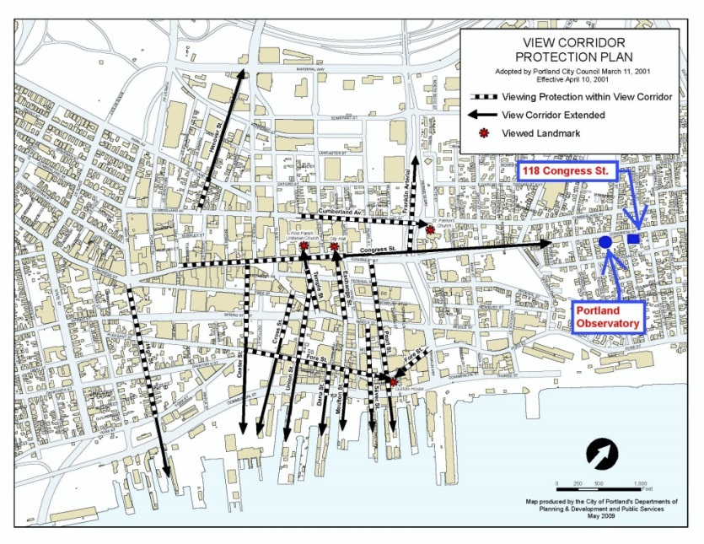
The Congress Street view looking east towards the Observatory is indicated as being of importance. The applicant was requested to show how the proposed building would appear within a “longer view” from the view corridor and the graphics in Plan P21, which includes 4 relevant photos and drawings . The line drawing (below) from the applicant (Plan P21) gives a sense of the scale of the proposed building as it appears behind the fire station. The photo lower right is taken from a location near the tip of the solid black arrow in the “View Corridor Protection Plan”. The large existing building just downhill from the Observatory largely blocks the view of the Observatory building itself and the proposed building is not prominent from this direction.
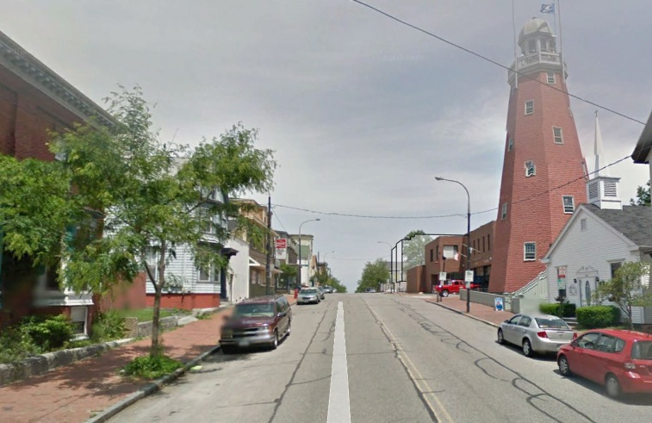
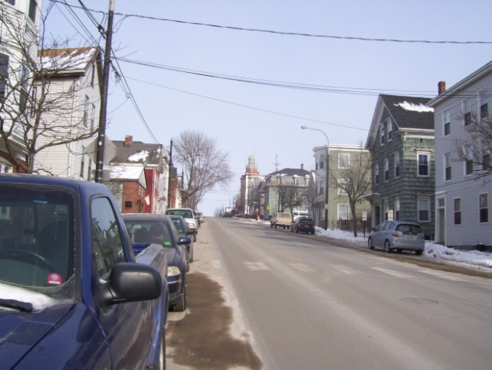

From applicant Staff photo from near Ponce Street

- Historic Resources
This project is not within 100 feet of an historic district or landmark and the ordinance does not apply. However, the Portland Observatory (a landmark) is located just over 200 feet to the west of the site and is discussed above under “View Corridors”.

- Exterior Lighting
The proposals include downlights along Congress Street (under overhangs) and wall lights on the St Lawrence and rear elevations that meet the technical standards (Attachment I). Two small “flood” type lights are also on the front elevation over the commercial units on arms that can be fixed to direct the light. A potential condition of approval is included (based on the technical standard) to ensure that the lighting is not directed upward or way from the building facade.

- Noise and Vibration- The B1 zone contains noise limitations that would apply to outside air heating/cooling condensers and use of the deck/rooftop areas, so the conditions of approval do not include any addititional potential conditions.

- Signage and Wayfinding- not considered a particular issue for this proposal.

- ZONING RELATED DESIGN STANDARDS IN THE SITE PLAN ORDINANCE

B1 Design Principles and Standards
Below is an extract of the relevant standards:

1. Building Location and Form
Buildings shall be located near the street so as to create an urban street wall. An urban street wall is created by a pattern of buildings which line the street in a consistent manner, thereby establishing a desirable spatial relationship between the building in the commercial district and the major object. Location is one of several related factors defining the street environment. Building Form, including height, bulk, and massing, contribute to the development of a street
wall.

The desired condition is to have the building frame and enclose the street, which is achieved by providing building height that is proportionate to the width of the adjoining major street. A ratio of building height to street width of one-to-two creates a strong "room-like" street, while a one to-three ratio provides good street definition and proportion. Shorter buildings of one story facing broad streets will not achieve the desired relationship..

For a fifty-foot street right-of-way, therefore, a minimum height of 15' is required, with 25' height preferred. An eighty-foot right-of-way requires about 27' to achieve the 1:3 proportion., with 40'-height preferred. Obviously, buildings located as close as possible to the street right-of way will provide better definition and proportion than buildings set further back.

2. Building Function
An urban street and business district requires a substantial intensity and variety of uses. It is beneficial to have mixed uses within portions of buildings situated near the street. For example, a retail first floor might have office or residential on the second or third floors. This provides both the scale of building height desired, as well as the economic vitality of the business district.

3. Orientation of Buildings and their Entrances to the Street
Major building entries shall be designed and located to provide the primary building access oriented to the public street and sidewalk. Doorways should be prominent and obvious in appearance, so as to attract the users toward the
entry. Major entry features should primarily address the street, with entry courts, display windows, signage, lights, walkways, and vestibules, as appropriate. Major entries should be adjacent to, or very close to, the street and public sidewalk.

4. Windows
Windows shall be located in all building facades visible from the public way, especially on building facades along the major public street. Retail uses with store fronts are the most desirable feature for locations adjacent to the public
sidewalk; and active, transparent (minimum visible transmittance (VT) of .7 or greater), and interesting windows contribute the maximum value. Limitations on transparency, such as dark or reflective glass, or interior coverings, should be avoided. Where uses (such as office) are not conducive to transparent viewing from the public way, windows can still convey a sense of activity and presence along the street. Even these more private windows can convey occupancy and habitation when lighted from within, as during evening hours, even if the interior is screened
from view.

5. Building Character, Detail, Scale, and Graphic Qualities
Building design will include various architectural and graphic amenities to provide a strong presence along a street and relate a building to its community. Awnings, canopies, and flags may be utilized to highlight entryways and to further identify the activity and identity of a use.Facade lighting may be used to highlight entryways or to provide visual interest along an otherwise blank façade. Building scale, roof pitch, architectural detail, and fenestration shall be designed to complement and be compatible with surrounding residential and commercial buildings.

- Development Relationship to Street
Building facades and site amenities shall form a cohesive wall of enclosure along a street.Where buildings are not located at the street line, site amenities, including masonry walls,fences, and landscaping, shall be placed along the street to provide a sense of enclosure or definition.

The City’s Urban Designer Caitlin Cameron has confirmed that the overall scale and bulk of the proposal is acceptable and has provided an updated analysis of the final proposals (Attachment 7):

Because of the building's size, design strategies which include variation and articulation are important. I continue to feel, as in my previous comments, that the project is successful in this regard in its use of materials, fenestration, variation in roof line and form, and the incorporation of landscape elements such as green screens and rain gardens. The East and South elevations have improved in response to workshop comments. Staff has two further comments/suggestions regarding 1) Retail storefront and 2) Building overhangs.

The mixed-use project will ideally enhance the street wall with its active retail storefront windows and close proximity to the sidewalk. It is for that reason staff would like to see the retail storefront window returned to the East elevation which has been removed in the latest iteration of the design. For urban design reasons, any additional landscaping would be more appropriate as vertical gardens or in the furnishing zone of the sidewalk along with the street trees rather than adding landscape elements to the retail facades.

In regards to the architectural elements proposed to overhang the public right of way, unlike other exceptions where this kind of easement over the right of way was granted, this project is not limited by site constraints, existing structure, or by maintaining historical character. The articulation of the facade is a benefit to the streetscape and produces a good design that meets the design standards. If the Planning Board decides that the overhangs into the public right-of-way are not appropriate, then staff would encourage the resulting design solution maintain the current quality of design in regards to facade articulation and variation of form. (Attachment 7)

Comparison of the elevations:

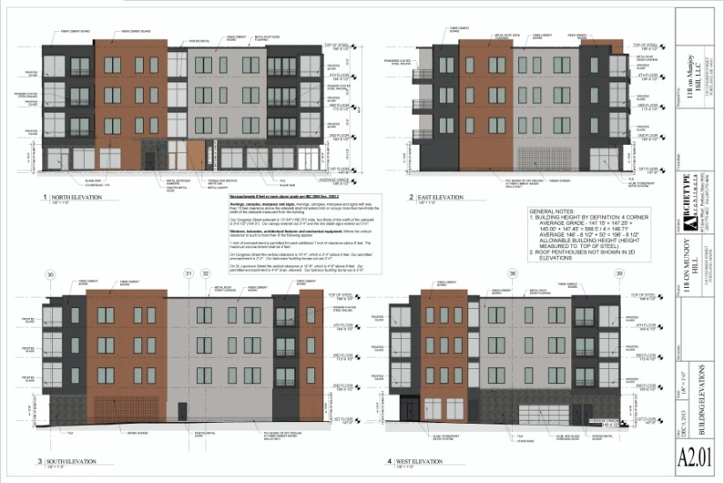
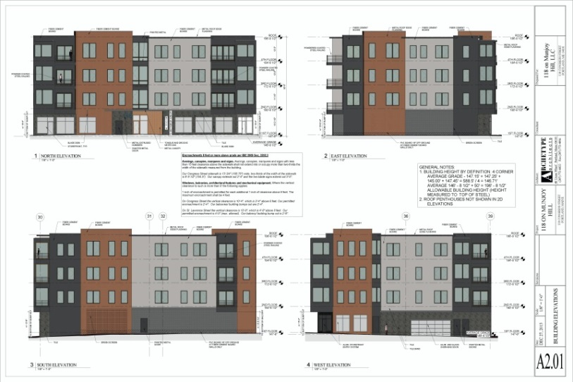
WORKSHOP FINAL (See Plan P15)

Multi-family and Other Housing Types Design Standard
This design standard also applies to this proposal is outlined in sections below with associated staff review comments:

(i) TWO-FAMILY, SPECIAL NEEDS INDEPENDENT LIVING UNITS, MULTIPLE-FAMILY, LODGING HOUSES, BED AND BREAKFASTS, AND EMERGENCY SHELTERS:
(1) STANDARDS. Two-family, special needs independent living units, multiple-family, lodging houses, bed and breakfasts, and emergency shelters shall meet the following standards:
a. Proposed structures and related site improvements shall meet the following standards:
1. The exterior design of the proposed structures, including architectural style, facade materials, roof pitch, building form and height, window pattern and spacing, porches and entryways, cornerboard and trim details, and facade variation in projecting or recessed building elements, shall be designed to complement and enhance the nearest residential neighborhood. The design of exterior facades shall provide positive visual interest by incorporating appropriate architectural elements;

Staff comment: See Urban Design comments (Attachment 7).

  - The proposed development shall respect the existing relationship of buildings to public streets. New development shall be integrated with the existing city fabric and streetscape including building placement, landscaping, lawn areas, porch and entrance areas, fencing, and other streetscape elements;

Staff comment: See Urban Design comments (Attachment 7).

3. Open space on the site for all two-family, special needs independent living unit, bed and
breakfast and multiple-family development shall be integrated into the development site. Such open space in a special needs independent living unit or a multiple-family development shall be designed to complement and enhance the building form and development proposed on the site. Open space functions may include but are not limited to buffers and screening from streets and neighboring properties, yard space for residents, play areas, and planting strips along the perimeter of proposed buildings;

Staff comment: All 12 of the new residential units will have generous balconies.

4. The design of proposed dwellings shall provide ample windows to enhance opportunities for sunlight and air in each dwelling in principal living areas and shall also provide sufficient storage areas;

Staff comment: This standard appears to be met.

5. The scale and surface area of parking, driveways and paved areas are arranged and landscaped to properly screen vehicles from adjacent properties and streets;

Staff comment: The parking is located within the building.

- Staff Recommendation
The proposed 14 unit commercial/residential condominium project appears to meet the minimum standards of review, subject to the proposed conditions, with the exception of the overhangs over the public sidewalk. Any licences for encroachment into the ROW must be approved by the City Council and the standard potential condition has been included to at least cover the canopy over the entrance.

Staff remain of the view that there is no need for the decks and living spaces to be outside the property boundaries except that they would allow better views, as noted in the marketing brochure distributed at the workshop. This is the first project where open decks have encroached into/over the ROW- other licenses have been for (usually fewer) enclosed bays that protrude from the plane of the building, so this project introduces a precedent.

The overhangs have a number of adverse impacts: ice and snow falling onto the sidewalk; visual encroachment into the public realm; and constraints on the street trees. They are not supported by DPS, City Arborist and the Urban Designer.

If the Planning Board approves the project with the overhangs as shown (six decks/overhangs encroaching 1’4” over Congress Street; three decks/overhangs encroaching 2’6” over St Lawrence Street) the City Council would consider that as support for the overhangs and support for the granting of a license from the City.

Staff have therefore included a potential condition of approval that requires the applicant to redesign the decks/overhangs so that there is no encroachment over the ROW while retaining the decks/overhangs to achieve articulation and interest on this façade. Staff suggest there are a number of ways this could be achieved without substantially altering the overall design. If the Board determine that the overhangs over the ROW are acceptable, this potential condition may be removed.

IX. MOTIONS FOR THE BOARD TO CONSIDER

- WAIVERS
On the basis of the application, plans, reports and other information submitted by the applicant, findings and recommendations, contained in the Planning Board Report for the public hearing on January 28, 2014 for application #2013-255 (118 Congress Street) relevant to Portland’s Technical and Design Standards and other regulations, and the testimony presented at the Planning Board hearing:

- The Planning Board (waives/does not waive) Technical Design Standard Section 1.14 Parking Lot and Parking Space Design to allow for 13of the indoor parking spaces to measure 18 feet by 8’6”.

- The Planning Board (waives/does not waive) Technical Design Standard Section 1.14 Parking Lot and Parking Space Design to allow a drive aisle of less than 24 feet, as shown on Plan P12.

- DEVELOPMENT REVIEW
On the basis of the application, plans, reports and other information submitted by the applicant, findings and recommendations contained in the Planning Board Report for the public hearing on January 28, 2014 for application #2013-255 (118 Congress Street) relevant to the Site Plan and Subdivision reviews and other regulations, and the testimony presented at the Planning Board hearing, the Planning Board finds the following:

- Subdivision:

That the Planning Board finds that the plan (is/is not) in conformance with the subdivision standards of the land use code, subject to the following conditions of approval:

Potential conditions of approval:

    - That the Subdivision Plat shall be finalized to the satisfaction of the Planning Authority, Corporation Counsel, and Department of Public Services and include detailed references as advised by the Associate Corporation Counsel in e-mail dated 1.23.2014 and relevant conditions; and

    - That a Stormwater Management Agreement and all easements shall be finalized to the satisfaction of the Corporation Counsel prior to the issuance of a Certificate of Occupancy; and

    - That the Condominium Association documents shall include references to the Stormwater Maintenance Agreement and Stormwater Inspection and Maintenance Plan, landscape maintenance (including in ROW) and all easements and licenses and be reviewed and approved by Corporation Counsel prior to the recording of the Subdivision Plat; and

    - That the applicant and all assigns shall comply with the conditions of Chapter 32 Stormwater including Article III, Post-Construction Storm Water Management, which specifies the annual inspections and reporting requirements. The developer/contractor/subcontractor must comply with conditions of the construction stormwater management plan and sediment & erosion control plan based on City standards and state guidelines. A maintenance agreement for the stormwater drainage system as described in Attachment J and Plans 10 and 11 of this Report, shall be approved by Corporation Counsel and Department of Public Services, and submitted and signed prior to the issuance of a Certificate of Occupancy with a copy to the Department of Public Services; and

    - That the applicant shall submit revised plans and associated documentation, for review and approval by the Planning Authority and City Arborist prior to the issuance of a building permit, to address the comments by the City Arborist, Jeff Tarling, dated 1.22.2014 regarding the street tree location, species and long term maintenance of the other plantings in the ROW; and

    - That the applicant shall make a contribution to the City’s Street Tree Fund of $1400 (for 7 trees) prior to the issuance of a certificate of occupancy.

- Site Plan Review

The Planning Board finds that the plan (is/is not) in conformance with the site plan standards of the Land Use Code, subject to the following condition(s) of approval:

Potential conditions of approval:

- The applicant shall submit a revised building design that results in the entire building (including decks and overhangs but not the entrance canopy, or particular specified decks/overhangs) being within the property boundaries while maintaining the current quality of design in regards to facade articulation and variation of form, for review and approval by the Planning Board prior to signing of the Subdivision Plat; and

- That the applicant shall obtain a license from the City Council, subject to review and approval by the Corporation Counsel’s office, for any building features associated with the approved design that extend over the City right-of-way, prior to the release of the signed Subdivision Plat; and

- That the applicant shall obtain easements or temporary construction agreements for all work outside the boundaries of the site; these (if any) shall be reviewed and approved by Corporation Counsel and the recorded copies shall be provided to the Planning Authority prior to the issuance of a building permit; and
- That the applicant may be required to install a crosswalk on Congress Street at the easterly side of the St. Lawrence Street intersection. The City’s Crosswalk Committee shall review the subject location and identify recommendations for installing a crosswalk. If deemed appropriate by the Crosswalk Committee the applicant shall be responsible for implementation of all features of the crosswalk including but not limited to pavement markings, signage, and ADA compliant ramps; and

- That the applicant shall submit the revised civil engineering plans to address the Engineering Review comments of Dave Senus dated 1.16.2014 for review and approval by the Planning Authority prior to the issuance of a building permit; and

- That the applicant shall submit a revised Landscape Improvement Plan to address the City Arborist comments of 1.22.2014 in respect of the site landscape (buffering and additional trellis), to also address CPTED principles as relevant, for review and approval by the Planning Authority and City Arborist prior to the issuance of a building permit; and

- That the applicant shall submit the plans, documents and other materials to address the Traffic Review comments of Tom Errico dated 1.23.2014 in respect of loading and servicing and impact on street parking/City’s Traffic Schedule, for review and approval by the Planning Authority, Department of Public Services and Parking Division prior to the issuance of a Certificate of Occupancy; and

- That the applicant shall submit, for review and approval by the Planning Authority and the Department of Public Services prior to the start of any work on site, a revised Construction Management Plan that addresses the comments of Tom Errico dated 1.23. 2014; and

- That the two adjustable “flood” lights on the front of the building over the commercial unit windows shall be adjusted in accordance with the City’s Technical Standard 12 “Site Lighting” Section 12.4.

ATTACHEMNTS

Staff Review comments and background information
  - Engineering Review comments 1.16.2014
  - Traffic Engineering Review comments 1.23.2014
  - Zoning comments 12.6.13 and 12.9.14
  - DPS (David Margolis-Pineo) comments 1.21.2014
  - Fire Department comments (not received as of completion of the report)
  - City Arborist comments 1.22.14 and 12.12.2013
  - Urban Designer Comments 1.22.14 and 12.13.13
  - Associate corporation Counsel comments 1.23.2014
  - View Corridor Protection Plan

Public comments
PC1 Linda Tyler 12.11.13
PC2 Francine O’Donnell 12.11.13
PC3 Linda Tyler 12.11.13
PC4 Susan Baker-Kaplan 12.11.13
PC5 Susan Baker-Kaplan 1.22.14
PC6 Larry Gross 1.22.14
PC7 David Kaplan 1.22.14
PC8 Tony Russo 1.22.14
PC9 Linda Tyler 1.20.14 (rec’d 1.24.14)

Applicant’s Submittal (newest first)
- Cover Letter for final submissions 1.2.2014
- Final application and updated data sheet 1.12.2014
- Waiver Request 1.2.2013
- Landscape and Pin Oak Assessment 12.31.2013
- Geotech Report Dec 2013
- Draft Condominium Documents Jan 2014
- Neighborhood Meeting Certificate, Sign In sheet and Notes 1.6.2014
- Utility capacity confirmation letters- wastewater and water
- Lighting plan and specifications updated Jan 2014
- Revised Stormwater Report 1.2.2014

(below all from November)
- Zone Information
- Project Description
- Right, title and Interest
- Maps
- Building and Fire code analysis
- Financial and Technical Capability letters
- Traffic Report
- Bike Rack Elevation
- Congress Street Emission Statement

Plans
P1. Boundary Survey
P2. Subdivision Recording Plat
P3. Condominium Plan
P4. Site Plan
P5. Existing Conditions and Demolition plan
P6. Grading and Utilities Plan
P7. Erosion Control Plan
P8. Details
P9. Details
P10. Landscape Improvement Plan
P11. Landscape Details
P12.Ground Floor Plan
P13.Typical Unit Floor Plan
P14.Roof Plan
P15.Building Elevations
P16.Construction Management Plan

Illustrative Graphics
P17.Section showing building in context of Observatory (“street view”)
P18.Line Diagram 1
P19.Line Diagram 2
P20.Near Perspectives (4)
P21.Far Perspectives (4)
P22.Overhangs compared to nearby building footprints

