118 Congress Street
Analysis re overhangs over ROW as approved

 | Open balconies (decks)- area over ROW | Enclosed building overhang – area over ROW
Congress St east (3 levels)  - Overhang over ROW  - Length of overhang  - Area over ROW | - 1.44 ft  - 11 ft  - 15.8 sq ft over ROW | - 1.44 ft  - 10.5 ft  - 15.1 sq ft over ROW
Congress St west (nearest St Lawrence (3 levels)  - Overhang over ROW  - Length of overhang  - Area over ROW | - 1.44 ft  - 13 ft  - 18.7 sq ft over ROW | - 1.44 ft  - 10.2 ft  - 14.7 sq ft over ROW
St Lawrence St (3 levels)  - Overhang over ROW  - Length of overhang  - Area over ROW | (none) | - 2. 6 ft  - 9.82 feet  - 25.5 sq ft over ROW
Entrance Canopy over Congress St  - Overhang over ROW  - Length of overhang  - Area over ROW | Canopy | - 1.44ft  - 29 ft  - 41.8 sq ft over ROW

Exhibit from approved license: Final Floorplan 2nd floor:

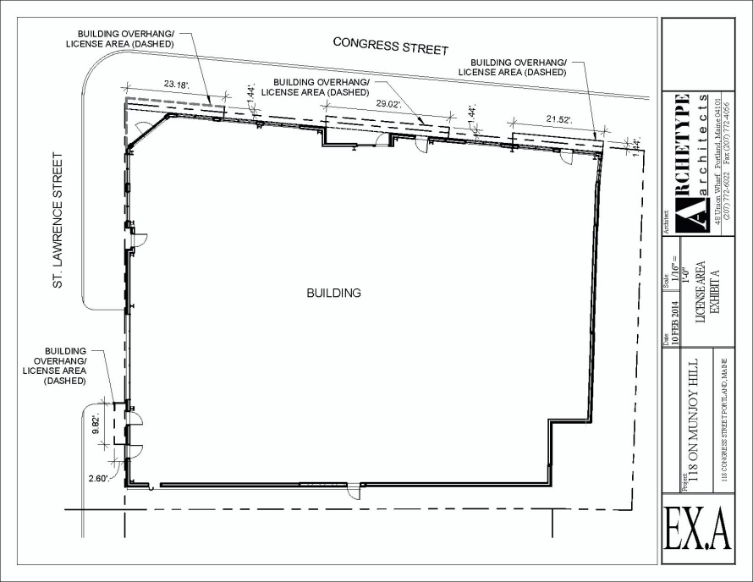

Updated 3.31.2014

