**118 Congress Street**

**Bike Racks**

1. **Proposed Amendment to an Approved Plan:** On Wednesday, March, 18th, David Lloyd, representing Chip Newell, applicant, requested an amendment to the approved site plan to install a custom made bike rack in the public right-of-way parallel to the curb line. As part of the submission, Chip Newell has offered to have the condominium maintain and replace the bike rack (e-mail attached).

* 



1. **Approved Plan: and Technical Manual Standards:** The custom rack was submitted in the original submission, but the final approved plans show two Dero bike racks meeting the City’s standards located in the public sidewalk (shown above). Since the plan showed the required type of bike racks in the public right-of-way, this was not raised as an issue. An excerpt from the Transportation Section of the Technical Manual is as follows:

*The following approved brands, installed according to company specifications,*

*shall be permitted in the public right of way. Equivalent bicycle racks by other*

*manufacturers are acceptable upon approval by the reviewing authority.*

*• DERO ‘Downtown Rack’ Inverted U-Rack (Figure I-35)*

*• DERO ‘Bike Hitch’ (Figure I-34)*

*• Old Port District, including Commercial Street: DERO Bike Hitch only*

*(Figure I-34)*

*Bicycle racks in the public right of way shall become the property of the City of*

*Portland.*

*Bicycle racks in the public right of way shall match the designated street*

*furniture color for that location as described in the Municipal Street Lighting*

*Standards in this manual. Where there is no designated street furniture color,*

*bicycle racks in the public right of way shall be black (manufacturer’s*

*specification.*

1. **Certificate of Occupancy:** Prior to the formal submission, this question was asked of Phil in regards to the C of O. I had discussed this with DPS who did not support a substitution. In addition, I had the precedent of an earlier decision with the Press Hotel (see background below). I had advised Phil to recommend that they put the specialty bike rack on their private property (either near the rain garden or near the lobby door) and retain the two Dero racks in the right-of-way. On Thursday, March 19th, we have received their formal request to put the bike rack in the right-of-way parallel to the curb line.
2. **Review:** Bruce’s comments regarding this specific request are as follows:

If it's on private property, we can approve it if I get more details on materials on placement, etc.

If it's in the public ROW we will not likely approve it (unless it was explicitly ALREADY part of the signed off/approved site plan). It would need to be a Bike Hitch or the Downtown Rack. We turned down a similar custom bike rack at the Press Hotel within the public ROW.

We currently only have guidance to say we approve "or equivalent" to the Bike Hitch/Downtown Rack, to my knowledge, within the public ROW.

Barbara can provide some background on this based upon our Press Hotel disapproval.

At the DPS meeting and the Development Review meeting, Tom Errico questioned the functionality of this bike rack. The longterm maintenance was also raised along with support for a unified municipal streetscape for such features, so it is clear the rack is for public use. Also, as designed it is hard to distinquish this as a bike rack versus signage for the building.

1. **Background :** The Press Hotel also asked for a specialty bike rack, which we did not approve. Here are my comments from that review:

Bike Racks:  Deb Andrews, Caitlin Cameron, Bruce Hyman and I have looked at the proposed bike racks.  While the design is attractive, Deb articulated well the urban design goals for the public infrastructure.  The technical manual calls for the Dero bike hitch and we concur that the city standard should be used in this location.   Bruce did ask to see the actual dimensions on the site plan for distance between the curb line (need a minimum of 24").   A minimum of 8" is needed for separation from raised granite planters, but I assume you will proceed with the flush grates.

The Portland Forge asked for clarification of the decision on the hotel and this is the e-mail that I sent after additional discussions with internal staff:

While the design of the proposed  bike rack was attractive and related to the Hotel, the City needs to consider the desired continuity of neighborhood streetscape features.  Consistent treatment of sidewalks, tree wells, and other features are intended to knit individual buildings into the larger public streetscape.   In addition, the City becomes responsible for the maintenance and replacement of public infrastructure located within the street right-of-way.  Thus Portland's Technical Manual specifies the requirements for infrastructure to be installed in the city right-of-way, including the standards for the bike racks.  <http://me-portland.civicplus.com/DocumentCenter/Home/View/2353>  Refer to pages 65 and 66 in the Transportation section for bike racks.

The technical manual has specifications for street lights that are chosen to reflect the character of specific neighborhoods.  The city is open to considering alternative bike racks that meet functional requirements, quality of materials/finish, cost effective to maintain,  and relate to the neighborhood context.  This would require amendments to the Technical Manual that must be adopted by the Planning Board.    Bruce Hyman, Transportation Program Manager, is aware of your interest and others to consider alternatives.  Currently, the position for the bike and pedestrian coordinator is vacant, but it is something that could be considered at a later time.

Please note that bike racks that are proposed on private property do not have to be the Dero Lock bike rack, so creative and functional alternatives can be proposed on private property.

1. **Staff Recommendation:** The staff continues to recommend that the custom made bike rack be located on the private property and to retain the two Dero bike racks in the public right-of-way.

**Parking Garage – Grit Separator**

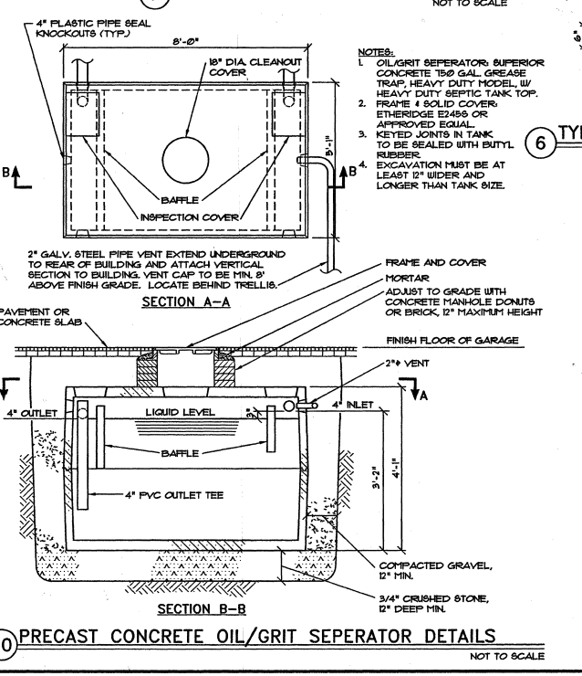

1. The plans for 118 Congress Street included a oil/grit separator in the structured parking area. The construction detail is inserted and it was shown in the floor of the garage on the site plan.

The applicant has submitted the plumbing contractor’s analysis that grease/grit separators are not required under the State plumbing code (attached)

1. While the applicant argues that this is not required in the Maine, the following are the comments from David Senus:

During review of covered parking structures, the City of Portland Department of Public Services has consistently required Applicants to provide a structure designed to remove oil and grit from the floor drain system prior to connection into the City’s Combined or Sanitary Sewer System. This is typically a stand-alone structure designed with a sump and a down-turned outlet with oil/floatable storage capacity in the configuration shown on the 118 Munjoy Hill Plans (sheets C1.4 & C1.7), dated 3/27/2014.  Although there is no specific code reference that I can point to for this requirement for parking garage areas, the City never allows runoff from a paved/traveled area to enter their system without some means of grit/sediment removal. Specifically the City of Portland Technical Manual requires 3’ deep sumps on all catch basin structures, along with a Casco Trap or Snout on the outlet:

* ***City of Portland Technical Manual 2.7.6. All catch basins shall be constructed with a minimum sump of 3’.***
* ***City of Portland Technical Manual Figure II-2 and II-9 reference and show Casco Traps for catch basin outlets***

In summary, in a typical parking garage scenario, floor drains can be designed to flow through an oil and grit separator or can be collected in City of Portland Standard catch basins with 3’ deep sumps and a trap on the outlet.  My understanding is that neither of these items have been installed at the 118 Munjoy garage.

Covered garage spaces receive a significant amount of sediment, grit and oil drippings from vehicles, arguably just as much as uncovered parking spaces.  The runoff from covered garage spaces tends to be very dirty, as it concentrates and is typically flushed out when the garage area is washed out.

If a covered garage space was designed to drain (at the surface) to the street, in other words no floor drains or internal collection system, the runoff would enter into the City’s catch basin system which includes sumps

1. **Staff Recommendation:** The staff offered the option of the catch basin described by David above that could be installed inside the garage or outside. If it is outside in the driveway apron (within the street right-of-way), then a license or agreement that the condominium association would be responsible for all maintenance and replacement would be required. The applicant’s engineer has indicated that there is insufficient space in the driveway apron due to underground utilities. While the floor drains do have baskets for collection of debris, the units do not handle oil and need frequent cleaning. DPS felt those units were not adequate. DPS is requesting an alternative that more effectively addresses grit, oil and floatables.