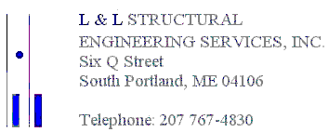

September 5, 2017

Otavio Lattanzi
65 Merrill Street
Portland, Maine 04101

Dear Otavio,

We reviewed your request regarding the existing building located at 65 Merrill Street in Portland, Maine to continue the rear shed dormer (detailed in Section 1A/S4 on the structural drawings prepared by our office) to the exterior wall of the building. It is acceptable to continue the shed dormer to the exterior wall which results in Section 1/S4 becoming obsolete and continuing the framing indicated in Section 1A/S4 to the end exterior wall of the building. The roof framing drawing S3 will not be affected except for the 12/12 pitch indicated on the rear corner (as the roof framing plan is oriented on the drawing) of the roof will be omitted and the 7.5/12 pitched roof will continue to the exterior wall of the building. The proposed structural design meets or exceeds the code stipulated design requirements, is acceptable to support the anticipated structural loading, and is in general compliance with our structural design concept.

If you have any questions or require any additional technical assistance, please do not hesitate to call.

Sincerely,

L&L Structural Engineering Services, Inc.

Joseph H. Leasure, P.E.
Principal
File

