Elizabeth Spencer Adams
49 Merrill Street
Portland, ME 04101

Planning Board
Planning and Urban Development Department
Planning Division
City of Portland
389 Congress St
Portland, ME 04101

Re: 30 Merrill Street

October 4, 2016

To the Members of the Planning Board and Planning Division Staff:

My husband Peter and I live at 49 Merrill Street. We also own a two-family house at 51 Merrill and an empty lot across from our house at 46 Merrill. We attended the neighborhood meeting and I have met with Helen Donaldson who very kindly helped me to better understand the review process. The following are my concerns, the first one an overarching concern and the others relating to specific aspects of the proposed design.

Increased R-6 density means large buildings in neighborhoods of smaller homes. The Board must carefully consider the Design Guidelines in this situation to preserve the character of our neighborhoods.

My overarching concern is the immediate and cumulative effect of allowing construction of large infill buildings that fail to respect the architectural details of the neighborhood. Munjoy Hill is an extremely important neighborhood to the city, drawing a wonderfully diverse group of residents and providing an excellent tax base. The Hill, and Merrill Street in particular, are susceptible, however, to irrevocably losing their character given the number of empty lots, tear-downs, and smaller homes that seem likely headed for tear-down in the not distant future. The strong profit motive to capitalize on the new infill regulations by constructing the maximum number of units at the lowest possible price appears to be irresistible. The Planning Board needs to step up and be sure that an unintended consequence of the R-6 infill regulations is not a proliferation of maximum size/minimum cost buildings that are totally alien to the design elements of the neighborhood. It may not be the tear down of Union Station, but it will be a real shame for us and for the city if unrestrained R-6 infill destroys our neighborhood.

I would to emphasize the fact that 30 Merrill sits at the boundary between the large apartment buildings to the south and the small residences to the north. To the south of 30 Merrill (towards Congress) are a few small residences plus two 5–10 family buildings and one 10-20 family building. Around the corner on Cumberland are several more large apartment buildings. At present, Merrill Street from Cumberland Avenue north (towards Melborne Street) consists of 9 single-family homes, 4 two-family homes, 2 three-family homes, 2 vacant lots and 1 office/business building. Most are older buildings and the few new ones preserve the architectural flavor of the neighborhood. The map below shows the size of the buildings in the nearby neighborhood and demonstrates the demarcation between the large apartment buildings to the south and the small residences to the north.

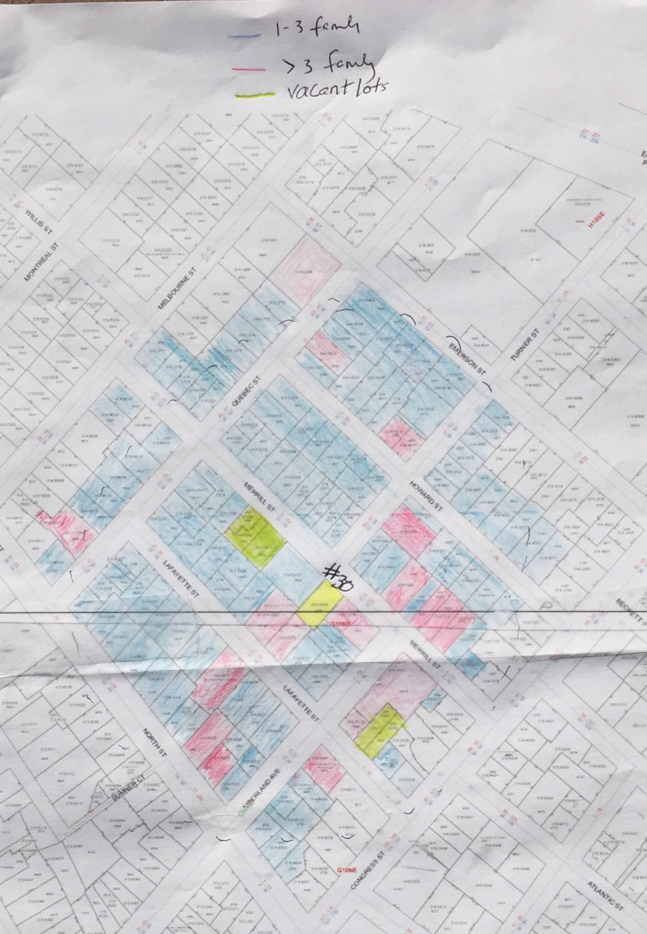

The architect and developer consistently ask the Planning Division to look south towards the large buildings for its claimed support for the design. They make no mention of the rest of the neighborhood except to mistakenly refer to the doublewide triple deckers “that exist throughout the neighborhood.” They do not. It is critical that these new large infill structures are sympathetic to the entire neighborhood, not just those structures that are purportedly similar on just one end of the street. And it is important to recognize that if the Board relies just on the design elements of the large buildings to the south towards Congress Street, the next R6 infill project on the street may do the same, and the next and the next, with a potential domino effect that overwhelms the neighborhood with large insensitively designed buildings.

The proposed project fails to consider the “overall context” of the neighborhood

This building does not in any recognizable way reinforce positive features of the surrounding area. Within the block the unique identity of the large buildings to the south are their bays and cornices and mansard roofs, to the north, for the smaller residence are their gable ends, their bays, window shapes and emphasized entrances. It is not impossible to design a larger building that is sympathetic to an existing neighborhood of smaller residences. An excellent example is the new 5-family building at 72 Munjoy Street. Although it is the largest building on the street it, it does not overwhelm the neighborhood; rather, it adopts numerous of the existing characteristics of its neighborhood and employs them in its design.
. 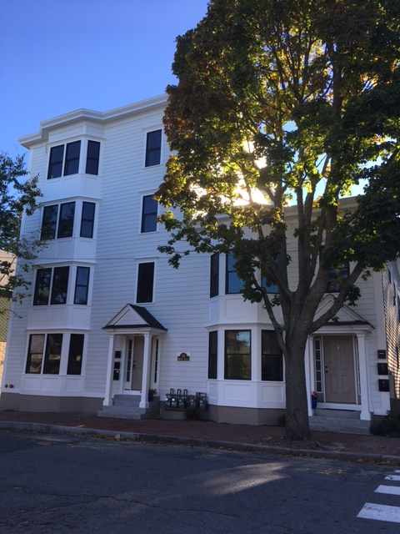
72 Munjoy Street

Furthermore, contemporary architecture is not anathema to the neighborhood. 39 Lafayette a beautifully designed single family home that at 1360 sq. feet is roughly 1/5th the size of the proposed structure.
.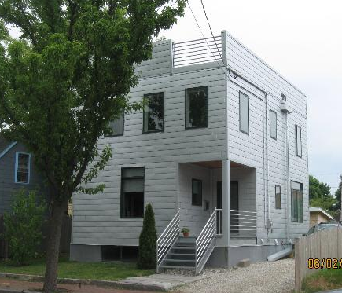
39 Lafayette Street

39 Lafayette incorporates the window dimensions of neighboring buildings, has a strongly recessed entry with steps, and is clad in horizontal material evoking the clapboard found throughout the neighborhood. The excellent design and small scale of 39 Lafayette makes it an interesting and respectful counterpoint to the older architecture in the neighborhood. The proposed design for 30 Merrill is 5 times larger than 39 Lafayette and will loom over the neighboring houses to the north. Because of its size it will have a very significant impact on the neighborhood making it imperative that its design embrace the context of the neighborhood, reinforcing its positive features and demonstrating compatibility with the nearby buildings. This is not to suggest that blowing 39 Lafayette up to five times its size would be an appropriate design for 30 Merrill. I am pointing out that contemporary design is not the problem. Non-contextual design is the problem.
Lack of Articulation

As for the balconies that the architect relies on heavily to satisfy the B-5 façade articulation standard (this because no other of the architectural elements of facade articulation exist: no gables or dormers, no recessed entry, no bay windows, and surely the small awning over the entry does not constitute a “covering”), the railings across the sliding doors used as windows do not in any way read as balconies and if they are also designed “pay homage to the traditional bay window,” ( a two’fer? balcony and bay?) they have missed the mark by a long shot. And does not Standard D-3 state that balconies must be a minimum of 6 feet in depth? What is presented to the Board as a balcony (or bay) in an attempt to satisfy the facade articulation standard in fact neither actually articulates the building nor does it create an impression of articulation. The most recent iteration has created an indentation running from the ground to the 3rd floor along the vertical line above the “front door.” Although it is an improvement to my eye, it is inadequate to satisfy the articulation standard.

Recent contemporary apartment buildings and condominiums developed in Portland in commercial areas have more architectural detail than the current 30 Merrill design. The Redfern development at 89-91 Anderson is one example, with real balconies, a true recessed front door above ground level, and significant “in and out” of the façade.

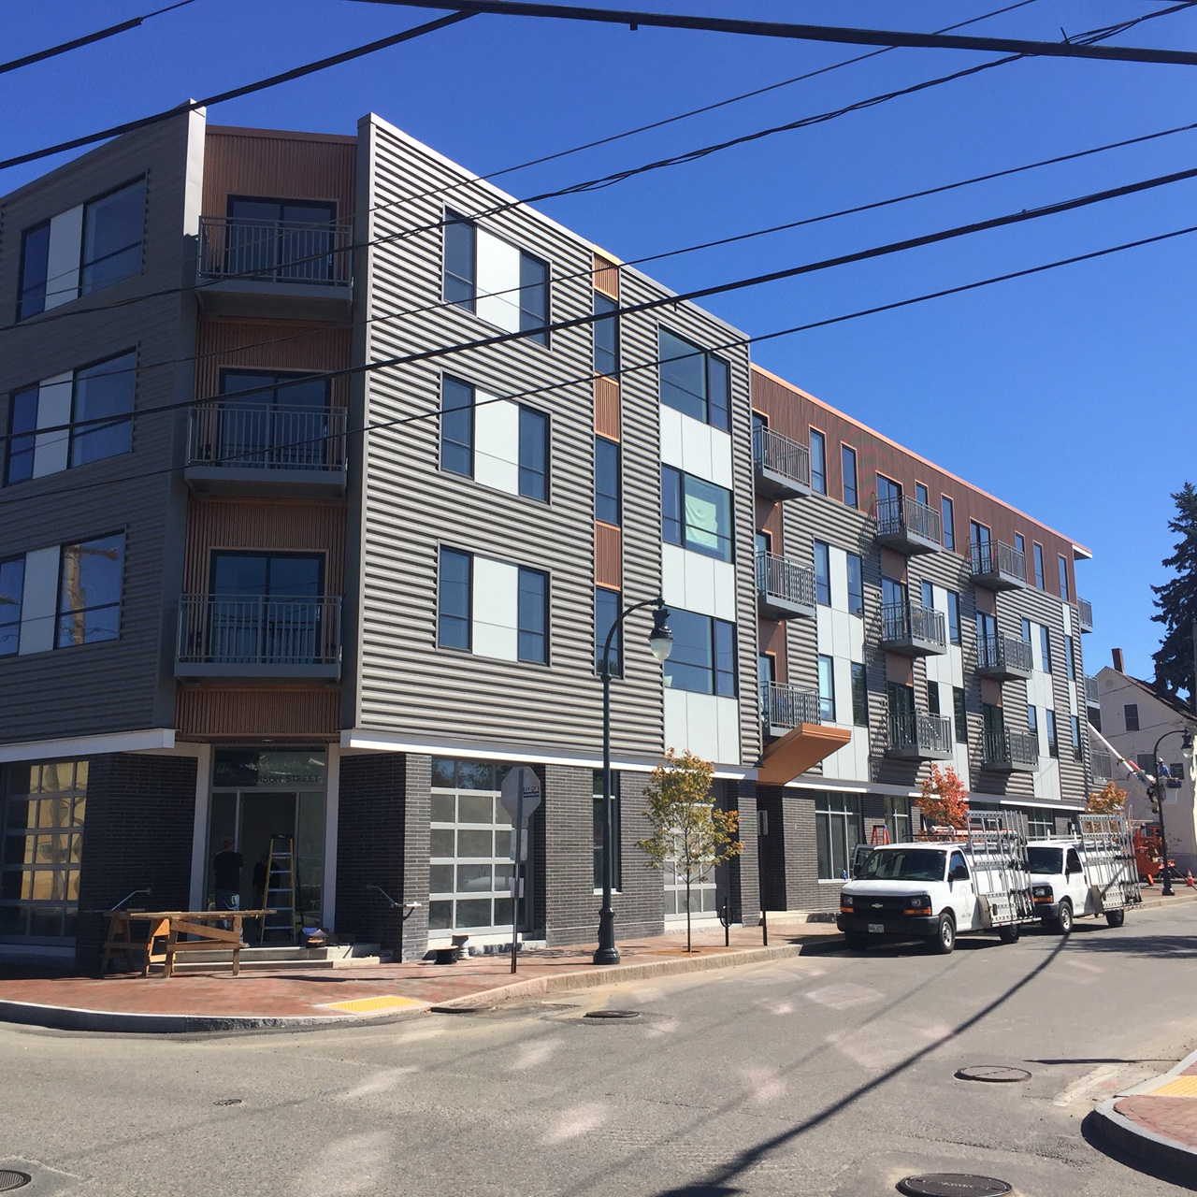
89 – 91 Anderson Street
The Avesta building at 409 Cumberland, presumably built with minimizing cost forefront in the mind of the developer, is superior in articulation to the 30 Merrill design. And this building sits in a neighborhood of other very large square commercial buildings.

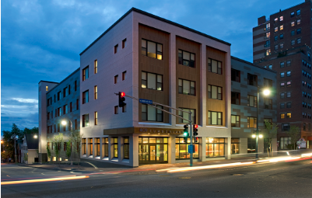
409 Congress Street

Massing and Roofing

Most definitely, when considering design, size matters. The bigger the project, the bigger the impact of the design, the bigger the effect on the neighborhood. The architect argues that the proposed building has massing and roofing much like the double-wide triple decker buildings “that exist throughout the neighborhood.” I believe he is referring to the three large multi-families towards Congress Street on Merrill and the several nearby on Cumberland Ave. Otherwise, I can find no double-wide triple deckers in a 2-block radius. There are a few two-entrance buildings, but no double wide triple deckers which seems reasonably interpreted to mean this:
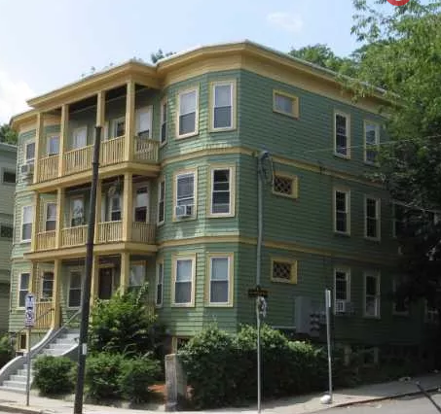
And, of these nearby early 1900’s multi-family buildings that might possibly be described as a double-wide triple decker, those that have flat roofs all have substantial bay windows and a large cornice created by the protrusion of the bays giving them significant articulation. The others have attractive mansard roofs creating harmony with a number of smaller mansard houses in the neighborhood and making the 3rd floor part of the roofline, thereby lowering the impression of the height of the building. The large boxy 4-story shape of the proposed 30 Merrill building has nothing in common with these earlier buildings other than size. And notably, again, these are all to the south, towards Congress street and most definitely not “throughout the neighborhood.” Perhaps the architect is referring to the new construction at 33 Lafayette that he designed. However, I don’t think anyone would refer to that as a “traditional double-wide style.”

The “Front Door “Is Not a Real Front Door

Design Standard C-1 states: “Emphasize and orient the main entrance to the street.” The 30 Merrill design includes a minimally-enhanced “main entrance,” which we learned at the neighborhood meeting is not a main entrance at all. In fact, it is an entrance to the basement that contains only storage areas for the units. It seems to be the argument that so long as it looks like a main entrance that is enough. It is not. There is a rationale behind this design standard that has been well articulated by numerous urban designers (Jan Gehl , Cities for Real People; Jane Jacobs, The Death and Life of Great American Cities; Christopher Alexander, A Pattern Language), planners and articulated in municipal standards. The rationales relate to the life of the street, community, walkability, and the safety of the inhabitants and passersby.

The interaction between people living on and walking along a street happens at the front door and in the “transition space” between the sidewalk and the door. People pause at the front door to find their keys and someone walking by says hello. A conversation starts and they linger chatting for a few minutes, community begins to form and street life is enhanced. In the proposed design, the residents will use the front door only for storage purposes, occasionally putting a bike in or out a few months of the year, pulling out the snow tires, grabbing skis for a weekend trip. This is not the 2, 3, 4, 5 times a day in and out of a building to go to work, run for groceries, make a trip to the gym, etc. that happens from the true main entrance to a building. Instead, they will enter the building at the back, unseen by passersby, a much less safe proposition, and much less likely to result in contact with the neighborhood. And will they linger at the sidewalk? Not if they are already in their car, of course, and even if on foot, they will have already begun their walk to wherever they are going and are not in a transition space and are far less likely to pause. Jane Jacobs explains that

A central challenge of [a] city, therefore, is to make its inhabitants feel safe, secure, and socially integrated in the midst of an overwhelming volume of rotating strangers. The healthy sidewalk is a critical mechanism for achieving these ends, given its role in preventing crime and facilitating contact with others.
.
Standard C-1 requires that the main entrance either be at the front of the building or on a covered porch to the side that extends all the way to the front of the building. It makes a mockery of this design standard to interpret it to mean that something that looks like a front door is good enough. It also fails to add to the city’s goal of walkability and health. Sam Newburg in his 2014 article “Front Doors and Walkable Cities” writes:

A city that is genuinely trying to be walkable must not only build public infrastructure that truly prioritizes the pedestrian, not just accommodates them, but also has buildings that relate well to those streets, and therefore front doors are very important. In a perfect world, a common sense approach would suffice; if the developer, architect and planning commission agree they’d be comfortable walking in and out of that door every day, then it is probably good enough.

The current design cannot even attempt to pass the test of “be[ing] comfortable walking in and out of that door every day” because it is not actually a main entrance that one will walk in and out of on any regular basis. That it might be dressed up to look like a main entrance is most definitely not good enough.

Finally, on this point of where the true main entrance is sited, the requested waiver for a narrowed driveway aisle makes stopping to visit even less likely for a resident who must take care not to be hit by a fellow resident turning into or coming out of the driveway. Many design standards require a full walkway in the event that an entrance to a building is at the back so people coming and going are not walking along a driveway. Not having a walkway is bad enough; narrowing the driveway is clearly unsafe.

Street Level Front Door

There is absolutely no precedent for street level front doors in residential buildings on Merrill Street. And the examples cited by the architect are all buildings that have attractive primary entrances on the side. The street level doors on the buildings he refers to are basement doors and they look like it.
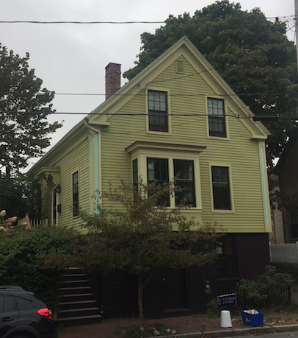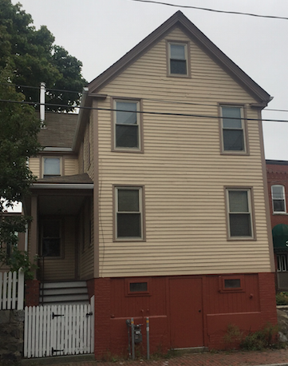

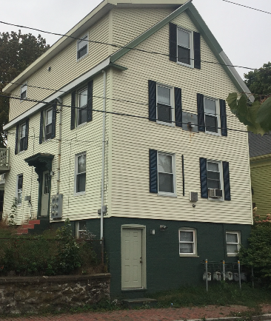

Windows

One of the reasons the building looks so out of place in the rendering is the size and horizontal effect of the front windows. The windows are in fact two sets of sliding doors put together and the net effect is a window of 11’10”H x 6’9 ¾”W, most definitely horizontal in effect. Again, there is nothing like this on Merrill Street. This design fails to recognize and be responsive to the patterns and characteristics of the buildings of the neighborhood. In addition, it ignores the design standard relating to windows (D-1), which states that the majority of windows shall be vertically proportioned, and encourages classic proportions. These grouped sliding doors are neither. In addition, it is startling to see first floor windows of this size. They would be appropriate for a commercial space, but despite being 48” from the ground are not in keeping with a first floor living space and again fails to find any sympathy with the predominant design features of the neighborhood. Where such large windows do exist on Congress Street they are all office and retail spaces, not residential.

In summary, given the very significant impact of this building on the neighborhood, it is vitally important that great care and time be given to assuring that the building meet all the applicable design principals and standards. It is a disappointment that there was no pubic workshop to allow for a more cooperative approach to the challenges presented by this design. It is incumbent on the Board to proceed carefully as it develops a thoughtful and fair approach to allowing R-6 infill while protecting the neighborhoods where this development will occur.

Thank you for your consideration.

Elizabeth (Lisa) Adams
49 Merrill Street

Additional signatories:

Peter Adams
49 Merrill Street

Carolyn Swartz
27 Merrill Street

Wayne Valzania
27 Merrill Street

Britt Knowlton
43 Merrill Street

Stephanie Doyle
43 Merrill Street

Teo Doyle
43 Merrill Street

Tim Adams
38 Howard Street

Birch Hincks
38 Howard Street

Gene Stone
34 Merrill

Cyrus Hagge
45 Turner Street
Katy Harkleroad
47 Howard Street

cc: Evan Carroll

