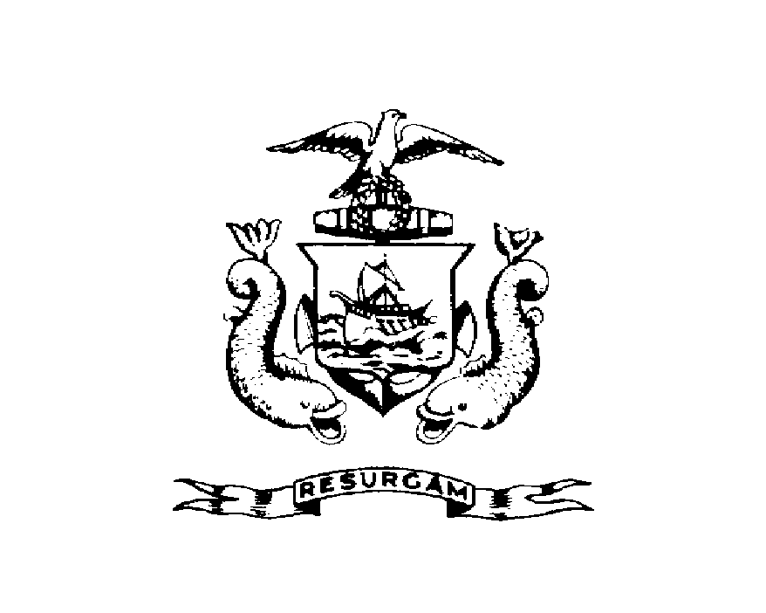
Certificate of Occupancy
CITY OF PORTLAND, MAINE
Department of Planning and Urban Development
Building Inspections Division

Location: 108 CUMBERLAND AVE CBL: 013- M-001-001

Issued to: Ralph W. Lamb/Otto’s Take Out Date Issued: 12/30/2011

This is to certify that the building, premises, or part thereof, at the above location, built-altered-changed as to use under Building Permit No. 2011-09-2320-ALTCOMM, has had a final inspection, has been found to conform substantially to the requirements of the Building Code and the Land Use Code of the City of Portland, and is hereby approved for occupancy or use, limited or otherwise, as indicated below.
PORTION OF BUILDING OR PREMISES APPROVED OCCUPANCY
Entire Use Group B, Type 5B, IBC 2009
Limitations – Occupancy expires on 1-13-2012 without Fire Department approval or an extension has been granted.
Approved:

12-30-11
(Date) Inspector Inspections Division Director
Notice: This certificate identifies the legal use of the building or premises, and ought to be transferred from owner to owner upon the sale of the property.

