Memorandum
Planning and Urban Development Department
Planning Division

To: Chair Morrissette and Members of the Portland Planning Board

From: Jean Fraser, Planner

Date: October 18, 2013

Re: October 22nd Planning Board Workshop
Level III Site Plan and Subdivision:
Munjoy Heights
29 unit condominium, 79 Walnut Street
Jonathan Culley, Redfern Munjoy LLC

- Introduction
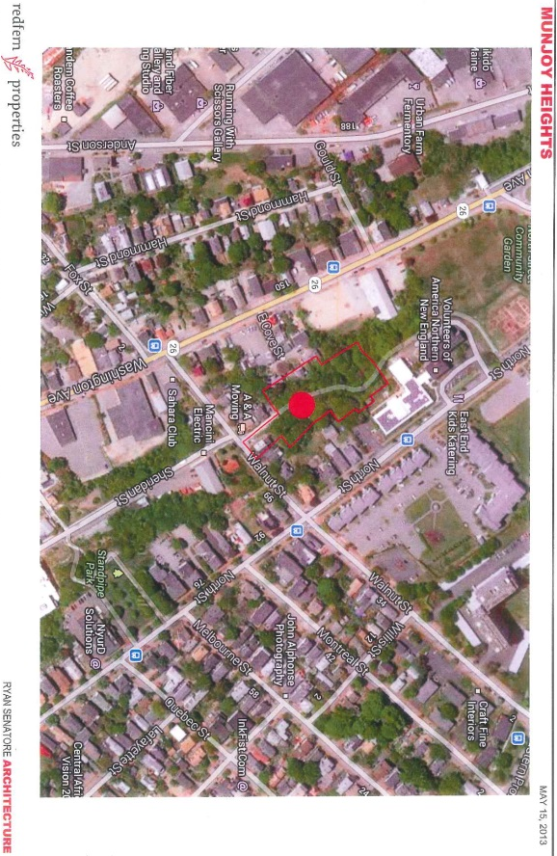
Jonathan Culley has submitted a Level III Site Plan and Subdivision application for the construction of a 30 unit residential subdivision made up of 29 new units in six 3-4 story townhouse-style buildings and one existing residential building on a reconfigured lot. The 1.59 acre site is within the R-6 zone and comprises 7 contiguous parcels (currently subject to Purchase and Sale agreements) on the western face of Munjoy Hill just below North Street. The site includes three existing residential buildings, of which two will be demolished and one will be retained on a reconfigured lot. The area is vegetated with mature trees and bisected by a well used Portland Trail (“Jack Path”).

The access from Walnut Street is located over what was thought to be a paper street, as shown as an extension of Sheridan Street on the City’s zoning map. The applicant’s attorney has confirmed (Attachment E) that the street was not preserved as a paper street and therefore there are no public rights of access. The existing home that will be retained with a reconfigured lot is currently accessed from North Street and that will not be altered.

The applicant held a Neighborhood Meeting on October 16, 2013 which was attended by 27 people- the attendance list and notes of the meeting are included in Attachment B. The Planning Division has received one public comment relating to connectivity (Attachment 9 (a)). Staff have spoken with Portland Trails and understand they have met with the developer and will be making formal comments when the design is further developed. A color montage of possible “mews” design approaches for the access driveway was prepared by and circulated widely by members of the public, and is included for information in
Attachment 9 (b).

This Workshop was noticed to 485 neighbors and interested parties, and the public notice appeared in the Portland Press-Herald on October 14th and 15th, 2013.

Required reviews and requested waivers (Attachment I):

Applicant’s Proposal | Applicable Standards
New residential structures totaling 29 units and one existing residential building with reconfigured lot (total of 30 “lots”) | Subdivision Review
Four Multifamily buildings totaling 70,756 square feet floorspace | Level III Site Plan Review and Multi-family Design Review
Bicycle Parking Spaces- waiver requested from the requirement as each unit has a garage that bicycles may be parked in. | Ordinance 14-526 Site Plan Standards requires 2 bicycle parking spaces for every 5 dwelling units, which would be 10 bicycle parking spaces for this project. Resident and visitor parking is addressed by this standard.
Motorcycle and Scooter Parking- waiver requested as garage would provide the required parking space. | Ordinance 14-526 Site Plan Standards requires the site plan to “accommodate access and parking” for such vehicles.
Street Trees- waiver requested locate required street trees within the property given limited street frontage | Ordinance 14-526 Site Plan (and Section 4.6 of the Technical Manual) requires one tree per unit planted in the City Right of Way. Ordinance 14-499 Subdivision Standards requires street trees “planted near the street line in full public view on private property”. Contribution to the street tree fund is an alternative.

- PROJECT DATA

SUBJECT | DATA
Existing Zoning | R-6
Existing Use | Undeveloped land, vegetated (large trees); Portland Trail path; 3 existing residential buildings (2 to be demolished; 1 to be retained on reconfigured lot)
Proposed Use | 29 units in 6 new buildings plus 1 existing reconfigured lot
Parcel Size | 1.59 acres
Impervious Surface Area  --Existing  --Proposed  --Net Change | 6,113 sq ft  38,992 sq ft  32,879 sq ft
Total Disturbed Area | 1.59 acres
Building Footprint  --Existing  --Proposed  --Net Change | 2,773 sq ft  22,333 sq ft  19,560 sq ft
Building Floor Area  --Existing  --Proposed  --Net Change | 4,484 sq ft  75,240 sq ft 9including garages)  70, 746 sq ft
Residential  --Proposed no. of affordable units  --Proposed no of res. buildings to be demolished  --Proposed no of res. units to be demolished  --Proposed no. of new residential units  --Proposed number of lots in subdivision | 0  2  5  29  30
Parking Spaces  --Existing  --Proposed | 0 (except driveway for retained existing buidling)  29 garages; 5 outside
Bicycle parking Spaces  --Existing  --Proposed | 0  0 outside;- each unit has garage
Proposed Paved Area | 16,659 sq ft
Estimated cost of project | $11 million

- EXISTING CONDITIONS
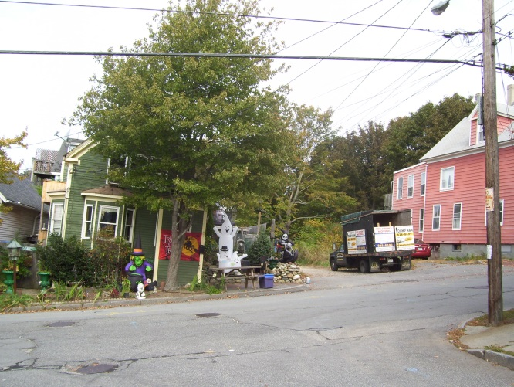
This 1.59 acre site is made up of 7 parcels/part parcels which has resulted in an irregular shape but also provides extra land to incorporate slope stabilization measures. Much of the slope is at 25% and this presents geotechnical and stormwater challenges as indicated in the Geotechnical reports/comments (Attachments N and O) and in the staff comments (Attachment 3). Also it is almost entirely wooded.

The proposal site is located on the north side of Walnut Street opposite where Walnut meets Sheridan Street. Currently there is a gravel road that provides access to the abutting residential buildings. This gravel road is indicated as a paper street on the City’s zoning map, but the public rights in this street were inadvertently released (due to an incorrect plan reference in 1997) and it is now private (Attachment E).

The red building has been purchased by the applicant; it contains 4 residential units and is proposed to be demolished. The gravel road leads to the start of the Portland Trails “Jack Path”.
From Sheridan looking across Walnut
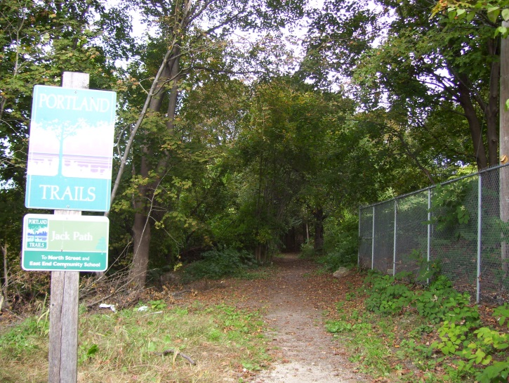
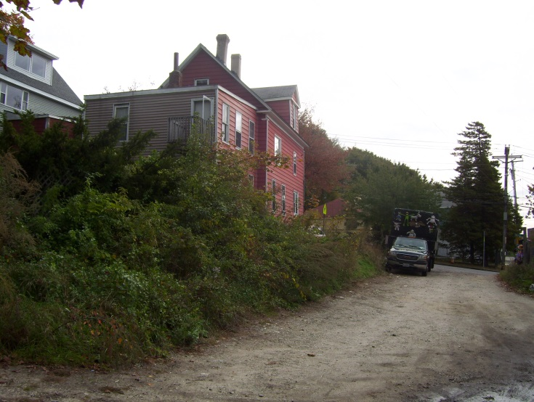
Gravel road within site leading to Walnut, private Start of Jack Path” near Walnut Street

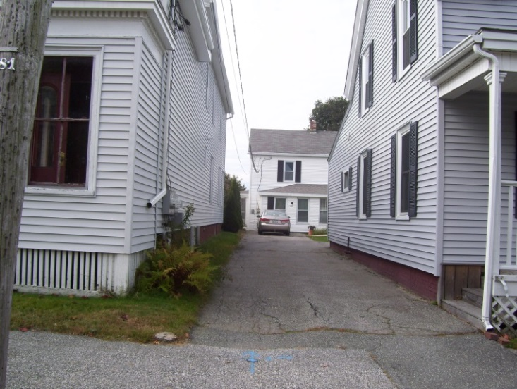
Uphill (east) the site abuts 2 residential properties on Walnut Street and one on North Street (not including the one to be demolished). Several other residential properties on North Street “overlook” the site (current view is into mature trees). The abutting property has been purchased by the applicant and its lot has been reconfigured. Its access remains from North Street via an easement over the driveway of the nearest house.

The site also abuts Bayview Heights, an elderly housing complex operated by Volunteers of America.

From North Street looking west towards site

To the north the “Jack Path” continues from the site and wraps around the rear of Bayview Heights to meet North Street at the community gardens and opposite the East End School. The METRO bus route #1 runs along North Street.
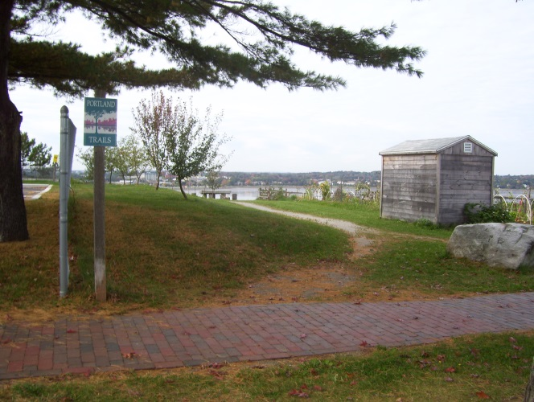
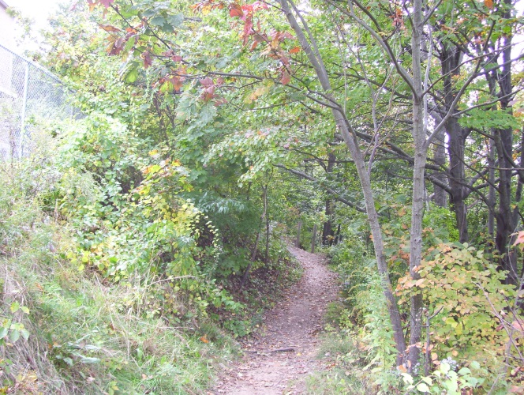

Jack Path just below Bayview Heights Jack Path where it meets North Street (Back Cove in background)

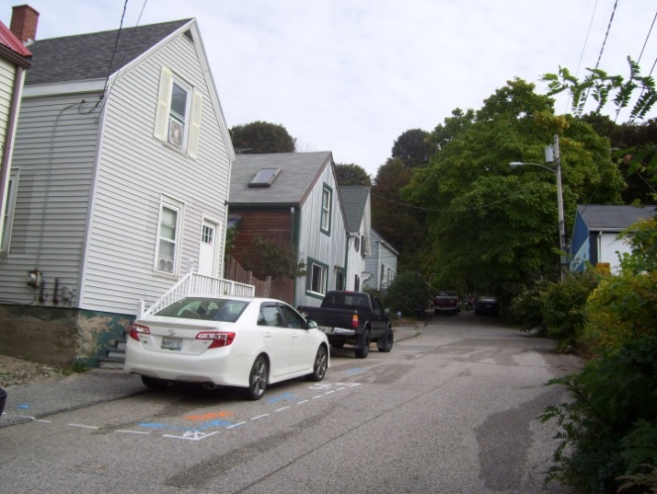
Downhill (west) is largely wooded, with the exception of two residential abutters on the private graveled section of Sheridan Street and the two homes at the end of East cove Street. The home at the north end of East Cove Street nearest the project site has been purchased by the applicant and will be demolished.

At the end of East Cove Street there is a fairly steep hill up into the site.

AT

East cove Str
East Cove Street is not an accepted street and does not have sidewalks; it leads to Washington Avenue and the Metro Bus route #6 runs along Washington Avenue with stops nearby. East Cove Street, looking uphill from Washington Ave.

- PROPOSED DEVELOPMENT
The three different versions of the (preliminary) site plan (Plans 4-6) illustrate the proposed layout and how the development relates to the surrounding area. The solid black lines denote high (20ft +) retaining walls (details in Plans 10 and 11) and the need for these and associated regrading has resulted in almost total disturbance of the site and loss of most trees.

The proposals are preliminary at this stage so the plans are still under development; a Landscape Plan has not been submitted. The applicant has commissioned a tree survey (all trees over 10” dbh) to inform the preparation of a detailed Landscape Plan.

The preparation of a Landscape Plan is also dependent on feedback regarding the treatment of the area between the two rows of buildings. The site plans show a sidewalk and road way but public and staff suggestions favor a shared pedestrian/vehicle space which could include more landscaping and possible LID stormwater treatment and functional open space areas (eg community gardens). The applicant has responded to these suggestions and more recently submitted the images in Plans 20 and 21 to provide more information on the design approach and provide a street-level rendering of how materials and landscaping might be introduced into this area. (Also see the discussion in Section V C.).

An architectural design narrative is included in Attachment F and Plans 12-19.

- STAFF REVIEW
This is a preliminary submission and staff have focused on identifying key issues and concerns. Some ordinance headings have not been discussed because the proposals are not at that level of detail.

        - ZONING ASSESSMENT

- Zoning Requirements
The proposed subdivision is within the R-6 Residential Zone. The applicant has submitted a Zoning Analysis in Attachment G which suggests that 58 units potentially may be allowed as compared to the 29 dwelling units proposed. The lot coverage is at 32% (maximum allowed is 40%) and it is not known whether Lot #30 (the existing home with reconfigured lot) has been excluded from the total site area used for this calculation. It appears that the proposal is not at the maximum allowable density for the site, but how far below will be clarified for the Workshop.

Comment from Marge Schmuckal, Zoning Administrator, were not received at the time this Memo was finalized and will be circulated at the Workshop.

- Housing Replacement
The applicant has purchased two properties that are proposed to be demolished (1 East Cove Street and 79 Walnut Street) and this would result in the loss of 5 dwelling units (Attachment P). The proposed 29 units will provide replacement but the Housing Replacement Ordinance requires a Performance Guarantee for the replacement (to be paid at the time of demolition) and includes other requirements regarding the noticing of the tenants etc that the applicant would need to comply with. Staff recommend inclusion of a condition on any approval relating to the Housing Replacement ordinance provisions.

B. SUBDIVISION STANDARDS

14-496. Subdivision Plat Requirements
The applicant has not submitted a draft Subdivision Plat and this has been requested. The Plat will show 30 “lots”: 29 new residential units in six multi-family buildings, plus one existing reconfigured lot (with existing home on it). Staff have noted that the final plans need to be stamped by a professional engineer and the Boundary Survey needs to be finalized and stamped by a Maine Licensed Professional Surveyor (Attachment 3). Draft Condominium Association documents are also outstanding; these should be submitted as soon as possible so that the relationship with Portland Trails regarding the “Jack Path” and the public access easement can be better understood.

14-497. General Requirements (a) Review Criteria

Water, Air Pollution and Soil Erosion
The provision of water to the site appears to have some complications and requires a new 8 inch supply, as outlined in the Portland Water District 8.23.13 letter (Attachment L). The Consulting Reviewing Engineer (David Senus of Woodard & Curran) has requested further information (Attachment 3). Plan 8 has been submitted to address erosion control.

Traffic and Vehicle parking
The proposed 29 new townhouses would be accessed by a new (private) drive from Walnut Street and the applicant has submitted a Traffic Assessment (Attachment K). Tom Errico, the Consulting traffic Reviewer, has commented (in relation to the impact on the surrounding streets and parking) (Att. 2):

- I have reviewed the traffic analysis report prepared by Bill Bray, P.E. and concur with the conclusions that the project will not cause traffic or safety problems to the public street system.
- The proposed units will be providing at least one parking space per unit and therefore I find parking conditions to be acceptable.

Sanitary Sewer
The applicant has submitted a Utility Plan (Plan 7) and DPS have noted that “Plan details, plan /profile showing invert elevations, pipe size/material and slopes will be required for the proposed stormwater and sanitary sewers.” (Attachment 7).

Soils/Geotechnical Issues
The applicant has submitted a Preliminary Geotechnical Report and supplementary information (Attachments N & O). The Report has noted that the proposed grading at the site will require the construction of retaining walls near both the east and west property lines, and that the walls are estimated to be up to 25-feet high. Both the City’s Deputy Engineer and the Consulting Engineering Reviewer have noted (Attachments 3 and 7) that extensive geotechnical and structural engineering documentation will be required, with the final plans to include “specific details for these proposed walls, in addition to any associated assumptions and geotechnical design criteria.” (Attachment 3)

Staff are concerned about the location and design of the retaining walls as they could constrain access and use of the areas or homes nearby and could be visually prominent. It is suggested that they be designed with other functions (other than just slope stabilization) in mind ie include tiered walls that might allow for small terraced gardens; be located to allow nearby spaces to be usable open space; be shaped to visually integrate into the landform. It is understood that some form of fencing will be placed along the top of the walls, and staff would encourage the landscape architect and structural engineers to work closely together so that the retaining walls and associated fencing are integrated into the overall design.

Storm water
This is a preliminary submission and the applicant has not prepared a full stormwater report but has provided a summary of the overall approach (Attachment M). The project is estimated to create an additional 32,879 sq ft of impervious surface and therefore is required to provide stormwater quality treatment. The Consulting Engineering Reviewer has commented:

“….The Applicant has noted that the intent is to provide an Underdrained Subsurface Sand Filter BMP to provide treatment for no less than 95% of the new impervious area, and 80% of the developed area. We anticipate that additional notes, details and calculations will be provided to allow us to review the design of this system. In addition, the subsurface stormwater management system is proposed on a steep fill slope; as such, the geotechnical engineer should provide a review of the system design relative to potential impacts on slope stability, foundation drainage, and potential for break-out of infiltrated stormwater on the downhill side of the system.
Flooding Standard: The project will result in a net increase in impervious area of approximately 32,879 square feet. As such, the project is required to provide stormwater management features to control the rate of stormwater runoff from the site, such that the peak rate of runoff from the post-development site will not exceed that from the pre-development site. (Att. 3)

Scenic Beauty

The subdivision ordinance includes the following requirement:
14-497 (8) Will not have an undue adverse effect on the scenic or natural beauty of the area, aesthetics, historic sites, significant wildlife habitat identified by the department of inland fisheries and wildlife or by the city, or rare and irreplaceable natural areas or any public rights for physical or visual access to the shoreline.

In single family subdivisions this requirement has generally resulted in the provision of treesave areas, retention/preservation of mature trees and the provision of buffer planting.

The site is wooded and visible from long views across Back Cove and from the peninsula. The Munjoy Heights Site Plan (Plan 4) states that all trees will be cleared with the exception of the east corner. It is understood this is necessary in order to allow regrading and stabilization of the site. The applicant has commissioned a tree survey and indicated that a Landscape Plan will be developed that includes tree preservation as possible within the proposed site stabilization framework already developed, and tree replacement and screening planting.

The proposal is not a typical single family subdivision and is providing infill housing on a steeply sloping site where there are other considerations. The interpretation of this standard is a subject for discussion at the Workshops- probably at a second Workshop where the tree survey and scope for some tree preservation and/or replacement will be available.

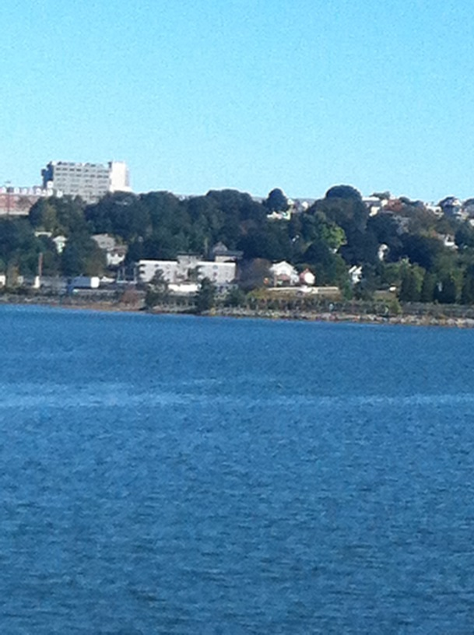
The City Arborist, Jeff Tarling has commented (Attachment 5):
1) Tree Save - Due to the site characteristics and proposed grading, only a small percentage of the existing trees & vegetation is proposed to be saved as shown. The environmental & scenic benefits of this grove of trees on Munjoy Hill is significant in relation to the nearby neighborhood land use. A more detailed study of the existing trees & vegetation on site and consideration to save or replace a larger percentage of this green space is warranted.

2) Landscape Planning - Related to item 1 above, is the need for the project to closer review the landscape architecture of the project site and its relationship to the surrounding neighborhood. From a quick view, the skyline view towards Munjoy Hill will be altered (see photo at right) as shown from this view from Back Cove. Views to the site and from North, Walnut, and Washington Avenue should be considered and the appropriate steps taken to help mitigate the impact. Green space and treatment of the retaining walls would benefit from 'Green wall' treatment and the use of naturalized materials where possible, this would include the use of native stone, boulders to help with grading. This was used nearby at the Sheridan Heights project.

14-498. Technical and designStandards

Open Space
The subdivision Ordinance includes the following standard:
14-498 Technical and Design Standards
(i) Public open space:

1. In all subdivisions open space may be provided for parks, recreational and other public areas. Where no public open space or recreational areas exist in close proximity to the subdivision, or where a lack of such areas in the subdivision would require its disapproval under section 14-497(a), general requirements, the Planning Board may require provision of land for park or recreational purposes. Such lands may be designated for public or private ownership in accordance with the conditions stated in this section, subject to the approval of the Planning Board.

The City Arborist has commented (Attachment 5):
The project as shown does not appear to have the percentage of useable green space for residential use. The landscape component should include details for patio, residential uses, that might include area for dog-walking, gardening, etc. Landscape & tree planting sites can be further explored once the details needed by Public Safety are better understood.

In this context it is suggested that the design of the retaining walls and central “driveway/trail” area may offer locations for usable open spaces.
Connectivity
The Subdivision Ordinance includes the following standard:
14-498 Technical and Design Standards
The proposed street layout shall be coordinated with the street system of the surrounding areas. All streets must provide for the continuation or appropriate projection of streets in surrounding areas and provide means of ingress and egress for surrounding acreage tracts.

When connecting streets within residential neighborhoods, new streets shall contribute to a neighborhood street system characterized by a network of interconnected streets, which minimizes through-traffic in residential neighborhoods. The layout of subdivision lots, streets, and pedestrian ways shall promote multiple paths of travel to get to destinations within and between neighborhoods by foot and bicycle, as well as auto.

The applicant has indicated a willingness to retain the existing “Jack Path” Portland Trail within the central access drive area of the project, probably with a public access easement. This is welcomed as an important neighborhood connection between Walnut Street and the East End School and nearby community gardens. Discussions are still taking place in the context of the design approach for the proposed drive/access. The Condominium Documents would confirm the responsibilities for this area (including the Path) once the development is complete and units have been sold.

Staff have requested the applicant to consider connecting the central access area/Jack Path to East Cove Street (to the west), as this would allow a pedestrian connection to Washington Avenue and its bus route and local stores. East Cove Street is not an accepted City street and does not have sidewalks, so further discussions are necessary to explore feasibility if the principle is supported by the Board. This connection is strongly recommended in light of the subdivision ordinance objectives.

The Public Comment in Attachment 9(a) notes that the current proposals fail to meet this standard in respect to both East Cove Street and Sheridan Street.

Street Trees
The Subdivision Ordinance requires street trees planted near the street line in full public view on private property (generally intended for single family subdivisions). (Note- the Site Plan Ordinance requires one tree per unit within the ROW). The applicant has requested a waiver from the Site Plan requirement as there is a no ROW location for street trees. This question has not been reviewed in detail, and would be subject to the required contribution of $200 per tee, if waived.

C. SITE PLAN STANDARDS

14-526 Requirements for approval

Traffic and Vehicular parking- as discussed above under Subdivision Review

Pedestrian Access/Trails
The proposed driveway is a private access drive and is anticipated to have a public access easement. The City’s Urban Designer, Caitlin Cameron, has encouraged a shared pedestrian/vehicular access (Attachment 8):
The Sheridan Street extension will be an important design component as the primary "frontage" for the project and how it relates to the neighborhood and pedestrians wishing to connect to the trail. Staff feel that a woonerf or shared street scenario would provide the best design solution and allow for more activity as well as landscaping and trees while maintaining adequate vehicular and emergency vehicle access. The applicant will work with city staff to refine the details of landscaping, fence selection, and paving materials in order to mitigate the development impacts on neighbors as well as provide for a pleasant and active shared-use passage.
This approach is broadly supported by the Consulting Traffic Reviewer (Attachment 2):

I continue to review the design of the private driveway and how it will integrate vehicular and pedestrian modes. The current plan is problematic from a pedestrian safety perspective given the number of driveway crossings required to navigate the site. I would note that I support a “woonerf” design that creates a shared driveway where the pedestrian, bicycle, and vehicle traffic coexist and are not segregated. Under this type of design, pedestrians and bicyclists have the right-of-way. I would further note that a shared facility needs to be designed such that vehicles are respectful of the driveway space and travel at very low speeds.

Staff are aware of public interest in this aspect of the project and suggest this be a key subject for discussion at this Workshop. While staff have encouraged the shared pedestrian/vehicular approach (see above), details have not been discussed. {Note: the term “woonerf” is often used to describe the shared use approach, based on its use in the Dutch context}.

The applicant has responded positively to this suggestion and submitted a rendering (Plan 21) that indicates an approach to this shared pedestrian/vehicular area (that is different from the submitted Site Plan in Plan 4 ). One public comment has suggested a similar “mews” concept for this space with an illustrated montage of photos as they might apply to this project (Attachment 9(b)).

Bicycle Parking
The Site Plan Ordinance requires that 10 bicycle parking spaces be provided. The applicant has requested a waiver from this requirement (Attachment I) because each new unit has a garage and bicycles can be parked in the garage. Staff suggest that some outdoor bicycle parking should be provided for visitors and perhaps “Jack Path” users, but this could be less than the specified 10 spaces.

Site Landscaping and Screening (see discussion re access/trail area above)
The applicant has not yet submitted a Landscape Plan but has commissioned a tree survey that will be available in the near future and inform the development of a Landscape Plan. An aerial “plan” with narrative outlining the proposed landscape approach has recently been submitted (Plan 20).

The City Arborist has commented in Attachment 5 with suggestions for landscape features; he has also raised the question of whether the units will have any “private” space and whether LID features could be incorporated. Staff have also noted the scale of the retaining walls and their proximity to the buildings and walkways, and have suggested that they should be designed to minimize impacts and address other objectives (see Sections V B and D ).

Water quality, Stormwater Management and Erosion Control: See above under Subdivision Review

Sidewalk and ROW
The driveway is technically owned to the middle by the property owners on both sides (since the public rights were released) but all abutters have access over it. Staff have requested confirmation that the applicant has rights to improve the area on the west side of the drive (were currently there is a gravel drive) and have noted that improvements in the ROW sidewalk will be required (Attachment 7).

Fire Prevention
The Fire Department is concerned at the length of the dead end drive and has commented (Att. 4):
1. 20' access needs to be maintained in front of buildings. At end of road at isle it is showing 15'.
2. A template of our largest fire truck needs to be provided showing how the turnaround requirements per NFPA are being met since the road is more than 150'.
3. It appears an NFPA site code analysis has not completed. This needs to be done. Once completed it will indicate needs for amount and locations of fire hydrants.
4. A Professional Engineer with a discipline in Fire Protection will need to provide a stamped letter stating the site plan meets all applicable codes.
5. A Professional Engineer with a discipline in Fire Protection will need to provide a stamped letter stating that the building and fire protection final plans meets all applicable codes before submitting the plans for permit approval with the City.
Further discussion is needed to develop a central access area that meets public safety objectives while also being a welcoming and usable shared space.

Site Design Standards
Staff have not completed this review and suggest it be an item for discussion at a second Workshop.

- DESIGN STANDARDS IN THE SITE PLAN ORDINANCE

Multi-family and Other Housing Types Design Standard
This design standard applies to this proposal as outlined in sections below with associated staff review comments:

(i) TWO-FAMILY, SPECIAL NEEDS INDEPENDENT LIVING UNITS, MULTIPLE-FAMILY, LODGING HOUSES, BED AND BREAKFASTS, AND EMERGENCY SHELTERS:
(1) STANDARDS. Two-family, special needs independent living units, multiple-family, lodging houses, bed and breakfasts, and emergency shelters shall meet the following standards:
a. Proposed structures and related site improvements shall meet the following standards:
1. The exterior design of the proposed structures, including architectural style, facade materials, roof pitch, building form and height, window pattern and spacing, porches and entryways, cornerboard and trim details, and facade variation in projecting or recessed building elements, shall be designed to complement and enhance the nearest residential neighborhood. The design of exterior facades shall provide positive visual interest by incorporating appropriate architectural elements;

Staff comment: Caitlin Cameron, the Urban Designer in the Planning Division, has reviewed the preliminary submission and provided the following comments (Attachment 8):

Aesthetically, the contemporary design of Munjoy Heights is respectful of the materiality and fenestration patterns of the neighborhood. Balcony components can also be found within the neighborhood vernacular. More information is needed to assess details such as cornerboard and trim detailing and final material choice. The project, having a contemporary design, uses flat roofs which is not typical for this residential neighborhood. However, the flat roofs alone do not cause the development to be out of character with the neighborhood in overall design.

The project has a narrow presence on Walnut Street; the three townhomes that interface with Walnut Street are two stories and fit the scale of the adjacent residential buildings. The Walnut Street facade uses an entry configuration that is found elsewhere in the neighborhood. The facades on that corner are broken up to create appropriate architectural elements relating to the street and the neighboring homes and provide a sense of integration with a similar mass and character. The remaining units in the proposed development, while adapting to the sloped site conditions have a proportion that is tall and slender. The north row of townhomes have one additional story in height (4) than is typical in this area while the southern row have 3 stories - staff question the choice to place the taller units on the uphill side of the site and whether it might be more appropriate from a neighborhood context standpoint to place the taller units on the downhill side of the development.

To encourage street activity, our design standards discourage predominant garage doors as is the case with the mews for this project. However, the street is internal and not subject to this standard - ideally, the design development of the mews and the trail connection will bring activity to the private street.

The retaining walls will require a fence for safety reasons - I recommend a more transparent or vegetated fence so as to not add additional height to the already tall retaining walls.

  - The proposed development shall respect the existing relationship of buildings to public streets. New development shall be integrated with the existing city fabric and streetscape including building placement, landscaping, lawn areas, porch and entrance areas, fencing, and other streetscape elements;

Staff comment: The proposal does not have a public street frontage and will not be viewed within the context of existing buildings except for the end building on Walnut Street as mentioned above. However, the requirement to integrate into “city fabric” will need to be borne in mind when reviewing the tree replacement/landscaping and architectural/retaining wall details.

3. Open space on the site for all two-family, special needs independent living unit, bed and
breakfast and multiple-family development shall be integrated into the development site. Such open space in a special needs independent living unit or a multiple-family development shall be designed to complement and enhance the building form and development proposed on the site. Open space functions may include but are not limited to buffers and screening from streets and neighboring properties, yard space for residents, play areas, and planting strips along the perimeter of proposed buildings;

Staff comment: See discussion of opportunities for open spaces on site under Section VB above.

4. The design of proposed dwellings shall provide ample windows to enhance opportunities for sunlight and air in each dwelling in principal living areas and shall also provide sufficient storage areas;

Staff comment: This standard appears to be met.

5. The scale and surface area of parking, driveways and paved areas are arranged and landscaped to properly screen vehicles from adjacent properties and streets;

Staff comment: This standard will be reviewed once the proposals are more detailed.

VI NEXT STEPS

This Workshop is anticipated to focus on “big picture’ issues such as overall layout; incorporation of the Portland Trail; connectivity; and the broad design approach to the pedestrian/vehicular access.

It is anticipated that a second Workshop is needed to consider the following in more detail: landscape including tree preservation/replacement; Drainage; how fire access will be incorporated; and design details.

Next steps include:
- Submission of additional plans eg Subdivision Plat; final Boundary Survey; Tree Survey; Landscape Plan
- Further discussions with staff and Portland Trails, as based on direction from this Workshop
- Applicant to address staff comments for the final submissions

ATTACHMENTS:
Attachments to Memorandum
  - Staff e-mail prelim review comments 10.4.2013
  - Traffic Engineering Review comments 10.17.2013
  - Engineering Review comments 10.9.2013
  - Fire Department comments 10.9.2013
  - City Arborist comments 10.9.2013
  - Zoning comments – not received at time Memo was finalized
  - DPS (David Margolis-Pineo) comments 10.17.2013
  - Urban Designer comments 10.18.2013
  - Public Comments:
      - Christian MilNeil 10.18.2013
      - Christian MilNeil on behalf of group 8.7.2013 with “mews” attachment

Applicant’s Submittal
- Application and Cover letter 9.27.2013
- Neighborhood Meeting Certificate and Notes
- Project Data
- Right, Title and Interest (Staff summary of submitted P&S Agreements)
- Legal rights in Sheridan Street: Tom Jewell letter 9.24.2013
- Design narrative
- Zoning analysis
- Fire code summary
- Waiver requests
- Financial and Technical Capacity
- Traffic Assessment 7.27.2013
- Utility letters
- Stormwater - Memo 9.27.2013
- Geotechnical Info- Preliminary July 2013
- Stormwater & Geotechnical Response letter 10.16.2013
- Housing Replacement: Jonathan Culley letter 9.30.2013

Plans
Plan 1 Aerial
Plan 2 Cover sheet
Plan 3 Preliminary Boundary survey
Plan 4 Site Plan
Plan 5 Site Plan (color on aerial)
Plan 6 Site Plan (lines on aerial)
Plan 7 Utility Plan
Plan 8 Grading, Drainage & Erosion Control Plan
Plan 9 Grading and Roadway Profile Plan
Plan 10 Wall 1 & 2 Profile Plan
Plan 11 Wall 3 Profile Plan
Plan 12 Elevation onto Walnut Street
Plan 13 East Elevation
Plan 14 South elevation (part)
Plan 15 South elevation (part)
Plan 16-19 Floor Plans

