Memorandum
Planning and Urban Development Department
Planning Division

To: Chair Morrissette and Members of the Portland Planning Board

From: Jean Fraser, Planner

Date: November 22, 2013

Re: November 26th Planning Board Workshop
Level III Site Plan and Subdivision:
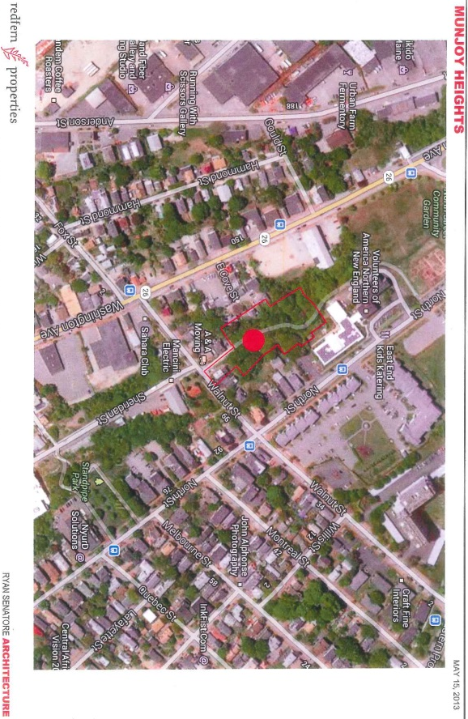
Munjoy Heights
29 unit condominium, 79 Walnut Street
Jonathan Culley, Redfern Munjoy LLC

- Introduction
This is the second Workshop to consider the proposal by Jonathan Culley for the construction of a 30 unit residential subdivision made up of 29 new units in six 3-4 story townhouse-style buildings and one existing residential building on a reconfigured lot. The 1.59 acre site is within the R-6 zone and comprises 7 contiguous parcels (currently subject to Purchase and Sale agreements) on the western face of Munjoy Hill just below North Street.

The first Workshop covered the overall concept of the project and scope for public access and connectivity. This Memo and Workshop concentrates on trees and landscape issues and stormwater impacts, and updates on the design development of the central paved area and treatment of the retaining walls.

The applicant held a Neighborhood Meeting on October 16, 2013 which was attended by 27 people- the attendance list and notes of the meeting are included in Attachment B. Five people spoke at the October PB Workshop, including Jaime Parker of Portland Trails.

The Planning Division has received one public comment relating to connectivity (Attachment 9 (a) and Portland Trails have provided input into the design process for the “woonerf” area (Attachment X). A number of abutters have contacted the Planning Division for information.

This Workshop was noticed to 485 neighbors and interested parties, and the public notice appeared in the Portland Press-Herald on November 18th and 19th, 2013.

Required reviews and requested waivers (Attachment I):

Applicant’s Proposal | Applicable Standards
New residential structures totaling 29 units and one existing residential building with reconfigured lot (total of 30 “lots”) | Subdivision Review
Four Multifamily buildings totaling 70,756 square feet floorspace | Level III Site Plan Review and Multi-family Design Review
Bicycle Parking Spaces- waiver requested from the requirement to provide 9 outside spaces, as residents bikes may be parked in the garage in each unit. | Ordinance 14-526 Site Plan Standards requires 2 bicycle parking spaces for every 5 dwelling units, which would be 10 bicycle parking spaces for this project.
Motorcycle and Scooter Parking- waiver requested as garage would provide the required parking space. | Ordinance 14-526 Site Plan Standards requires the site plan to “accommodate access and parking” for such vehicles.
Street Trees- waiver requested locate required street trees within the property given limited street frontage | Ordinance 14-526 Site Plan (and Section 4.6 of the Technical Manual) requires one tree per unit planted in the City Right of Way. Ordinance 14-499 Subdivision Standards requires street trees “planted near the street line in full public view on private property”. Contribution to the street tree fund is an alternative.

- BACKGROUND
The site includes three existing residential buildings, of which two will be demolished and one will be retained on a reconfigured lot. The area is vegetated with mature trees and bisected by a well used Portland Trail (“Jack Path”).

The access from Walnut Street is located over what was thought to be a paper street, as shown as an extension of Sheridan Street on the City’s zoning map. The applicant’s attorney has confirmed (Attachment E) that the street was not preserved as a paper street and therefore there are no public rights of access. The existing home that will be retained with a reconfigured lot is currently accessed from North Street and that will not be altered.

At the first Workshop a number of concerns were raised, including the impact on treesand scenic beauty, pedestian connectivity, stormwater impacts on downhill neighbors and erosion control, particularly during construction. The Board specifically asked for more information on the visual impact on neighbors, exterior lighting, and the elevations of the large building blocks. The applicant has addressed these issues in an 11.19.2013 letter in Attachment V and 13 Photomontages/Renderings in Attachment W.

- PROJECT DATA

SUBJECT | DATA
Existing Zoning | R-6
Existing Use | Undeveloped land, vegetated (large trees); Portland Trail path; 3 existing residential buildings (2 to be demolished; 1 retained on reconfigured lot)
Proposed Use | 29 units in 6 new buildings plus 1 existing reconfigured lot
Parcel Size | 1.59 acres
Impervious Surface Area  --Existing  --Proposed  --Net Change | 6,113 sq ft  38,992 sq ft  32,879 sq ft
Total Disturbed Area | 1.59 acres
Building Footprint  --Existing  --Proposed  --Net Change | 2,773 sq ft  22,333 sq ft  19,560 sq ft
Building Floor Area  --Existing  --Proposed  --Net Change | 4,484 sq ft  75,240 sq ft 9including garages)  70, 746 sq ft
SUBJECT | DATA
Residential  --Proposed no. of affordable units  --Proposed no of res. buildings to be demolished  --Proposed no of res. units to be demolished  --Proposed no. of new residential units  --Proposed number of lots in subdivision | 0  2  5  29  30  30
Parking Spaces  --Existing  --Proposed | 0 (except driveway for retained existing buidling)  29 garages; 5 outside
Bicycle parking Spaces  --Existing  --Proposed | 0  0 outside;- each unit has garage
Proposed Paved Area | 16,659 sq ft
Estimated cost of project | $11 million

- EXISTING CONDITIONS
This 1.59 acre site is made up of 7 parcels/part parcels which has resulted in an irregular shape but also provides extra land to incorporate slope stabilization measures. Much of the slope is at 25% and this presents geotechnical and stormwater challenges as indicated in the Geotechnical reports/comments (Attachments N and O) and in the staff comments (Attachment 3). Also it is almost entirely wooded.

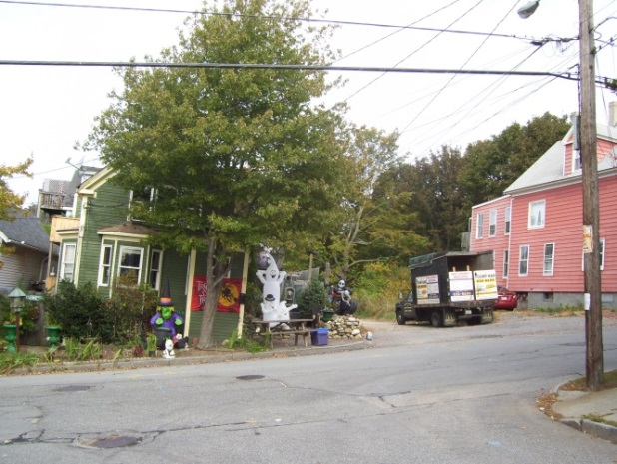
The proposal site is located on the north side of Walnut Street opposite where Walnut meets Sheridan Street. Currently there is a gravel road that provides access to the abutting residential buildings. This gravel road is indicated as a paper street on the City’s zoning map, but the public rights in this street were inadvertently released (due to an incorrect plan reference in 1997) and it is now private (Attachment E).

The red building has been purchased by the applicant; it contains 4 residential units and is proposed to be demolished. The gravel road leads to the start of the Portland Trails “Jack Path”. From Sheridan St. looking across Walnut St.

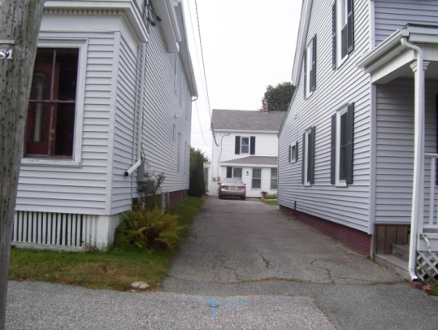
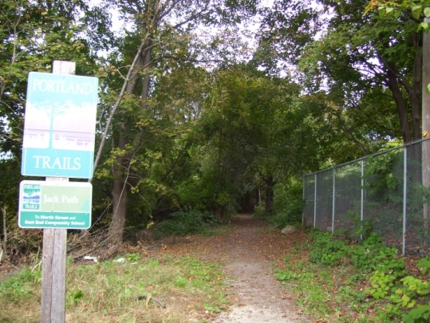
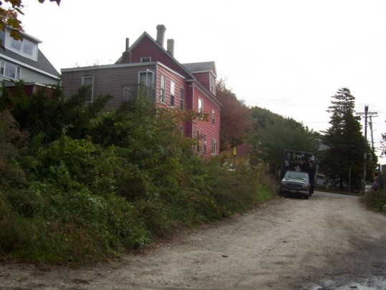
Sheridan Street where meets Walnut Start of Jack Path” near Walnut Street From North St. looking W to the Maxwell ho

Uphill (east) the site abuts 2 residential properties on Walnut Street and one on North Street (not including the one to be demolished). Several other residential properties on North Street “overlook” the site (current view is into mature trees). The applicant has purchased the intervening property, known as the Maxwell lot, which includes an existing house set back from North Street with access from North Street via an easement over the driveway of the nearest house. This is included in the Subdivision by State Law as lot #30 (Attachment R and Plan 5).

The site also abuts Bayview Heights, an elderly housing complex operated by Volunteers of America.
To the north the “Jack Path” continues from the site and wraps around the rear of Bayview Heights to meet North Street at the community gardens and opposite the East End School. The METRO bus route #1 runs along North Street.
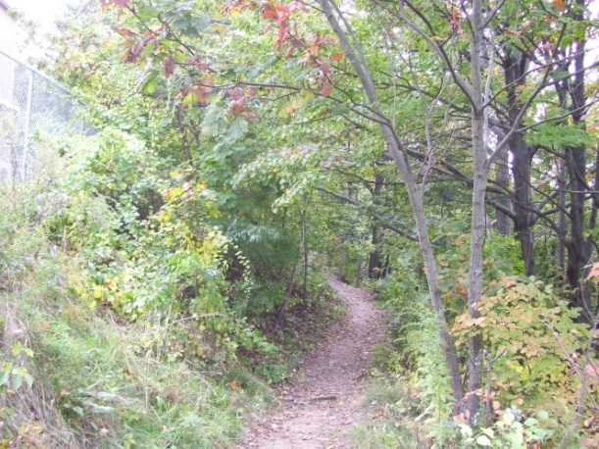
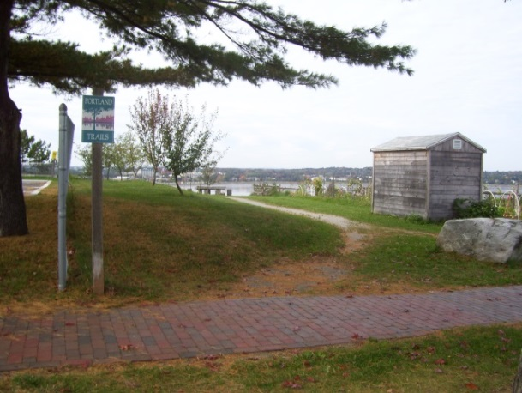

Jack Path where it meets North St. (Back Cove in bkground) Path just below Bayview Heights

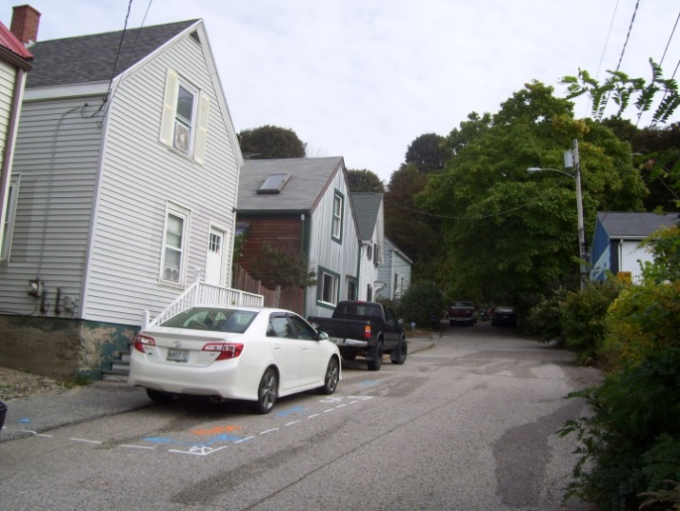
Downhill (west) is largely wooded, with the exception of two residential abutters on the private graveled section of Sheridan Street and the two homes at the end of East Cove Street. The home at the north end of East Cove Street nearest the project site has been purchased by the applicant and will be demolished. At the end of East Cove Street there is a fairly steep hill up into the site.

AT

East cove Str
East Cove Street is not an accepted street and does not have sidewalks; it leads to Washington Avenue and the Metro Bus route #6 runs along Washington Avenue with stops nearby. East Cove Street, looking uphill from Washington Ave.

- PROPOSED DEVELOPMENT
The proposals comprise 29 new townhouse units (lots) and the Maxwell lot will be reconfigured and included as the 30th lot (Attachment R). The site plan has been slightly revised since the Workshop to add a stair/ramp link to East Cove Street and modify the detail of the area between the houses (Plan 6). Plan 7 shows the earlier site plan within the aerial context and has been retained in the plan set as it shows how the development relates to the surrounding area.

The applicant has been working to reduce the retaining walls to improve integration of the project into the site, and they are approximately 5-13 feet (exposed) on the west side and 17 feet high behind the houses on the east side (see Sections in Plan 34). The exposed retaining wall at the north end of the “street” appears to be 8-12 feet in height (details in Plans 18 and 19).

Due to the steep slopes over most of the site, the regrading and construction of retaining walls will result in almost total disturbance of the site and loss of most trees except at the eastern corner. The applicant commissioned a Tree Study/Report (counting all trees and identifying all trees over 10” dbh) which was submitted in Attachment Q. The Study identified 9 trees worthy of preservation, but the proposals do not include these as preserved trees but are retaining one area of existing vegetation to the east behind the Walnut Street properties. The Landscape Plan and Planting Plans (Plans 30 and 31) indicate substantial proposed tree planting. The proposals for the central shared-use area reflect input from staff. That area features an alle of London Plane trees in the central paved (shared use) area long with benches, planted areas (bioretention cells) and bollard lighting.

An architectural design narrative is included in Attachment F and Plans 21-29.

- RIGHT, TITLE AND INTEREST and FINANCIAL CAPABILITY
The applicant has purchase and sale agreements for 7 lots that comprise the site, and most of these will be reconfigured to give land to abutters and to modify the Maxwell Lot so that it remains a viable lot for the existing house (Plan 5).

The private status of the paper streets presents some complications in terms of right, title and interest because all properties in the subdivisions (in this case dating from the 1800s) technically may have private rights in the street (see letter from applicant’s attorney in Attachment E). Also there are two abutters to Sheridan Street (near Walnut) who have rights of access over half of the width of the paper street, and where improvements to their property is [proposed easements will be needed (Att. 12).

The applicant intends to “claim” the streets through notices under State law XXXXX. The Legal Department has indicated that they would request the applicant to provide an independent title opinion or title insurance to confirm that the claim is likely to succeed, and would want evidence that the associated notices have been served.

A letter from the Androscoggin Bank, confirming potential financing for the project, is included in Attachment T.

- STAFF REVIEW
The applicant has submitted further details of the proposed landscape/tree planting, stormwater management system, erosion control, central paved area and retaining walls. These have been reviewed for conformance with the relevant review standards of Portland’s site plan ordinance and applicable regulations. Staff comments are listed below.

        - ZONING ASSESSMENT

- Zoning Requirements
The proposed subdivision is within the R-6 Residential Zone. The applicant has submitted a Zoning Analysis in Attachment G which suggests that 58 units potentially may be allowed as compared to the 29 dwelling units proposed. The lot coverage is at 32% (maximum allowed is 40%) and it is not known whether Lot #30 (the existing home with reconfigured lot) has been excluded from the total site area used for this calculation. It appears that the proposal is not at the maximum allowable density for the site, but how far below will be clarified for the Workshop.

Comment from Marge Schmuckal, Zoning Administrator, were not received at the time this Memo was finalized and will be circulated at the Workshop.

- Housing Replacement
The applicant has purchased two properties that are proposed to be demolished (1 East Cove Street and 79 Walnut Street) and this would result in the loss of 5 dwelling units (Attachment P). The proposed 29 units will provide replacement but the Housing Replacement Ordinance requires a Performance Guarantee for the replacement (to be paid at the time of demolition) and includes other requirements regarding the noticing of the tenants etc that the applicant would need to comply with. Staff recommend inclusion of a condition on any approval relating to the Housing Replacement ordinance provisions.
B. SUBDIVISION STANDARDS
14-496. Subdivision Plat Requirements
The applicant submitted a draft Subdivision Plat (Plan 5) on 11.19.2013. Staff have not had time to review the Plat, but it appears comprehensive in presentation. The easements, which include a “Pedestrian Easement serving Portland Trails” is listed but the area is not shown and staff request that the areas of all easements be included and that the City of Portland be a party to the public access easement. The Draft Condominium Association documents are also outstanding; these should be submitted as soon as possible so that the relationship with Portland Trails regarding the “Jack Path” and the public access easement can be better understood.

14-497. General Requirements (a) Review Criteria

Water, Air Pollution and Soil Erosion
The provision of water to the site appears to have some complications and requires a new 8 inch supply, as outlined in the Portland Water District (PWD) 8.23.13 letter (Att. L). The Consulting Reviewing Engineer (David Senus of Woodard & Curran) has recommended that final approval from the PWD be made a condition of final approval (Att. 10). Plan 33 has been submitted to address erosion control.

Traffic and Vehicle parking
The proposed 29 new townhouses would be accessed by a new (private) drive from Walnut Street and the applicant has submitted a Traffic Assessment (Attachment K). Tom Errico, the Consulting Traffic Reviewer, has confirmed that the proposals are acceptable from a traffic viewpoint (Att. 9) but notes that “The City has received a comment regards high vehicle speeds on Walnut Street. I will provide a response to this issue in the future.”

Sanitary Sewer
The applicant has submitted a Utility Plan (Plan 7) and DPS have noted that “Plan details, plan /profile showing invert elevations, pipe size/material and slopes will be required for the proposed stormwater and sanitary sewers.” (Attachment 7 and 12).

Geotechnical
The applicant submitted a Preliminary Geotechnical Report and supplementary information (Attachments Ni), which has been updated to show wall designs and identify additional soil test locations at the north end of the site (Attachment Nii and Niii). The soil information for the additional boreholes has not been included in this PB Memo but was available to reviewers and will be available for reference at the meeting. At this stage we have not seen a report explaining the implications of the additional soil tests nor for the retaining walls which now range from 8 to 17 feet in height.

Both the City’s Deputy Engineer and the Consulting Engineering Reviewer have noted (Attachments 3 and 7) that extensive geotechnical and structural engineering documentation will be required, with the final plans to include “specific details for these proposed walls, in addition to any associated assumptions and geotechnical design criteria.” (Attachment 3). The updated comments recommend that these be subject to a condition of approval (Attachment 10, item 23).

At the first Workshop both the Board and staff raised concerns about the location and design of the retaining walls as they could constrain access and use of the areas or homes nearby and could be visually prominent. It was suggested that they be designed with other functions (other than just slope stabilization) in mind ie include tiered walls that might allow for small terraced gardens; be located to allow nearby spaces to be usable open space; be shaped to visually integrate into the landform. The proposed retaining walls remaiin vertical and linear - see discussion under Site Plan Review.

Storm water
A full stormwater report was recently submitted (Attachment Mii). The project is estimated to create an additional 32,879 sq ft of impervious surface and therefore is required to provide stormwater quality treatment. The Consulting Engineering Reviewer has commented (summary of comments in Attachment 10):
- Concerns regarding the increase in stormwater flows towards Walnut Street (even thought the overall flows are below the pre-development levels) and the need to confirm that the City drainage system has adequate capacity;
- Need for a separated storm storm drain line in East Cove Street (private street) to allow for a future connection to a separated system in Washington Avenue
- Need details of proposed raingardens
- Details that need reconsideration.

The first two issues are currently under discussion and an update will be provided to the Board to confirm that the proposed stormwater approach is workable. The other issues should be addressed in the final submissions.

Scenic Beauty
The subdivision ordinance includes the following requirement:
14-497 (8) Will not have an undue adverse effect on the scenic or natural beauty of the area, aesthetics, historic sites, significant wildlife habitat identified by the department of inland fisheries and wildlife or by the city, or rare and irreplaceable natural areas or any public rights for physical or visual access to the shoreline.
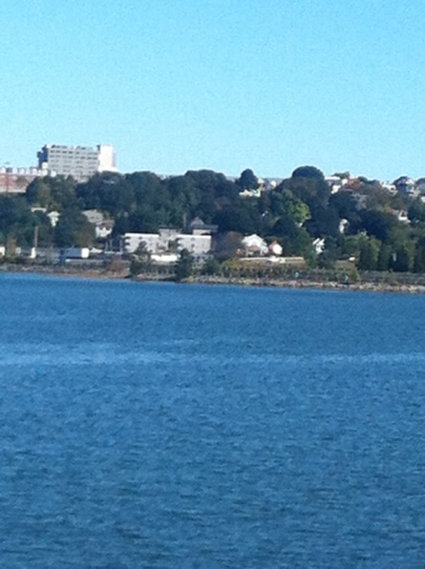
The site is wooded and visible from long views across Back Cove and from the peninsula (also see Attachment Wi). The proposal is not a typical single family subdivision and is providing infill housing on a steeply sloping site where there are other considerations. The interpretation of this standard is a subject for discussion.

The Board requested further information regarding the impact on the existing dense area of trees, as the proposal requires clearance of all but the stands in the northeast corner. The applicant commissioned a Tree Study and the Report (Attachment Q) confirmed that there are 162 trees on the site, largely comprising Norway Maple. Norway Maple is described as an “undesirable imported invasive species” that does not have forest and ecological value. There were 9 trees over 10dbh that were not Norway Maple (shown in a plan at the end of the Report) but none are proposed for preservation.

Balanced against the loss of 162 trees is the proposed planting of 67 trees and extensive areas of shrubs and perennials. The applicant has described the proposal as providing a “transition from invasive species to native plants and trees on the site [that] will lead to improved ecological health for the neighborhood...” (Attachment V). Photomontages showing the impact of the development on views toward the site have also been submitted in Attachment Wii.
The City Arborist has commented (Attachment 11):

Due to it's hillside location and elevation the proposed Munjoy Heights project is visible from a number prominent locations: Back Cove, Baxter Boulevard, I-295 Northbound are some of the locations where the change from existing tree line to buildings will alter the overall skyline and character of Portland's Munjoy Hill. The scale or height of the proposed residential units in relationship to the scale of the landscape when installed will take several years to grow into view. Ideally, a mixture of staggered building heights vs the straight line row might have helped to interrupt the skyline view as shown in the recent perspective.

The proposed landscape treatments and tree-save reviews are as follows:
a) Tree replacement & scenic values - In review of the existing tree survey conducted by Southern Maine Forestry the majority of species on site were invasive Norway Maple. This stand has a low ecological value but a high scenic & moderate environmental value (shade for cooling the urban heat island on this Westerly exposure). Tree-saves and replacement trees to achieve similar to existing is challenging given the sites compact shape, steep slopes and building density. Recent view shed perspectives show the amount of change. Quantitative values and achievable goals to address "scenic beauty" loss are unclear. This is partially due to the sites prominence and limitations due to size and slope. Tree-save areas are very limited and restricted to the corners and edges of the proposed project. Tree replacement given the space available with the density proposed is projected in the recent landscape plan. Recommendations would include a review of tree specie types and sizes to best meet environmental, ecological and scenic values.

Native plant species are highly recommended for the edges and spaces outside of the "Woonerf" planting.
Species include: Yellow Birch, Red Maple, Amelanchier, and trying to introduce a few conifers and fruit trees. This could be accomplished by 'tweaking' slightly the proposed tree list by the project team and the City Arborist. 'Tree Save' areas should follow recommendations restricting or limiting site work with tree protection measures including fencing, root zone protection and practices such as cleanly cutting damaged roots. This is typically shown on the final plan and included in the pre-construction meeting.

14-498. Technical and DesignStandards

Open Space
The subdivision Ordinance includes the following standard:
14-498 Technical and Design Standards
(i) Public open space:

1. In all subdivisions open space may be provided for parks, recreational and other public areas. Where no public open space or recreational areas exist in close proximity to the subdivision, or where a lack of such areas in the subdivision would require its disapproval under section 14-497(a), general requirements, the Planning Board may require provision of land for park or recreational purposes. Such lands may be designated for public or private ownership in accordance with the conditions stated in this section, subject to the approval of the Planning Board.

The City Arborist has commented (Attachment 5):
The project as shown does not appear to have the percentage of useable green space for residential use. The landscape component should include details for patio, residential uses, that might include area for dog-walking, gardening, etc. Landscape & tree planting sites can be further explored once the details needed by Public Safety are better understood.
As updated 11.20.2013 (Attachment 11):
The landscape plan as shown is quite extensive and the majority of open ground landscape is planted. The project proposes very limited turf or open non planted space that might have more of a mixed use. Space for resident community gardening or space to walk your dog should be considered but not identified.

The applicant has indicated that there is no identified usable open space provided on the site other than within the “woonerf” area, but that residents have access to a number of nearby open spaces including the Eastern Promenade, the North Street Community Gardens etc. (Attachment V). The area between the proposed uphill buildings and the 17 foot high retaining wall is crushed stone with ferns (Plan 34).

Connectivity
The Subdivision Ordinance includes the following standard:
14-498 Technical and Design Standards
The proposed street layout shall be coordinated with the street system of the surrounding areas. All streets must provide for the continuation or appropriate projection of streets in surrounding areas and provide means of ingress and egress for surrounding acreage tracts.

When connecting streets within residential neighborhoods, new streets shall contribute to a neighborhood street system characterized by a network of interconnected streets, which minimizes through-traffic in residential neighborhoods. The layout of subdivision lots, streets, and pedestrian ways shall promote multiple paths of travel to get to destinations within and between neighborhoods by foot and bicycle, as well as auto.

Jack Path
At the first Workshop the applicant confirmed that they would be retaining the existing “Jack Path” Portland Trail within the central access drive area of the project, probably with a public access easement that covered the entire area. This was welcomed as maintaining an important neighborhood connection between Walnut Street and the East End School and nearby community gardens.

A meeting between the applicant, staff and Portland Trails took place on 11.6.2013 and the submitted Landscape and Planting Plans and revised Site Plan (Plans 6, 30 and 31) reflect those discussions. Portland Trails were invited to the meeting in view of their long term future involvement with that trail link and have provided some comments on the current proposals (as Public comments Attachment X).

Staff requested that the pavement indicated for vehicle use be narrowed so that vehicle space did not dominate and so vehicles would expect pedestrians sharing the space. The actual width of flush paved area is over the 20 feet required for fire access, so the different paving materials are visual only.

There have not been any further discussions regarding the Public Access Easement for this area (although it is referred to as Easement #4 on the draft Subdivision Plat in Plan 5) and a draft of this should be included in the final submission. It would be helpful to see the draft of the Condominium Documents (or this section of the Condo documents) that clarifies the responsibilities for this area (including the Path) once the development is complete and units have been sold.

The applicant does not own all of the Jack Path and to the north of the site it is largely over private land. Staff consider that the applicant has met the Subdivision requirement to “coordinate” and “promote” connectivity through the provision of the public access easement (trail) through the site and that the ordinance does not support a requirement for further off-site improvements.

Link to East Cove Street
The applicant has incorporated a stair and ramp link to the top end of East Cove Street in the west side of the development to facilitate connectivity to Washington Avenue. Again the link is welcomed to facilitate connectivity and is strongly supported by Portland Trails. The Public Comment in Attachment 9(a) also suggests this is a potentially important link.

The status of East Cove Street itself has been determined as “private” and the applicant has confirmed verbally that he intends to “claim” the eastern portion which lies underneath the proposed development. The western end of East Cove Street is paved and has houses along all of one side and part of the other side. The establishment of a public access route here may be possible but presents legal challenges and, as with Jack Path, staff consider that the applicant has met the Subdivision requirement to “coordinate” and “promote” connectivity through the provision of the link to East Cove Street within the development.

Where there is an adopted Master Plan the site plan ordinance requires development to be “consistent”; however, neither Sheridan Street nor East Cove Street are shown as part of the “Bikeway & Pedestrian Network” Plan in the adopted Pedestrian and Bicycle Chapter of the Comprehensive Plan.

Street Trees
The Subdivision Ordinance requires street trees be planted near the street line in full public view on private property (a requirement generally intended for single family subdivisions). (Note- the Site Plan Ordinance requires one tree per unit within the ROW). The applicant has requested a waiver from the Site Plan requirement as there is a no ROW location for street trees.

The City Arborist considers the trees within the ‘woonerf” area to meet the ordinance requirements, with an additional recommendation (Attachment 11):
b) Street-trees - The project proposes a consistent number of street trees to meet the per unit to tree guidelines. Trees proposed for the "Woonerf" should work to achieve the desired effect. At the Northerly end where the pavement widens, the number of trees seem to have been reduced from three to one. My recommendation would return to three trees, as a single tree in this wide open space is very unlikely to survive. Three trees adds scale enough to be noticed and avoided, a single tree from experience, is often backed into or fails over time.

C. SITE PLAN STANDARDS

14-526 Requirements for approval

Traffic and Vehicular parking- as discussed above under Subdivision Review

Pedestrian Access/Trails
The proposed driveway along the paper street Sheridan Street is a private access drive and is anticipated to have a public access easement. The applicant has responded to staff suggestions re the incorporation of something like a “woonerf” (shared pedestrian/vehicular access as outlined Attachments 2 and 8). The Landscape, Planting Plans and illustrative renderings (Plans 30 and 31; Attachments Wii and X) show how the concept has developed. It includes:
- Paved area the meets fire department turning and width requirements
- Alle of London Plane trees within paved central area
- Stormwater gardens along southwest Block (Block F on key on Plan X)
- Portland Trail “nodes” at each end plus several benches
- Stair connection to Jack Path at north end
- Bicycle and guest car parking
- Stair link to west and East Cove Street
- Planting between and around the buildings
- Bollard and pole lighting

Staff consider the proposals have developed along the right lines and that this approach is generally successful (Attachments 9 and 14), but have some concerns as identified by Tom Errico (Attachment 9):
- The woonerf design of the roadway sections is acceptable and I believe it will be effective in attaining the goal of a shared use facility. There appears to be some locations where bollards have been added and feedback on the need should be provided.
- How visitor parking is accommodated on site needs further consideration given that the parking spaces will be located where pedestrian activity is expected to be high.
- The applicant should provide information on the radii size at Walnut Street and whether a smaller configuration will work.
- The City plows the sidewalk on Walnut Street in conjunction with the school walking needs. Accordingly, the driveway entrance area will need to accommodate City sidewalk plows. The applicant shall coordinate with DPS on this issue.
- The stairs to the Jack Path should also include a ramping system for bicycles.

Portland Trails have also raised concerns over the location of parking impeding the physical and visual links for pedestrians; the need for a bicycle ramp to connect to Jack Path at north end; and the treatment of the retaining wall at the north end (Attachment X).

Staff have asked whether a crosswalk in Walnut near the proposed access drive/trail crossing would be desirable. The Traffic Engineer comments (Attachment 9):
A crosswalk on Walnut Street between the site drive and Sheridan Street should be considered. It is suggested that the City’s Crosswalk Committee review this location and render a decisions on a crosswalk and supporting treatment. Accordingly, the project may need to incorporate inclusion of a crosswalk.

Bicycle Parking
The Site Plan Ordinance requires that 10 bicycle parking spaces be provided. The applicant originally requested a waiver from this requirement (Attachment I) because each new unit has a garage and bicycles can be parked in the garage. The current proposals (Plan 6) show 9 outside bicycle parking spaces at the north end of the central paved area and this is considered acceptable by staff.

Site Landscaping and Screening (see discussion re Scenic Beauty under Subdivision Review above)
The Tree Report (Attachment Q), Landscape and Planting Plans (Plans 30 and 31) were recently submitted to provide more detail. The City Arborist comments (Attachment 11):

c) Landscape treatment - The landscape plan as shown is quite extensive and the majority of open ground landscape is planted. The project proposes very limited turf or open non planted space that might have more of a mixed use. Space for resident community gardening or space to walk your dog should be considered but not identified. Plant spacing around the units is geometric, planted in uniform rows and not naturalized. Ideally, the landscape planting might want to include geometric uniform spacing in the more formal locations and a more naturalized approach along the edges.

Plants in the formal areas could be more of the ornamental character and native in the less formal areas. The landscape key shows a mixture of native and non-native ornamental plants as proposed. The project should consider a more naturalized spacing of the native plants as mentioned above.

Due to the complexity of the project and the percentage of change from existing to proposed,
a landscape treatment contingency plan (percentage) should be included to address unforseen or under planted spaces. The areas of concern include retaining walls, fence line views from North Street and along the project edges. Areas in need of additional landscape treatment would be determined in the later stages of construction between the project team and city staff.

Retaining Walls
The recently submitted Landscape Plan (Plan 30) refers to a “pile and lag wall with 4’ tall black chain link fence along top edge on the uphill side, and for the downhill side the wall (5-13 ft high) is described as “gravity wall block with ivy planted at base” and shown with some type of fence in the Sections (Plan 34). The proposed the western retaining walls is not specified). The fencing is not screened except in a couple of places with 3 trees each (Plan 30).

All three retaining walls remain linear and vertical: the Landscape Plan refers to a “pile and lag” wall to the east but staff do not know what this will look like and previous requests for “natural” materials (boulders etc) on the exposed section at the north end of the “woonerf” have not been addressed.
The material and appearance of the retaining wall is suggested by the submission of the “Recon” Brochure but the specific materials for each part of the wall have not been confirmed and renderings showing how the walls are integrated by landscape have not been submitted.

Water quality, Stormwater Management and Erosion Control: See above under Subdivision Review

Sidewalk and ROW
The revised Site Plan (Plan X) includes curbing, tip downs and signage where the new drive meets the ROW in Walnut Street. The proposal include restoration of the whole width of pavement in Walnut Street in the vicinity. DPS have commented (Attachment X):

Fire Prevention
The Fire Department is concerned at the length of the dead end drive and has commented (Att. 4):
1. 20' access needs to be maintained in front of buildings. At end of road at isle it is showing 15'.
2. A template of our largest fire truck needs to be provided showing how the turnaround requirements per NFPA are being met since the road is more than 150'.
3. It appears an NFPA site code analysis has not completed. This needs to be done. Once completed it will indicate needs for amount and locations of fire hydrants.
4. A Professional Engineer with a discipline in Fire Protection will need to provide a stamped letter stating the site plan meets all applicable codes.
5. A Professional Engineer with a discipline in Fire Protection will need to provide a stamped letter stating that the building and fire protection final plans meets all applicable codes before submitting the plans for permit approval with the City.
Captain Pirone has seen the turning templates that underpin the design of the “woonerf” area and has confirmed that aspect of the proposal is acceptable (Attachment X).

Site Design Standards

Massing, Ventilation and Wind Impact/Shadows
The proposed townhouses on the east side are 42 feet high (above grade) and Block B (units 4-9) comprise a row of 6 units. The City’s urban Designer comments (Attachment X):

The remaining units in the proposed development, while adapting to the sloped site conditions have a proportion that is tall and slender. The north row of townhomes have one additional story in height (4) than is typical in this area while the southern row have 3 stories - staff question the choice to place the taller units on the uphill side of the site and whether it might be more appropriate from a neighborhood context standpoint to place the taller units on the downhill side of the development.

The Planning Board requested an elevation of one of the central buildings (with 5 or 6 townhouses) to better understand the massing. The buildings will be prominent on the hill as viewed from across Back Cove and other long views and the scale/proportions are a concern.

Ventilation, wind impacts and shadows are not a concern in terms of any impacts on neighbors.

Exterior Lighting
The Landscape Plan in Plan 30 shows 9 bollard lights and 1 pole light along the eastern side of the “woonerf’ area, located in planted areas, plus 7 pole lights along the western edge within planters. The photometric plans for these proposed lights have not been submitted. No lighting is proposed for the stair/ramp link to East Cove Street and it is anticipated that the pedestrian access easement for that link may be limited to daylight hours.

- DESIGN STANDARDS IN THE SITE PLAN ORDINANCE

Multi-family and Other Housing Types Design Standard
This design standard applies to this proposal as outlined in sections below with associated staff review comments:

(i) TWO-FAMILY, SPECIAL NEEDS INDEPENDENT LIVING UNITS, MULTIPLE-FAMILY, LODGING HOUSES, BED AND BREAKFASTS, AND EMERGENCY SHELTERS:
(1) STANDARDS. Two-family, special needs independent living units, multiple-family, lodging houses, bed and breakfasts, and emergency shelters shall meet the following standards:
a. Proposed structures and related site improvements shall meet the following standards:
1. The exterior design of the proposed structures, including architectural style, facade materials, roof pitch, building form and height, window pattern and spacing, porches and entryways, cornerboard and trim details, and facade variation in projecting or recessed building elements, shall be designed to complement and enhance the nearest residential neighborhood. The design of exterior facades shall provide positive visual interest by incorporating appropriate architectural elements;

Staff comment: Caitlin Cameron, the Urban Designer in the Planning Division, has reviewed the preliminary submission and provided the following comments (Attachment 8):

Aesthetically, the contemporary design of Munjoy Heights is respectful of the materiality and fenestration patterns of the neighborhood. Balcony components can also be found within the neighborhood vernacular. More information is needed to assess details such as cornerboard and trim detailing and final material choice. The project, having a contemporary design, uses flat roofs which is not typical for this residential neighborhood. However, the flat roofs alone do not cause the development to be out of character with the neighborhood in overall design.

The project has a narrow presence on Walnut Street; the three townhomes that interface with Walnut Street are two stories and fit the scale of the adjacent residential buildings. The Walnut Street facade uses an entry configuration that is found elsewhere in the neighborhood. The facades on that corner are broken up to create appropriate architectural elements relating to the street and the neighboring homes and provide a sense of integration with a similar mass and character.

To encourage street activity, our design standards discourage predominant garage doors as is the case with the mews for this project. However, the street is internal and not subject to this standard - ideally, the design development of the mews and the trail connection will bring activity to the private street.

The retaining walls will require a fence for safety reasons - I recommend a more transparent or vegetated fence so as to not add additional height to the already tall retaining walls.

  - The proposed development shall respect the existing relationship of buildings to public streets. New development shall be integrated with the existing city fabric and streetscape including building placement, landscaping, lawn areas, porch and entrance areas, fencing, and other streetscape elements;

Staff comment: The proposal does not have a public street frontage and will not be viewed within the context of existing buildings except for the end building on Walnut Street as mentioned above. However, the requirement to integrate into “city fabric” will need to be borne in mind when reviewing the tree replacement/landscaping and architectural/retaining wall details.

3. Open space on the site for all two-family, special needs independent living unit, bed and
breakfast and multiple-family development shall be integrated into the development site. Such open space in a special needs independent living unit or a multiple-family development shall be designed to complement and enhance the building form and development proposed on the site. Open space functions may include but are not limited to buffers and screening from streets and neighboring properties, yard space for residents, play areas, and planting strips along the perimeter of proposed buildings;

Staff comment: See discussion of opportunities for open spaces on site under Section VB above.

4. The design of proposed dwellings shall provide ample windows to enhance opportunities for sunlight and air in each dwelling in principal living areas and shall also provide sufficient storage areas;

Staff comment: This standard appears to be met.

5. The scale and surface area of parking, driveways and paved areas are arranged and landscaped to properly screen vehicles from adjacent properties and streets;

Staff comment: This standard will be reviewed once the proposals are more detailed.

VI NEXT STEPS
The applicant needs to address the following as part of the final submissions:
- Independent title opinion/title insurance
- Letter from Fire Professional confirming NFPA requirements have been met, including re hydrants
- Revision to the Subdivision Plat to address comments
- Clarify extent of easements
- Revise plan for “woonerf” area to reconsider parking and snow storage areas and add bicycle ramp at north end
- Resolve stormwater issues and address detailed comments from the Consulting Engineering reviewer
- Revise Landscape and Planting Plans to address (screening) (trees) (scenic beauty)
- Material and treatment of Retaining walls, including at north end of Woonerf
- Address Planning Board comments

ATTACHMENTS:
Attachments to Memorandum for first Workshop
  - Staff e-mail prelim review comments 10.4.2013
  - Traffic Engineering Review comments 10.17.2013
  - Engineering Review comments 10.9.2013
  - Fire Department comments 10.9.2013
  - City Arborist comments 10.9.2013
  - Zoning comments – not received at time Memo was finalized
  - DPS (David Margolis-Pineo) comments 10.17.2013
  - Urban Designer comments 10.18.2013

Update Attachments to Memorandum for second Workshop

  - Traffic Engineering Review comments 11.20.2013
  - Consulting Engineering Review comments 11.20.2013
  - City Arborist comments 11.20.2013
  - DPS (David Margolis-Pineo) comments
  - Urban Designer comments
  - Public Comments:
      - Christian MilNeil 10.18.2013
      - Christian MilNeil on behalf of group 8.7.2013 with “mews” attachment
      - Portland Trails comments

Applicant’s Submittal as in Memorandum for first Workshop
- Application and Cover letter 9.27.2013
- Neighborhood Meeting Certificate and Notes
- Project Data
- Right, Title and Interest (Staff summary of submitted P&S Agreements)
- Legal rights in Sheridan Street: Tom Jewell letter 9.24.2013
- Design narrative
- Zoning analysis
- Fire code summary
- Waiver requests
- Financial and Technical Capacity
- Traffic Assessment 7.27.2013
- Utility letters
Updated applicants submittal items for Memorandum for second Workshop
- Stormwater
- Memo 9.27.2013
- Stormwater Report 11.12.2013
- Geotechnical Info
- Preliminary July 2013
- Wall plan set Nov 2013
- Location of added boreholes Nov 2013
- Stormwater & Geotechnical Response letter 10.16.2013
- Housing Replacement: Jonathan Culley letter 9.30.2013
- Tree Report 11.12.2013
- Maxwell Property Site Plan
- Retaining Wall Details
- Financial Capability letter 11.15.2013
- Clarification re building references
- Redfern “cover” letter 11.19.2013
- Photomontages and Renderings
          - Existing view from across Back Cove
          - Photomontages and Renderings
- Woonerf Rendering

Plans
Plan 1 Aerial
Plan 2 Cover sheet (revised)
Plan 3 Notes
Plan 4 Revised Boundary survey
Plan 5 Draft Subdivision Plat
Plan 6 Revised Site Plan
Plan 7 Site Plan (lines on aerial)
Plan 8 Utility Plan
Plan 9 Revised Grading, Drainage & Erosion Control Plan
Plan 10 Revised Grading and Roadway Profile Plan
Plans 11 to 17 Detail Plans
Plan 18 Revised Wall 1 & 2 Profile Plan
Plan 19 Revised Wall 3 Profile Plan
Plan 20 Snow Storage Plan
Plan 21 Elevation onto Walnut Street
Plan 22 East Elevation
Plan 23 South elevation (part)
Plan 24 South elevation (part)
Plan 25 to 29 Floor Plans
Plan 30 Landscape Plan
Plan 31 Planting Plan
Plan 32 Construction Management Plan
Plan 33 Erosion and Sedimentation Control
Plan 34 Building and Retaining Wall sections

