PLANNING BOARD REPORT
PORTLAND, MAINE

Munjoy Heights
29 residential townhouses (condominium) plus one existing lot
(30 lot subdivision)
79 Walnut Street
Level III Site Plan and Subdivision
Project ID 2013-228
Jonathan Culley, Redfern Munjoy LLC

Submitted to:  Portland Planning Board  Public Hearing Date: December 17th, 2013 | Prepared by: Jean Fraser, Planner  Date: December 13th, 2013  Planning Board Report # 57-13

- Introduction
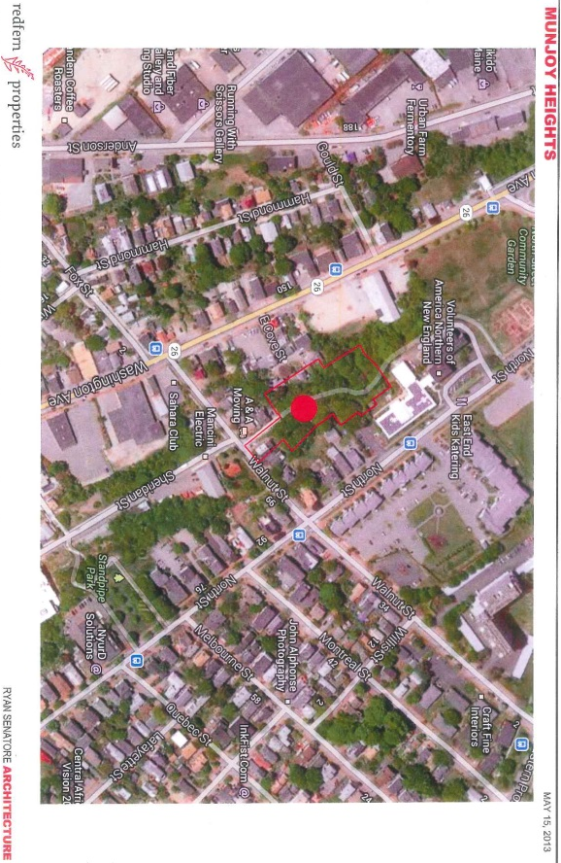
Jonathan Culley of Redfern Munjoy, LLC has requested a final review hearing for the proposed construction of a 30 “lot” residential subdivision made up of 29 new units in six 3-4 story townhouse-style buildings and one existing residential building on a reconfigured lot. The 1.59 acre site is within the R-6 zone and comprises 7 contiguous parcels (currently subject to Purchase and Sale agreements) on the western face of Munjoy Hill just below North Street.

There have been two workshops on this project. The first workshop covered the overall concept of the project and scope for public access and connectivity. The second workshop concentrated on trees and landscape issues and stormwater impacts, with updates on the design development of the central paved area and treatment of the retaining walls.

The applicant held a Neighborhood Meeting on October 16, 2013 which was attended by 27 people- the attendance list and notes of the meeting are included in Attachment B. Twenty-four written comments have been received in total at the time this Report was completed, including: two from Portland Trails; 12 writers who support the project; and 6 writers in (2 have sent two letters each) in
objection (Attachment 9). The objections largely relate to the scale of tree and habitat loss.

This Hearing was noticed to 485 neighbors and interested parties, and the public notice appeared in the Portland Press-Herald on December 9th and 10th, 2013.

Required reviews and requested waivers (Attachment I):

Applicant’s Proposal | Applicable Standards
New residential structures totaling 29 units and one existing residential building with reconfigured lot (total of 30 “lots”) | Subdivision Review – Article IV of Land Use Code
Four Multifamily buildings totaling 70,756 square feet floorspace | Level III Site Plan Review and Multi-family Design Review – Article V of Land Use Code
Demolition of a total of 5 existing residential units | Preservation and Replacement of Housing Units, Division 29 of Land Use Code
Bicycle Parking Spaces- waiver requested from the requirement, as 9 are proposed outside and residents bikes may be parked in the garage in each unit. | Ordinance 14-526 Site Plan Standards requires 2 bicycle parking spaces for every 5 dwelling units, which would be 12 bicycle parking spaces for this project.
Motorcycle and Scooter Parking- waiver requested as garage would provide the required parking space. | Ordinance 14-526 Site Plan Standards requires the site plan to “accommodate access and parking” for such vehicles.
Waiver re design of sidewalks- waiver suggested by Traffic Engineering Reviewer to allow tip down curbing for the sidewalk to achieve an optimal walking alignment | Technical Manual Section 1.7.1.5 that requires granite curbing be installed along the full radius of the driveway entrance
Street Trees- waiver requested locate required street trees within the property given limited street frontage | Ordinance 14-526 Site Plan (and Section 4.6 of the Technical Manual) requires one tree per unit planted in the City Right of Way. Ordinance 14-499 Subdivision Standards requires street trees “planted near the street line in full public view on private property”. The City Arborist considers that proposed tree planting meets the street tree requirement and that a waiver is not required.

- PROJECT DATA

SUBJECT | DATA
Existing Zoning | R-6
Existing Use | Undeveloped land, vegetated (large trees); Portland Trail path; 3 existing residential buildings (2 to be demolished; 1 retained on reconfigured lot)
Proposed Use | 29 units in 6 new buildings plus 1 existing reconfigured lot
Parcel Size | 1.59 acres
Impervious Surface Area  --Existing  --Proposed  --Net Change | 6,113 sq ft  38,992 sq ft  32,879 sq ft
Total Disturbed Area | 1.59 acres
Building Footprint  --Existing  --Proposed  --Net Change | 2,773 sq ft  22,333 sq ft  19,560 sq ft
Building Floor Area  --Existing  --Proposed  --Net Change | 4,484 sq ft  75,240 sq ft 9including garages)  70, 746 sq ft
Residential  --Proposed no. of affordable units  --Proposed no of res. buildings to be demo.  --Proposed no of res. units to be demolished  --Proposed no. of new residential units  --Proposed number of lots in subdivision | 0  2  5  29  30
Parking Spaces  --Existing  --Proposed | 0 (except driveway for retained existing buidling)  29 garages; 5 outside
Bicycle parking Spaces  --Required  --Proposed | 12  9 outside; plus can be stored in each unit’s garage
Proposed Paved Area | 16,659 sq ft
Estimated cost of project | $11 million

- BACKGROUND AND WORKSHOP SUMMARY
The site includes three existing residential buildings, of which two will be demolished and one will be retained on a reconfigured lot to be sold. The area is vegetated with mature trees and bisected by a well used Portland Trail (“Jack Path”).

The access from Walnut Street is located over what was thought to be a paper street, as shown as an extension of Sheridan Street on the City’s zoning map. The applicant’s attorney has confirmed (Attachment D) that the street was not preserved as a paper street and therefore there are no public rights of access. The existing home that will be retained with a reconfigured lot is currently accessed from North Street and that will not be altered.

At the first Workshop a number of concerns were raised, including the impact on trees and scenic beauty, impact on neighbors, pedestian connectivity, scale of the new buildings, stormwater impacts on downhill neighbors and erosion control, particularly during construction. At the second Workshop the applicant provided additional information (eg tree report, photomontages and stormwater report) to illustate the impacts and explain what steps had been taken to mitigate the impacts. The Board requested additional illustrative material and Plans 37-50 iclude phtomontages and renderings to address that request.

- EXISTING CONDITIONS
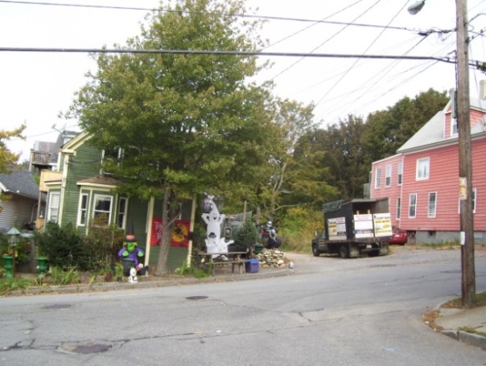
This 1.59 acre site is made up of 7 parcels/part parcels which has resulted in an irregular shape but also provides extra land to incorporate slope stabilization measures. Much of the slope is at 25% and this presents geotechnical and stormwater challenges as indicated in the Geotechnical reports (Attachment K) and in the staff comments (Attachment 2 and 4). The site is almost entirely wooded, with many mature trees.

The proposal site is located on the north side of Walnut Street opposite where Walnut meets Sheridan Street. Currently there is a gravel road that provides access to the abutting residential buildings. This gravel road is indicated as a paper street on the City’s zoning map, but the public rights in this street were inadvertently released (due to an incorrect plan reference in 1997) and it is now private (Attachment D). Portland Trails’ “Jack Path” roughly follows the line of the Sheridan Street paper street across the site (Plan 3).

The red building (79 Walnut) has been purchased by the applicant; it contains 4 residential units and is proposed to be demolished.
From Sheridan St. looking across Walnut St.
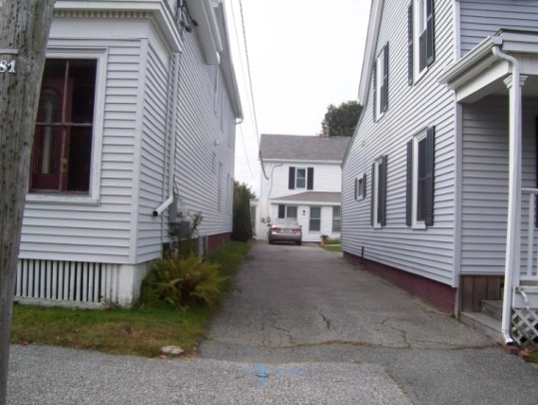
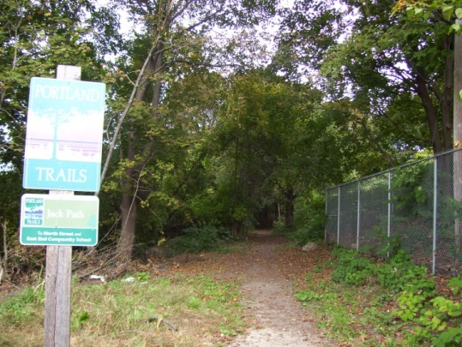
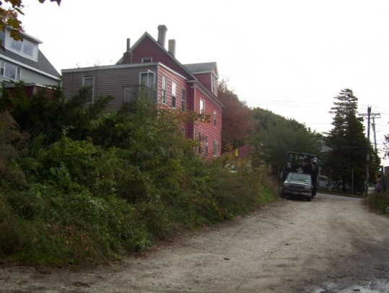
Current gravel road in Sheridan paper street Start of Jack Path” near Walnut Street From North St. looking W to the Maxwell house

Uphill (east) the site abuts 2 residential properties on Walnut Street and one on North Street (not including the one to be demolished). Several other residential properties on North Street “overlook” the site (current view is into mature trees). The applicant has purchased the intervening property, known as the Maxwell lot at 128 North (rear), which includes an existing house set back from North Street with access from North Street via an easement over the driveway of the nearest house. This is included in the Subdivision by State Law as lot #30 (Plans 4 and 5).

The site also abuts Bayview Heights, an elderly housing complex operated by Volunteers of America.
The gravel road into the site from Walnut Street leads to the start of the Portland Trails “Jack Path”. The “Jack Path” continues across the site to the north and then wraps around the rear of Bayview Heights to meet North Street at the community gardens and opposite the East End School. The METRO bus route #1 runs along North Street.
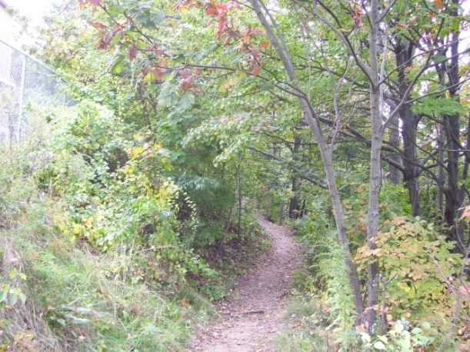
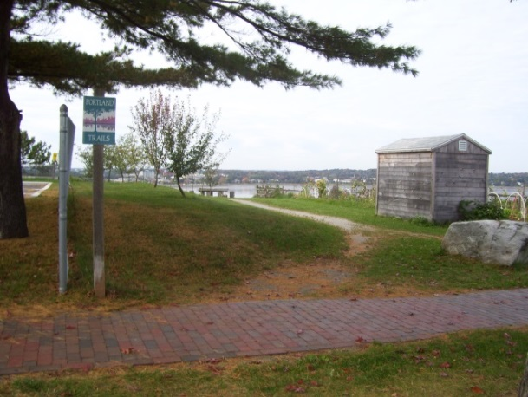

Jack Path where it meets North St. (Back Cove in bkground) Path just below Bayview Heights
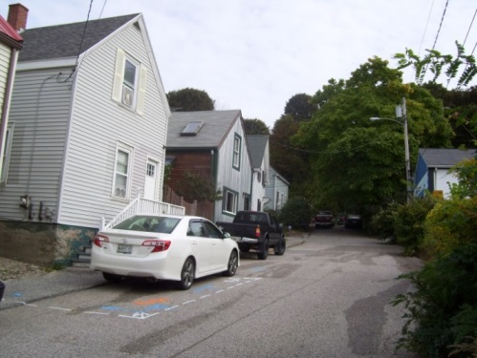
Downhill (west) is largely wooded, with the exception of two residential abutters on the private graveled section of Sheridan Street and the two homes at the end of East Cove Street. The home at the north end of East Cove Street (1 East Cove Street) nearest the project site has been purchased by the applicant and will be demolished. At the end of East Cove Street there is a fairly steep hill up into the site.

East Cove Street is not an accepted street and does not have sidewalks; it leads to Washington Avenue and the Metro Bus route #6 runs along Washington Avenue with stops nearby.
East Cove Street, looking uphill from Washington Ave.

- PROPOSED DEVELOPMENT
The proposals comprise 29 new townhouse units (lots) and the Maxwell lot at 128 North Street (rear) will be reconfigured and included as the 30th lot (Plan 4 Subdivision Plat). The Site Plan and Landscape Plan in Plans 6 and 32 have been revised since the initial submission to create a “woonerf” (shared pedestrian and vehicle space between the buildings). The Jack Path will remain within a public access easement approximately along its existing alignment, and be linked by stair/ramp links into the remainder of the path to the north, and with East Cove Street to the west.

The new townhouses are designed in 6 buildings of 3-4 stories, with each unit including 3 bedrooms, balcony, roof deck and internal garage but no outdoor ground level private space (Plans 22 to 31 and renderings in Plans 37-50).

Three retaining walls surround the townhouses to stabilize the slopes and create buildable envelopes. Plan 17 shows the location and types of retaining wall construction proposed; Plan 18 shows the heights of the retaining walls. The applicant has been working to reduce the retaining walls to improve integration of the project into the site, and they are approximately 5-13 feet (exposed) on the west side and 17 feet high behind the houses on the east side. The exposed retaining wall at the north end of the “street” appears to be 8-12 feet in height (rendering in Plans 37-50).

Due to the steep slopes over most of the site, the regrading and construction of retaining walls will result in almost total disturbance of the site and loss of most trees except at the eastern corner. The applicant commissioned a Tree Study/Report (counting all trees and identifying all trees over 10” dbh) which was submitted in Attachment N. The Study identified 9 trees worthy of preservation, but the proposals do not include these as preserved trees though one area of existing vegetation is retained to the east behind the Walnut Street properties. The Landscape Plan and Planting Plans (Plans 32 and 33) indicate substantial proposed tree planting. The proposals for the central shared-use area feature an alle of London Plane trees in the central paved (shared use) area long with benches, planted areas (bioretention cells) and bollard lighting.

VI. PUBLIC COMMENT

- Public comment:
The focus of public comments at the Workshops has been the need for connectivity, loss of existing trees and impact of stormwater drainage on neighbors to the west. The earlier written public comments supported connectivity and the concept of a shared pedestrian/vehicle space and these have largely been addressed.

More recent comments (8 of the comments in Attachment 9) have raised concerns over the loss of this large area of trees and associated eco-system and the importance of preserving this area within Munjoy Hill. Many of the letters objecting to the loss of trees and the implications of the loss were received in time for inclusion in this Report but there was not time for reviewers to prepare a detailed comment on all the points that were raised. Further staff response will be prepared for the hearing meeting.

E-mails of support have been received from 12 Portland residents (Attachment 9).

- Neighborhood Meeting:
The applicant held a neighborhood meeting in October that was attended by a total of 27 people and the notes of the meeting are included in Attachment B.

- RIGHT, TITLE AND INTEREST AND FINANCIAL CAPACITY
The applicant has purchase and sale agreements for 7 lots that comprise the site (Attachment C), and most of these will be reconfigured to give land to abutters and to modify the Maxwell Lot (128 North street rear). The Maxwell Lot (Plan 5) will be brought into greater conformity with current zoning and is to be sold.

The private status of the paper streets (as explained under “Existing Conditions” above) presents some complications in terms of right, title and interest because all properties in the subdivisions (in this case dating from the 1800s) technically may have private rights in the street (see letter from applicant’s attorney in Attachment D). The applicant intends to “claim” the streets through notices under State law Title 33 MRS Sec 3033. The Legal Department has confirmed that they have requested the applicant to provide an independent title opinion or title insurance to confirm that the claim is likely to succeed, and would like evidence that the associated notices and other actions are taken (Attachment 8). The applicant has confirmed they will submit title insurance/title opinion (Attachment D) and the first suggested subdivision condition of approval is included to address this requirement.

Also there are two abutters to Sheridan Street near Walnut Street (Rando and McAdam) who have rights of access over half of the width of the paper street, and where improvements to the paper street near their property are proposed. Reciprocal easements are currently under discussion and the drafts (Attachment V) have been seen by the Associate Corporation Counsel (Attachment 8) and referenced on the Subdivision Plat. These would need to be signed and recorded and more clearly identified on the plat prior to the project proceeding if approved; the suggested subdivision conditions include this requirement.

A letter from the Androscoggin Bank, confirming potential financing for the project, is included in Attachment F.

- STAFF REVIEW
A final site plan/subdivision submission was received on 12.2.2013 and comprises the same proposal as presented at the second Workshop along with additional technical and legal documentation. Staff have reviewed the submission in the context of the ordinance requirements and the issues and questions that arose at the Planning Board Workshops.

        - ZONING ASSESSMENT
The Zoning Administrator raised several questions re the height calculations and setbacks during the initial review in October, and these have been addressed satisfactorily (Attachment 5).

        - HOUSING REPLACEMENT
The applicant has purchased two properties that are proposed to be demolished (1 East Cove Street and 79 Walnut Street) and this would result in the loss of 5 dwelling units (Attachment L). The proposed 29 units will provide replacement but the Housing Replacement Ordinance requires a Performance Guarantee for the replacement (to be paid at the time of demolition) and includes other requirements regarding the noticing of the tenants etc that the applicant would need to comply with. A potential condition of approval addresses the Housing Replacement ordinance provisions.
        - SUBDIVISION STANDARDS

14-496. Subdivision Plat Requirements
The applicant submitted a Subdivision Plat (Plan 4) which is generally acceptable but requires the usual revisions to include conditions of approval and notes regarding maintenance responsibilities and stormwater requirements, and also more information regarding the easements, including showing the location and dimensions that define the area of the easements (Attachment 4 and 8).

There are six easements identified on the plat:
- “Pedestrian Access Easement to Portland Trails and City (Portland Trails easement) securing public pedestrian access to the access drive/”Jack path” area and connections to north and west (Submitted in Attachment P and V. It should be noted that in para 7 the easement confirms that the developer (Condo Association in future) will not undertake snow removal for the link to East Cove Street and this issue is discussed below. Portland Trails have seen the draft easement and are comfortable with the draft subject to further discussions to address concerns regarding the landscape design and maintenance issues (Attachment 9i). The Associate Corporation Counsel considers the draft easement to be generally acceptable in terms of form but she comments (Attachment 8):
However, to the extent that the terms of the arrangement between PT and the developer (relating, to example, responsibility for maintenance and snow removal) change or are further clarified following input from the Board, that document will need to change accordingly.
- Two easements in Sheridan Street that underpin right, title and interest in Sheridan Street (drafts (Att. V) seen by Associate Corporation Counsel; these appear acceptable but are not final;
- To abutters on East Cove Street re use of land; (Attachment T).
- Maintenance of the eastern retaining wall (shown on Lot #30)- not yet submitted but referenced on the Plat
- Utility easement- not yet submitted but noted on the Plat

The Draft Condominium Association document was submitted (Attachment P). The Board had noted that the wording of the Condominium Association obligations regarding tree and trail maintenance was particularly important and staff consider the reference to these obligations should be in one place and set out in detail; at present the references are under “Definitions” and there is no mention of the Portland Trail Public Access Easement and stair/ramp connections in the body of the document. A potential condition of approval is included in the motion for the Board to consider and supported by Associate Corporation comments in Attachment 8.

Subdivision 14-497. General Requirements (a) Review Criteria

- Will Not Result in Undue Water and Air Pollution (Section 14-497 (a) I), and Will Not Result in Undue Soil Erosion (Section 14-497 (a) 4
Consulting Engineer Dave Senus has confirmed (Attachment 2) that the applicant has provided a detailed Erosion and Sediment Control Plan for the project as part of their mid-November submittal (Attachment J). This, in addition to the submitted Construction Management Plan (Plan36); C-30 GRADING, DRAINAGE & EROSION CONTROL PLAN (Plan 8); and C-43 EROSION CONTROL DETAILS & NOTES (Plan 13) sufficiently address erosion and sediment control practices and approach. The applicant has addressed specifically the sequence of construction work to minimize impact on downhill properties.

- Sufficient Water Available (Section 14-497 (a) 2 and 3)
A letter from the Portland Water District dated 8.23.2013 (Attachment M) confirms the availability of water, though the provision of water to the site appears to have some complications and requires a new 8 inch supply. The Consulting Reviewing Engineer (David Senus of Woodard & Curran) has recommended that final approval from the PWD be made a condition of final approval (Att. 10) and a potential condition has been included to this effect.

- Will Not Cause Unreasonable Traffic Congestion (Section 14-497 (a) 5)
The proposed 29 new townhouses would be accessed by a new (private) drive from Walnut Street and the applicant has submitted a Traffic Assessment (Attachment G). Tom Errico, the Consulting Traffic Reviewer, has confirmed that the proposals are acceptable from a traffic generation viewpoint (Attachment 1). During the review the issue of speeding traffic in Walnut Street was raised and Mr Errico confirms that the City has studied this problem but not yet identified a workable solution and that no action is required of the applicant.

- Will Provide for Adequate Sanitary Sewer and Stormwater Disposal (Section 14-497 (a) 6), and Will Not Cause an Unreasonable Burden on Municipal Solid Waste and Sewage (Section 14-497 (a) 7)
A full stormwater report was submitted in November and discussed further with staff because of concerns regarding the increase in stormwater flows towards Walnut Street (even though the overall flows are below the pre-development levels) and the need to confirm that the City drainage system has adequate capacity.

The Stormwater Management system was revised and the Report was resubmitted (Attachment I). The Consulting Engineer Dave Senus has confirmed that most comments have been adequately addressed, with the outstanding concerns recommended to be addressed through the imposition of conditions of approval (Attachment 2.)

The Wastewater capacity letter is included in Attachment M and confirms adequate capacity.

- Scenic Beauty, Natural, Historic, Habitat and other Resources (Section 14-497 (a) 8)
The subdivision ordinance includes the following requirement:
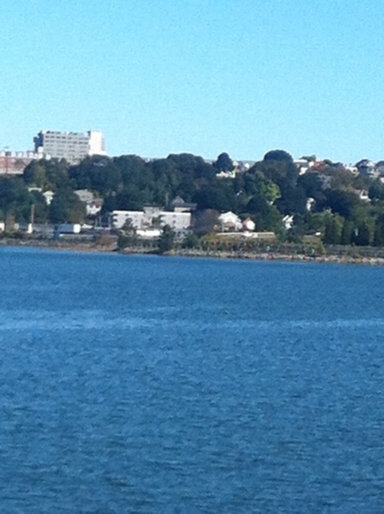
14-497 (8) Will not have an undue adverse effect on the scenic or natural beauty of the area, aesthetics, historic sites, significant wildlife habitat identified by the department of inland fisheries and wildlife or by the city, or rare and irreplaceable natural areas or any public rights for physical or visual access to the shoreline.

The site is heavily wooded and visible from long views across Back Cove and from the peninsula (also see Plans 37-50 which include photomontages from Back Cove and 295). It is valued as a local natural area along the existing Jack Path.

Early in the review the impact on the existing trees was a concern as the scale of the regrading required to provide site stabilization was anticipated to require removal of most of the existing trees, including many mature trees.

The Board requested further information regarding the impact on the existing trees and the applicant commissioned a Tree Study and the Report (Attachment N). This study confirmed that there are 162 trees on the site, largely comprising Norway Maple. Of these, 39 were “mature” and over 10 inches dbh. Of these larger trees, 30 were Norway Maple, described as an “undesirable imported invasive species” that does not have forest and ecological value. Nine trees of other species were over 10”dbh, including some elm and oak (see plan at end of Tree Report) but none are proposed for preservation.

The site is made up of seven private parcels and is not identified on any state or local maps as having ecological or wildlife importance, nor is it identified in the comprehensive plan or Land Bank Commission list. It is understood that the site was considered by the Land Bank Commission and only the “Jack Path” was listed as a Priority.

Balanced against the loss of 162 trees is the proposed planting of 67 trees and extensive areas of shrubs and perennials. The applicant has described the proposal as providing a “transition from invasive species to native plants and trees on the site [that] will lead to improved ecological health for the neighborhood...” (Attachment O). Photomontages showing the impact of the development on views toward the site have also been submitted in Plans 37 to 50 and illustrate that areas of mature trees remain around the edge of the site.

The City Arborist has commented (Attachment 3):

Response on 'clear cutting' and loss of open space from my earlier review comments cover this:

"Due to it's hillside location and elevation the proposed Munjoy Heights project is visible
from a number prominent locations: Back Cove, Baxter Boulevard, I-295 Northbound are
some of the locations where the change from existing tree line to buildings will alter the
overall skyline and character of Portland's Munjoy Hill. The scale or height of the
proposed residential units in relationship to the scale of the landscape when installed will
take several years to grow into view. Ideally, a mixture of staggered building heights vs the straight line row might have helped to interrupt the skyline view as shown in the recent perspective."

a) Tree replacement & scenic values - In review of the existing tree survey conducted by Southern Maine Forestry the majority of species on site were invasive Norway Maple. This stand has a low ecological value (compared to native woodlands) but a high scenic & moderate environmental value (shade for cooling the urban heat island on this Westerly exposure). Tree-saves and replacement trees to achieve similar to existing is challenging given the sites compact shape, steep slopes and building density. Recent view shed perspectives show the amount of change. Quantitative values and achievable goals to address "scenic beauty" loss are unclear. This is partially due to the sites prominence and limitations due to size and slope. Tree-save areas are very limited and restricted to the corners and edges of the proposed project. Tree replacement given the space available with the density proposed is projected in the recent landscape plan.

Recommendations would include a review of tree specie types and sizes to best meet environmental, ecological and scenic values. Native plant species are highly recommended for the edges and spaces outside of the "Woonerf" planting.

Species include: Yellow Birch, Red Maple, Amelanchier, and trying to introduce a few conifers and fruit trees.This could be accomplished by 'tweaking' slightly the proposed tree list by the project team and the City Arborist. 'Tree Save' areas should follow recommendations restricting or limiting site work with tree protection measures including fencing, root zone protection and practices such as cleanly cutting damaged roots. This is typically shown on the final plan and included in the pre-construction meeting.

Review update -

Land Bank & Local 'open space' - The existing 'Jack Path' improved by Portland Trails and the City of Portland was listed as a 'Priority' by the Portland Land Bank Commission. The fragmented open lots were not included. The proposed project does continue the spirit of the 'Jack Path' through the development in a more urban, built environment. While on a regional
level 'in-filling' of residential development is encouraged both in the State of Maine's "Beginning With Habitat" program and US Forest Service's "Forests on the Edge" recommendation in order to hopefully save more habitat valuable rural / sub-urban lands. The proposed development does remove a great percentage of existing vegetation on Munjoy Hill adjacent to the Eastern Promenade. "Scenic Beauty" loss does occur on a local level and from easterly views from Baxter Boulevard vicinity including I-295 Northbound as it travels through Portland. Determining the weight of these values from an emotional viewpoint and a quantitative value are unknown to the extent of the current ordinance language. The existing tree evaluation included in the project package appears to be accurate. Field visit noted a large Sugar Maple and Apple all within the driveway area along with several American Elm trees. Invasive plants that entered the site after past land clearing and development including grading dominates the site with a large percentage of Norway Maple and Japanese Knotweed.

Recommendation: increase the native plant percentage of proposed landscape planting, noted above, to improve wildlife values. Future considerations: determine threshold values to 'Scenic Beauty', local habitat with Planning Board and Land Bank.

Tree Save areas should follow city standard guidelines for protection. This includes limit of work signage and construction fencing, storage of materials.

Subdivision14-498. Technical and Design Standards

- Open Space
The subdivision Ordinance (Section 14-498) includes the following standard regarding open space :

(i) Public open space:

1. In all subdivisions open space may be provided for parks, recreational and other public areas. Where no public open space or recreational areas exist in close proximity to the subdivision, or where a lack of such areas in the subdivision would require its disapproval under section 14-497(a), general requirements, the Planning Board may require provision of land for park or recreational purposes. Such lands may be designated for public or private ownership in accordance with the conditions stated in this section, subject to the approval of the Planning Board.

The City Arborist has commented (Attachment 5):
The project as shown does not appear to have the percentage of useable green space for residential use. The landscape component should include details for patio, residential uses, that might include area for dog-walking, gardening, etc. Landscape & tree planting sites can be further explored once the details needed by Public Safety are better understood.
As updated 11.20.2013 (Attachment 11):
The landscape plan as shown is quite extensive and the majority of open ground landscape is planted. The project proposes very limited turf or open non planted space that might have more of a mixed use. Space for resident community gardening or space to walk your dog should be considered but not identified.

The applicant has indicated that there is no identified usable open space provided on the site other than within the “woonerf” area, but that residents have access to a number of nearby open spaces including the Eastern Promenade, the North Street Community Gardens etc. (Attachment O). The area between the proposed uphill buildings and the 17 foot high retaining wall is crushed stone with ferns (Plan 34).

- Connectivity
The Subdivision Ordinance (Section 14-498 Technical and Design Standards) includes the following standard:
(2) The proposed street layout shall be coordinated with the street system of the surrounding areas. All streets must provide for the continuation or appropriate projection of streets in surrounding areas and provide means of ingress and egress for surrounding acreage tracts.

When connecting streets within residential neighborhoods, new streets shall contribute to a neighborhood street system characterized by a network of interconnected streets, which minimizes through-traffic in residential neighborhoods. The layout of subdivision lots, streets, and pedestrian ways shall promote multiple paths of travel to get to destinations within and between neighborhoods by foot and bicycle, as well as auto.

- Jack Path (Portland Trail path)
At the first Workshop the applicant confirmed that they would be retaining the existing “Jack Path” Portland Trail within the central access drive area of the project, probably with a public access easement that covered the entire area. This was welcomed as maintaining an important neighborhood connection between Walnut Street and the East End School and nearby community gardens. The applicant does not own all of the Jack Path and to the north of the site it is largely over private land and then connects to public land nearer to North Street. Staff consider that the applicant has met the Subdivision requirement to “coordinate” and “promote” connectivity through the provision of the public access easement (trail) through the site and that the ordinance does not support a requirement for further off-site improvements.

A meeting between the applicant, staff and Portland Trails took place on 11.6.2013 and the final Landscape and Planting Plans and revised Site Plan (Plans 6, 32 and 33) reflect those discussions. The applicant has submitted a draft easement to Portland Trails (and the city- a public access easement) (Attachment Q and U) that clarifies rights and obligations. Both staff and Portland Trails (Attachment 9.i) consider there are two key aspects of the design that need further attention:

- The location of designated parking spaces abuts the Trail nodes and pedestrians emerge from both of the stair connections direct into parked cars. The location of the stairs should be relocated and a pedestrian “path” created within the shared area so that the trail has priority and visability; and
- The public access easement as drafted excludes winter maintenance of the East Cove Street connection, and neither the easement nor the condominium documents clearly state that maintenance of the entire Portland Trail easement will be included in the term maintenance obligations of the Condominium Association. Staff recommend a condition that requires the connection to East Cove Street to be maintained in the same way as the rest of the trail and connections:

That the Portland Trails Agreement shall be revised to: include snow removal and other maintenance obligations within the obligations of the Grantor/Condominium Association and to be consistent with the obligations for the rest of the easement area; address the staff and Portland Trail comments in this report; and be agreed with Portland Trails, the City’s Corporation Counsel, Department of Public Services and the Planning Authority prior to the release of the signed subdivision plat, and recorded prior to the issuance of the certificate of occupancy with a copy to the Planning Authority; and

- Link to East Cove Street
The applicant has incorporated a stair and ramp link to the top end of East Cove Street in the west side of the development to facilitate connectivity to Washington Avenue. Again the link is welcomed to facilitate connectivity and is strongly supported by Portland Trails. The Portland Trail letter in Attachment 9i confirms this is a potentially important link. The connection within the site has been incorporated into the Portland Trail Easement Area (Attachment U) though as mentioned above the snow removal for this section has not been committed by the applicant and staff have recommended a condition to address this issue.

The status of East Cove Street itself has been determined as “private” and the applicant has confirmed that he intends to “claim” the eastern portion which lies underneath the proposed development (Attachment D). The western end of East Cove Street is paved and has houses along all of one side and part of the other side. The establishment of a public access route here may be possible but presents legal challenges and, as with Jack Path, staff consider that the applicant has met the Subdivision requirement to “coordinate” and “promote” connectivity through the provision of the link to East Cove Street within the development.

DPS have noted (Attachment 4) that the proposed stair/ramp link directs people onto a private street. Portland Trails is working to formalize public access rights in East Cove Street and it is hoped that this will be achieved soon. It should be noted that the use of the connection will be subject to resolution of these legal issues.

Where there is an adopted Master Plan the site plan ordinance requires development to be “consistent”; however, neither Sheridan Street nor East Cove Street are shown as part of the “Bikeway & Pedestrian Network” Plan in the adopted Pedestrian and Bicycle Chapter of the Comprehensive Plan.

- Street Trees
The Subdivision Ordinance requires street trees be planted near the street line in full public view on private property (a requirement generally intended for single family subdivisions). (Note- the Site Plan Ordinance requires one tree per unit within the ROW). The applicant has requested a waiver from the Site Plan requirement as there is a no ROW location for street trees.

The City Arborist considers the trees within the ‘woonerf” area to meet the ordinance requirements, with additional recommendations that the species mix be revised to diversify the red maple and address concerns about the long term survival of London Plane trees in this climate (Attachment 3). A suggested condition of approval would require the Planting Plan to address Mr Tarling’s comments.

- Comprehensive Plan (Section 14-497 (a) 9)
The project is compatible with Comprehensive Plan goals and policies for new housing.

C. SITE PLAN STANDARDS 14-526 Requirements for approval

- Transportation Standards

- Impact on Surrounding Street Systems and Access and Circulation- see Subdivision Review.

- Pedestrian Access/Trails
The proposed driveway along the paper street Sheridan Street is a private access drive and is subject to the Portland Trails (Public Access Easment) in Attachments Q and U. The applicant has responded to staff suggestions re the incorporation of something like a “woonerf” (shared pedestrian/vehicular access) and the Landscape, Planting Plans and illustrative renderings (Plans 32, 33 and Plans 37-50) show how the concept has developed. It includes:
- Paved area the meets fire department turning and width requirements, though mechanisms to prevent parking in the fire access area has not been fully resolved
- Alle of London Plane trees within paved central area (though the City Arborist is concerned regarding survival of this species – see below)
- Stormwater gardens along southwest Block (Block F on key on Plan 34)
- Portland Trail “nodes” at each end plus several benches
- Stair connection to Jack Path at north end
- Bicycle (9 spaces) and guest car parking (5 spaces)
- Stair link to west and East Cove Street
- Planting between and around the buildings
- Bollard and pole lighting

The plans reflect the staff request that the pavement indicated for vehicle use be narrowed so that vehicle space did not dominate and so vehicles would expect pedestrians sharing the space. The actual width of flush paved area is over the 20 feet required for fire access, so the different paving materials are visual only. The Fire Department are concerned that cars do not park within the 20 foot fire access lane and this is discussed below.

Both staff and Portland Trails (Attachments 1, 3, 7 and 9.i) have indicated that the overall design is acceptable, subject to the reconsideration of the location of the stair links to Jack path and towards East Cove Street so that the guest parking areas do not conflict with the trail and pedestrian use. This has been addressed in a suggested condition of approval.

Staff have asked whether a crosswalk in Walnut near the proposed access drive/trail crossing would be desirable to provide a further connection in the walking route along the paved portion of Sheridan over to the new development. The Traffic Engineer comments (Attachment 1):

Status: The applicant may be required to install a crosswalk on Walnut Street between their driveway and Sheridan Street. The request for a crosswalk will be reviewed by the City’s Crosswalk Committee in assessing the appropriateness of a crosswalk at the subject location. If deemed to be required by the Crosswalk Committee, the applicant will be responsible for the installation of the crosswalk with supporting features. These supporting features may include (in addition to paint markings and signs) lights for safe illumination, ADA compliant ramps, curb extensions, etc. If required, the applicant will be responsible for submitting a plan to DPS for review and approval.
- Vehicle parking
The proposal meets the zoning requirements for parking (internal garages for each unit) and provides an additional 5 spaces for guests. The Traffic (Attachment 1) and Fire Department (Attachment 7) reviewers have requested conditions of approval to ensure that residents or visitors do not park in the areas at the side of the “woonerf” area and block or partially block the 20 foot wide fire access lane. They state:
- (Fire Department)
The 20' access needs to be maintained at all times. This includes no parking(fire lane) and snow removal plan. These conditions should be placed in the condo documents. I understand this is a European street style and there will be different pavement styles but is to remain flush and able to withstand the weight of Fire Department Vehicles. As an example a fire department ladder truck sets its aerial ladder to the roof, it needs to deploy its outriggers to the edge of the access road, and road will be able to support this load.
TE: Vehicles shall be prohibited from parking in front of garages for units 1 through 11 due to encroachment into the 20-foot circulation required by the Fire Department. I will leave it to other City staff to best determine how to ensure this restriction is noted.
- (Tom Errico)
Vehicles shall be prohibited from parking in front of garages for units 1 through 11 due to encroachment into the 20-foot circulation required by the Fire Department. I will leave it to other City staff to best determine how to ensure this restriction is noted.

- Bicycle and Scooter Parking
The Site Plan Ordinance requires that 12 bicycle parking spaces be provided. The current proposals (Plan 6) show 9 outside bicycle parking spaces at the north end of the central paved area and it is noted that each new unit has a garage and bicycles can be parked in the garage. Staff support a waiver of the 12 bicycle parking space and scooter parking requirement.

- Sidewalk and ROW
The revised Site Plan (Plan 6) includes curbing, tip downs and signage where the new drive meets the ROW in Walnut Street. The proposal includes restoration of the whole width of pavement in Walnut Street in the vicinity.

Tom Errico, Traffic Engineering reviewer, raised some concerns during the review and has concluded that the final plans should be revised to ensure safe pedestrian use and winter maintenance of the sidewalk:

It is recommended that the radii be eliminated from the plans and standard tip down curbing be provided. This change deviates for City standards, but I support a waiver from our technical standards to allow for optimal sidewalk alignment along Walnut Street and to ensure easier routing of sidewalk snow plows (this subject sidewalk is a school walking route and maintenance and function are a priority).(Attachment 1)

A potential condition of approval has been included in the motions for the Board to consider.

- Loading and Servicing
The private access drive is adequate for residential loading and servicing.

- Public Transit Access
The public transit requirements do not apply to this project.

- Snow Storage
A ‘Snow Storage Plan” (Plan 21) has been submitted and is acceptable.

- TDM - does not apply to this proposal.

- Environmental Quality Standards

- Preservation of significant Natural Features/Landscape Preservation- see Subdivision Review (Scenic Beauty)

- Site Landscaping and Screening
See discussion re Scenic Beauty under Subdivision Review above.

The City Arborist has commented on the trees (see under Subdivision- Street trees) and also requests a reduction to the non-native shrub count to further diversify the wildlife values and native plant types. A suggested condition of approval would require the Planting Plan to address the City Arborist comments on Site landscape in Attachment 3.

Retaining Walls
The type and location of the retaining walls is shown in Plan 17 and the exposed height of the walls is illustrated in Plan 18.

At the Workshops both the Board and staff raised concerns about the location and design of the retaining walls as they could constrain access and use of the proposed homes and some abutters, and could be visually prominent. The applicant has not altered the location of the walls but has worked to lower them and integrate them into the slopes and provide landscape buffering. Several of the renderings in Plans 37-50 illustrate the likely appearance of the retaining walls.

The highest walls are behind the eastern rows of new buildings and range up to 17 feet. Elsewhere they are much lower, between 5 and 8 feet. It appears that a 4’ tall black chain link fence is proposed on top of all retaining walls for safety. The relevant Geotechnical information is included in Attachment K and reviewers have recommended a condition that requires the final detailed engineering designs for the walls to be submitted for reviewed and approval and a suggested condition has been included.

Impact on Abutters
Board members and Staff have asked for information as to impact of the proposal on abutters and the applicant has submitted a letter summarizing current discussions with abutters (Attachment S). Staff understand that discussions are currently being finalized with abutters to the west that would provide mitigation of the proximity of the retaining walls.

Staff recommend the inclusion of the following potential condition to allow the applicant to work with abutters and staff to develop appropriate treatment around the “edges” or along in the vicinity of retaining walls to address any impacts on abutters.

- Street Trees, Water quality, Stormwater Management and Erosion Control
As discussed above under Subdivision Review.

- Public Infrastructure and Community Safety Standards

- Consistency with City Master Plans
The proposals do not conflict with any City Master Plan.

- Public Safety and Fire Prevention
The applicant submitted a Fire Code Review and this is acceptable at this stage; details will be finalized at the building permit stage. Captain Pirone has commented that the 911 addressing needs to be resolved and a potential condition of approval has been included to address that concern.

The design of the shared pedestrian and vehicle area has addressed the need for a 20 foot fire access and Captain Pirone has seen the turning templates that underpin the design of the “woonerf” area and has confirmed that aspect of the proposal is acceptable. However, he is concerned that snow storage and ad hoc parking could compromise the fire and emergency vehicle access “lane” and requested conditions of approval to (Attachment 7) as discussed above.

- Public Infrastructure and Community Safety Standards
The Crime Prevention through Environmental Design (CPTED) standards in the site plan ordinance address the principles of natural surveillance, access control and territorial reinforcement so that the design of developments enhance the security of public and private spaces and reduce the potential for crime.

- Availability and Adequate Capacity of Public Utilities –see Subdivision Review

- Site Design Standards

- Massing, Ventilation and Wind Impact/Shadows
The proposed townhouses on the east side are 41.5 feet high (above grade) and Block B (units 4-9) comprise a row of 6 units. The City’s Urban Designer comments (Attachments 6):

The remaining units in the proposed development, while adapting to the sloped site conditions have a proportion that is tall and slender. The north row of townhomes have one additional story in height (4) than is typical in this area while the southern row have 3 stories - staff question the choice to place the taller units on the uphill side of the site and whether it might be more appropriate from a neighborhood context standpoint to place the taller units on the downhill side of the development.

The Planning Board requested an elevation of one of the central buildings (with 5 or 6 townhouses) to better understand the massing and these are included in the Plans 37-50. The buildings will be prominent on the hill as viewed from across Back Cove and other long views.

Ventilation, wind impacts and shadows are not a concern in terms of any impacts on neighbors.

- Shadows/Snow and Ice Loading - not considered an issue for this proposal.

- View corridors
The Portland Planning ordinances protect views where they are identified as a protected "view corridor" as per the “View Corridor Protection Plan” approved by the Portland City Council in 2001. The project does not impinge on an identified view corridor.

- Historic Resources
The proposal is not within 100 feet of an historic district or landmark.

- Exterior Lighting
A Photometric Plan has been submitted (Plan 35) and shows that the lighting levels within the central mixed pedestrian/vehicular area generally meet the city’s lighting standards, thoough there are “hot spots” (in excess of the standard) under the lighting fixtures which may result in glare. The light specifications have not been submitted. Staff recommend a condition of approval that requires further information and consideration of this aspect of the proposals.

No lighting is proposed for the stair/ramp link to East Cove Street and it is anticipated that the pedestrian access easement for that link may be limited to daylight hours.

- Noise and Vibration and Signage and Wayfinding - These standards do not apply to the proposal.

- ZONING RELATED DESIGN STANDARDS IN THE SITE PLAN ORDINANCE

Multi-family and Other Housing Types Design Standard
This design standard applies to this proposal and is outlined in sections below with associated staff review comments:

(i) TWO-FAMILY, SPECIAL NEEDS INDEPENDENT LIVING UNITS, MULTIPLE-FAMILY, LODGING HOUSES, BED AND BREAKFASTS, AND EMERGENCY SHELTERS:
(1) STANDARDS. Two-family, special needs independent living units, multiple-family, lodging houses, bed and breakfasts, and emergency shelters shall meet the following standards:

a. Proposed structures and related site improvements shall meet the following standards:
- The exterior design of the proposed structures, including architectural style, facade materials, roof pitch, building form and height, window pattern and spacing, porches and entryways, cornerboard and trim details, and facade variation in projecting or recessed building elements, shall be designed to complement and enhance the nearest residential neighborhood. The design of exterior facades shall provide positive visual interest by incorporating appropriate architectural elements;

Staff comment: Caitlin Cameron, the Urban Designer in the Planning Division, reviewed the preliminary submission and provided comments in Attachment 6. The architecture has not been revised, but the choice of chain link fencing reflects her suggestion that the safety fencing be as transparent as possible.

- The proposed development shall respect the existing relationship of buildings to public streets. New development shall be integrated with the existing city fabric and streetscape including building placement, landscaping, lawn areas, porch and entrance areas, fencing, and other streetscape elements;

Staff comment: The proposal does not have a public street frontage and will not be viewed within the context of existing buildings except for the end building on Walnut Street as mentioned above. The building fronting onto Walnut has a side face that contains a stair and entry that reflects the pattern of other house entries on the sloping sidewalk of Walnut Street. The Walnut Street facing facade of this proposed structure is scaled in harmony with the context of other houses along the street. A prominent feature of the rest of the development is the extensive retaining walls which are required to stabilize the site. The applicant has revised these elements and associated screening planting to better integrate into the hillside and neighboring areas.

- Open space on the site for all two-family, special needs independent living unit, bed and breakfast and multiple-family development shall be integrated into the development site. Such open space in a special needs independent living unit or a multiple-family development shall be designed to complement and enhance the building form and development proposed on the site. Open space functions may include but are not limited to buffers and screening from streets and neighboring properties, yard space for residents, play areas, and planting strips along the perimeter of proposed buildings;

Staff comment: The site does not include open space uses but the applicant has argues that the “woonerf” space will be an attractive open area and that public open spaces are nearby (Attachment O).

- The design of proposed dwellings shall provide ample windows to enhance opportunities for sunlight and air in each dwelling in principal living areas and shall also provide sufficient storage areas;

Staff comment: This standard appears to be met.

- The scale and surface area of parking, driveways and paved areas are arranged and landscaped to properly screen vehicles from adjacent properties and streets;

Staff comment: This standard appears to be met.

- Staff Recommendation
The proposed condo project appears to meet the minimum standards of review, subject to the proposed conditions.

The number of conditions is necessitated by several factors:
- The need to coordinate a large number of legal documents and negotiations;
- The importance of the maintenance provisions, including for trees, trails and fire access;
- The complexity of the stormwater and geotechnical designs at this location.

Staff note the concerns raised in the public comments regarding the loss of trees and have requested Jeff Tarling, the City Arborist, to attend the Hearing to answer questions on this issue.

- MOTIONS FOR THE BOARD TO CONSIDER

- WAIVERS
On the basis of the application, plans, reports and other information submitted by the applicant, findings and recommendations, contained in the Planning Board Report #57-13 for application 2013-228 (Munjoy Heights, 79 Walnut Street) relevant to Portland’s Technical and Design Standards and other regulations, and the testimony presented at the Planning Board hearing:

- The Planning Board (waives/does not waive) Section 14-526 (a) (4) (b) and (c) Bicycle, Motorcycle and Scooter Parking to allow the proposed parking in garages to meet the standard, subject to 9 outside bicycle parking spaces being provided along the access drive for visitors.
- The Planning Board (waives/does not waive) the Technical Manual Section 1.7.1.5 that requires granite curbing along the full radius of the driveway entrance to allow tip down curbing to be incorporated for the sidewalk, subject to a revised design being reviewed and approved by the Planning Authority and Department of Public Services and shown on the final site plan and relevant engineering drawings prior to issuance of the building permit.

- DEVELOPMENT REVIEW
On the basis of the application, plans, reports and other information submitted by the applicant, findings and recommendations contained in Planning Board Report # 57-13 for application 2013-228 (Munjoy Heights, 79 Walnut Street) relevant to the Site Plan and Subdivision reviews and other regulations, and the testimony presented at the Planning Board hearing, the Planning Board finds the following:

- Subdivision:

That the Planning Board finds that the plan (is/is not) in conformance with the subdivision standards of the land use code, subject to the following conditions of approval:

Potential conditions of approval:

    - That the applicant shall submit title insurance/title opinion regarding the rights to develop the portions of the former Sheridan and East Cove paper streets prior to release of signed Subdivision Plat, and submit evidence that the actions associated with the claims have been taken prior to the issuance of a building permit; and

    - That the easements and other documentation demonstrating right title and interest shall be finalized to the satisfaction of the Corporation Counsel and recorded prior to the release of the signed subdivision plat; and

    - That the Subdivision Plat shall be finalized to the satisfaction of the Planning Authority, Corporation Counsel, and Department of Public Services and include detailed references to easements, parking limitations for units 1-11, snow removal, trail and trail connection maintenance, Condominium Association documents and relevant conditions; and

    - That the Condominium Association documents shall reference the Stormwater Maintenance Agreement and Stormwater Inspection and Maintenance Plan, adequate snow removal and the ongoing maintenance of the 20 foot wide vehicle access lane and the trail and trail connections, to be reviewed and approved by Corporation Counsel. The documents shall also address the relevant conditions of approval and be finalized to the satisfaction of the Corporation Counsel prior to the recording of the Subdivision Plat; and

    - That the Portland Trails Agreement shall be revised to: include snow removal and other maintenance obligations for the connection to East Cove Street within the obligations of the Grantor/Condominium Association and to be consistent with the obligations for the rest of the easement area; address the staff and Portland Trail comments in this report; and be agreed with Portland Trails, the City’s Corporation Counsel, Department of Public Services and the Planning Authority prior to the release of the signed subdivision plat, and recorded prior to the issuance of the certificate of occupancy with a copy to the Planning Authority; and

    - That the applicant shall add notes to the subdivision plat, condominium documents and/or unit deeds and obtain such other legal agreements/easements as are necessary, subject to the review and approval of Corporation Counsel and prior to the release of the signed subdivision plat, to secure the rights and limitations listed below:

- That the basic arrangements shown on the draft plat and in draft easements with abutters Rando and McAdam remain as presented to reviewers in the final review for the Planning Board hearing;
- That the agreed public access (Portland Trails Easement) is maintained at all times and available for safe use year round, over the area shown in Attachment V to this Report;
- That the minimum vehicle access of 20 feet is maintained at all times by adequate snow removal in accordance with the approved Snow Storage Plan (Plan 21 to this Report) and a specific prohibition on parking in front of the garages for Units 1-11 due to encroachment into the 20 foot circulation area required by the fire Department;
    - That the applicant shall post the performance guarantee required under the Housing Preservation and Replacement Ordinance prior to the issuance of a demolition permit for the demolition of the two existing residential buildings at 79 Walnut Street and 1 East Cove Street; and

    - That the applicant and all assigns shall comply with the conditions of Chapter 32 Stormwater including Article III, Post-Construction Storm Water Management, which specifies the annual inspections and reporting requirements. The developer/contractor/subcontractor must comply with conditions of the final submitted construction,stormwater management and sediment & erosion control plans and reports (Attachments H and J and Plans 8 and 36 to this Report) and relevant City standards and state guidelines. A maintenance agreement for the stormwater drainage system shall be submitted for review and approval by Corporation Counsel and Department of Public Services prior to the issuance of a building permit, and signed prior to the issuance of a Certificate of Occupancy with a copy to the Department of Public Services.

- Site Plan Review

The Planning Board finds that the plan (is/is not) in conformance with the site plan standards of the Land Use Code, subject to the following condition(s) of approval:

Potential conditions of approval:

- That the applicant shall submit final plans to the Portland Water District for their review and approval, and forward documentation of PWD’s approval to the Planning Authority prior to the issuance of a building permit; and

- That the applicant may be required to install a crosswalk on Walnut Street between their driveway and Sheridan Street. The crosswalk question will be reviewed by the City’s Crosswalk Committee to assess the appropriateness of a crosswalk at the subject location. If deemed to be required by the Crosswalk Committee, the applicant shall be responsible for the installation of the crosswalk with supporting features. These supporting features may include (in addition to paint markings and signs) lights for safe illumination, ADA compliant ramps, curb extensions, etc. If required, the applicant shall be responsible for submitting a plan to DPS for review and approval; and

- That the applicant shall submit detailed/revised Landscape Plans to address the following, for review and approval by the Planning Authority and City Arborist prior to the issuance of a building permit:
- Mitigation of the retaining wall and other impacts for abutters or where viewed directly by abutters;
- Resolution of the Portland Trail node locations (ie where the stairs meet the access drive/parking area) so that the stairs enter the area via a dedicated pedestrian way and the trail is more visible (to address PT comments in letter dated 12.11.2013 and Traffic review comments dated 12.11.2013); and
- To address the City Arborist Jeff Tarling comments dated 12.12.2013 concerning planting material.

- That the applicant shall provide illustrative material to show how the ramp leading to East Cove Street will appear to users and further discuss the design of this ramp with the City Arborist and Portland Trails to develop a design that meets Crime Prevention, safety and maintenance objectives, for review and approval by the Planning Authority prior to the issuance of a building permit; and

- That the applicant shall submit the revised civil engineering plans to confirm that the 20 foot access width in the central drive access is flush and constructed to withstand the weight of Fire Department vehicles and their outriggers for the entire 20 foot width over the entire length of the access drive, and to address the Engineering Review comments of Dave Senus dated 12.6.2013 items 2); 3); 12); 13); 17); 18); and 19); all for review and approval by the Planning Authority prior to the issuance of a building permit; and

- The applicant has noted on Plans Sheet C-32 & C-33 that Summit Engineering Services in coordination with Structural Integrity Consulting Engineers, Inc shall provide the retaining wall design, global stability analysis, and the design of the temporary soil restraint measures, as required. The referenced retaining wall designs shall be completed, stamped by a professional engineer, and submitted to the City of Portland Inspections Department and Planning Authority as part of the Building Permit process prior to construction of any retaining walls; and
- That the applicant shall have the proposed street addresses for the townhomes approved by the City E-911 Addressing Officer prior to the issuance of a certificate of occupancy; and

- That the applicant shall submit additional lighting information to clarify whether the proposed site lighting (including building mounted lighting) meets the City’s Technical Standards; and

- All signage shall be subject to separate permits through the Inspections Division, with any traffic signage subject to view and approval by the Planning authority and Department of Public Services.

ATTACHMENTS:

Attachments to PB Report
  - Traffic Engineering Review comments 11.20.2013 as updated 12.11.2013
  - Consulting Engineering Review comments 11.20.2013 as updated 12.6.2013
  - City Arborist comments 11.20.2013; as updated 12.12.2013
  - DPS (David Margolis-Pineo) comments 12.12.2013
  - Zoning comments 12.4.2013 and 12.9.2013
  - Urban Designer comments 10.18.2013 and 11.19.2013
  - Fire Department comments 12.4.2013
  - Associate Corporation Counsel comments 12.11.2013
  - Public Comments:
      - Christian MilNeil 10.18.2013
      - Christian MilNeil on behalf of group 8.7.2013 (graphic not included)
      - John and Judith Rastl 10.19.2013
      - Portland Trails comments 11.14.2013
      - Jed Harris 11.26.2013
      - Christian Mil Neil 12.3.2013
      - Kathleen McKeon 12.4.2013
      - Karen Snyder 12.9.2013
      - Jed Rathband 12.9.2013
      - Richard Marino 12.9.2013
      - Bill Mitchell 12.10.2013
      - Portland Trails letter 12.11.2013 Kara Wooldrik, Executive Director
      - Catherine York, 12.11.2013
      - Lucy Flight, 12.11.2013
      - Brian eng, 12.11.2013
      - Kathleen McKeon, 12.12.2013
      - Kat Richman, 12.12.2013
      - Keith Lane, 12.12.2013
      - Karen Snyder, 12.12.2013
      - Zeynep Turk, 12.12.2013
      - Jada W. 12.12.2013
      - Susan Yandell, 12.12.2013
      - Tilar Mazzeo, 12.12.2013
      - Peter Bagg, 12.12.2013

Applicant’s Final Submittal
- Final Application and Cover letter December 2013
- Neighborhood Meeting Certificate and Notes
- Right, Title and Interest (P&S Agreements)
- Legal letters re rights in Sheridan Street (Tom Jewell) 9.24.2013; 10.16.2013; 12.05.2013
- Fire Code Review Memo
- Financial Capacity (Androscoggin Bank letter)
- Traffic Assessment 7.27.2013
- Stormwater Report 12.1.2013
- Stormwater Response letters 12.4.2013 and 12.6.2013
- Erosion and Sedimentation Control Plan 11.12.2013
- Geotechnical Info
- Housing Replacement: Jonathan Culley letter 9.30.2013
- Utility letters
- Tree Report 11.12.2013
- Redfern letter 11.19.2013
- Condominium documents
- Draft Easement Portland Trails (Public access)
- Average Grade Information
- Redfern letter re abutters 12..6.13
- Draft Easement to abutter
- Area of Portland Trail Easement (Public Access)
- Draft Easements Sheridan Abutters

Final Plans
Plan 1 Cover sheet (C-01)
Plan 2 Notes (C-02)
Plan 3 Boundary survey
Plan 4 Subdivision Plat
Plan 5 Lot #30 Detail Survey
Plan 6 Site Plan (C10)
Plan 7 Utility Plan (C-20)
Plan 8 Grading, Drainage & Erosion Control Plan (C-30)
Plan 9 Grading and Roadway Profile Plan (C-31)
Plans 10 to 16 Detail Plans
Plan 17 Retaining wall types and locations (jpeg)
Plan 18 Building Sections and retaining walls
Plan 19 & 20 Wall 1, 2 & 3 Profile Plan (C-32 and C-33)
Plan 21 Snow Storage Plan (SN-1)
Plan 22 to 27 Elevations
Plan 28 to 31 Floor Plans
Plan 32 Landscape Plan (L1.0)
Plan 33 Planting Plan (L2.0)
Plan 34 Landscape Details (L3.)
Plan 35 Site Lighting Plan
Plan 36 Construction Management Plan
Plan 37 to 50 Views and Renderings

