AN IMPORTANT NOTICE FROM THE CITY OF PORTLAND PLANNING DIVISION
RE: 425 MARGINAL WAY

To Residents and Property Owners: The Portland Planning Board will hold a public hearing to consider a proposed rezoning from the Urban Commercial Mixed Use B-5 Zone to the Industrial IL-B Zone with an accompanying text amendment to add self-storage facilities and outdoor storage and rental of moving equipment as permitted uses. The Board will also consider an alternative option to add the proposed text amendment in the B-5 zone.Public comments will be taken at this meeting.
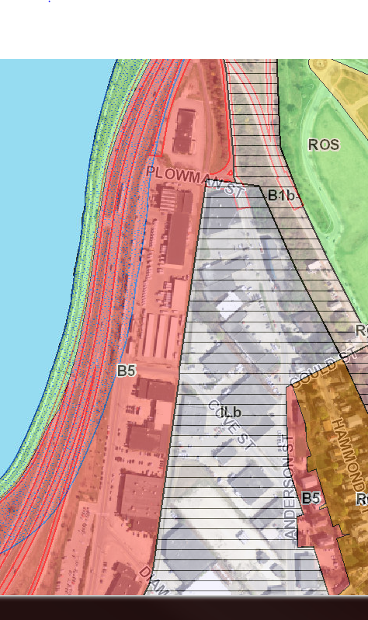

The PUBLIC HEARING will be held:
Tuesday, September 29, 2015
7:00 p.m.
City Hall, Council Chambers, 2nd Floor

Please visit http://www.portlandmaine.gov/211/Planning-Board on or after the preceding Friday of the Planning Board meeting for current memos and reports. The proposed text and map amendment is available for viewing, in person, in the Building Inspections Division, 3rd Floor, City Hall, by referencing Application #2015-090 or CBL #8-A-5. If you wish to submit written comments, address them to Rick Knowland, Senior Planner, Planning Division, City Hall, 4th Floor, 389 Congress Street, Portland, ME 04101; contact by phone at 207-874-8725 or e-mail at rwk@portlandmaine.gov

