Inspection Services Department of Urban Development
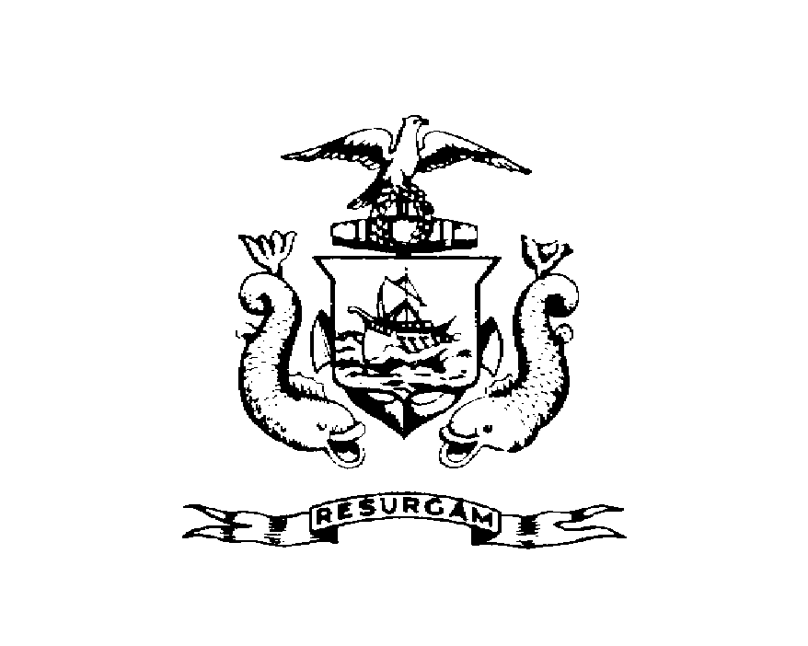
Michael J. Nugent Joseph E. Gray, Jr.
Manager Director

CITY OF PORTLAND

December 3, 1999

Della Chester
107 Congress Street
Portland, ME 04101

RE: 22 Obrion Street
CBL: 003-O-003

Dear Ms. Chester: Certified Mail Receipt # P 487 771 490

An evaluation of your property at 22 Obrion Street on 12/1/99 revealed that the structure fails to comply with Sections 22.3 & 12.19 of the Code of the City of Portland

The following violations are:
  - Accumulation of miscellaneous trash debris, rubble, wood, and windows
12.19 Accumulations of refuse in uncovered containers – not in compliant blue bags

This is a notice of violation pursuant to Sections 22.3 & 12.19 of the Code. All referenced violations shall be corrected within 30 days of the date of this notice. A re-inspection of the premises will occur on 12/30/99 at which time compliance will be required. Failure to comply will result in this office referring the matter to the City of Portland Corporation Counsel for legal action and possible civil penalties, as provided for in Section 1-15 of the Code and in Title 30-A M.R.S.A. ss 4452.

This constitutes an appealable decision pursuant to Section 22.21 of the Code. Please feel free to contact me at 874-8715, if you wish to discuss the matter or have any questions. Please be advised that the Portland City Council has amended the Building regulations to include a $75.00 re-inspection fee. This violation will automatically cause a re-inspection at no charge. If there are any subsequent inspections, however, the $75.00 fee will be assessed for each inspection. A copy of the amendment has been attached for your convenience.

Sincerely

Jeannie Bourke
Code Enforcement Officer

cc/Central File

