Inspection Services Department of Urban Development
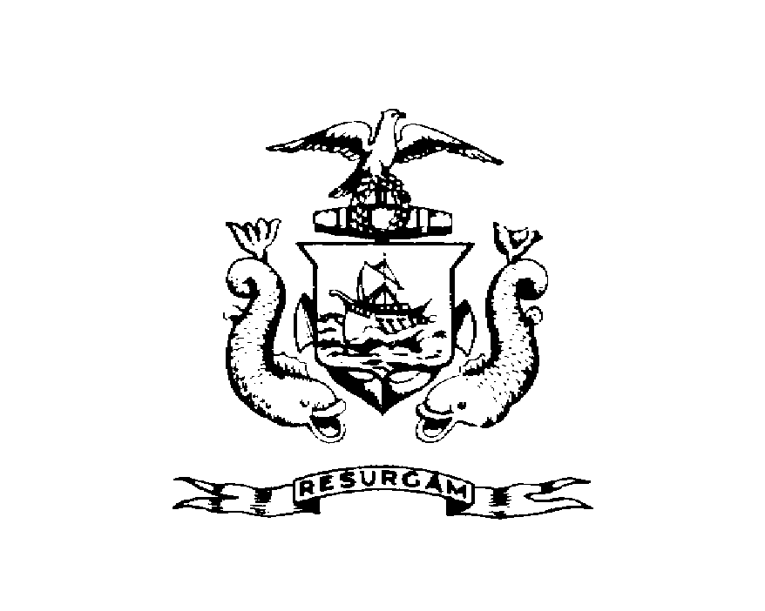
Michael J. Nugent Joseph E. Gray, Jr.
Manager Director

CITY OF PORTLAND

October 28, 1999

Beverly & Lawrence Tirrell
461 Buxton Rd
Saco, ME 04072

RE: 56 Wilson St
CBL: 003-N-00900101

Dear Mr. & Mrs. Tirrell:

A re-inspection at the above noted property was made on Oct-25-1999.

This is to certify that you have complied with our request to correct the violation(s) of the Municipal Code relating to housing conditions noted on our letter dated

Thank you for your cooperation. If you have any questions, feel free to contact this office at
874-8715.

Sincerely,

Jeannie Bourke
Code Enforcement Officer

Nbw/

