Inspection Services Department of Urban Development
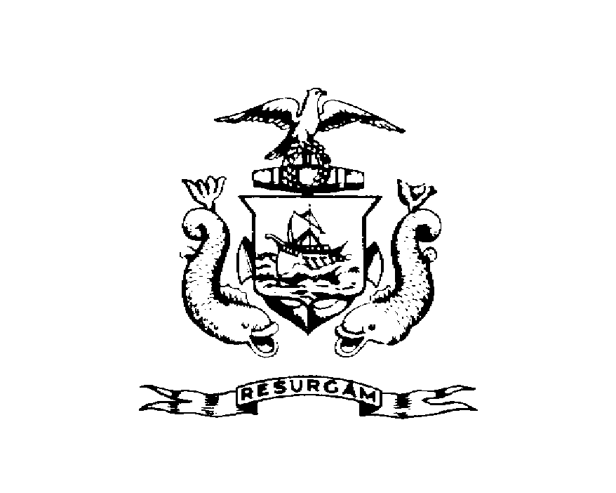
Michael J. Nugent Joseph E. Gray, Jr.
Manager Director

CITY OF PORTLAND

September 17, 1999

Beverly & Lawrence Tirrell
461 Buxton Rd.
Saco, ME 04072

RE: Wilson/Obrion St.
CBL: 003-N-009

Dear Mr. & Mrs. Tirrell;
Certified Mail Receipt # Z 434 206 688

An evaluation of your property at Wilson/Obrion St. on 9/17/99 revealed that the premises fails to comply with Section 12.79 of the Garbage and Solid Waste Removal Code of the City of Portland.

Junk motor vehicle gray Subaru Justy with broken windows.

This is a notice of violation pursuant to Section 12-30 of the Code. All referenced violations shall be corrected within 30 days of the date of this notice. A reinspection of the premises will occur on October 17, 1999 at which time compliance will be required. Failure to comply will result in this office referring the matter to the City of Portland Corporation Counsel for legal action and possible civil penalties, as provided for in Section 1-15 of the code and in title 30-A M.R.S.A. ss 4452.

Please feel free to contact me at 874-8715, if you wish to discuss the matter or have any questions.

Sincerely,

Jeanie Bourke
Code Enforcement Officer

Nbw/
CC: Central file
Betsy Marsano

