Inspection Services Department of Urban Development Michael J. Nugent Joseph E. Gray, Jr.
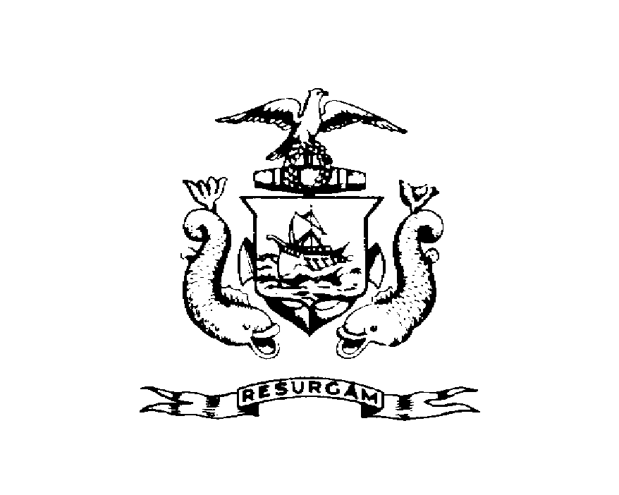
Manager Director

CITY OF PORTLAND

November 24, 1999

Norman E. Maze Jr
51 Moody St #2
Portland, ME 04101

RE: 49 Moody St
CBL: 003-L-01700101

Dear Mr. Maze:

A re-inspection at the above noted property was made on May-19-1999.

This is to certify that you have complied with our request to correct the violation(s) of the Municipal Code relating to housing conditions noted on our letter dated May 19, 1999.

Thank you for your cooperation. If you have any questions, feel free to contact this office at
874-8715.

Sincerely,

Jeannie Bourke
Code Enforcement Officer

/nbw

