Inspection Services Department of Urban Development
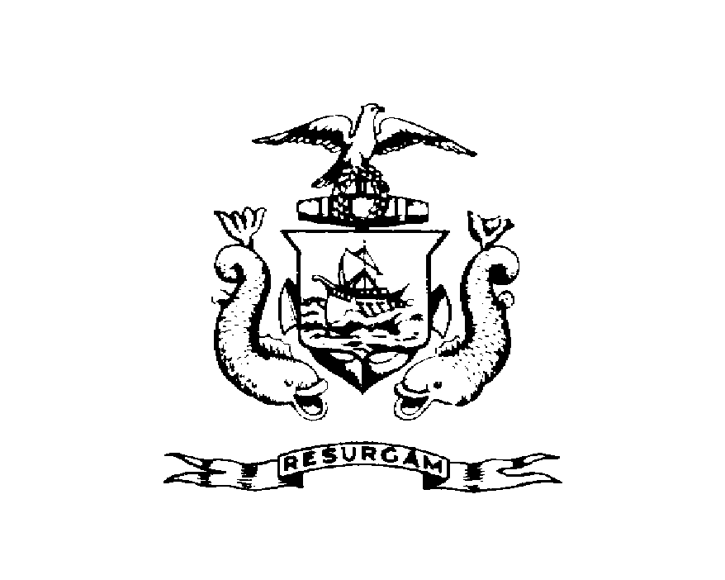
Michael J. Nugent Joseph E. Gray, Jr.
Manager Director

CITY OF PORTLAND

July 28, 2026

Melissa Turcotte
P.O. Box 11205
Portland ME 04104

RE: 84 Monument St
CBL: 017F00300101

Dear Melissa Turcotte:

A re-inspection at the above noted property was made on Jan-13-2000.

This is to certify that you have complied with our request to correct the violation(s) of the Municipal Code relating to housing conditions noted on our letter dated Dec-14-1999.

Thank you for your cooperation. If you have any questions, feel free to contact this office
Arthur Rowe @ 874-8697.

Sincerely,

Arthur Rowe @ 874-8697
Code Enforcement Officer

