Inspection Services Department of Urban Development
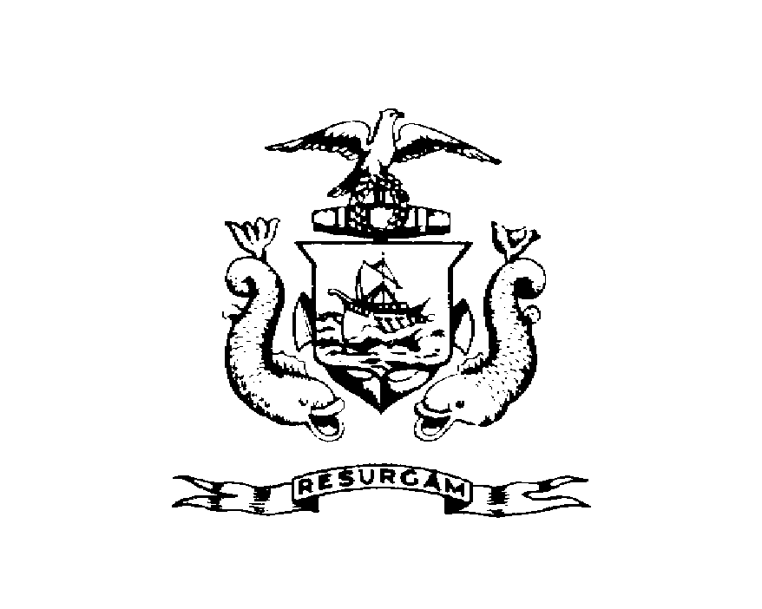
Michael J. Nugent Joseph E. Gray, Jr.
Manager Director

CITY OF PORTLAND

July 31, 2026

Keith E & Bonnie G Brown Jts
76 Beckett St
Portland ME 04101

RE: 76 Beckett St
CBL: 003L00800101

Dear Keith E & Bonnie G Brown Jts:

A re-inspection at the above noted property was made on Nov-01-2000.

This is to certify that you have complied with our request to correct the violation(s) of the Municipal Code relating to housing conditions noted on our letter dated Aug-16-2000.

This notice is intended to document that you have corrected the specific violations as previously noted. It is not intended to indicate compliance with other City regulations, it also does not imply that the structure or premises is violation free.

Thank you for your cooperation. If you have any questions, feel free to contact this office
Steve Wentworth@874-8709.

Sincerely,

Steve Wentworth@874-8709
Code Enforcement Officer

