Inspection Services Department of Urban Development
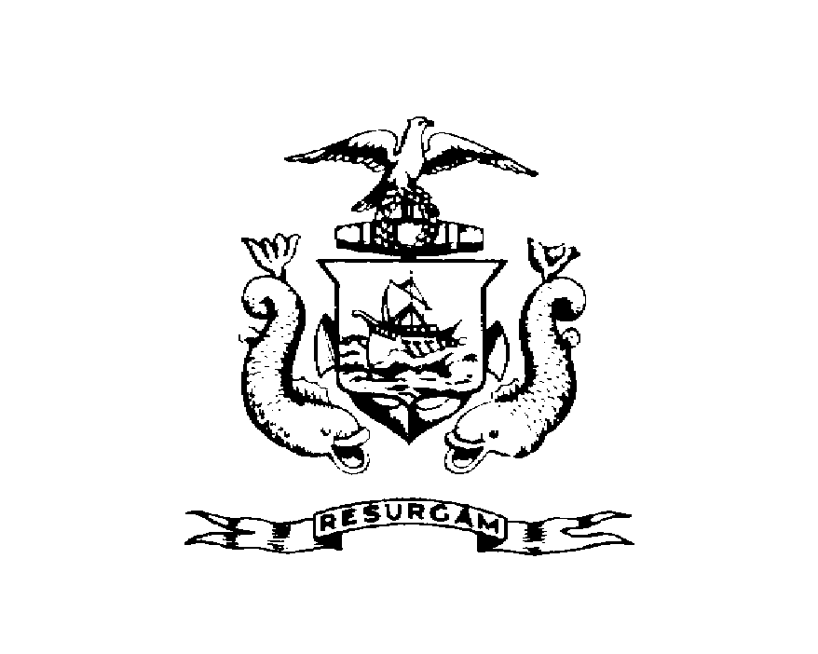
Michael J. Nugent Joseph E. Gray, Jr.
Manager Director

CITY OF PORTLAND

November 2, 1999

Michael Graff
84 Beckett St. Apt #3
Porland, ME 04101

RE: 84 Beckett St
CBL: 003-L-00600101

Dear Mr. Michael Graff:

A re-inspection at the above noted property was made on Oct-28-1999.

This is to certify that you have complied with our request to correct the violation(s) of the Municipal Code relating to housing conditions noted on our letter dated on September 17, 1999.

Thank you for your cooperation. If you have any questions, feel free to contact this office at
874-8715.

Sincerely,

Jeanie Bourke
Code Enforcement Officer

Nbw/

