Inspection Services Department of Urban Development
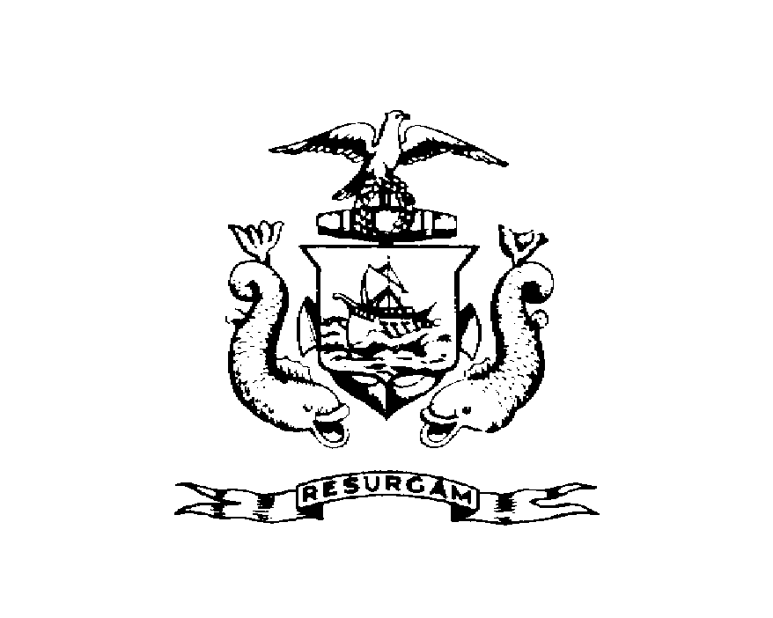
Michael J. Nugent Joseph E. Gray, Jr.
Manager Director

CITY OF PORTLAND

September 20, 1999

Michael Graff
84 Beckett St. #3
Portland, Me 04101

RE: 84 Beckett St
CBL: 003-L-00600101

Dear Mr. Graff:
Certified Mail Receipt # Z 397 901 717

An evaluation of your property at 84 Beckett St on September 17, 1999 revealed that the structure fails to comply with Chapter 6.Article V. of the Code of Ordinances of the City of Portland, The Housing Code. Attached is a list of the violations and copies of the referenced Code sections.

This is a notice of violation pursuant to Section 6-118 of the Code. All referenced violations shall be corrected within 30 days of the date of this notice. A reinspection of the premises will occur on
October 21, 1999 at which time compliance will be required. Failure to comply will result in this office referring the matter to the City of Portland Corporation Counsel for legal action and possible civil penalties, as provided for in Section 1-15 of the Code.

This constitutes an appealable decision pursuant to Section 6-127 of the Code. Please feel free to contact me at 874-8703, if you wish to discuss the matter or have any questions.

Please be advised that the Portland City Council has amended the Building regulations to include a $75.00 reinspection fee. This violation will automatically cause a reinspection at no charge. If there are any subsequent inspections, however, the $75.00 fee will be assessed for each inspection. A copy of the amendment has been attached for your convenience.

Sincerely,

Jeannie Bourke
Code Enforcement Officer

Nbw/

