Inspection Services Department of Urban Development
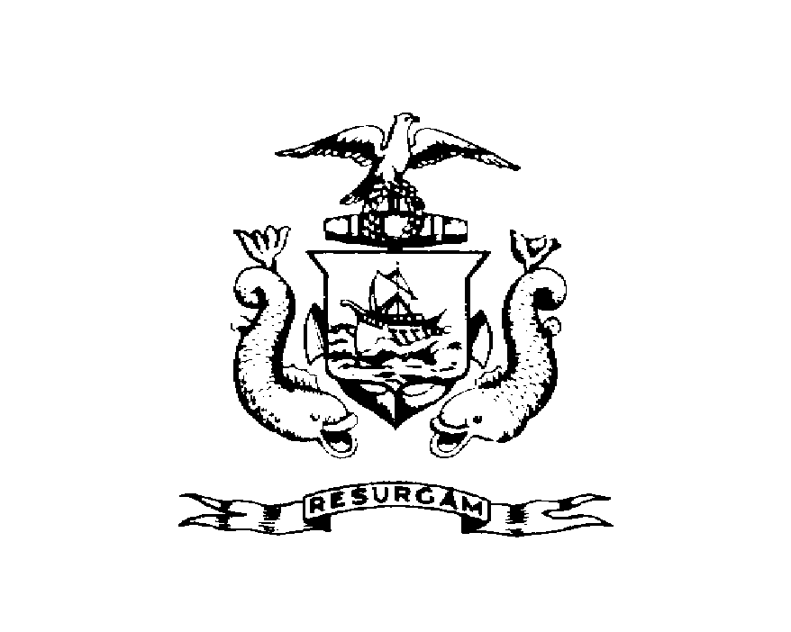
Michael J. Nugent Joseph E. Gray, Jr.
Manager Director

CITY OF PORTLAND

July 31, 2026

Jeffery Lowery
94 Beckett Street, Apt 3
Portland, Maine 04101

RE: 94 Beckett Street
CBL: 003-L-003

Dear Mr. Lowery:

A re-inspection at the above noted property was made on March 21, 2001.

This is to certify that you have complied with our request to correct the violation(s) of the Municipal Code relating to housing conditions noted on our letter dated March 17, 1998.

This notice is intended to document that you have corrected the specific violations as previously noted. It is not intended to indicate compliance with other City regulations, it also does not imply that the structure or premises is violation free.

Thank you for your cooperation. If you have any questions, feel free to contact this office
874-8702.

Sincerely,

Jonathan J. Reed
Code Enforcement Officer

