

Memorandum
Department of Planning and Development
Planning Division

To:
Leslie Kaynor, Public Works (*.pdf and word files enclosed)

From: Molly Casto, Planner

Date:
July 30, 2026

Re: The Estates at Longfellow Inn- 130 Eastern Promenade
Application #: 2007-0123
CBL: 003 C001001

Approved Plans and Subdivision Recording Plat
______________________________________________________

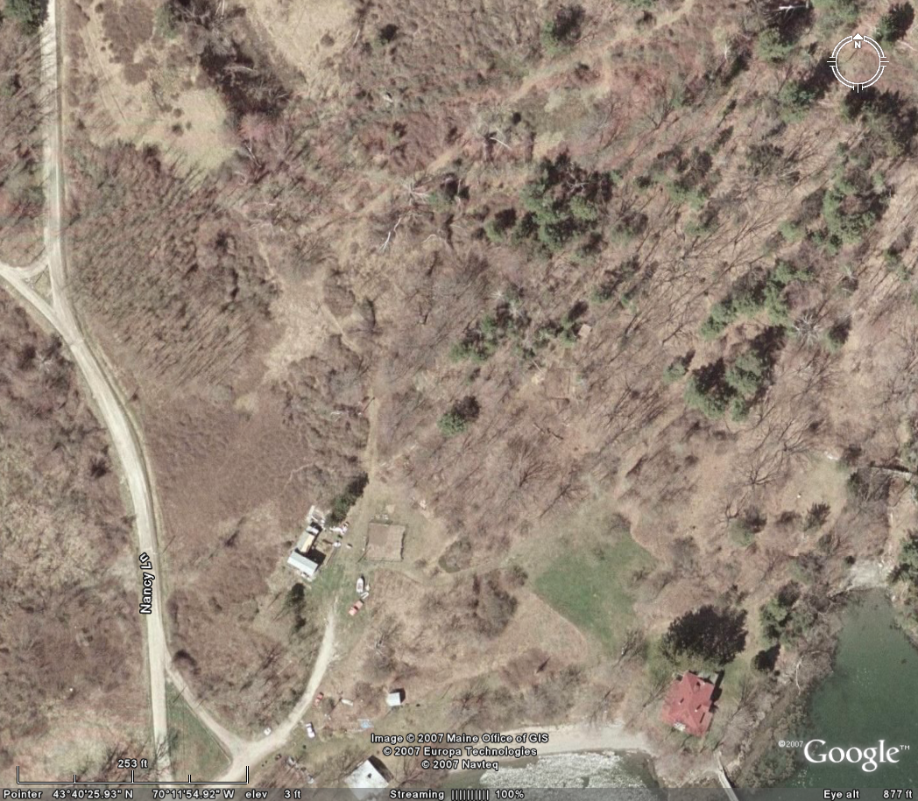
Approximate location of proposed Nicholas Street extension indicated by arrow

Hopefully this CD has the correct files on it. The files appear to be MS word and .pdf documents. As I recall, that works for you, though AutoCAD is preferable? I requested AutoCAD but maybe this is all they could get me. Let me know if this is ok

Let me know if you have any questions- 874-8901 or mpc@portlandmaine.gov

rator

