PLANNING BOARD REPORT #: 05-08

THE ESTATES AT LONGFELLOW INN

130 EASTERN PROMENADE

CASCO BAY VENTURES, APPLICANT

SITE PLAN AND SUBDIVISION REVIEW

Submitted to:
Portland Planning Board
Portland, Maine

Submitted by:
Molly Casto, Planner

Prepared on: January 18, 2008
Meeting Date: January 22, 2008

Introduction
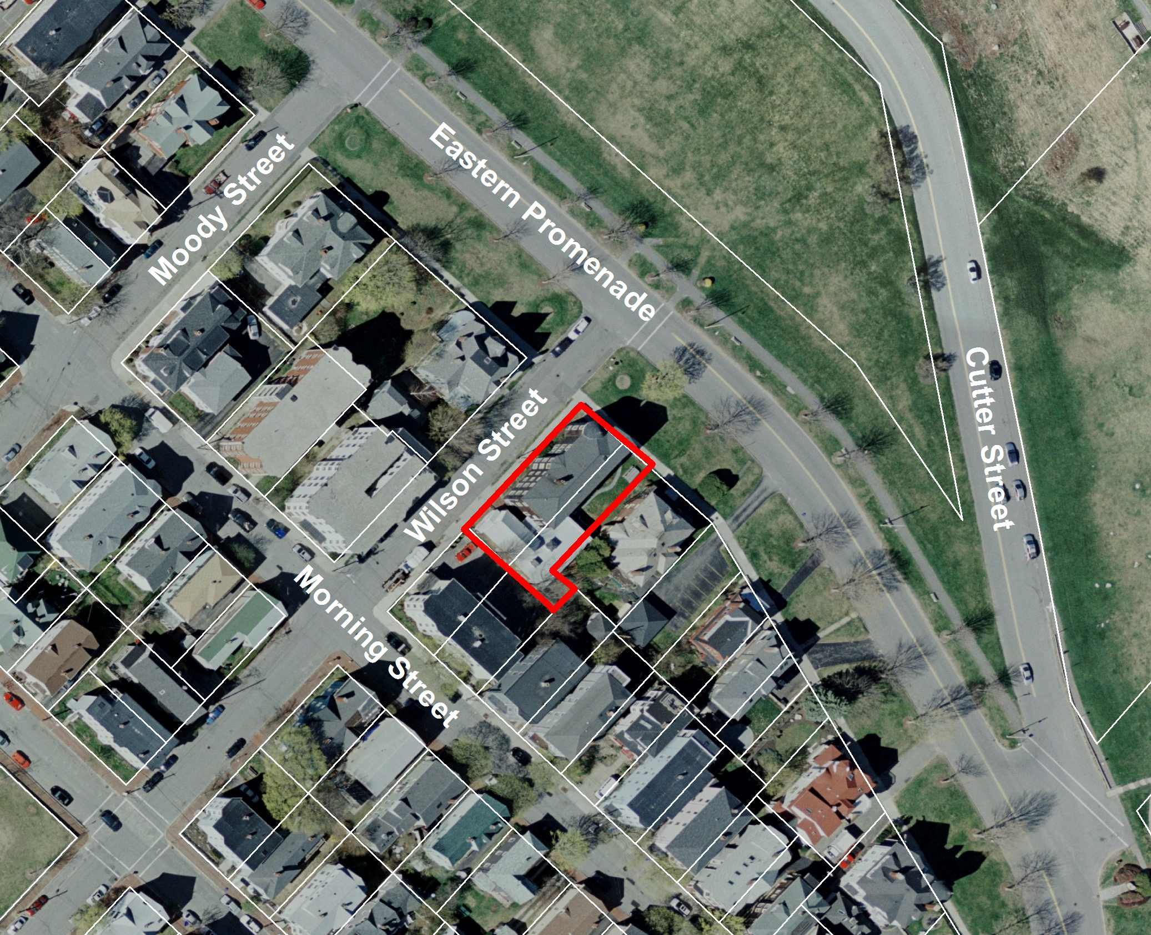
Site Location Map
Casco Bay Ventures has requested subdivision and site plan review and approval for their proposal to renovate and add a three-story addition to the existing building at 130 Eastern Promenade. The project is to be reviewed according to the City of Portland standards for subdivision and for major site plan. The site is located within an R-6 Residential zone.

Notice of the public hearing was sent to 111 area property owners and was advertised in the Portland Press Herald and on the City website.

Representatives for the applicant include TFH Architects and Back Bay Boundary, Inc., both of Portland, Maine.

Findings for 130 Eastern Promenade

Total Land area: 7,905.9 square feet (.18 acres)
Tax Map: Tax Map 3-C Lots 1 and 2
Zone: R-6 Residential
Existing Use: 11-unit apartment building with 2-car garage.
Proposed Use: 7-unit apartment building with paved 7-car parking lot.
Parking: Proposal to remove garage and construct a seven-car parking lot on site.
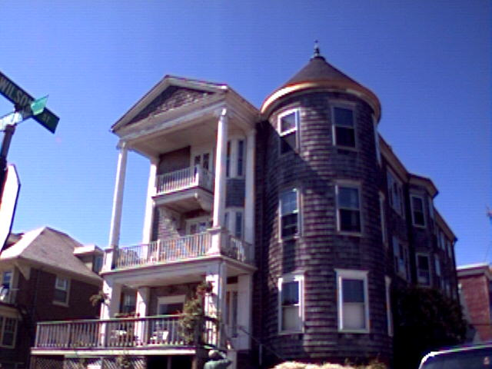Image 1- 130 Eastern Promenade

Site Description

The site, located at the corner of Eastern Promenade and Wilson Street contains a vacant, eleven (11) unit residential structure composed of a three-story frame building containing nine (9) units, with a single story addition containing two (2) units and a two-car garage.

Proposed Development

The applicant proposes to renovate the existing three-story frame building, demolish the one-story addition and add a three story, three-unit addition on the southeast side. The proposed building will contain seven (7) apartments ranging in size from 1,123 to 1,442 gross sq. ft (excluding porches, decks and balconies). The applicant proposes to demolish the existing garage in order to accommodate a seven (7) car parking lot including covered parking for five (5) full-size cars and two (2) additional outside parking spaces for compact size vehicles (see submitted plans- Attachment 14(e)).

The total square footage of the proposed building footprint is 3,891 sq. ft. The total gross square footage of the proposed development is 10,534 gross sq. ft. The proposal includes a remaining 2,006 sq. ft of landscaped open space.

Waiver Request- Section 14-483
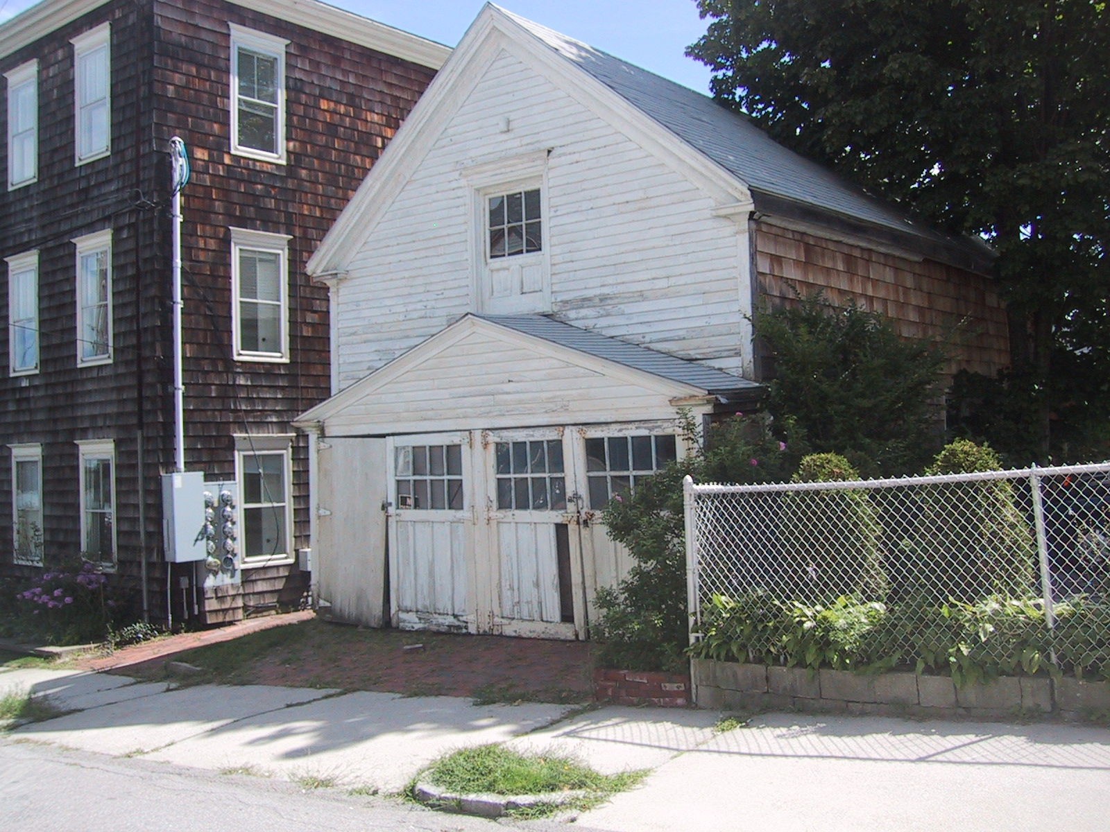
Image 2- Existing garage to be demolished

The applicant has submitted a letter to the Planning and Inspections Divisions requesting that the Planning Board grant an exemption from the requirements of Section 14-483- Preservation and Replacement of Housing Units (see Attachment 13). Section 14-483 requires the review and approval of the Planning Authority. The applicant is seeking to reduce the number of units in this building from eleven (11) to seven (7).

Section 14-483 is intended to limit the net loss of housing units caused by the demolition, consolidation or conversion of residential property. The provisions of this section apply in all zoning districts in cases where three or more lawfully existing dwellings, including dwelling units within multi-family buildings, are demolished, converted to non-residential uses, or eliminated through the reduction or consolidation of units within a residential property within a five (5) year period. The applicant has submitted documentary evidence that they meet exemption criteria (6) as outlined in this section of the Ordinance. Criteria 6 states:

(6) Existing residential structure which, exclusive of additions thereto, contain more dwelling units than they were originally designed and built to accommodate and which are being modified to contain fewer dwelling units, subject to the condition that the number of dwelling units originally intended to be accommodated in such structures can be established by documentary evidence.

The applicant is seeking to reduce the number of units from eleven (11) to seven (7). The applicant has submitted documentation to support their determination that the building at 130 Eastern Promenade was originally built and occupied as a building with three (3) dwelling units in 1903 (see Attachment 13). The number of dwelling units subsequently increased when the building was converted to hotel use as the Ye Longfellow Inn in 1916.

Zoning

Marge Schmuckal, Zoning Administrator, has reviewed this project for compliance with the City's zoning requirements. Her memo is attached as Attachment 9 and contains the following conclusions:

- The seven (7) requested dwelling units would meet the land area per dwelling unit requirements of the R-6 zone.
- The seven (7) units would require a minimum lot size of 7,800 sq ft of land area. Currently the lot is 7,905.9 square feet, which is in excess of the minimum lot size required.
- The applicant is not prohibited from enlarging the building under section 14-388.
- The enlargement can meet the R-6 zone setbacks as currently shown.

Two abutters to the project have raised concerns about Marge’s interpretation of Section 14-382(d) of the City Code with the Planning Board. Those concerns, including a request that the Board table this matter, are included as Attachment 13 (Public Comment). Corporation Counsel's Office indicated at the December 11, 2007 workshop that the Planning Board does not have the authority to make zoning determinations. Such determinations are exclusively within the purview of the Zoning Administrator and the Zoning Board of Appeals.

Parking requirements:
The applicant is not required by zoning (Section 14-332) to incorporate additional parking into their proposal because the proposal does not increase the number of units. The only requirement is that they not reduce off-street parking to less than what exists currently. At present, the property can accommodate approximately two parking spaces in the existing garage. The applicant proposes to increase off-street parking to seven (7) parking spaces, providing one parking space for each unit.

The following chart compares the dimensional requirements of the R-6 zone to the proposed development:
Standard | R-6 Requirements | Proposed Development
Min. Lot Size | 4,500 sq. ft | 7,905.9 sq. ft.
Min, Area per Unit | 1000 sq. ft/DU for existing building. 1,200 sq. ft. after first 3 DU's = 7,800 sq. ft minimum for 7 units | 7,905.9 sq. ft.
Min, Street Frontage | 40 ft | Approx. 65 ft
Min. Front Yard | 10 ft | 5 ft- existing bldg /15 ft – bldg addition
Min. Side Yard | 10 ft | Approx. 2.5 ft- existing bldg/ 10 ft - bldg addition
Min. Rear Yard | 20 ft | 20 ft
Max. Lot Coverage | 50% | 49.20%
Min. Lot Width | 50 ft | Approx. 65 ft
Min. Structure Height | Min. of 2 stories of living space | 3 stories of living space
Max. Structure Height | 45 ft | Approx. 39 ft.
Open Space Req. | Min width/length = min. 15 ft and slope = <10%. | Approx. (15.7 x 29.3 ft.) + 18.6 x 10 ft.) Open space (25.4%). Slope = < 10%

Right, Title or Interest

The applicant submitted a warranty deed as appropriate evidence of ownership of the property (see Attachment 2).

Financial Capacity

Casco Bay Ventures submitted a letter from Bangor Savings Bank, dated January 2, 2008 stating that the applicant has the financial capacity to complete the project (see Attachment 3).

Neighborhood meeting

Casco Bay Ventures held a neighborhood meeting, a required by City ordinance, on December 27, 2007. Documentation from that meeting is included as Attachment 6

SUBDIVISION and Site Plan REVIEW
The proposed development has been reviewed by Planning staff for conformance with the relevant review standards of the subdivision and site plan ordinances. Staff comments are highlighted in this report.

Subdivision Recording Plat
The proposed 3-story addition contains three dwelling units and is therefore defined as a subdivision.

According to Section 14-493 of the City Code of Ordinances - Definitions, a subdivision is defined as:
… The division of a lot, tract or parcel of land into three (3) or more lots, including lots of forty (40) acres or more, within any five-year period whether accomplished by sale, lease, development, buildings or otherwise and as further defined in 30-A M.R.S.A. Section 4401. The term subdivision shall also include the division of a new structure or structures on a tract or parcel of land into three (3) or more dwelling units within a five-year period and the division of an existing structure or structures previously used for commercial or industrial use into three (3) or more dwelling units within a five-year period. The area included in the expansion of an existing structure is deemed to be a new structure for the purposes of this paragraph. A dwelling unit shall include any part of a structure, which, through sale or lease, is intended for human habitation, including single-family and multifamily housing condominiums, time-share units and apartments.

The recording plat is included as Attachments 14-d. Any conditions of approval that the Board places on the subdivision must be shown on the plat. A revised plat meeting these requirements must be submitted pending the Planning Board’s decision.

Boundary Survey
Public Works submitted comments on December 4, 2007 addressing two notes, which should be included on the boundary survey stating that, the project survey coincides with approved City standard. The applicant has submitted a revised boundary survey, however, this has not yet been reviewed and approved by Public Works.

Planning staff recommends including review and approval of the revised boundary survey by Public Works as a condition of approval.

Water and Air Pollution
The project will not result in undue water or air pollution. The site is not within a flood plain and the project will be served by public water and public sewers.

- Water
The project has sufficient water available and will not cause an unreasonable burden on the existing water supply. Water for domestic use and fire suppression will be provided by a six inch cast iron water main on the east side of Wilson Street. The applicant has submitted a letter from Portland Water District (PWD) dated August 1, 2007 stating that they have adequate capacity to serve the development (see Attachment 4-c). While the letter from PWD refers to a nine-unit development, which had been proposed in earlier versions of the proposal, the proposed reduction to seven units does not impact their ability to service the project.

- Soil Erosion
The applicant proposes to erect silt fencing as a soil and sedimentation control measure prior to commencing work. Erosion control details have been provided on sheet C1-3 of the submitted plans (Attachment 14). Dan Goyette, Consulting Engineer to the Department of Public Works, has reviewed and approved the proposed erosion control measures.

Traffic, Parking and Pedestrian Circulation
As stated in the zoning section of this memorandum, the applicant is not required to increase the number of off- street parking spaces due to an overall reduction in the number of units. The applicant, however, has chosen to incorporate seven (7) parking spaces into their proposal. Five (5) of these are standard sized spaces (approx. 9’ x 19’) located under a building overhang. The remaining two (2) are compact –sized surface parking spaces (7’6” x 15’).

Jim Carmody, Traffic Engineer, has reviewed parking and circulation and submitted the following comments:

I have reviewed the plan showing the parking layout. The layout is sufficient in dimensions of the parking spaces including 2 compact spaces, and the aisle width meets city standards. There is adequate width for vehicles to maneuver and able to exit the parking area going forward.
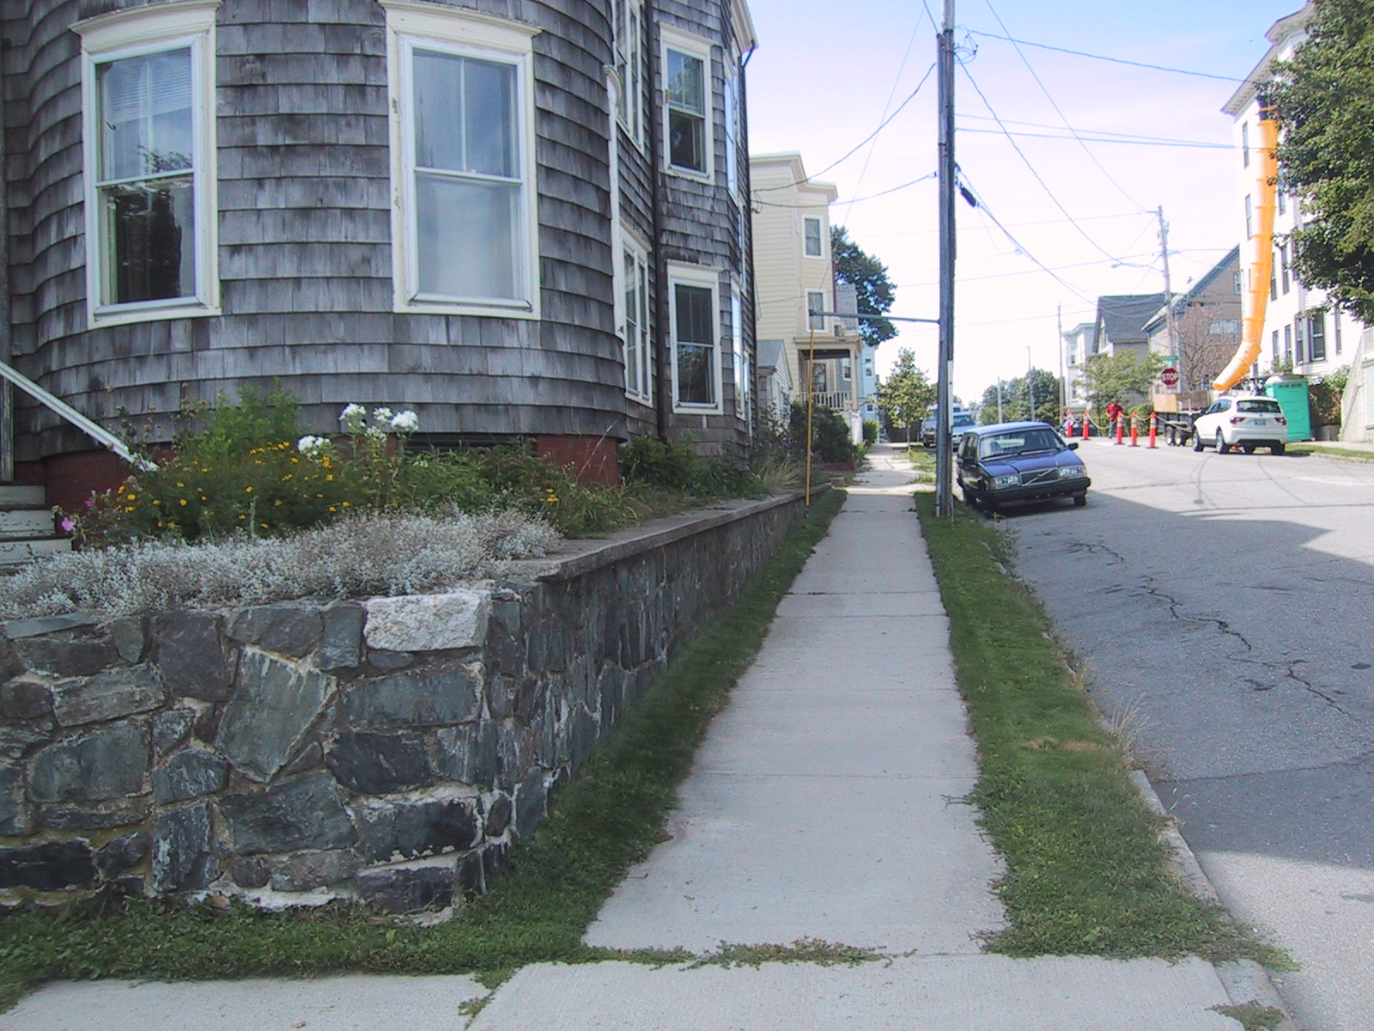
Image 4 - Existing sidewalk on Wilson Street

A buffer of arborvitae has been proposed around the parking area. The two existing cedar trees and two existing elms between the proposed lot and the abutter’s parking lot at 14 Wilson Street will be preserved, providing additional screening (see submitted landscape plan. Sheet C1.4- Attachment 14(g).

Continuation of the Wilson Street Sidewalk:
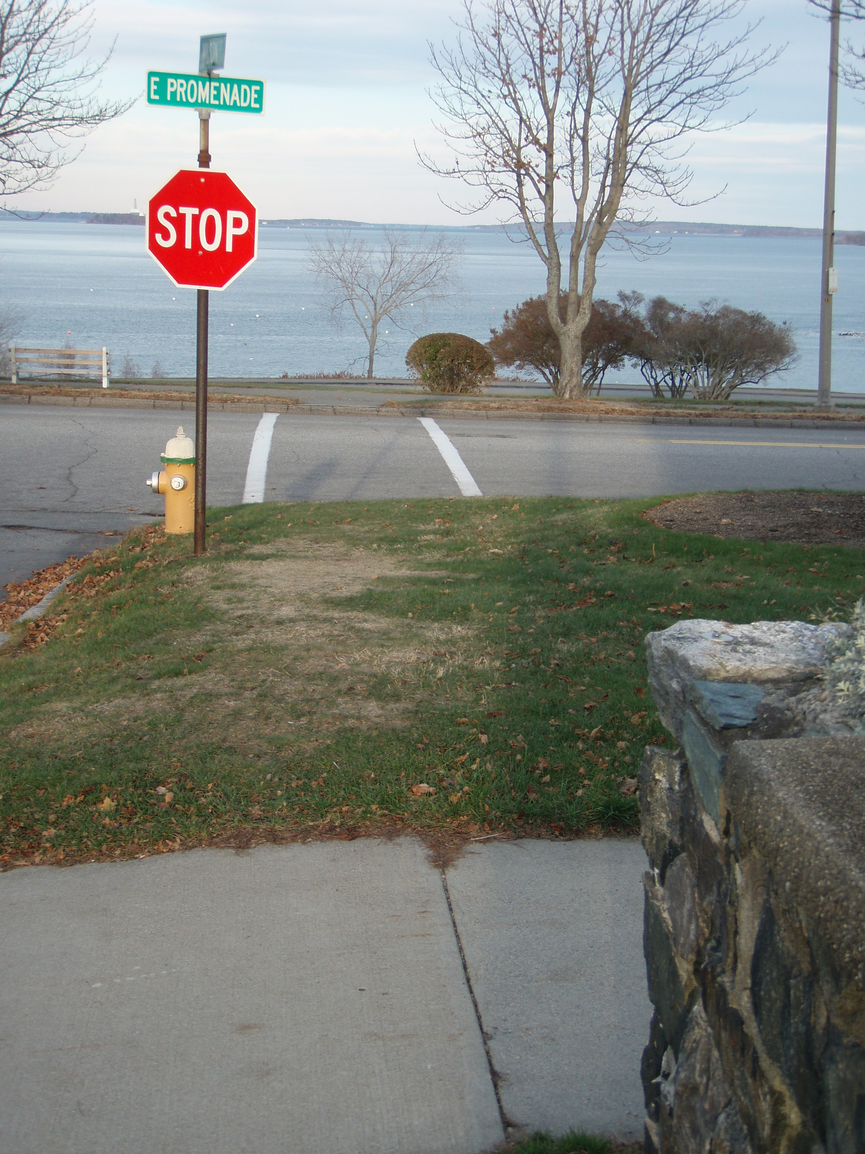
Image 5- Esplanade at intersection of Wilson and Eastern Promenade.

Section 14-498- Technical and Design Standards, of the Subdivision Ordinance grants Public Works the authority to promulgate technical and design standards for subdivisions and site plans. Section 14-498 (8) – sidewalks and curbs states:

Sidewalks shall be constructed on each side of each street in accordance with article III of chapter 25. Sidewalks to be used by pedestrians are to be so located as to minimize contacts with normal automotive traffic, with preference given to interior walks away from streets in common open space in block interiors.

Section 14-499 of the Subdivision Ordinance lists required improvements for all subdivisions. 14-499 (d) states:

Sidewalks and curbs shall be constructed as required in section 14-498.

The applicant proposes to repair a portion of and to add street trees to the existing concrete sidewalk along Wilson Street. Currently, there is concrete sidewalk on both sides of Wilson Street and along the frontage on the Eastern Promenade. There is a crosswalk across the E. Prom on the right east side of Wilson Street, however there is no sidewalk linking to it across the Prom’s grass esplanade. With the exception of the intersection at Moody Street and Eastern Prom, which has a similarly disconnected pedestrian system, all remaining intersections along the Prom (Congress; Turner; Quebec; Melbourne; Montreal and Walnut) include sidewalks along the edge of curb on the esplanade connecting to at least one crosswalk across the Prom (Congress Street has crosswalks on both sides).

The 2004 Eastern Promenade Master Plan states, under Priority One in the introduction to the Implementation section:

On Eastern Promenade, it is recommended to expand the walk and crosswalk system.

The Report’s Summary Recommendations section addresses appropriate pavement materials. It states that sidewalks on both sides of the Eastern Promenade should be replaced with brick as required for consistency with the City’s sidewalk material policy for historic parks (Eastern Promenade Master Plan (2004) pp. 4). The City’s Sidewalk Replacement Material Policy map from District 1 corresponds to this, indicating that brick sidewalks should be used in this area.

Based on the above information, the applicant has revised their proposal to include new brick sidewalk connecting the sidewalk at Wilson Street to the crosswalk along Eastern Promenade. Public Works has reviewed the proposal to leave the existing sidewalk as concrete and determined that, so long as any disturbance is less than 10 feet and kept within two sections of concrete sidewalk, the disturbed area may be repaired with concrete. For a larger disturbance, the applicant must replace disturbed sections with brick sidewalk (see Attachment 8). This could apply for the proposed sewer connection on the Eastern Promenade side. The applicant proposes to dig pits on both sides and jack a pipe under the existing retaining wall and concrete sidewalk. The depth of the wall footing and the pipe elevation, however, remain uncertain until they actually dig into the ground.

The applicant has included this requirement as a note on the plans.

Stormwater-
The submitted stormwater plan is included as Attachment 5. Engineering review comments from Dan Goyette, Consulting Development Review Engineer, are included as Attachment 7. Dan recommends minor revisions to the site plans pertaining to stormwater management. City Technical Standards stipulate that the rate of runoff of stormwater leaving the site after development shall not exceed the pre development rate. The City recognizes the difficulties that on-site detention poses to urban development. As the amount of impervious coverage increases, the quantity of water leaving the site will inevitably increase with it. The rate and quality of runoff, however, must be regulated. The submitted stormwater report shows that there will be a slight increase in flow for the post development site conditions. The capacity of the existing combined sewer system and the effect of the proposal’s stormwater and sanitary sewer flows on the system must be verified and taken into account in the design prior to approval. The applicant submitted revisions addressing Dan’s comments on January 2, 2008 (see Attachments 16 and 17). These revisions have been submitted to but have not yet been approved by Public Works.

Planning staff recommends including a condition of approval that revisions to the stormwater management plan must be reviewed and approved by Public Works prior to the issuance of a building permit.

- Public Utilities
The applicant has submitted a letter, dated September 18th, from Public Works stating that they have adequate capacity to handle wastewater flows from the proposed development. The applicant has also submitted a letter from Portland Water District (PWD) dated August 1, 2007 stating that they have adequate capacity to serve the development. The applicant has also submitted letters from both Central Maine Power (CMP), dated August 17, 2007 and Northern Utilities dated August 7, 2007 indicating that there is both sufficient electrical capacity and availability of natural gas in that location to service the proposed project. These letters have been included as Attachment 4. The applicant proposes to install all electric utility connections underground.

- Solid Waste Disposal
The applicant proposes locating trash bins with wheels at the rear of the proposed parking area enclosed behind a gated stockade fence. There will be a row of arborvitae along three sides of the trash storage area, providing additional screening.

- Groundwater
This proposed development will be served by public water and sewer, thus it will not adversely affect the quality or quantity of ground water.

Flood Hazard/Shoreland
The proposed development is not located within a flood plain zone or a shoreland zone.

- Wetlands
No wetlands have been identified on this proposed site.

- Comprehensive Plan

The components of the Comprehensive Plan relevant to this residential subdivision include:
- Eastern Promenade Master Plan – Adopted November 2003
- Housing: Sustaining Portland’s Future – Adopted November 2002

The above two elements of Portland’s Comprehensive Plan encourage housing to be created in Portland near neighborhood assets and to develop in a way that supports goals related to landscape character and public infrastructure along the Eastern Promenade. The Estates at Longfellow Inn is an infill redevelopment project located near businesses, services, mass transit and open space (Eastern Promenade park).

Exterior Lighting
The applicant has submitted a detailed lighting plan showing 3 exterior lighting fixtures (Sheet C-1.5- Attachment 14(h)). Proposed lighting is positioned to illuminate the parking area and entrance on the Wilson Street-side of the building. The Portland Technical and Design Standards and Guidelines stipulate that exterior lighting shall be adequate for the safety of users of the site but shall not cause glare or direct spillover to adjacent properties or create visual distraction to motorists on adjacent streets. According to the submitted photometric plan, the illumination levels of the proposed lighting meet the standards of the Portland Technical and Design Standards, Section XV (4).

Fire Safety
The applicant submitted a life safety plan (Sheet G-1.2- Attachment 14(b)) and fire department checklist for review. Captain Greg Cass of the Portland Fire Department has reviewed and approved these materials.

- Landscaping
The applicant has submitted a revised landscaping plan for review (Sheet C1.4- Attachment 14(g). The applicant proposes to add assorted perennials and a weeping cherry (prunus snowfozam) above the retaining wall along Eastern Promenade. The plans include measures to both enhance and preserve the existing planting beds along the Eastern Prom and Wilson Street frontages with summer annuals and perennial species. As previously stated, the applicant proposes to plant forty five (45) arborvitaes around the parking area as screening. In addition there are two mature cedar and two mature elm trees along the southwest property boundary, between the proposed parking area and an abutter’s existing parking lot. The submitted landscaping plan identifies measures to preserve these trees during construction.

The applicant proposes two street trees along Wilson Street as required by Section VI .5.B (1) of the Technical and Design Standards (see submitted landscape plan - Attachment 14(g)). In addition, the applicant has met with Jeff Tarling, City Arborist concerning proposed landscaping along the Eastern Promenade frontage and has designed their landscaping to coincide with landscaping improvements currently being designed and implemented along the Eastern Promenade

Jeff submitted review comments for the most recent plans (see Attachment 10). In summary, Jeff notes that the landscape treatment of ornamental shrubs and landscape beds fits into the character of the nearby residential landscape. Jeff noted that the proposed Elm tree along the Eastern Promenade should be revised to an Autumn Blaze Maple in order to reflect revisions to the Eastern Promenade Street Tree Plan, Atlantic Street to Wilson Street segment, as designed by Regina S. Leonard, Landscape Architect and submitted by Woodard and Curran for the Eastern Promenade Master Plan Improvements. Jeff also suggests the following conditions of approval:

- To meet the 2-trees per residential unit guidelines as required by the Technical and Design Standards, a contribution for 10 additional trees to the City Tree Fund is recommended. The project unit calculations would require 14 trees and the project is placing four with the project area. The new trees would help fill gaps or replace missing trees in the surrounding neighborhood of the project.

- That impact to the Eastern Prom lawn area be limited during construction. This would include: no storage of trucks, equipment, or materials on the lawn area. All damaged areas to be repaired in a timely manor, the sidewalk pedestrian way along the Eastern Prom be maintained in good condition during construction work.

- The project team or contractor shall contact Parks & Recreation concerning construction activities that might affect the Eastern Prom and park areas.

Relationship to existing development
The proposed building is shown in context with the surrounding structures on the submitted site plan. In terms of preservation of views, the applicable Site Plan Standard reads as follows:

View corridors: The placement and massing of proposed development shall not substantially obstruct those public views to landmarks and natural features from those locations identified on the View Corridor Protection Plan, a copy of which is on file in the department of planning and urban development;

The proposed development is not located in an area identified in the View Corridor Protection Plan. As requested by the Board at the December workshop, Corporation Counsel has provided a memorandum advising the Board on their review of potential view diminution (see Attachment 15).

- Urban Design

The proposal shall be evaluated in terms of Section 14-526 (15) of the Site Plan standards. This section states:

Two-family, special needs independent living unit, multiple-family development, lodging houses, bed and breakfasts, and emergency shelters shall meet the following standards:
a. Proposed structures and related site improvements shall meet the following standards:
- (a) The exterior design of the proposed two-family structures, lodging houses and emergency shelters, including architectural style, facade materials, roof pitch, building form and height, shall be designed to complement and enhance the nearest residential neighborhood;

Carrie Marsh, Urban Designer for the City of Portland reviewed the submitted site plan and elevation drawings and has submitted the following comments (see Carrie’s email- Attachment 11)

The building design is consistent with the nearest residential neighborhood in terms of architectural style, facade materials, roof pitch, building form and height. The elevations indicate a building that is similar in scale to the structure across Wilson Street, and other buildings along the Prom. The design therefore appears to be consistent with the Site Plan Standards.

STAFF RECOMMENDATION

Staff recommends that the Planning Board approve the Estates at Longfellow Inn subdivision and site plan with the proposed waivers and conditions of approval.

MOTIONS FOR THE BOARD TO CONSIDER

On the basis of plans and materials submitted by the applicant, public comment received at the public hearing and the information contained in Planning Report # 05-08 relevant to standards for subdivision and site plan regulations, and the Portland Planning Board finds:

- That the subdivision plan The Estates at Longfellow Inn at 130 Eastern Promenade [is / is not] in conformance with the subdivision standards of the land use code, subject to the following conditions:

Potential Conditions of Approval

- The final recording plat meeting the requirements of Portland’s Subdivision Ordinance and listing conditions imposed by the Planning Board will be submitted for the Planning Board’s Signature.

- That the plan [is / is not] in conformance with the site plan standards of the land use code, subject to the following waivers and conditions:

- That the revised boundary survey submitted by the applicant be reviewed and approved by Public Works prior to the issuance of a building permit.

- All final plan sheets must stamped and signed by a professional engineer.

- All comments submitted by Public Works in their memorandum dated January 16, 2008 must be addressed and approved by Public Works prior to the issuance of a building permit.

- All comments submitted by Jeff Tarling, City Arborist pertaining to the submitted landscaping plan and identified in his review letter dated January 18, 2008 must be addressed and approved by him prior to the issuance of a building permit.

- The proposed street tree along the Eastern Promenade should be revised to show an Autumn Blaze Maple (Acer freemanii). This change to the plans must be reviewed and approved by Jeff Tarling, City Arborist prior to the issuance of a building permit.

Attachments:

- Site Plan application and cover letter
- Evidence of Right, Title or Interest- Warranty Deed
- Letter from Bangor Savings Bank - dated January 2, 2008
- Utility Capacity Letters
  - Letter from Central Maine Power - dated August 17, 2007
  - Letter from Northern Utilities - dated August 7, 2007
  - Letter from Portland Water District - dated August 1, 2007
  - Letter from Portland Public Works - dated September 18, 2007
- Revised Stormwater management report - dated November 19, 2007
- Evidence of Neighborhood Meeting
- Memorandum from Dan Goyette, Consulting Engineer from Woodard and Curran - dated December 4, 2007
- Memorandum from Dan Goyette dated December 19, 2007
- Memorandum from Marge Schmuckal - dated November 2, 2007
- Memorandum from Jeff Tarling, City Arborist – dated January 18, 2008
- Memorandum from Carrie Marsh – dated January 18, 2008
- Zoning determination addressed to Wally Geyer and Anthony Salem of Casco Bay Ventures from Marge Schmuckal- dated September 26, 2007
- Letter from Wally Geyer, Casco Bay Ventures requesting exemption from Section 14-483 of the City Code - dated October 22, 2007
- Revised Plans with cover sheet - dated November 20, 2007
  - General Notes- Sheet G-1.1
  - Life Safety Plan- Sheet G-1.2
  - Boundary Survey
  - Subdivision Plan – Sheet C-1.1
  - Site Plan – Sheet C-1.2
  - Details – Sheet C-1.3
  - Landscaping Plan – Sheet C-1.4
  - Lighting Plan – Sheet C-1.5
  - Basement and Roof Plan – Sheet A-1.1
  - First Floor Plan – Sheet A-1.2
  - Second Floor Plan – Sheet A-1.3
  - Third Floor Plan – Sheet A-1.4
  - Exterior Elevations – Sheet A-2.1
- Memorandum from Penny Littell, Associate Corporation Counsel re: property rights in view preservation. – Dated January 16, 2008
- Letter of response to Public Works comments, from LCE, PA dated January 2, 2008
- Revised drainage plan and pipe calculations- January 2, 2008
- Public Comment
  - Letter from Bruce McGlauflin, Esq. Petrucelli, Martin & Haddow, LLP. Dated September 4, 2007
  - Letter from Bruce McGlauflin, Esq. Petrucelli, Martin & Haddow, LLP. Dated December 6, 2007
  - Letter from Bruce McGlauflin, Esq. Petrucelli, Martin & Haddow, LLP. Dated December 17, 2007
  - Letter from Bruce McGlauflin, Esq. Petrucelli, Martin & Haddow, LLP. Dated January 8, 2008
  - Letter from Bruce McGlauflin, Esq. Petrucelli, Martin & Haddow, LLP. Dated January 17, 2008

