PLANNING BOARD REPORT
PORTLAND, MAINE

8-unit Condominium Development
65 Munjoy Street
Level III Site Plan and Subdivision Review
2015-225
Adam’s Apple LLC

Submitted to: Portland Planning Board  Date: February 4, 2016  Public Hearing Date: February 9, 2016 | Prepared by: Nell Donaldson, Planner  CBL: 003 M 001  Project #: 2015-225

I. INTRODUCTION
Adam’s Apple, LLC appears before the Planning Board for a final site plan and subdivision review for an eight-unit affordable housing development at 65 Munjoy Street in the city’s East End. The plans include a three-story building, eight parking spaces on a surface lot partially covered by the building, landscaping, stormwater treatment, and sidewalk improvements.

The 65 Munjoy Street site, as a portion of a larger property formerly occupied by the Adams School, is owned by the city. The site currently houses a surface parking lot. The city’s Housing and Community Development Committee issued an RFP for the development of the site in 2014. The conceptual plan for this development was submitted in response.

This development is being referred to the Planning Board for compliance with the site plan and subdivision standards. No Planning Board workshop was held. A total of 281 notices were sent to property owners within 500 feet of the site and a legal ad for the Planning Board hearing ran on February 1 and 2, 2016.

Applicant: Ethan Boxer-Macomber, Adam’s Apple, LLC
Consultants: John Mahoney, Ransom Consulting; Owen Haskell, Surveyor; Evan Carroll, Bild Architecture

II. REQUIRED REVIEWS
Waiver Requests | Applicable Standards
Aisle width – To allow a 19’ aisle in the parking area  Supported by consulting traffic engineer. | Technical Manual, Section 1.14, requiring that aisle width for right-angle parking be 24’ per Figure I-27.
Parking dimensions – To allow two 9’ x 15’ spaces and one 8’ x 18’ space  Supported by consulting traffic engineer. | Technical Manual, Section 1.14, requiring that standard parking space be 9’ x 18’.
Street trees – 8 units = 8 trees required. One street tree proposed to be preserved, five proposed to be visible from street along drive. Meets waiver. Contribution for two trees. Supported by city arborist. | Site Plan Standard, Section 14-526(b)2.b(iii) and Technical Manual, Section 4.6.1. All multi-family development shall provide one street tree per unit. Waiver permitted where site constraints prevent it, with applicant contributing proportionate amount to Tree Fund.
Review | Applicable Standards
Site Plan | Section 14-526
Subdivision | Section 14-497
III. PROJECT DATA
Existing Zoning | R-6
Existing Use | Surface parking
Proposed Use | Residential (8 condominium units)
Parcel Size | 6,778 SF
 | Existing | Proposed | Net Change
Building Footprint | 0 SF | 3,336 SF | 3,336 SF
Building Floor Area | 0 SF | 10,008 SF | 10,008 SF
Impervious Surface Area | 6,470 SF | 5,178 SF | -1,292 SF
Parking Spaces | 24 | 8 | -16
Bicycle Parking Spaces | 0 | 2 | 2
Estimated Cost of Project | $1.7 million
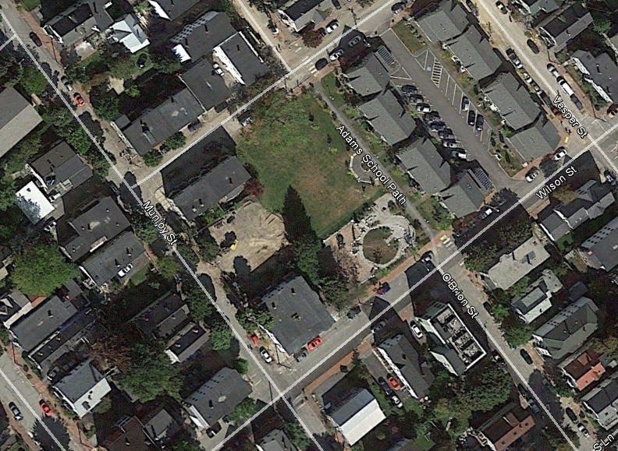
65 Munjoy Street
Former Adams School property
Danforth Street

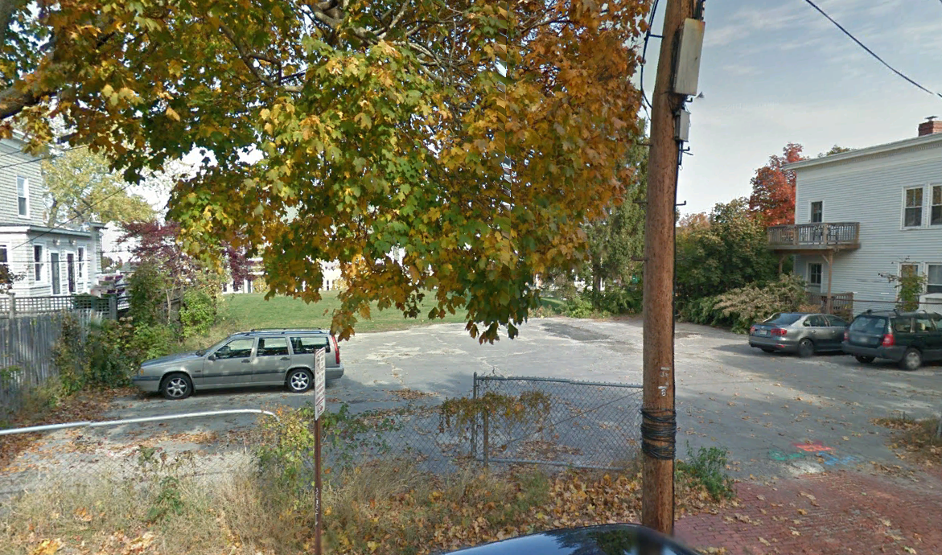
Figures 1 and 2: 65 Munjoy Street and the former Adams School property from above (top) and from Munjoy Street (right).

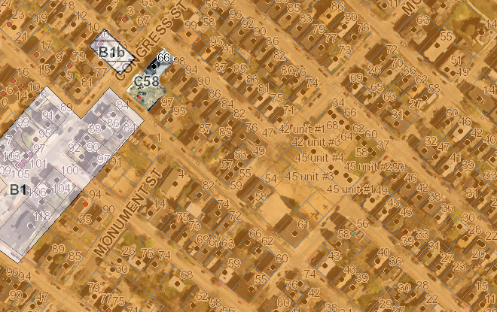

R6

Figure 3: 65 Munjoy zoning context

IV. BACKGROUND
65 Munjoy Street is a city-owned lot located on the east side of Munjoy Street in the heart of Munjoy Hill. The site was originally part of a larger property which housed the grounds of the Adams School, an elementary school which served the Munjoy Hill neighborhood from the late 1950s until 2006. Shortly following the school’s closure, the city established the Adams School Reuse Committee to consider possible future uses for the school property. The final report of the committee, completed in 2007, outlined a set of goals for the property’s redevelopment (Attachment BG-1). The report informed an RFP (Attachment BG-2), and in 2010, the eastern portion of the former school property was sold and redeveloped into a 16-unit affordable housing complex (Attachments BG-3 and 4). Under the same plans, the middle portion was developed as a city park (Attachments BG-3 and 4). The redevelopment of the 65 Munjoy Street site was considered in the responses to the RFP, but not included in the final site plan. Instead, the lot remained as a surface parking area used mainly for the purposes of snow ban parking.

In 2014, the City Council’s Housing and Community Development Committee (HCDC) issued an RFP for the sale and redevelopment of the 65 Munjoy site (Attachment BG-5). The RFP was informed by the original Adams School Reuse Committee report, public input from the surrounding neighborhood, an environmental site assessment performed by Credere Associates, LLC, and a feasibility study completed by Bluestone Planning Group. The city received one response from Adam’s Apple, LLC (Attachment BG-6). The HCDC subsequently recommended that the council approve the sale of the land for the purposes of the Adam’s Apple development. This development is the subject of the current site plan and subdivision review. A summary of this RFP process, described by Mary Davis, Director of the city’s Housing and Community Development Division, is included as Attachment BG-7.

The site lies in an R-6 zone and is surrounded by residential uses, including both single and multi-family homes. As discussed above, a city park neighbors the site to the immediate northeast. Environmental contaminants, including lead, arsenic, Polycyclic Aromatic Hydrocarbons (PAHs), and Extractable Petroleum Hydrocarbons (EPHs), have been found in the soil on the site. These contaminants require remediation prior to redevelopment (Attachmnet BG-5).

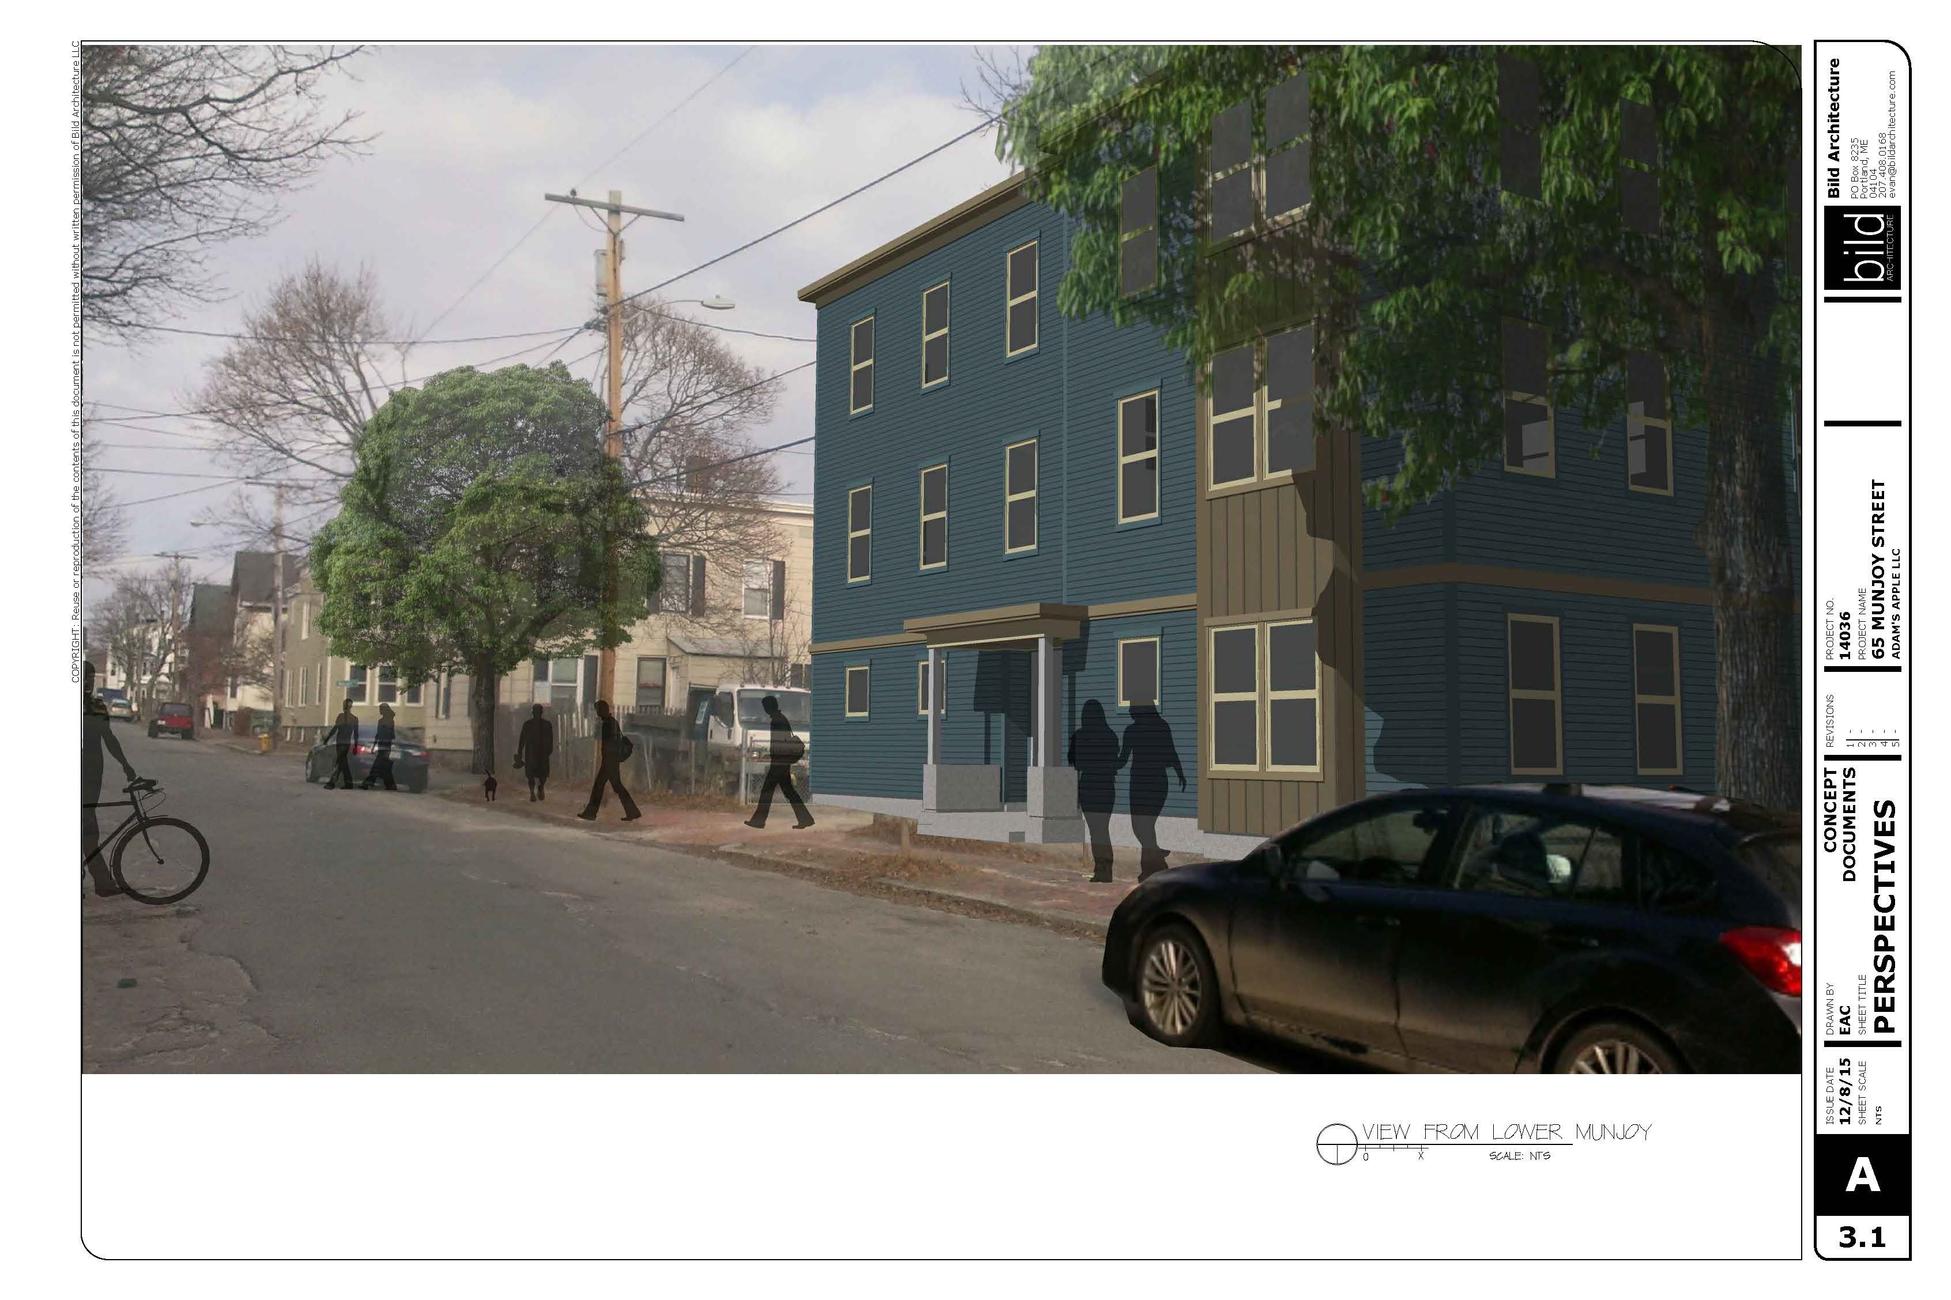
Figure 4: Proposed development at 65 Munjoy Street, looking north
V. PROPOSED DEVELOPMENT
The applicant’s plans show an eight-unit condominium building, including two 3-bedroom units, two 2-bedroom units, and four 1-bedroom units, all of which would be deed restricted to households of less than 120% of area median income for a period of 90 years. The plans show a driveway cut from Munjoy Street and eight parking spaces, six of which are proposed beneath the building. Entrances are shown at the front of the building on Munjoy Street, the side of the building, and the rear. The side entrance, near the parking, is proposed as the designated accessible entrance. The plans include landscaping at the front, side, and rear, a new brick sidewalk, and stormwater detention in three rain gardens. Some grading and landscaping on the site of the adjacent city park is proposed.

The building is designed to stand three stories in height, with clapboard and board-and-batten siding. A bay window is proposed on the southern portion of the front façade. The front entry is defined by a small porch feature with a concrete bench and steel columns. A small roof defines the side entry of the building as well.

VI. PUBLIC COMMENT
The Planning Division received comments on the plans from several neighboring property owners (Attachments PC-1-10). The applicant has also provided neighborhood meeting minutes (Attachment Q). The comments from these sources identify the following concerns:
- Parking: Neighbors expressed concern at the loss of snow ban parking and questioned whether additional residential development would overburden the existing parking supply.
- Design: Several neighbors have expressed concerns with respect to the design of the building, particularly its relationship to the surrounding context. These neighbors have questioned the height of the building, the width of the building, the level of articulation and detail, and the way the building references the neighborhood vernacular. Neighbors have suggested revising the design entirely to a side-by-side triple decker typology, enhancing the front stoop, raising the first floor plate, and integrating additional traditional elements, such as bay windows.
- Public Process: Several neighbors have also raised concerns about the Adams School reuse process more broadly, from the time of the Adams School Reuse Committee’s report to the current RFP and site plan and subdivision review. Several members of the committee have argued that the neighborhood’s original design vision is not adequately reflected in the current proposal.

VII. RIGHT, TITLE, & INTEREST
On February 1, the City Council authorized a purchase and sale agreement for the sale and redevelopment of the 65 Munjoy Street site to Adam’s Apple, LLC (Attachment G). The transaction includes an interim sale to the Portland Housing Development Corporation in order to secure a $200,000 brownfields grant from Greater Portland Council of Governments for the purposes of environmental remediation.

The applicant’s plans show regrading at the rear of the site which extends into the adjacent city park. This regrading is necessary to allow the site to capture and infiltrate its runoff. The applicant also shows landscaping on adjacent city property in order to screen the view of the parking area from the neighboring park. In conjunction with Corporation Counsel, David Margolis-Pineo, of the city’s Department of Public Works, has requested a license for this work. He writes,

The applicant is required to execute an easement or license with the City of Portland for access, grading and landscaping by the applicant on City property.

This license has been included as a condition of approval.

VIII. FINANCIAL & TECHNICAL CAPACITY
The applicant has submitted a letter from Gorham Savings Bank stating that the project team has “demonstrated both the management capabilities and the financial resources necessary to see a project like [65 Munjoy Street] through to completion” (Attachment H).

IX. ZONING ANALYSIS
Staff conducted a zoning analysis which found that the project meets the requirements of the R-6 zone, including minimum lot area per dwelling unit, setbacks, and building height. The elevations show the height, based on average grade, at 34.69’ (Plan 14). The R-6 permits 45’ in height.

X. SITE PLAN SUBMISSION REQUIREMENTS (Section 14-527) and SUBDIVISION PLAT
AND RECORDING PLAT REQUIREMENTS (Section 14-496)
The applicant has submitted a draft subdivision plat (Plan 6). A final plat, meeting the requirements of Section 14-496, will require review by William Clark, the city’s surveyor, as well as Corporation Counsel. This review has been included as a condition of approval. A review of condominium documents has also been included as a condition of approval.

XI. SUBDIVISION REVIEW (14-497(a). Review Criteria)
The proposed development has been reviewed by staff for conformance with the relevant review standards of the City of Portland’s subdivision ordinance. Staff comments are below.

1. Water, Air Pollution
As discussed above, the project will involve some environmental remediation. The city has developed a Voluntary Response Action Program (VRAP) work plan to address the environmental site work. No detrimental water or air quality impacts are anticipated.

2 & 3. Adequacy of Water Supply
The applicant has provided evidence of capacity from the Portland Water District (Attachment P).

4. Soil Erosion
No unreasonable soil erosion or reduction in the capacity of the land to hold water is anticipated.

5. Impacts on Existing or Proposed Highways and Public Roads
Tom Errico, the city’s consulting traffic engineer, has reviewed the plans and has not raised any concerns about impacts to the existing street network associated with trip generation (Attachment 2).

6. Sanitary Sewer/Stormwater Disposal
Sanitary sewer and stormwater impacts are discussed in more detail under site plan review below.

7. Solid Waste
The applicant has proposed a location for solid waste receptacles in the under-building parking area. Solid waste and recycling will be collected by the city.

8. Scenic Beauty
This proposal is not deemed to have an adverse impact on the scenic beauty of the area.

9. Comprehensive Plan
The plans meet multiple goals from the city’s housing plan, including ensuring “the construction of a diverse mix of housing types that offers a continuum of options across all income levels” and “encourag[ing] higher density housing for both rental and home ownership opportunities, particularly located near services, such as schools, businesses, institutions, employers, and public transportation.”

10. Financial and Technical Capacity
As noted above, the applicant has submitted a letter from Gorham Savings Bank attesting to the applicant’s financial capacity (Attachment H).

11. Wetland/Water Body Impacts
There are no anticipated impacts to wetlands or water bodies.

12. Groundwater Impacts
There are no anticipated impacts to groundwater supplies.

13. Flood-Prone Area
Per the city’s existing flood maps, the site is not located in a flood zone.

XII. SITE PLAN REVIEW
The proposed development has been reviewed by staff for conformance with the relevant review standards of the City of Portland’s site plan ordinance. Staff comments are below.

- Transportation Standards
- Impact on Surrounding Street Systems
The development includes eight residential units, which are not anticipated to generate significant traffic volumes. Mr. Errico has reviewed the applicant’s submittals and has not noted any appreciable impact on surrounding street systems (Attachment 2).

- Access and Circulation
The final plans include a new eight foot brick sidewalk along the frontage of the site. This sidewalk would provide access to the front door of the building, which is proposed to be connected via corridor to the building’s central stairwell. An accessible entrance is proposed on the side of the building. This entrance is proximate to parking and, in the revised plans, has been accentuated with a canopy.

The plans also include a new curb cut, which is shown in the plans with a brick apron. Of this material choice, Mr. Margolis-Pineo writes,

The applicant has proposed a brick driveway apron which does not meet the City’s driveway apron material policy. If the applicant is agreeable to an agreement that the applicant will be responsible for maintaining the brick apron, this Department is supportive of waiving the material policy for this project.

The applicant would be required to have the change in material approved by the council. This has been included as a condition of approval.

The plans show a new paved drive aisle which would provide access to eight parking spaces, six of which would sit under the first floor of the building. The drive aisle is proposed at 19 feet in width, narrower than the city standard of 24 feet. As such, a waiver is required. Mr. Errico has met with the applicant to simulate parking maneuvers under the plan and expressed his support for this waiver (Attachment 2).

- Public Transit Access
The proposed development is not located along a public transit route. As such, no provisions for transit access are required.

- Parking
Division 20 of the land use ordinance provides an exception for the off-street parking requirement for the first three units in the R-6 zone and a 1:1 requirement thereafter. Per the ordinance then, only five off-street spaces are technically required. The applicant has elected to provide eight off-street spaces. On the final plans, the applicant shows three spaces whose dimensions technically fail to meet the Technical Manual standard; two spaces are proposed at 9’ x 15’ and one space is proposed at 8’ x 18’. Mr. Errico has expressed his support for this waiver (Attachment 2).

Two bicycle spaces per five dwelling units are required under the site plan ordinance. As such, four bicycle parking spaces are required. The final plans denote a bicycle rack on the sidewalk in front of the building to provide space for one visiting bicycle. The architectural plans show additional bicycle parking spaces in the under-building parking area. The plans meet the bicycle parking standard.

- Transportation Demand Management
A transportation demand management plan is not required.

2. Environmental Quality Standards
- Preservation of Significant Natural Features
There are no known significant natural features on the site.

- Landscaping and Landscape Preservation
The landscaping plan includes assorted perennials interspersed with decorative granite blocks along the building frontage and blueberries, dogwood, switchgrass, and iris in the rain gardens at rear. Jeff Tarling, the city’s arborist, has reviewed the plans and offered the following comments,

Along Munjoy Street - would recommend adding in at least a few 'woody'
plants for four season interest. Concern that this time of year just the granite
blocks would be the only visible landscape feature. Also lets define 'Assorted
Perennials' - It should be in keeping with the Native Sod theme and looks like
it is from the perspective drawing. Note that establishing the native sod can
be a challenge, extra water is needed for the first two years.

Rain Garden - …plant names should show where plants
are located. Caution on the use of 'Red Twig' knowing their expanding size,
might be worth looking at 'Kelsey Dwarf' or other low growing types to better
fit this space.

Wilson Street side - Landscape Treatment, This narrow space does not appear to
have a landscape treatment type shown. Is this going to be the only turf area on
the property or other?

The plans also include some planting on the adjacent city park. Of these plans, Mr. Tarling writes,

Adams School Playground Plants - We like the upright, 'Regal Prince' Oak, lets tweak the arrangement and line them up near the property line to reduce hiding spots and have the grasses grouped on the park side or near the corners. Grass type we would like to use 'The Blues', Little Bluestem grass vs the taller Switchgrass proposed.

Mr. Tarling’s comments have been reflected in the proposed conditions of approval.

Per the city’s site plan ordinance, eight street trees are required for the eight residential units proposed. The plans include five gingko trees on the northern property line and the retention of one existing street tree. Mr. Tarling has agreed that the five gingkos and the existing tree qualify toward the street tree requirement. Site constraints prevent the planting of additional street trees. A waiver for the planting of the two remaining street trees, with a contribution of $400 as required by ordinance, is proposed.

- Water Quality/Storm Water Management/Erosion Control
As it stands as a surface parking lot, the site is mostly impervious, and the majority of the site drains toward the city park at the rear of the site. The proposed development will reduce the impervious area on site by approximately 20%. As a result, the applicant is not required by ordinance to treat stormwater runoff. However, the applicant has proposed three rain gardens, two at the rear of the site and one at the back of sidewalk, to capture and infiltrate stormwater. The majority of runoff would be directed to the gardens at rear, with a small area of the driveway directed to the garden at the front of the building. The applicant has designed the rain gardens at the back of the site to overflow via grassed level spreaders to the adjacent city park land. The system generally maintains existing drainage patterns but will decrease the amount of stormwater leaving the site. David Senus, the city’s consulting civil engineer, has reviewed this system and indicated his approval (Attachment 4).

As noted above, prior to construction the site will undergo environmental remediation for contaminants found in the soil. The city has developed a Voluntary Response Action Program (VRAP) work plan and a Soil Management Plan in order to address the treatment of these contaminants. Remediation work is scheduled to begin this spring.

3. Public Infrastructure and Community Safety Standards
- Consistency with Related Master Plans
As noted above, the project is generally deemed consistent with related master plans.

- Public Safety and Fire Prevention
Keith Gautreau, of the Fire Prevention Bureau, has noted that he is satisfied with the plans as proposed (Attachment 5). The site has generally been planned in accordance with Crime Prevention Through Environmental Design (CPTED) principles.

- Availability and Capacity of Public Utilities
The plans depict underground electric from a pole directly in front of the proposed building on Munjoy Street. Electrical service to neighboring buildings will need to be moved in order to eliminate conflicts with the proposed building. This is noted on the plans.

A sewer connection is proposed to an existing line in Munjoy Street. The applicant has provided a wastewater capacity letter from David Margolis-Pineo of the Department of Public Works attesting to the city’s capacity to transport and treat the anticipated wastewater flows from the project via this sewer line (Attachment P).

Gas and water are also proposed to and from Munjoy Street. The applicant has provided evidence of water capacity (Attachment P).

4. Site Design Standards
- Massing, Ventilation, and Wind Impact
The bulk, location, and height of the proposed building are not anticipated to result in health or safety problems from a reduction in ventilation or changes to the wind climate. Likewise, these elements of the plan are not anticipated to result in substantial diminution in the value or utility of neighboring structures. HVAC mechanisms are denoted at the center of the roof, away from the public park at the rear of the site, as well as the street.

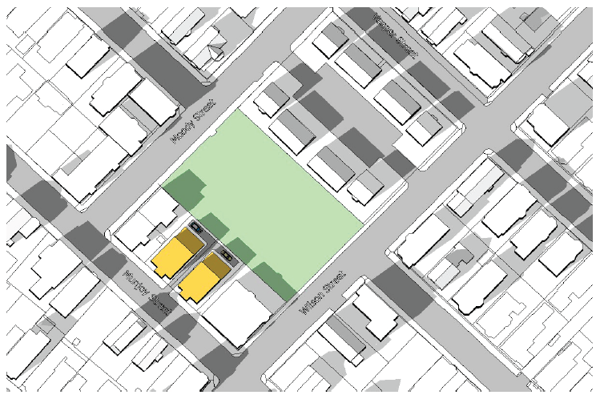
- Shadows
Figure 5: Preliminary shadow study by Bluestone Planning Group
Per the city’s Technical Manual, proposals for structures greater than 45 feet tall outside the B3, B5, B6, and B7 zones are required to include a preliminary shadow analysis to determine if adverse impacts to publicly accessible open spaces are likely. The proposed building stands less than 45 feet tall. However, in this case, since the site lies west of a city park, the city’s advance planning work by the Bluestone Planning Group considered the issue of shadow impacts. The study found that a three story structure including eight dwelling units and set back from the rear property line, with an additional stepback, would “have very minimal shadow impact on the playground on Wilson Street, although there may be some shadows cast on the open space at the center of the block” (Attachment BG-5). It should be noted that the applicant’s design differs from that identified in this preliminary shadow study. However, given that the building is generally similar in height, and that the height is well below 45 feet, no additional shadow study was required through site plan review.

- Snow and Ice Loading
Accumulated ice and snow are not anticipated to load onto adjacent properties or public ways.

- View Corridors
Munjoy Street is not a protected view corridor.

- Historic Resources
The site is not within or adjacent to a designated historic resource.

- Exterior Lighting
The applicant has provided a photometric plan and a specification for a building light. The lighting meets the city’s Technical Manual standards.

- Noise and Vibration
On the final elevations, mechanical equipment is shown on the roof at the interior of the site.

- Signage and Wayfinding
No signage or wayfinding is proposed.

- Zoning-Related Design Standards
The 2014 RFP for the development of this site included guidelines around “design compatibility.” These guidelines were developed by the Adams School Reuse Committee in 2007 and suggest that the development “connect to the neighborhood,” be “reflective of the surrounding traditional neighborhood,” and “enhance the pedestrian experience and the public realm,” among other objectives (Attachment BG-5). In addition, the 2014 Bluestone report identified a preferred design concept for 65 Munjoy Street. This concept showed two triple deckers with shared access. The Bluestone report was included as an attachment to the RFP for 65 Munjoy (Attachment BG-5). Ms. Davis, the Director of Housing and Community Development, writes,

The issue of design was discussed as part of the process of drafting the RFP as well as during the work [Bluestone Planning Group] did to create the massing and feasibility study. The study looked at alternative designs for the site, and while there was one preferred alternative in the study, that did not rule out the possibility that respondents to the RFP could put forth other design options. The RFP included a section devoted to "Design Compatibility" which called for a high quality, compatible design. Detailed design review was acknowledged as the responsibility of the Planning Board.

Adam’s Apple responded to the 65 Munjoy Street RFP with drawings which depicted one larger building, instead of two side-by-side triple deckers. In their proposal, they wrote, “[i]nitial plans to develop the site with two buildings…was [sic] abandoned due to the much higher costs of building redundant foundations, envelopes, circulation spaces, utility connections, metering systems, mechanical systems, and stair towers.” They also noted the high cost of environmental remediation (Attachment BG-6).
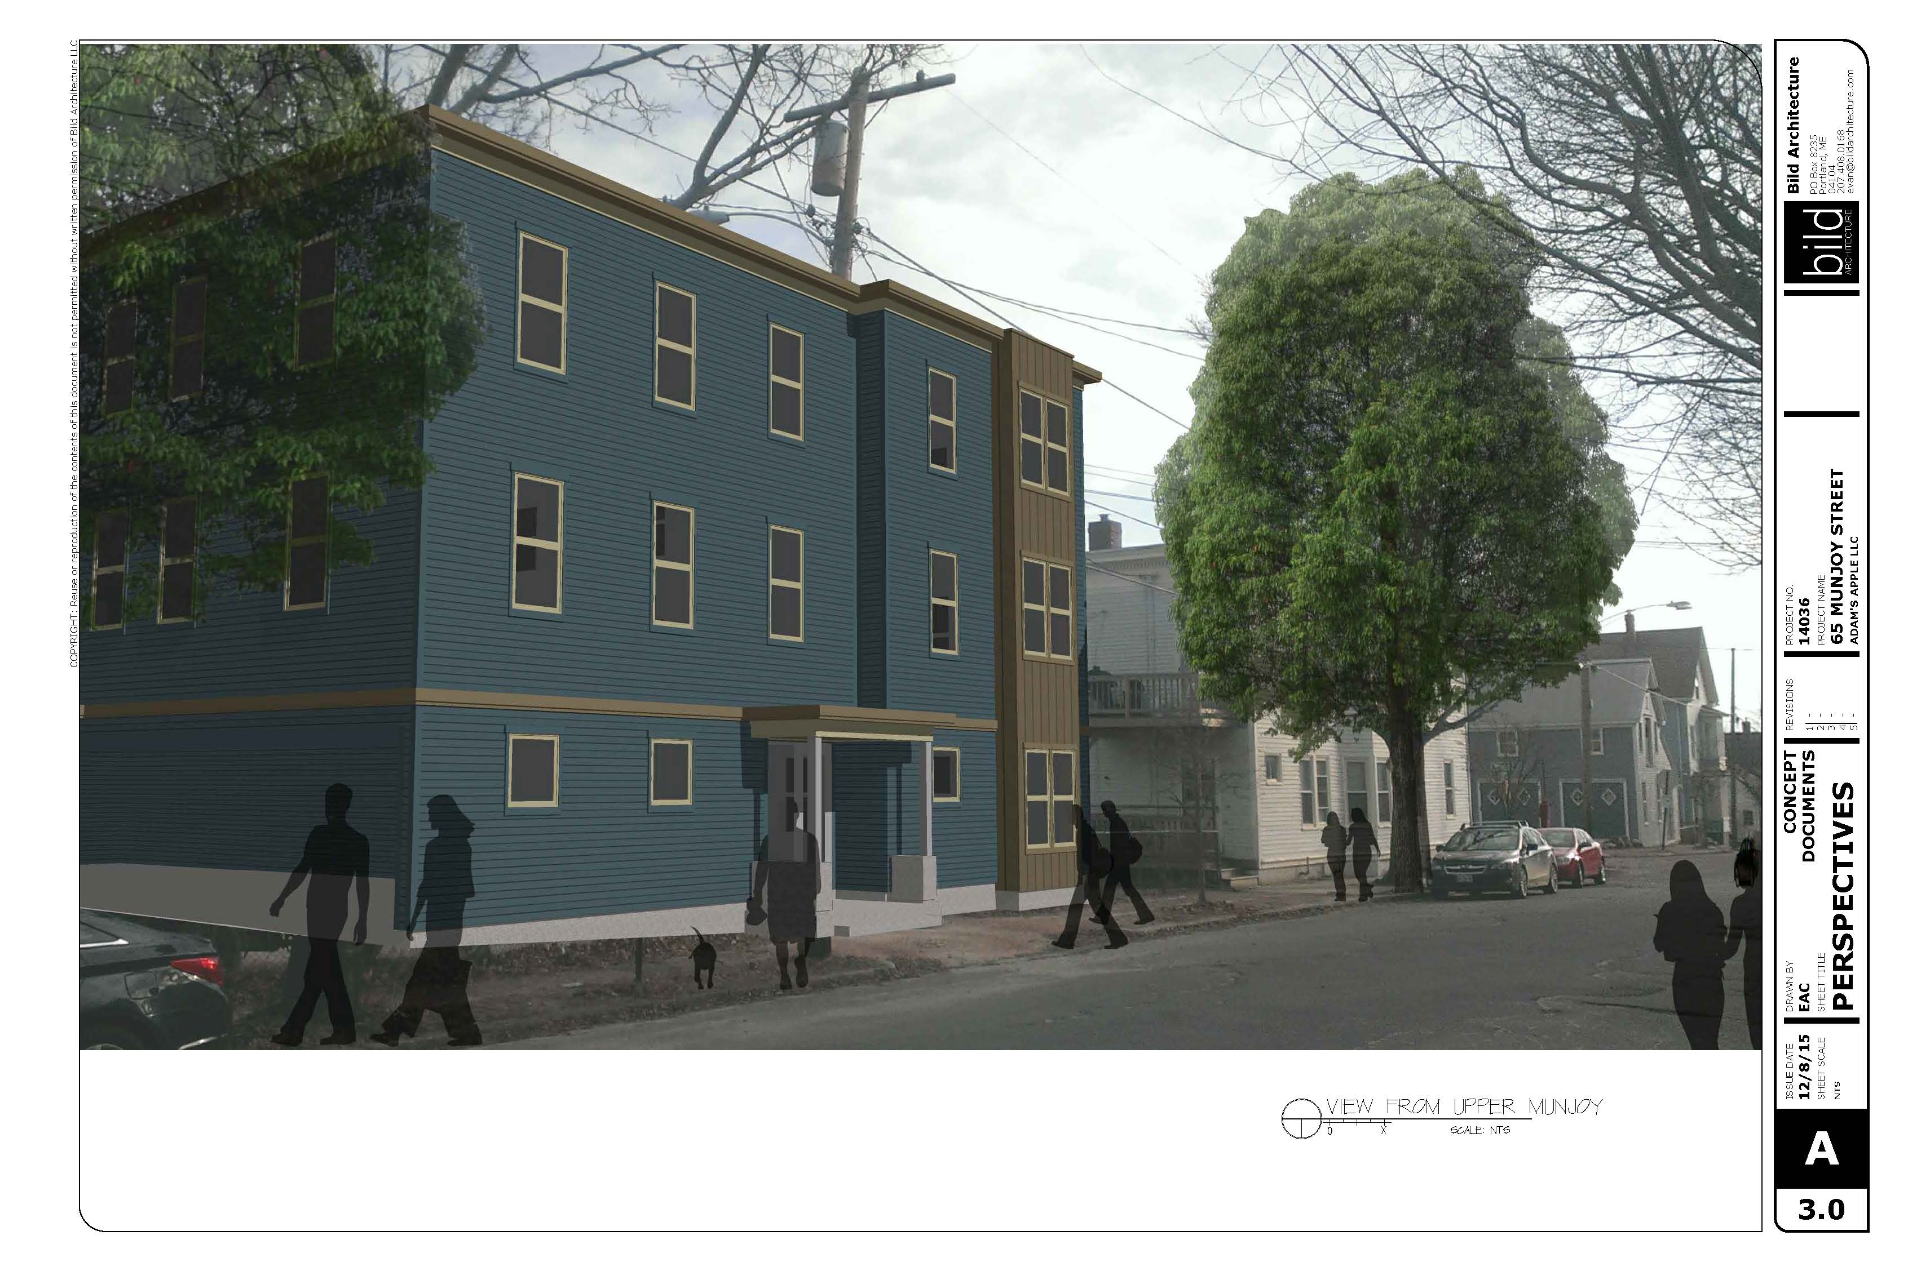
Figure 6: Proposed development at 65 Munjoy Street from the north
The preliminary architectural drawings submitted by the applicant for the purposes of site plan review remained relatively unchanged from the response to the RFP (Plans 12 and 13). In these drawings, the exterior of the building was designed to appear as two adjoining triple deckers, but the interior of the building was organized as an apartment building with three units on the upper two floors and two on the first. Based on a preliminary R-6 design review, staff suggested that the applicant move away from the triple decker exterior design concept in an effort to more accurately reflect the interior composition of the building and improve the quality of interior spaces. Staff suggested that the applicant add elements reflective of the neighborhood which might lend articulation, such as bay windows, and modify the proportions of the front porch. The applicant subsequently held their neighborhood meeting to gain feedback on the design. Revised plans were provided to the city in late January.

Staff reviewed the revised plans (Figures 6 and 7) against the R-6 design guidelines and found that the proposed design met all design criteria. Caitlin Cameron, the city’s urban designer, writes,

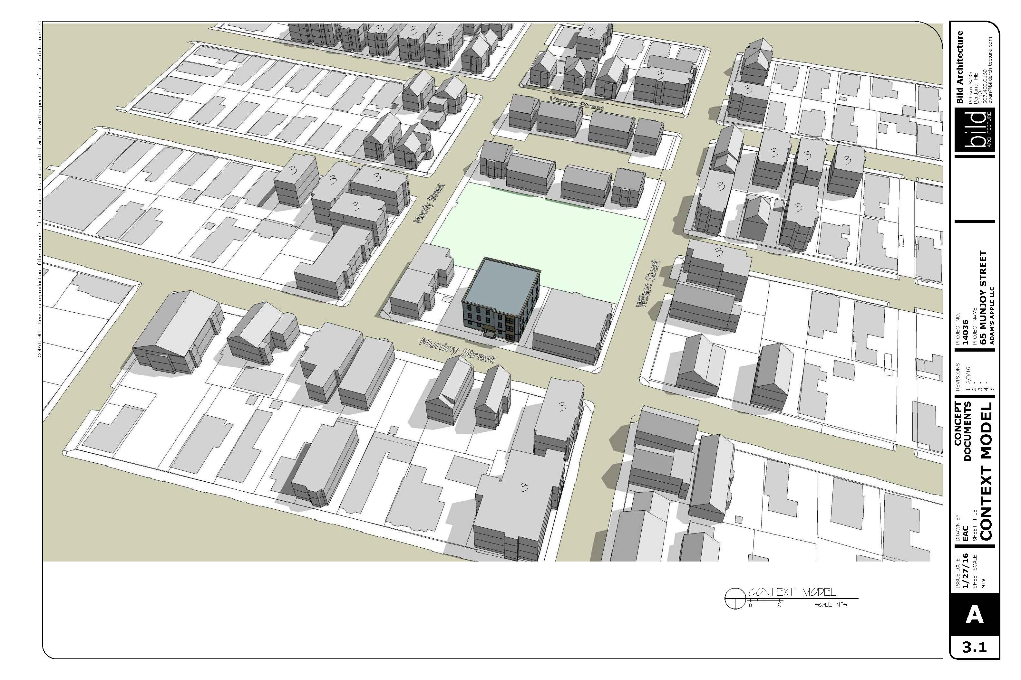
A‐1 Scale and Form: The form is defined by rectilinear masses in keeping with typical multifamily buildings in the neighborhood, the roof line is flat with expressed cornice lines. The proposed mass is three stories and 55’ wide on the street – the length of the building at the street is similar to neighboring double‐houses; triple‐deckers are also in the context making the height of three stories an appropriate scale. On Munjoy Street, the building length is mitigated by breaking it into two masses and a bay projection.
Figures 7 and 8: Proposed development at 65 Munjoy Street front elevation and massing study

A‐2 Composition of Principal Facades: The building overall takes its cues from the surrounding forms, materials, and façade composition but combines them in a contemporary way. The composition of the Munjoy Street façade is well‐balanced and is simple but with visual interest created through a change in planes, bay window, and trim and material details. As noted below, the overall composition of the facades meets the standard in terms of rhythm, size, orientation, and proportion of window and door openings.

A‐3 Relationship to the Street: The building placement is consistent with the spacing of the residential fabric – residential buildings are typically raised with a small front yard setback. The ground floor is raised consistent with residential development patterns.
The street wall is maintained and the garage is side‐facing. Architectural features such as a covered stoop and bay window are employed, picking up on the vernacular language in the neighborhood.

XIII. STAFF RECOMMENDATION
Subject to the proposed motions and conditions of approval listed below, Planning Division staff recommends that the Planning Board approve the proposed eight-unit condominium development at 65 Munjoy Street.

XIV. PROPOSED MOTIONS
- Waivers
On the basis of the application, plans, reports and other information submitted by the applicant; findings and recommendations contained in the Planning Board report for the public hearing on February 9, 2016 for application 2015-225 relevant to Portland’s technical and design standards and other regulations; and the testimony presented at the Planning Board hearing:

- The Planning Board finds/does not find, based upon the consulting transportation engineer’s review, that extraordinary conditions exist or undue hardship may result from strict compliance with the Technical Manual standard (Section 1.14) which requires that aisle width for right-angle parking be 24 feet per Figure I-27, that substantial justice and the public interest are secured with the proposed variation in this standard, and that the variation is consistent with the intent of the ordinance. The Planning Board waives/does not waive the Technical Manual standard (Section 1.14) to allow a 19 foot wide aisle in the parking area;

- The Planning Board finds/does not find, based upon the consulting transportation engineer’s review, that extraordinary conditions exist or undue hardship may result from strict compliance with the Technical Manual standard (Section 1.14) which requires that a standard parking space be 9’ x 18’, that substantial justice and the public interest are secured with the proposed variation in this standard, and that the variation is consistent with the intent of the ordinance. The Planning Board waivers/does not waive the Technical Manual standard (Section 1.14) to allow two 9’ x 15’ spaces and one 8’ x 18’ space;

- The Planning Board finds/does not find that the applicant has demonstrated that site constraints prevent the planting of all required street trees in the right-of-way. The Planning Board waives/does not waive the site plan standard (Section 14-526 (b) (iii)) to allow for a contribution of $400 to Portland’s tree fund to be substituted for the provision of additional trees on site.

- SUBDIVSION
On the basis of the application, plans, reports and other information submitted by the applicant; findings and recommendations contained in the Planning Board report for the public hearing on February 9, 2016 for application 2015-225 relevant to the subdivision regulations; and the testimony presented at the Planning Board hearing, the Planning Board finds that the plan is/is not in conformance with the subdivision standards of the land use code, subject to the following conditions of approval, which must be met prior to the signing of the plat:

      - The applicant shall finalize the subdivision plat for review and approval by Corporation Counsel, the Department of Public Services, and the Planning Authority; and

      - Prior to Certificate of Occupancy, the applicant shall finalize condominium documents for review and approval by Corporation Counsel.

- Development Review
On the basis of the application, plans, reports and other information submitted by the applicant; findings and recommendations contained in the Planning Board Report for the public hearing on February 9, 2016 for application 2015-225 relevant to the site plan regulations; and the testimony presented at the Planning Board hearing, the Planning Board finds that the plan is/is not in conformance with the site plan standards of the land use code, subject to the following conditions of approval that must be met prior to the issuance of a building permit, unless otherwise stated:

- The applicant shall obtain a license agreement for grading and landscaping to be performed on the adjacent city park property for review and approval by the Department of Public Works and Corporation Counsel;

- The applicant shall provide a revised plan set either eliminating the brick driveway apron or obtain a change in sidewalk material policy from City Council and submit a maintenance agreement for review and approval by the Department of Public Works; and
- The applicant shall submit a revised landscaping plan depicting plant types and locations as requested by the city’s arborist for review and approval by the city arborist.

XV. ATTACHMENTS
Planning Board Report Attachments
- Department of Public Works review (memo from David Margolis-Pineo, 2/3/16)
- Traffic engineer review (memo from Thomas Errico, 2/2/16)
- City arborist review (memo from Jeff Tarling, 1/27/16)
- Civil engineer review (memo from David Senus, 2/3/16)
- Fire Prevention Bureau review (memo from Keith Gautreau, 1/7/16)
- Design review (memo from Caitlin Cameron, 1/27/16)

Applicant’s Submittals
- Cover Letter (from John Mahoney, 12/11/15)
- Level III Site Plan Application
- Description of Project
- Accessibility Narrative
- Crime Prevention Through Environmental Design Narrative
- Compliance With Zoning
- Evidence of Right, Title, & Interest
- Evidence of Financial Capacity
- Parking Memo
- Stormwater Management Narrative
- Consistency with City Master Plans
- Solid Waste Management
- NFPA Code Summary
- Design Standards Assessment
- Geotechnical Report
- Utility Capacity Letters
- Neighborhood Meeting Summary
- Comment Response Letter (from John Mahoney, 1/27/16)

PLANS
- Boundary Survey
- Site Plan
- Grading, Drainage, and Utilities Plan
- Details
- Details
- Subdivision Plat
- Landscape Plan
- Photometric Plan
- Construction Management Plan
- First Floor Plan
- Second and Third Floor Plan
- Preliminary Proposed Elevations (12/8/15)
- Preliminary Proposed Elevations (12/8/15)
- Final Proposed Elevations (1/27/16)
- Final Proposed Elevations (1/27/16)
- Perspective View
- Perspective View
- Perspective View
- Context Model

PUBLIC COMMENT
- Thayer email (1/15/16)
- Thayer editorial (1/20/16)
- Thayer email (1/21/16)
- Thayer email (1/21/16)
- Thayer email (2/2/16)
- Thayer email (2/3/16)
- Marcisso email (2/3/16)
- Lindholm email (2/4/16)
- Lloyd email (2/4/16)
- Thayer email (2/4/16)

BAckground documents
BG-1. Adams School Reuse Committee Report (7/27/2007)
BG-2. Adams School Reuse RFP (2008)
BG-3. Adams School Development Proposal, Avesta Housing (7/22/08)
BG-4. Adams School Development Subdivision Plat (4/30/12)
BG-5. 65 Munjoy Street RFP (including Credere Associates Work Plans and Bluestone Planning Group Reports) (11/19/14)
BG-6. 65 Munjoy Development Proposal, Adam’s Apple (1/13/15)
BG-7. Division of Housing and Community Development memo (memo from Mary Davis, 2/1/16)

